The Project Gutenberg EBook of History of the United States, Volume 6 (of
6), by E. Benjamin Andrews

This eBook is for the use of anyone anywhere at no cost and with
almost no restrictions whatsoever. You may copy it, give it away or
re-use it under the terms of the Project Gutenberg License included
with this eBook or online at www.gutenberg.org

Title: History of the United States, Volume 6 (of 6)

Author: E. Benjamin Andrews

Release Date: December 24, 2007 [EBook #24023]

Language: English

Character set encoding: ASCII

*** START OF THIS PROJECT GUTENBERG EBOOK HISTORY OF THE UNITED STATES ***

Produced by Don Kostuch

[Transcriber's Notes]

Text has been moved to avoid fragmentation of sentences and paragraphs.

This is the last volume in a set of six. The other five volumes are at:
Volume I -- http://www.gutenberg.org/etext/20925
Volume II -- http://www.gutenberg.org/etext/22567
Volume III -- http://www.gutenberg.org/etext/23748
Volume IV -- http://www.gutenberg.org/etext/22676
Volume V -- http://www.gutenberg.org/etext/22777

Here are the definitions of some uncommon words.

capitation
Numbering or assessing by the head. Poll tax. Fee or payment of a uniform amount for each person.

cumberer
Hindrance.

imperatively
Absolutely necessary; unavoidable; commanding.

justiciable
Capable of being settled by law or by the action of a court:

munificent
Very generous.

[End Transcriber's Notes]
HISTORY OF THE UNITED STATES

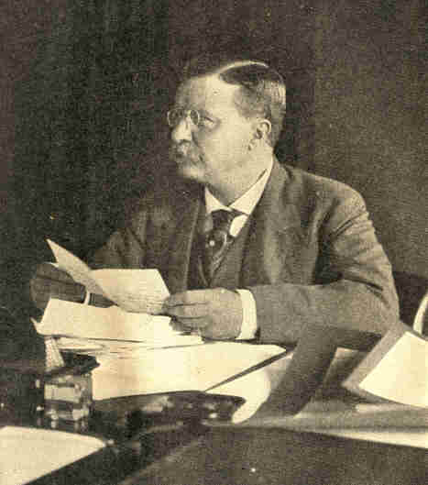
Copyright, 1907, by Clinedinst. Washington, D. C.
Theodore Roosevelt
At his desk in the executive offices of the
White House during his term as president
HISTORY OF THE UNITED STATES

FROM THE EARLIEST DISCOVERY OF AMERICA
TO THE PRESENT TIME

BY
E. BENJAMIN ANDREWS
CHANCELLOR OF THE UNIVERSITY OF NEBRASKA
FORMERLY PRESIDENT OF' BROWN UNIVERSITY

With 650 Illustrations and Maps

VOLUME VI.

NEW YORK
CHARLES SCRIBNER'S SONS
1912
COPYRIGHT, 1912, BY
CHARLES SCRIBNER'S SONS
7

CONTENTS
PAGE
CHAPTER I. THE RISE OF THEODORE ROOSEVELT 21
Career of Theodore Roosevelt.--Characteristics.--Temper and Method.--Administration.--Reciprocity.--Trusts.--Industrial Confederations.--Railway, Steel and Steamship Combinations.--Ship Subsidy Bill.--Beef Trust.--Steel Strike of 1901.--Anthracite Coal Strike of 1902.--President Roosevelt Calls Conference for Its Settlement.

CHAPTER II. ROOSEVELT'S FIRST ADMINISTRATION 43
His Fine Equipment for the Office of President.--A Remarkable Cabinet.--Mr. Root's Work for Cuba and the Philippines.--For the Army.--The Diplomacy of John Hay.--Department of Commerce and Labor Created.--The Panama Canal Achievement.--Recognition of Panama.--The Galveston Flood.--Plan of City Government.--Cuba an Independent Republic.--The Philippines under United --States Rule.--The Baltimore Fire.--The St. Louis Exposition.

CHAPTER III. PRESIDENTIAL ELECTION OF 1904 71
President Roosevelt Renominated.--Nominations of the Democratic Convention.--Of the Conventions of the Populist, Socialist and Prohibitionist Parties.--Character of the Campaign.--Charges Made against the Republicans.--President Roosevelt's Reply to Judge Parker's Statements.--Results of the Election.

8 CONTENTS

PAGE
CHAPTER IV. AMERICA AND THE CHINESE OPEN DOOR 85
Aggressive Policy of President Roosevelt.--Secretary Hay Continued in Office.--William H. Taft Made Secretary of War.--Trade of America and European Nations with China.--Secretary Hay's Request for Equal Trade Rights in China for All Nations.--The Boxer Rebellion.--Portion of China's Indemnity Cancelled by Congress.--Chinese Students in America.--Russia's Influence in China.--New Commercial Treaty between United States and China.--Opening of Manchurian Ports to All Nations.--Secretary Hay and Chinese Neutrality during the Russo-Japanese War.--Effects of too Strict Interpretation of Chinese Exclusion Act.--President Roosevelt's Instructions to Immigration Officials.

CHAPTER V. INTERNATIONAL ARBITRATION. 94
Progress Made in Settlement of International Difficulties by Arbitration.--First Meeting of the Hague Peace Conference.--Work of the Conference.--Chief Features of a Permanent International Court of Arbitration.--Advantages of Such Court.--Convened for the First Time in 1901.--The Pious Fund Case.--The Venezuela Case.--Mr. Carnegie's Gift for a "Palace of Peace."--The Building.--Peace Congresses Held in the United States in 1904.--Resolutions Adopted.--The Nations Invited by President Roosevelt to a Second Hague Conference.--Work of Second Conference.--Number of Treaties Concluded between the Nations.

CHAPTER VI. THE UNITED STATES AND LATIN-AMERICA 110
Interest in South American Republics.--Meeting of Pan-American Congress in Washington.--In City of Mexico.--Comparison of Foreign Commerce of South American States with European Countries and with the United States.--Progress of South American States.--The Third Pan-American Congress, at Rio Janeiro Bureau of Pan-American Republics Founded.--New Interpretation of the Monroe Doctrine.--The Santo Domingo Situation.--Its Adjustment by President Roosevelt.

CONTENTS 9

PAGE
CHAPTER VII. CONSERVATION OF NATURAL RESOURCES 124
Waste of Nation's Resources.--Establishment of a Division of Forestry.--Mariposa Forest Reservation.--Preservation of Niagara Falls.--Inland Waterways Commission Appointed by President Roosevelt.--Conference on Conservation Held at the White House.--Resolutions Adopted.--First National Conservation Commission.--The National Conservation Association Formed.--First North American Conservation Congress, called by President Roosevelt.--Irrigation and the Reclamation Act.--The Roosevelt Dam.--The Shoshone Dam.--The Truckee-Carson Canal.--Proceeds from Sales of Public Lands.--Reclamation of the Swamp Lands.--The Mississippi Basin.--The Lakes to the Gulf Deep Waterways Association.--Projects Submitted by the Inland Waterways Commission.--Appropriation for Enlargement of Erie Canal.

CHAPTER VIII. DEVELOPMENT OF THE NEW SOUTH 146
Splendid Natural Gifts of the South.--Its Water Power Facilities.--Wealth of Minerals and Forests, Coal and Iron.--Waste of Forest Lands.--Wonderful Economic Advancement.--Mr. Rockefeller's Gift.--Cotton Production.--Improved Methods of Agriculture.--Roads.--Methods of Financing the Plantation System.--Cultivation of Hay and Corn.--Stock-Raising.--The New Social Life.--Bright Prospect for the Future.

CHAPTER IX. PRESIDENT ROOSEVELT'S SECOND ADMINISTRATION 158
Exposition at Portland, Oregon, Commemorating Lewis and Clark Expedition.--Interstate Commerce Commission.--Provisions of Interstate Commerce Laws.--Pure Food and Drugs Law. --Investigation of Meat-Packing Methods.--The Earthquake in San Francisco.--Relief Fund.--Rebuilding of the City.
10 CONTENTS

PAGE
CHAPTER X. THE FINANCIAL PANIC OF 1907 170
Popular Explanations of Its Cause.--The Real Causes.--Insolvency of Knickerbocker Trust Company.--Lack of Confidence in Financial Institutions.--Aid from the United States Treasury's Surplus Fund.--Enormous Amounts Paid Out to Depositors.--Radical Steps Taken by Bankers.--"Emergency Currency" Issued.--Strengthening of the New York Stock Exchange.--Gold from Foreign Countries.--Sale of Panama Bonds and Notes.--Confidence Restored.--Discussions Concerning Financial System. --The Aldrich-Vreeland Act.

CHAPTER XI. IMMIGRATION AND EMIGRATION 187
Great Increase in Immigration.--Change in Its Character.--Gain in Percentage from Southern Europe over that from Northern Europe.--Reasons Why These Foreigners Emigrate to America.--The Immigration Act of 1907.--And Its Effect.--The Emigration of Italians.--Slavs in the United States.--The Jews.--The Question of Oriental Immigration.--Dangers of Increasing Immigration.--Foreign Colonies in Chicago and Other Cities.--Increase in Criminality.--The Chief Problem.--Emigration of United States Farmers to Canada.

CHAPTER XII. NOTABLE SUPREME COURT DECISIONS 211
The Northern Securities Company Case.--The Alonzo Bailey Case.--Case of Loewe vs. Lawler, or the Danbury Hatters Case.--The Standard Oil Case.--The Case of the American Tobacco Company.

CHAPTER XIII. PRESIDENT ROOSEVELT'S SECOND ADMINISTRATION--
CONTINUED 225
President Roosevelt's Advocacy of a Larger and More Efficient Navy.--Rear-Admiral Evans's Effective Work.--Cruise of the Atlantic Fleet.--Unusual Honors Tendered by Brazil and Other Countries Visited by the Fleet.--Purchase and Settlement of Oklahoma Territory.--Indian System of Government.--Oklahoma and Indian Territory Admitted to the Union.--Exclusion of Japanese Students in San Francisco and President Roosevelt's Prompt Action.--Child-Labor in the United States.--The Beveridge-Parsons Bill.--New Uses of Electricity.--Wireless Telegraphy, Air-Ships and Submarine Boats.--Business and Political Reforms.--Advances in Educational Work.--Notable Gifts of Mr. Carnegie and Mr. Rockefeller.

CONTENTS 11

PAGE
CHAPTER XIV. THE PRESIDENTIAL CAMPAIGN OF 1908 253
The Republican Convention.--William H. Taft Nominated for President.--Other Candidates for Nomination.--James S. Sherman Nominated for Vice-President.--The Democratic Convention.--And Its Nominations.--Platforms of Both Parties.--The Socialist Convention and Platform.--Convention of the Prohibition Party and Its Platform.--Lack of Campaign "Issues."--Personal Fitness of the Candidates.--Fear of the Power of Great Corporations.--Efficiency of President Roosevelt's Administration.--Results of the Election.

CHAPTER XV. THE ADMINISTRATION OF PRESIDENT TAFT 271
Inauguration of President Taft.--His Cabinet.--Increase of Salaries of Principal Executive Officers.--Alaska-Yukon-Pacific Exposition.--Alaskan Products.--Hudson-Fulton Celebration.--Arctic Exploration.--Commander Peary's Expedition.-- Dr. Cook's Claims.--State Constitutions of Arizona and New Mexico Formed.--President Taft's Disapproval of Them.--New Mexico Admitted to the Union.--Population and Products of Arizona.--Of New Mexico.--The Aeroplane.--Tests and Records Made by Aviators.--The Federal Publicity Law.--President Taft's Recommendation Concerning Classified Service.--His Advance Position on International Arbitration.

CHAPTER XVI. THE THIRTEENTH CENSUS, 1910 301
Permanent Census Bureau Established.--Work of the Enumerators.--Special Attention Given to Character of Questions.--Enormous Labor of Tabulation and Classification.--Cost of Census.--Population of United States and Territorial Possessions. --Comparisons of Population with That of Previous Decade.--Rapid Growth of Cities.--Westward Advance of Centre of Population.--Emigration to Canada.--Congressional Reapportionment.--Farms of the United States.--Value of Foreign Commerce.--Of Exports.
12 CONTENTS

PAGE
CHAPTER XVII. THE PROGRESSIVE MOVEMENT 313
Government by the People.--Attitude Toward Senator La Follette, the First Progressive.--Number of Progressives in Senate.--Laws Annulled by Courts.--National Progressive Republican League Formed.--Its Platform.--The "Initiative."--The "Referendum."--The "Recall."--Tariff Revision.--The Payne-Aldrich Bill Passed.--Criticism of the Cotton Schedule.--Of the Wool Schedule.--The "Maximum and Minimum" Clause.--Democratic Revision of the Tariff.--Farmers' Free List Bill.--Reciprocity with Canada.--President Taft and the Progressive Movement.

APPENDIX:

I. CONSTITUTION OF THE UNITED STATES OF AMERICA 333
II. ARTICLES OF CONFEDERATION 352
III. THE DECLARATION OF INDEPENDENCE 362
IV. PRESIDENTS OF THE UNITED STATES 368
V. STATES ADMITTED INTO THE UNION 369
VI. AREA OF THE UNITED STATES 370
VII. POPULATION OF CONTINENTAL UNITED STATES BY DECADES,
1790--1910 372
VIII. APPROXIMATE POPULATION UNDER THE AMERICAN FLAG, 1910. 372
IX. POPULATION OF THE UNITED STATES, 1910, 1900, 1890 373
X. NUMBER OF MEMBERS IN THE HOUSE OF REPRESENTATIVES
AFTER EACH APPORTIONMENT 374
XI. POPULATION LIVING IN URBAN AND RURAL TERRITORY
1890-1900. 376
XII. TWENTY-FIVE LARGEST CITIES FROM 1880 to 1910. 377
INDEX 379
LIST OF ILLUSTRATIONS 13

PAGE
THEODORE ROOSEVELT AT HIS DESK IN THE EXECUTIVE
OFFICES OF THE WHITE HOUSE DURING HIS TERM AS
PRESIDENT. (Copyright, 1907, Clinedinst, Washington), Frontispiece
THEODORE ROOSEVELT.
(From a copyrighted photograph by Pach Bros., New York), . 23
THEODORE ROOSEVELT, AS LIEUT.-COLONEL OF THE "ROUGH RIDERS," 26
COLLIS P. HUNTINGTON, 30
JAMES J. HILL. (Copyright, 1902, by Pach Bros., N. Y.), 31
E. H. HARRIMAN, 32
JOHN W. GATES, 33
ANDREW CARNEGIE. (Copyright, 1902, by Rockwood, N. Y.), 34
J. PIERPONT MORGAN. (Copyright, 1901, by Pach Bros., N. Y.), 35
COL. CLEMENTS. GEN. GOBIN COMMANDING TROOPS SENT TO
SHENANDOAH IN THE COAL STRIKE OF 1902, 37
COAL STRIKE AT SHENANDOAH, PA., 1902. A STRIKERS' PICKET, 38
THE COAL STRIKE ARBITRATORS CHOSEN BY THE PRESIDENT.
(Copyright, 1902, by George Grantham Bain), 39
JOHN HAY, SECRETARY OF STATE. (Copyright, 1904, by Pach Bros., N. Y.), 44
ELIHU ROOT, SECRETARY OF WAR.
(Copyright, 1903, by Clinedinst, Washington), 45
GEORGE B. CORTELYOU, SECRETARY OF THE DEPARTMENT
OF COMMERCE AND LABOR. (Photograph by Rice), 47
THE ISTHMIAN CANAL COMMISSION, TAKEN MARCH 22,1904, 48
THE AMERICAN ISTHMUS, SHOWING ROUTES INVESTIGATED
FOR A SHIP-CANAL, 52
M. BUNAU-VARILLA, MINISTER FROM PANAMA.
(Photograph by Clinedinst), 54
GREAT HEAPS OF WRECKAGE PILED HIGH BY THE GALVESTON
DISASTER. (Copyright, 1900, by Underwood & Underwood, N. Y.), 56
THE BOULEVARD AND SEA-WALL, GALVESTON. BUILT AFTER
THE FLOOD. (Photograph by H. H. Morris), 57
14 LIST OF ILLUSTRATIONS

PAGE
TOMASO ESTRADA Y PALMA, FIRST PRESIDENT OF CUBA, IN THE
PALACE, HAVANA. (Copyright, 1902, by Underwood & Underwood, N. Y.), 59
LOWERING THE STARS AND STRIPES ON THE PALACE, MAY 20, 1902,
FOR THE FLAG OF THE CUBAN REPUBLIC.
(Copyright, 1901, by Underwood & Underwood), 60
GOV. WILLIAM H. TAFT, 63
THE BALTIMORE FIRE. (Lombard and Calvert Streets,
showing Continental and Equitable Buildings), 65
THE BALTIMORE FIRE. (Hopkins Place and German Street, looking east), 66
OPENING DAY AT THE LOUISIANA PURCHASE EXPOSITION.
PRESIDENT D. K. FRANCIS DELIVERING THE OPENING ADDRESS.
(Copyright, 1904, by William H. Rau, Philadelphia), 67
THE LOUISIANA PURCHASE EXPOSITION.
THE VARIED INDUSTRIES BUILDING, 68-69
CHARLES W. FAIRBANKS, VICE-PRESIDENT OF THE UNITED STATES, 72
THE REPUBLICAN CONVENTION AT CHICAGO, 1904, 73
WILLIAM R. HEARST, 75
THE DEMOCRATIC CONVENTION AT ST. LOUIS, 1904, 77
ALTON B. PARKER, 80
INAUGURATION OF PRESIDENT ROOSEVELT, MARCH 4, 1905.
(Photograph by Clinedinst, Washington, D. C.), 81
COUNT VON WALDERSEE, ESCORTED BY OFFICERS OF THE ALLIED
ARMIES BETWEEN LINES OF U. S. TROOPS TOWARD THE SACRED
GATE, PEKING. (Copyright by Underwood & Underwood, N, Y.), 87
AMERICAN FLAG RAISED OVER BATTERED REMNANTS OF SOUTH
GATE IMMEDIATELY AFTER CITY'S CAPTURE. BATTLE OF
TIEN-TSIN CHINA. (Copyright, 1901, by Underwood & Underwood), 89
ARRIVAL OF CHINAMEN AT MALONE, N. Y., FROM CANADA,
ACCOMPANIED BY OFFICIALS, 91
THE HOUSE IN THE WOODS, THE HAGUE, HOLLAND, WHERE
THE FIRST PEACE CONFERENCE WAS HELD, 95

LIST OF ILLUSTRATIONS 15

PAGE
PRESIDENT CASTRO OF VENEZUELA, 99
THE NEW PEACE PALACE, THE HAGUE, HOLLAND, 101
RUSSIAN AND JAPANESE PEACE ENVOYS IN SESSION
AT PORTSMOUTH, N. H., 103
BUILDING WHERE THE SECOND PEACE CONFERENCE WAS HELD,
THE HAGUE, HOLLAND, 106
FIRST SESSION OF THE SECOND PEACE CONFERENCE,
THE HAGUE, HOLLAND, 107
FEDERAL PALACE, WHERE THE SECOND PAN-AMERICAN
CONGRESS WAS HELD IN THE CITY OF MEXICO.
(Courtesy of the Pan-American Union), 111
MONROE PALACE, WHERE THE THIRD PAN-AMERICAN CONFERENCE
WAS HELD IN RIO DE JANEIRO. (Courtesy of the Pan-American Union), 114
ARRIVAL OF SECRETARY ROOT AT RIO DE JANEIRO.
(Courtesy of the Pan-American Union), 116
THE BUREAU OF THE PAN-AMERICAN REPUBLICS.
(Photograph by Clinedinst), 118
GRIZZLY GIANT, MARIPOSA GROVE, CALIFORNIA,
WITH A SQUAD OF CAVALRY AT ITS BASE, 125
BIG TREE "WAWONA," SHOWING THE RELATIVE SIZE OF OTHER
CONIFERS COMPARED WITH BIG TREES. MARIPOSA GROVE, 127
THE PRESIDENT, GOVERNORS, AND OTHER LEADING MEN AT THE
NATIONAL RESOURCES CONFERENCE, AT THE WHITE HOUSE,
MAY 13 TO 15, 1908. (Copyright by Underwood & Underwood), 131
GIFFORD PINCHOT, PRESIDENT OF THE CONSERVATION COMMISSION, 135
ROOSEVELT DAM FROM THE ROAD, 137
SHOSHONE DAM, WYOMING. HIGHEST DAM IN THE WORLD.
HEIGHT, 328.4 FEET, 139
SHOSHONE PROJECT. WYOMING PARK WAGON ROAD, SHOWING
WONDERFUL TUNNELLING WORK ON THE NEW WAGON ROAD
FROM CODY, WYO., TO THE NATIONAL PARK VIA
THE SHOSHONE DAM. (Photograph by Clinedinst), 141
TRUCKEE-CARSON RECLAMATION PROJECT. DIVERSION DAM
AND GATES AT HEADING OF MAIN CANAL, 142

16 LIST OF ILLUSTRATIONS
PAGE
INLAND WATERWAYS COMMISSION, 144
THE PORT OF NEW ORLEANS. (Copyright, 1900, by Detroit Photographic Co.), 147
JAMES WILSON, SECRETARY OF AGRICULTURE, 148
A FIELD OF COTTON, 150
BALES OF COTTON READY FOR SHIPMENT.
COTTON-PRESS YARD, NEW ORLEANS, 151
LOADING COTTON ON THE LEVEE, NEW ORLEANS, 153
THE PRICE-CAMPBELL COTTON-PICKING MACHINE,
WHICH DOES THE WORK OF FIFTY PERSONS, 155
THE LEWIS AND CLARK EXPOSITION, PORTLAND, ORE.
GENERAL VIEW ACROSS THE LAGOON, 159
THE LEWIS AND CLARK EXPOSITION, PORTLAND, ORE.
THE GOVERNMENT BUILDINGS ACROSS THE LAGOON,. 160
DR. HARVEY W. WILEY, MANY YEARS CHIEF OF THE U. S. BUREAU
OF CHEMISTRY. (Copyright by Clinedinst, Washington), 161
U. S. GOVERNMENT INSPECTION OF A PACKING-HOUSE, 163
EARTHQUAKE AT SAN FRANCISCO, APRIL 18, 1906. UPHEAVAL OF
SIDEWALK AT EIGHTEENTH AND CAPP STREETS, 164
BURNING OF SAN FRANCISCO FOLLOWING THE EARTHQUAKE, 165
SHOWING DESTRUCTION OF BUILDINGS AFTER THE
EARTHQUAKE AND FIRE IN SAN FRANCISCO, 166
REFUGEES IN GOLDEN GATE PARK, SAN FRANCISCO, 167
THE JAMESTOWN EXPOSITION--MANUFACTURES AND LIBERAL
ARTS BUILDING--FROM THE AUDITORIUM.
(Copyright by Underwood & Underwood, N. Y.), . 168
THE PANIC OF 1907. RUN ON THE KNICKERBOCKER TRUST
COMPANY, 34TH STREET AND FIFTH AVENUE, 173
THE PANIC OF 1907. UPTOWN BRANCH OF THE KNICKERBOCKER
TRUST COMPANY, 125TH STREET, 175
THE PANIC OF 1907. RUN ON THE COLONIAL TRUST COMPANY.
LINE OF DEPOSITORS IN ANN STREET WAITING THEIR TURN, 177
THE PANIC OF 1907. RUN ON THE LINCOLN TRUST COMPANY,
FIFTH AVENUE ENTRANCE, 179
THE PANIC OF 1907. WALL STREET, IN FRONT OF THE SUB-TREASURY
BUILDING, WHEN THE RUN ON THE TRUST COMPANY OF AMERICA
WAS AT ITS HEIGHT, 181

LIST OF ILLUSTRATIONS 17

PAGE
THE PANIC OF 1907. RUN ON THE STATE BANK,
GRAND STREET, NEW YORK, 185
EMIGRANTS BOUND FOR AMERICA, 189
ENTRANCE TO EMIGRANT STATION OR "MODEL TOWN" IN HAMBURG.
BUILT FOR EMIGRANTS WAITING TO SAIL, 191
ONE OF SEVERAL CHURCHES BUILT FOR EMIGRANTS OF VARIOUS
FAITHS IN THE STATION OR "MODEL TOWN" OF THE HAMBURG-
AMERICAN COMPANY, FOR USE WHILE WAITING TO SAIL, 193
U. S. IMMIGRANT STATION, ELLIS ISLAND, N. Y., 195
GROUPS OF IMMIGRANTS UPON THEIR ARRIVAL AT ELLIS ISLAND, 203
GROUP OF COSSACK IMMIGRANTS CONSIDERED DESIRABLE AND
QUALIFIED TO ENTER, 207
SWEDISH IMMIGRANT FAMILY CONSIDERED DESIRABLE AND
QUALIFIED TO ENTER, 209
JUSTICES OF THE UNITED STATES SUPREME COURT WHO ACTED
UPON THE CASES OF THE STANDARD OIL AND AMERICAN TOBACCO
COMPANIES. (Copyright by Clinedinst, Washington), 213
CHIEF JUSTICE MELVILLE W. FULLER.
(Photograph copyright by Clinedinst, Washington), 219
REAR-ADMIRAL ROBLEY D. EVANS. (Copyright, 1908, by Harris & Ewing), 227
THE ATLANTIC FLEET STARTING ON ITS JOURNEY
ROUND THE WORLD, DECEMBER, 1907.
(Copyright, 1907, by Underwood & Underwood), 229
REAR-ADMIRAL CHARLES S. SPERRY, 231
COTTON-MILL OPERATIVES SO SMALL THAT IN ORDER TO REACH
THEIR WORK THEY HAVE TO STAND UPON THE MACHINERY, 238
THE SPINNING-ROOM OVERSEER AND HIS FLOCK
IN A MISSISSIPPI COTTON-MILL, 239
ELECTRIC TRAIN, LONG ISLAND R. R., 242
GUGLIELMO MARCONI AND HIS WIRELESS TELEGRAPH, 243
MARCONI TRANSATLANTIC STATION
AT SOUTH WELLFLEET, CAPE COD, MASS., 244
THE "ARROW" GETTING UNDER WAY. (Courtesy of Scientific American), 245
18 LIST OF ILLUSTRATIONS

PAGE
BALDWIN'S AIRSHIP "ARROW" AT A HEIGHT OF 600 FEET
OVER THE EXPOSITION PALACES, ST. LOUIS, OCTOBER 25, 1904, 247
CARNEGIE FREE PUBLIC LIBRARIES, 249
JOSEPH G. CANNON. (Copyright by Clinedinst, Washington), 254
JAMES S. SHERMAN, NOMINATED FOR VICE-PRESIDENT.
(Photograph by C. M. Bell, Washington), 255
WILLIAM H. TAFT ON HIS TRIP, STUMPING FOR THE NOMINATION, 263
MR. TAFT FORMALLY ACCEPTING THE REPUBLICAN NOMINATION
FOR THE PRESIDENCY, ON THE VERANDA OF THE RESIDENCE OF
HIS BROTHER, MR. CHARLES P. TAFT, OF CINCINNATI, OHIO.
(Copyright, 1908, by Young & Carl, Cincinnati, Ohio), 267
PRESIDENT WILLIAM H. TAFT AND GOVERNOR HUGHES ON THE
REVIEWING STAND AT THE INAUGURATION, MARCH 4,1909.
(Copyright by Clinedinst, Washington), 272
PRESIDENT TAFT AND CABINET, 1909.
(Copyright, 1909, by Brown Bros., N. Y.), 273
THE ALASKA-YUKON-PACIFIC EXPOSITION, SEATTLE.
THE PALACE OF FINE ARTS, 277
THE HUDSON-FULTON CELEBRATION. THE CLERMONT PROCEEDING
UP THE HUDSON RIVER UNDER HER OWN STEAM, 279
COMMANDER PEARY'S SHIP, THE ROOSEVELT, 281
COMMANDER ROBERT E. PEARY, AND THREE OF HIS ESKIMO DOGS,
ON THE ROOSEVELT, 283
DR. F. A. COOK ON HIS ARRIVAL IN NEW YORK, SEPTEMBER 21, 1909.
(Photograph by Brown Bros., N. Y.), 284
PRESIDENT TAFT SIGNING THE PROCLAMATION MAKING ARIZONA
THE FORTY-EIGHTH STATE OF THE UNION, AT THE WHITE HOUSE,
FEBRUARY 14, 1912. (Copyright by Clinedinst, Washington), 285
PRESIDENT TAFT SIGNING THE PROCLAMATION MAKING
NEW MEXICO A STATE, JANUARY 6, 1912.
(Photograph, copyright, by Clinedinst, Washington), 287
CHARLES K. HAMILTON RACING AN AUTOMOBILE ON THE BEACH
AT GALVESTON, TEXAS. (From a photograph by H. H. Morris), 291

LIST OF ILLUSTRATIONS 19

PAGE
WILBUR AND ORVILLE WRIGHT, AND THE LATE KING
EDWARD OF ENGLAND. (Photograph by Brown Bros., N. Y.), 293
WILBUR WRIGHT IN HIS AEROPLANE AT PAU, FRANCE, WITH
KING ALFONSO OF SPAIN, 295
HARRY K. ATWOOD WITH LIEUT. FICKLE FLYING OVER
GOVERNOR'S ISLAND, N. Y., AFTER COMPLETING HIS
LIGHT FROM ST. LOUIS TO NEW YORK, 296
E. DANA DURAND, DIRECTOR OF THE CENSUS.
(Copyright by Clinedinst, Washington), 303
CENTRE OF POPULATION AT EACH CENSUS, 307
ROBERT M. LA FOLLETTE. (Copyright by Harris & Ewing, Washington), 314
ALBERT J. BEVERIDGE, SENATOR FROM INDIANA.
(Copyright by Clinedinst, Washington), 320
SENATOR NELSON W. ALDRICH. (Photograph by Clinedinst, Washington), 334
20
PERIOD VII

PROBLEMS OF THE NEW CENTURY
1902-1912

CHAPTER I

THE RISE OF THEODORE ROOSEVELT

Theodore Roosevelt was born in New York City, October 27, 1858. He was graduated from Harvard in 1880. At the age of twenty-three he entered the New York State Assembly, where he served six years with great credit. Two years he was a "cowboy" in Dakota. He was United States Civil Service Commissioner and President of the New York City Police Board. In 1897 he became Assistant Secretary of the Navy, holding this position long enough to indite the despatch which took Dewey to Manila. He then raised the first United States Volunteer Cavalry, commonly spoken of as "Rough Riders," and went to Cuba as their lieutenant-colonel.
22 PROBLEMS OF THE NEW CENTURY [1900

Gallantry at Las Guasimas made him their colonel, the first colonel, Leonard Wood, having received a brigadier-general's commission. Returning from the war, Colonel Roosevelt found himself, as by a magic metamorphosis, Governor of his State, fighting civic battles against growing corporate abuses. He urged compulsory publicity for the affairs of monopolistic combinations, and was prominently instrumental in the enactment of the New York Franchise Tax Law.
The party managers in the 1900 convention hoped by making him Vice-President to remove him from competition for the presidency in 1904. But the most unexpected of the many swift transitions in his career foiled their calculations and brought him in a moment to the summit of a citizen's ambition.
The new chief magistrate was no less honest, fearless, or public-spirited than the recent one; it only remained to be seen whether he were not less astute and cautious. Coming to the office as he did, he was absolutely unfettered, which, in one of so frank a temperament, might prove a danger.
23

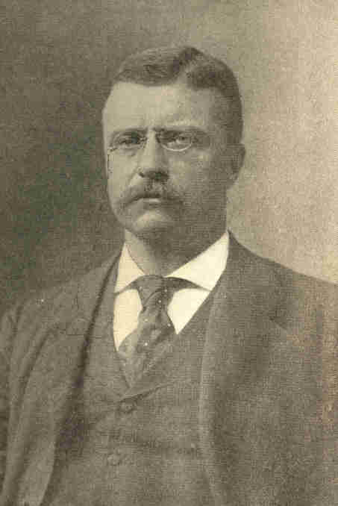
From a copyrighted photograph by Pach Bros., N. Y.
Theodore Roosevelt.
24
1900] RISE OF THEODORE ROOSEVELT 25

He was more popular with the people than with politicians. Though highly educated and used to the best associations, he was more approachable than any of his predecessors. At a public dinner which he attended, one round of cheers was given him as "the President of the United States" another as "Roosevelt," and a third as "Teddy." Had McKinley been in his place a corresponding variation would have been unthinkable.
President Roosevelt's temper and method were in pointed contrast to McKinley's. Whereas McKinley seemed simply to hold the tiller, availing himself of currents that to the eye deviously, yet easily and inevitably, bore him to his objective, Roosevelt strenuously plied the oar, recking little of cross currents or head winds, if, indeed, he did not delight in them. Chauncey Depew aptly styled McKinley "a Western man with Eastern ideas." Roosevelt, "an Eastern man with Western ideas." This aspect of the new President's character gave him hold on both West and East. Roosevelt was the first President since William Henry Harrison to bring to his office the vigor and freshness of the frontier, as he was, anomalously, the first city-born or wealthy-born incumbent.
26 PROBLEMS OF THE NEW CENTURY [1901

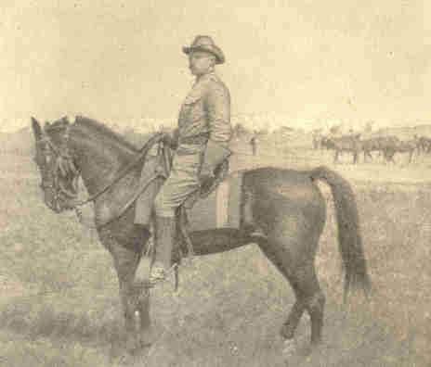
Theodore Roosevelt, as Lieut.-Colonel of the "Rough Riders."

1901] RISE OF THEODORE ROOSEVELT 27

The members of President McKinley's cabinet were invited to retain their portfolios, which they agreed to do. At the time, Roosevelt was reputed to be the foremost civil service reformer in the country. Politicians were soon made aware that the President regarded fitness for office as the first test. Unfortunately during the presidency of McKinley, some 8000 offices had been taken out of the competitive lists. During Roosevelt's first term, however, the list of offices placed under the merit system was greatly extended. Within the twenty-one years from the enactment of the first national civil service reform law wonders had been accomplished in that more than one-half of the 300,000 offices in the executive civil service were placed in the classified competitive service.
President Roosevelt stood for liberal reciprocity with Cuba, urging this, at first, with results disastrous to party harmony. He was vindicated by public opinion, but learned wisdom. Though believed to be favorable to a decided easing of custom-house levies, his administration soon frankly avowed itself unable to proceed further than high-protectionists would follow. The evidence of his tariff convictions won him strong support in the West, which was prepared to go greater lengths than he. In the congressional campaign of 1902, ex-Speaker Henderson, of Iowa, a stanch protectionist, withdrew from public life, as was supposed, rather than misrepresent himself by acceding to tariff reform or his constituents by opposing it.
28 PROBLEMS OF THE NEW CENTURY [1901

Mr. Roosevelt signalized his accession by an effort to make the federal anti-trust law something more than a cumberer of the statute-book. His inaugural message and innumerable addresses of his boldly handled the whole trust evil and called for the regulation of capitalistic combinations in the interest of the public.
Appreciation of the President's attitude on these matters may be assisted by some notice of the then threatening vigor and universality of the movement toward industrial combination. Mr. Beck, Assistant Attorney-General of the United States, declared in 1892:
1901] RISE OF THEODORE ROOSEVELT 29

"Excessive capitalization of corporations, dishonest management by their executive officers, the destruction of the rights of the minority, the theft of public utilities, the subordination of public interests to private gain, the debauchery of our local legislatures and executive officers, and the corruption of the elective franchise, have resulted from the facility afforded by the law to corporations to concentrate the control of colossal wealth in the hands of a few men . . . . The question presses ever more importunately for decision whether these marvellous aggregations of capital can be subordinated to the very laws which created them."
Legislation in many States, the enactment of the Sherman anti-trust law by Congress, and the decision of the Supreme Court in the Trans-Missouri case rendered insecure trust agreements of the old type, in which constituent corporations surrendered the control of their affairs to trustees. But the current merely shifted to a different channel, the trust proper giving way to the giant corporation having the same aims, methods, and efficiency, while, as more legal, it was less vulnerable.
In the railway world, "community of interest" assumed the place of pooling agreements. The Union Pacific acquired large holdings from Collis P. Huntington's estate and controlled the Southern Pacific. The power behind the Southern Railway got control of nearly all the other Southern railways, including the Atlantic Coast Line, the Plant System, and at last even the Louisville and Nashville. The New York Central dominated the other Vanderbilt roads. The Pennsylvania secured decisive amounts of Baltimore and Ohio stock, as well as weighty interests in the Chesapeake and Ohio and the Norfolk and Western, and so on.
30 PROBLEMS OF THE NEW CENTURY [1902

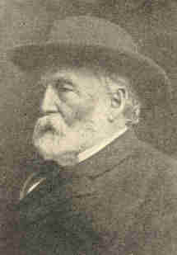
Collis P. Huntington.

Great banking establishments, foremost among them the house of J. P. Morgan & Co., took to financing these schemes. Morgan re-organized the Northern Pacific, and it would forthwith have pooled issues with the Great Northern but for opposition by the State of Minnesota. James J. Hill was master of the Great Northern, and confidence existed between him and Morgan.
1902] RISE OF THEODORE ROOSEVELT 31

They wished a secure outlet for the products of the Northwest, also access to Chicago over a line of their own. After a survey of the field the promoters selected as the most available for the latter office the Chicago, Burlington and Quincy. Purchase of shares in this corporation was quietly begun. Soon the Burlington road was apparently in hand. Prices rose.

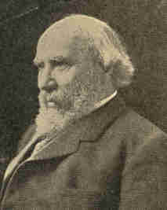
Copyright. 1902. by Pach Bros., N. Y.
James J. Hill.

The Union Pacific control perceived in the aggression of the two northern lines a menace to its northwestern and Pacific coast connections. The Union Pacific leader, E. H. Harriman, resorted to an unexpected coup. He attempted to purchase the Northern Pacific, Burlington and all. A mysterious demand, set Northern Pacific shares soaring. The stock reached $1,000 a share and none was obtainable. Panic arose; bankers and brokers faced ruin.
32 PROBLEMS OF THE NEW CENTURY [1902

The two sides now declared a truce. The Northern Securities Company was created, with a capital approaching a billion dollars, to take over the Burlington, Northern Pacific, and Great Northern stocks.

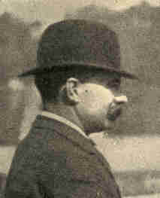
E. H. Harriman.

The States of Minnesota and Washington, unable in their own courts to thwart this plan, sought the intervention of the United States Supreme Court. Their suit was vain till the Administration came to the rescue. At the instance of the Attorney-General, an injunction issued from the high court named forbidding the Securities Company to receive the control of the roads, and the holders of the railroad stocks involved to give it over. It was observed, however, that at the very time of the above proceedings the Southern Railways' power obtained control of the Louisville and Nashville without jar or judicial obstruction.
1902] RISE OF THEODORE ROOSEVELT 33

While general, the process of confederation was specially conspicuous in the iron and steel trade. In rapid succession the National Steel Company, the American Sheet Steel Company, and the American Tin Plate Company were each made up of numerous smaller plants. Each of these corporations, with a capital from $12,000,000 to $40,000,000, owned the mines, the ships, and the railways for hauling its products, the mills for manufacturing, and the agencies for sale. Through the efforts of John W. Gates numerous wire and nail works were combined into the American Steel and Wire Company. The Federal Steel Company, the American Bridge Company, the Republic Iron and Steel Company, huge and complete, were dictators each in its field.

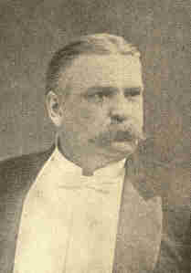
John W. Gates.

34 PROBLEMS OF THE NEW CENTURY [1902

The Carnegie Steel Company long remained independent. Determined not to enter a "combine," Andrew Carnegie sought to fortify his position. He obtained a fleet of ships upon the lakes, purchased mines, undertook to construct tube works at Conneaut, Ohio, and planned for railroads. A battle of the giants, with loss and possible ruin for one side or the other, impended. Carnegie was finally willing to sell. Hence, the United States Steel Corporation capitalized for a billion dollars. Carnegie and his partners were said to receive about $300,000,000 in bonds of the new corporation, while the other trusts and the promoters absorbed the stock for their properties and services. The underwriting syndicate probably realized $25,000,000.

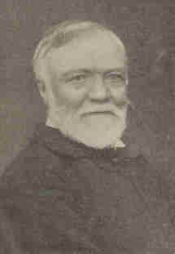
Copyright. 1902, by Rockwood. N. Y.
Andrew Carnegie.

1902] RISE OF THEODORE ROOSEVELT 35

The trust creators extended their operations abroad. In 1901 J. Pierpont Morgan and associates acquired the Leyland line of Atlantic steamships. British nerves had not recovered tone when a steamship combination, embracing not only American and British but also German lines and ship-building firms at Belfast and on the Clyde was announced. Of the great Atlantic companies, only the Cunard line remained independent. Parliamentary and ministerial assurances of governmental attention only emphasized the strength of the association.

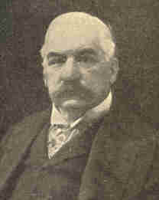
Copyright, 1901. by Pach Bros., N. Y:
J. Pierpont Morgan.

One effect of this organization at home was to place the Ship Subsidy Bill, which passed the Senate in 1901, for the time, at least, on the table. The sentiment of the country, especially of the Middle West, would not permit the payment of public money to a concern commercially able to defy Britannia on the sea.

36 PROBLEMS OF THE NEW CENTURY [1902

The Yankee Peril confronted Londoners when they saw American capital securing control of their proposed underground transit system. At their tables they beheld the output of food trusts. One of these, the so-called Beef Trust, called down upon itself in 1902 domestic as well as foreign anathema.
The failure of the corn crop in 1900, together with a scarcity of cattle, tended to raise the price of beef. In 1902 outcry became emphatic. Advance in meat values drew forcibly to view the control held by six slaughtering concerns acting in unison.
The President ordered an investigation, and, as a result, proceedings under the Sherman Act to restrain the great packers from continuing their alleged combination. A temporary injunction was granted. The slow machinery of chancery bade fair to work out a decree, but long before it was on record, alert spirits among the packing firms evolved a new plan not obnoxious to decrees, but effective for union.
If the public suffered from these phalanxed industries while they ran smoothly, it endured peculiar evils from the periodical conflicts between the capital and the labor engaged in them.
1902] RISE OF THEODORE ROOSEVELT 37

The Steel Strike of 1901 was a conflict over the unionizing of certain hitherto non-union plants of the United States Steel Corporation. It resulted in defeat for the strikers and in the disunionizing of plants.

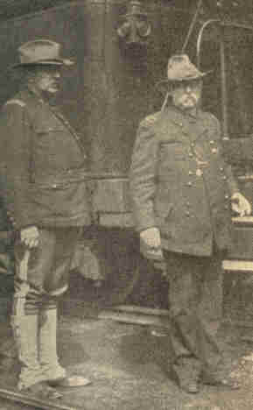
Col. Clements. Gen. Gobin, commanding troops
sent to Shenandoah in the coal strike of 1902.

This strike had no such consequences for the consuming public as attended the anthracite coal strike of 1902, which was more bitterly fought in that it was a conflict over wages. The standard of living had been lowered in one of the coal-fields by the introduction of cheap foreign labor. Now the same process threatened the other coal-field.
38 PROBLEMS OF THE NEW CENTURY [1902

A strike ordered by the United Mine Workers began May 12, 1902, when one hundred and forty-seven thousand miners went out. Though the record was marred at places, they behaved well and retained to a large degree public sympathy. When the price of anthracite rose from about $5 a ton to $28 and $30, the parts of the country using hard coal were threatened with a fuel famine and had begun to realize it. For the five months ending October 12th, the strike was estimated to have cost over $126,000,000. The operators stubbornly refused to arbitrate or to recognize the union, and the miners, with equal constancy, held their ranks intact.

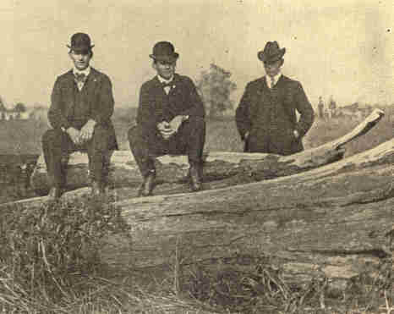
Coal strike at Shenandoah, Pa., 1902. A strikers' picket.

39

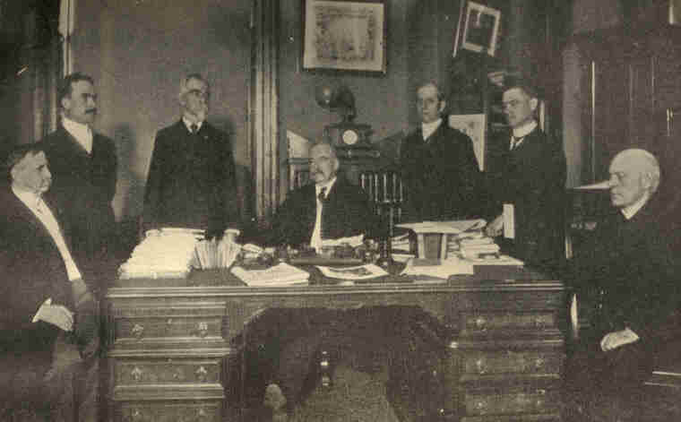
Copyright, 1902, by George Grantham Bain.
The coal strike arbitrators chosen by the President.
Carroll D. Wright, Recorder; T. H. Watkins, General J. M. Wilson,
Judge Gray, Presiding Officer; E, W. Parker, E. E. Clark. and Bishop Spalding.
40
1902] RISE OF THEODORE ROOSEVELT 41

The problem of protecting the public pressed for solution as never before. The only suggestion at first discussed was arbitration. Enforced arbitration could not be effected in the absence of contract without infringing the workingman's right to labor or to decline to do so; in other words, without reducing him, in case of adverse decision by arbitration, to a condition of involuntary servitude. It looked as though no solution would be reached unless State or nation should condemn and acquire ample portions of the mining lands to be worked under its own auspices and in a just manner. This course was suggested, but nearly all deemed it dangerously radical; nor was it as yet likely to be adopted by Congress or by the Pennsylvania legislature, should these powers be called to deal with the problem.
42 PROBLEMS OF THE NEW CENTURY [1902

On October 3 President Roosevelt called the coal operators and President Mitchell of the United Mine Workers to a conference at the White House, urging them to agree. His effort, at first seeming unsuccessful, was much criticised, but very few failed to praise it when, a few days later, it was found to have succeeded completely. An able and impartial commission, satisfactory to both sides, was appointed by the President to act as arbitrator, both miners and operators agreeing to abide its decrees. The miners, the four hundred thousand women and children dependent on them, the poor beginning to suffer from cold, indeed the whole nation, including, no doubt, the operators, felt relief.
"How much better," said the young President, once, addressing a fashionable assembly, "boldly to attempt remedying a bad situation than to sit quietly in one's retreat, sigh, and think how good it would be if the situation could be remedied!"
CHAPTER II

ROOSEVELT'S FIRST ADMINISTRATION, 1901-1905

The sentiment noted at the end of the last chapter seemed to be the motive of Mr. Roosevelt's public life. Not only was he better informed on the whole than almost any President who had sat in the chair before, but he was a good lawyer, familiar with national and general history and awake to all contemporary doings, questions, and interests south, west, east, and abroad. He was also more a man of action and affairs than any of his predecessors. He had, in a very high degree, alertness, energy, courage, initiative, dispatch. Physically as well as mentally vigorous, he read much, heard all who could usefully inform him, apprehended easily, decided quickly, and toiled like Hercules. He was just and catholic in spirit, appreciating whatever was good in any section of the country or class of people. He respected precedent but was not its slave. Rather than walk always in ruts with never a jolt, he preferred some risks of tumbling over hummocks. Few public men of any age or country have more fully met Aristotle's test of a statesman: "ability to see facts as they exist and to do the things needing to be done."
44 PROBLEMS OF THE NEW CENTURY [1902

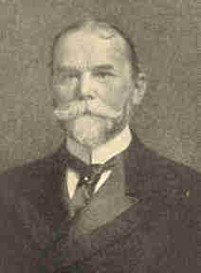
Copyright. l904. by Pach Bros., N. Y.
John Hay, Secretary of State. [Died July 1, 1905.]

He had able aids; pre-eminent among these were John Hay, Secretary of State, and Elihu Root, Secretary of War. Each was, to say the least, the peer of his greatest predecessors in his office. It was mainly to Mr. Root that we were indebted for starting the Cubans prosperously as an independent nation. His service for the Philippines so far as it went was not less distinguished; and he effected vitally important reorganization and reform in the war office.

1902] ROOSEVELT'S ADMINISTRATION 45

A well co-ordinated plan was developed whereby army officers were given advanced training in the various branches of military science as in the European countries. Neither the President nor Secretary Root advocated a large standing army, but they both strove to bring the army "to the very highest point of efficiency of any army in the civilized world." The ability of Secretary Root to inaugurate reforms in a department which when he became its head was overridden by tradition, was well expressed by President Roosevelt as follows: "Elihu Root is the ablest man I have known in our governmental service. I will go further. He is the greatest man that has appeared in the public life of any country, in any position, on either side of the ocean in my time."

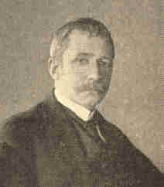
Copyright. 1903. by Clinedinst, Washington.
Elihu Root, Secretary of War.
[Secretary of State, July 1905.]

46 PROBLEMS OF THE NEW CENTURY [1902

Under Secretary Hay our State Department attained unprecedented prestige, due in part to the higher position among the nations now accorded us. This result itself Mr. Hay had done much to achieve; and he passed hardly a month in his office without making some further addition to the renown and influence of his country. If the United States has--which may be doubted--raised up diplomatists with Mr. Hay's mastery of international law and practice and his art and skill in conducting delicate negotiations, we have probably never had his equal in diplomatic initiative, or in the thorough preparation and presentation of cases. He did not meet occasions merely but made them, not arbitrarily but for the world's good. Settling the Alaskan boundary favorably to the United States at every point save one, crumbling with the single stroke of his Pauncefote treaty that Clayton-Bulwer rock on which Evarts, Blaine, and Frelinghuysen in turn had tried dynamite in vain, were deeds seldom matched in statecraft.
1902] ROOSEVELT'S ADMINISTRATION 47

By an act of Congress, in 1903, a new member was added to the President's cabinet in the person of the Secretary of the Department of Commerce and Labor. George B. Cortelyou was the first man appointed to that office. Two bureaus, those of corporations and of manufactures, were created for the department. The other bureaus, such as the Bureau of Statistics, Bureau of Standards of Weights and Measures and Coast and Geodetic Survey, were transferred from the other departments. The place of this new department was defined by the President in the following: "to aid in strengthening our domestic and foreign markets, in perfecting our transportation facilities, in building up our merchant marine, in preventing the entrance of undesirable immigrants, in improving commercial and industrial conditions, and in bringing together on common ground those necessary partners in industrial progress--capital and labor."

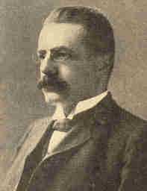
Photograph by Rice.
George B. Cortelyou,
Secretary of the Department of Commerce and Labor.

48 PROBLEMS OF THE NEW CENTURY [1902

Among the problems engaging President Roosevelt none was of wider interest than the construction of an Atlantic-Pacific canal. A commission of nine, Rear-Admiral Walker its head, had been set by President McKinley to find the best route. It began investigation in the summer of 1899, visiting Paris to examine the claims of the French Panama Company, and also Nicaragua and Panama. It surveyed, platted, took borings, and made a minute and valuable report upon the work which each of the proposed canals would require.

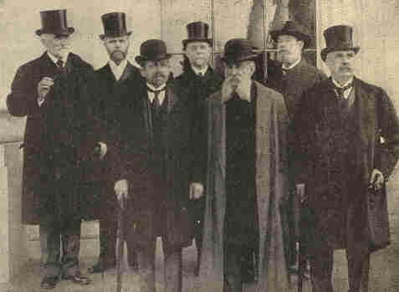
The Isthmian Canal Commission, taken March 22, 1904.
1. Col. Frank J. Hecker. 2. William Barclay Parsons. 3. Wm. H. Burr.
4. C. E. Grunsky. 5. Ad. J. G. Walker. 6. B. M. Harrod. 7. Gen. Geo. W. Davis.

1902] ROOSEVELT'S ADMINISTRATION 49

The most practicable routes were Nicaragua and Panama. The Nicaragua way was between three and four times the longer--183 miles to 49; 38 hours from ocean to ocean as against 12. The Panama way was straighter, had less elevation at its summit, and required fewer locks. Congress finally decided to construct a high level lock-canal. The cost of keeping up and operating a Panama canal was estimated at six-tenths that of one across Nicaragua. Harbor expenses and facilities would be nearly the same for both lines. The time required for construction, probably nine or ten years, would be a trifle the less at Nicaragua. Control works, to keep always the proper depth of water in the canal, could be more easily maintained at Panama.
Panama political and commercial complications were serious. The isthmus was Colombia territory, and, since October, 1899, a civil war had been raging in that republic. Its financial condition was desperate. Two hundred million inconvertible paper pesos had depreciated to the value of two cents each in gold, yet were legal tender for all obligations. In such a country, especially as war was in progress, the only government able to maintain itself was despotic. Civil troubles were intensified by dissension between Catholics and Protestants. Revolution accompanied any change in administration.
50 PROBLEMS OF THE NEW CENTURY [1902

Under Ferdinand de Lesseps, creator of the Suez Canal, the French company had performed extensive excavations at Panama. The New Panama Canal Company of France held certain concessions from the Colombian government. The value of its assets was $109,000,000 at most. If we dug at Nicaragua these would be worth little. Besides, a Nicaragua canal completed, some $6,000,000 of stock owned by the French company in the Panama railroad would dwindle in value.
The validity of the French company's rights was questioned. Its agreement to work some each year had not been kept. Its charter was to expire in October, 1904, but, for 5,000,000 francs, the Colombia President granted a six-year extension. Even with this the French franchise would revert to Colombia in 1910.
1902] ROOSEVELT'S ADMINISTRATION 51

Colombia wished delay. The United States transcontinental railroads did not want a canal, as it would divert from them heavy, bulky, and imperishable freight. They therefore joined Colombia in seeking delay, playing off the Nicaragua plan against the Panama, hoping to defeat both.
Late in 1901, newspapers in the United States began urging the purchase from Colombia of a land belt across the isthmus to be United States territory. Our Senate, December 16, 1901, by a vote of 72 to 6, ratified the Hay-Pauncefote treaty with Great Britain, in which it was agreed that we should build a canal, allowing all other nations to use it. Meantime, spite of the fact that the Walker commission had recommended Nicaragua route, public sentiment began to favor Panama. Even the Walker commission changed to this view.
The Spooner act of Congress, approved June 28, 1902, authorized the President to build an isthmian canal. The Panama properties and franchises were to be bought if he could get good title and also obtain the fee of a right of way from Colombia; otherwise he must pierce Nicaragua. The act provided for all necessary funds. The French company's claims were investigated, pronounced valid, and in due time acquired by the United States.
52 PROBLEMS OF THE NEW CENTURY [1902

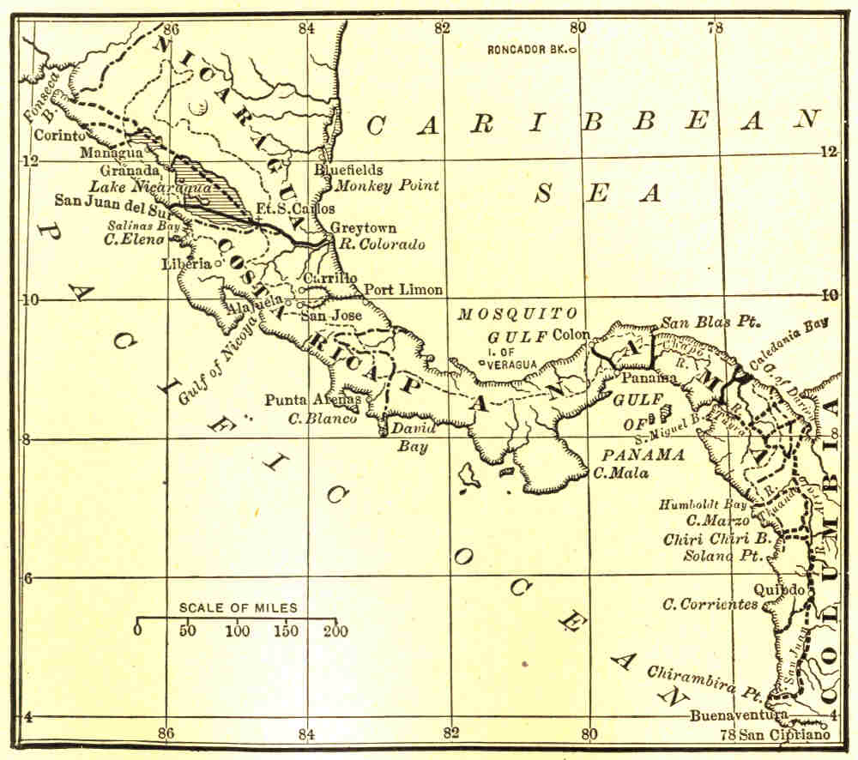
The American Isthmus, showing routes investigated for a ship-canal.
Solid Lines -- Routes investigated by the Isthmian Canal Commission.
Dashed Lines -- Routes investigated by others.

1902] ROOSEVELT'S ADMINISTRATION 53

Effort to secure from Colombia the required territorial rights was made in the proposed Hay-Herran treaty, ratified by our Senate, 73 against 5, March 17, 1903, under which we were to pay Colombia, besides an annual rental $10,000,000 for the lease of a belt six miles wide from sea to sea. August 17, 1903, the Colombian Senate rejected this treaty, and, October 18, the government of that country proposed another, involving the payment by us of $25,000,000 instead of $10,000,000. If we offered this, would not the price rise to $30,000,000 or more?
Papers in the United States argued for a revolution in Panama. The isthmus, it was urged, was in time nearer to Washington than to Bogota. All Panama interests centred in the canal. Should Nicaragua get the canal, Colon and Panama would be deserted. Both places owed their peace to the presence of our navy. On the principle that treaties concerning territory run with the territory, ignoring changes of sovereignty, our time-honored obligation to keep peace on the isthmus, bound us, if Panama set up for herself, to protect her even against Colombia. England would concur. English ships would use the canal more than ours. Great Britain, risking and spending nothing, would gain incalculably.
54 PROBLEMS OF THE NEW CENTURY [1902

France, too, would acquiesce. The Frenchmen got some $40,000,000 if the canal crossed Panama but lost everything if it passed to Nicaragua. Other European nations wished the canal built and felt that now was the accepted time. Latin-American States alone showed sympathy with Colombia.

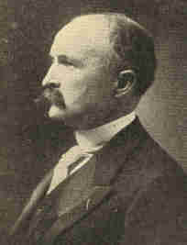
Photograph by Clinedinst.
M. Bunau-Varilla,
Minister from Panama.

Revolution took place. On the afternoon of November 3, 1903, the Panama city council declared that city independent of Colombia. Colon followed. A provisional Panama government was organized. November 6 we recognized Panama as an independent State. November 7 she appointed M. Bunau-Varilla her diplomatic agent at Washington. November 13 he was, as such, formally received by President Roosevelt. November 18 Secretary Hay and M. Bunau-Varilla signed a treaty whose first article read: "The United States guarantees and will maintain the independence of the Republic of Panama."
1802] ROOSEVELT'S ADMINISTRATION 55

Articles II and III gave us, in effect, sovereignty over a ten-mile wide canal zone between the oceans. This treaty was ratified by Panama December 2, and by our Senate February 23, 1904. November 16, 1903, Colombia protested to Great Britain against our action, and, November 28, offered us a canal concession free if we would permit her to subjugate Panama.
Both at home and abroad the administration was charged with sharp practice for its Panama coup, and the case made out by critics was prima facie strong--less, indeed, on its legal than on its ethical and prudential side. We had allowed ourselves to profit by Colombia's distress, encouraged secession in federal republics like our own, and rendered ourselves and our Monroe doctrine objects of dread throughout Central and South America. Still, Colombia had been so stiff and greedy and the settlement was in the main so happy, that censure soon subsided. All the powerful nations speedily followed our example and recognized Panama's independence.
56 PROBLEMS OF THE NEW CENTURY [1902

In September, 1900, the city of Galveston was visited by one of the greatest disasters known in American history. A fierce storm swept the waters of the gulf over the island on which Galveston is situated, destroying property aggregating many millions of dollars and causing the loss of 6,000 lives out of the total population of 37,000.

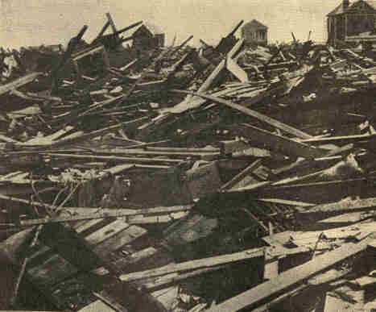
Copyright, 1900. by Underwood & Underwood, N. Y:
Great heaps of wreckage piled high by the Galveston disaster.

1902] ROOSEVELT'S ADMINISTRATION 57

For a time it seemed that the site of the city would have to be abandoned, for the highest land on which buildings stood was but a few feet above the highest waves. It was determined, however, to build a stone wall three miles in length which should be massive enough to protect the city from any similar attack.

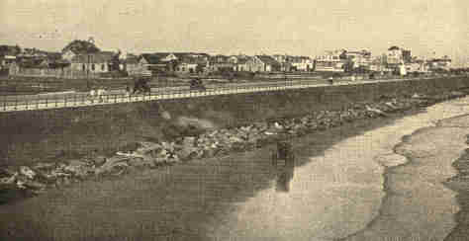
Photograph by H. H. Morris.
The boulevard and sea-wall, Galveston. Built after the flood.

Its top, which is five feet thick, is three feet above the highest point reached by the water. The bottom of the wall is sixteen feet thick. This wall, which is built concave toward the gulf, is protected by earth and stone filled in for two hundred feet, thus providing a driveway thirty feet wide with walks on either side, beautified with trees and shrubs.
58 PROBLEMS OF THE NEW CENTURY [1902

The management of public affairs during the rebuilding of the city was entrusted to a committee of experts. So efficiently and economically was the administration of the government, that the Galveston Plan, commonly spoken of as the Commission Plan, soon became a model for municipal organization. A modification of this plan was soon put into operation at Des Moines, Iowa. This plan consists of government by five salaried persons, one of them acting as mayor. This body performs both legislative and executive duties, each member being in charge of a department of the city government. The arguments in favor of this type of government are: (1) Responsibility is easily located; (2) a few men receive such salaries that they may be expected to give their whole time to the duties of their offices; (3) more civic interest will be aroused. All officers are subject to removal at any time by vote of a certain proportion of the people.
The Cuban government was organized in the spring of 1902. On May 20 of that year, Governor-General Wood for the United States turned over the government house at Havana to President Tomaso Estrada y Palma.
1902] ROOSEVELT'S ADMINISTRATION 59

The ceremonies attending the transfer were impressive. A letter from President Roosevelt addressed to the President and the Congress of the Republic of Cuba was handed to President Palma. This declared the occupation of Cuba by the United States to be at an end and tendered the sincere friendship and good wishes of this country. At noon General Wood hauled down the American flag, which had floated above the Governor's palace at Havana, and assisted General Gomez in raising to the breeze the red triangle with central silver star and three blue and two white stripes constituting the flag of the new republic. All of the foreign ships in the harbor likewise ran up the Cuban flag in honor of the occasion. Forty-five shots, one for each State in the Union, were fired as the stars and stripes were lowered from Morro Castle and the other fortresses. The American troops saluted the new emblem, fired twenty-one guns in honor of the new nation, and then embarked for the United States. Thus was kept to the letter--a noble example of public faith--the promise we made when invading Cuba, that we would not acquire territory.
60 PROBLEMS OF THE NEW CENTURY [1902

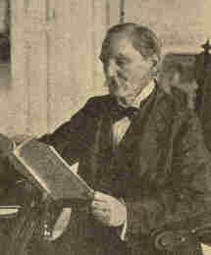
Copyright, 1902, by Underwood &Underwood, N.Y.
Tomaso Estrada y Palma,
First President of Cuba, in the palace, Havana.

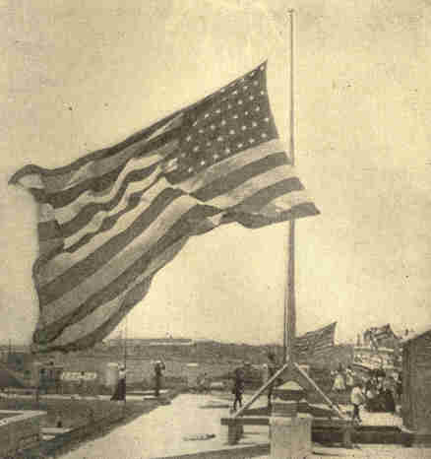
Copyright. 1902, by Underwood & Underwood.
Lowering the Stars and Stripes on the palace,
May 20, 1902, for the flag of the Cuban Republic.

1902] ROOSEVELT'S ADMINISTRATION 61

Those who prophesied a short life for the new republic and a reign of fraud and corruption were mistaken. During the first year economy became the rule in the administration of all branches of the public service, the government was self supporting, and a balance accumulated in the treasury. Moreover, the reforms inaugurated by Americans continued. Some 3,400 teachers were employed in the island and 120,000 pupils were in constant attendance upon the schools. In all parts of the island the effects of American rule were visible. Ten million dollars had been expended in sanitation reforms and the cleansing of Havana and the other cities. Industrial schools for orphan boys and girls were begun and hospitals and asylums for the sick, helpless, and insane were reestablished. By 1901 a railroad, with branch lines, was constructed between Santiago and Havana, thus giving the whole island excellent transportation facilities.
Cuba could not gain prosperity at a bound. Whereas the island should, under natural conditions, have had $30,000,000 to $40,000,000 due her from foreign countries in 1902, she was $50,000,000 in debt. Her manufactures were insignificant. It was estimated that, in the year named, $80,000,000 of American money was invested in Cuba. The main enterprises were railroads, sugar and tobacco plantations, mines, and fruit farms.
62 PROBLEMS OF THE NEW CENTURY [1902

Free commercial intercourse with Spain no longer existing, Cuban sugar and tobacco producers sought markets in the United States, leading to the "reciprocity" conflict touched upon in Chapter XIII, Vol. V. During 1902 a reciprocity treaty was negotiated and promptly ratified in Cuba. Our Senate amended it and returned it to Cuba for reconsideration. Brought hither again, it was passed by our Senate in December, 1903. President Roosevelt signed it December 17, declaring its provisions effective in ten days.
The Philippine Commission (Chapter XV, Vol. V), four Americans and three islanders, at first enacted laws by the authority of the President as Commander-in-Chief. After the Congressional Act of July 1, 1902, the formula ran: "By authority of the United States be it enacted by the Philippine Commission."
1902] ROOSEVELT'S ADMINISTRATION 63

The government was pronouncedly civil both in nature and in spirit, the natives being gradually placated, and only an occasional outbreak demanding the presence of troops. Schools were established, the English language and American ideas of government and business introduced. No promise of Philippine independence was given, yet the tenor of our whole policy toward the Filipinos, of official utterances and of public sentiment relating to them, was to the effect that we should never look upon any of the islands as a crown colony.

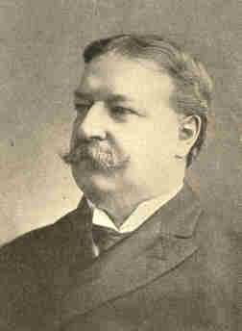
Gov. William H. Taft
[Secretary of War, 1905.]

64 PROBLEMS OF THE NEW CENTURY [1902

The same interests that forbade Cuban reciprocity opposed tariff concessions to the Philippines. A 25 per cent reduction from the Dingley rates was the best that Congress would grant, though the commission besought one of at least 75 per cent. For a time our behavior in this too much resembled English and Spanish dealings with colonies centuries ago. The United States acquired from the Philippine religious orders 422,337 acres of land, three-fifths of it highly cultivated and thickly inhabited, for $7,239,000. In all, the government owned about 61,000,000 out of the perhaps 70,000,000 acres of land in the islands. Of the government lands, 40,000,000 acres were forest.
The law of July 1, 1902, to supplement the commission, provided for a native assembly of not more than 100 members or less than 50, with annual sessions of 90 days. Municipal autonomy was allowed and became common. An efficient constabulary was established, also a Philippine mint and coinage system on a gold basis. Careful exploitation of the agricultural, mineral, and other resources of the islands was provided for, as well as an increasing number of public improvements in the interest of order, health, and cleanliness. To promote investment in the Philippine public works, 4 per cent bonds were issued, guaranteed by the United States.
1904] ROOSEVELT'S ADMINISTRATION 65

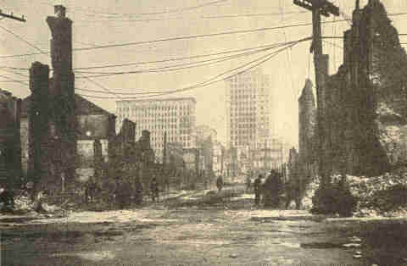
The Baltimore fire.
Lombard and Calvert Streets,
Showing Continental and Equitable Buildings.

Preparatory to forming the Philippine Assembly the commission took a census of the islands. In 1905 the population returned from 342 islands was 7,635,426. Of this number only about 9 per cent were wild tribes, though more than half the entire population could neither read nor write in any language. Of the 370,000 pupils in the newly established schools, or double the number in attendance two years previously, one in nine on the average had some understanding of English. Twelve thousand adults were in the night schools, chiefly engaged in acquiring the English language.
66 PROBLEMS OF THE NEW CENTURY [1904

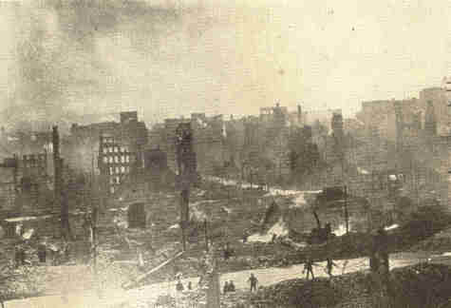
The Baltimore fire.
Hopkins Place and German Street, looking east.

In February, 1904, a fire broke out in the heart of the city of Baltimore. Some 1,337 structures were either entirely destroyed or rendered unfit for occupancy. The loss in buildings and other property destroyed was about $75,000,000. With a few exceptions, the financial district of the city was burned. For a time it was feared that the losses would be so great that restoration could not be made, but new plans were projected which included broader streets and better buildings. Instead of a decrease in the number of business concerns, there was an increase through the entrance of firms from the outside.
1904] ROOSEVELT'S ADMINISTRATION 67

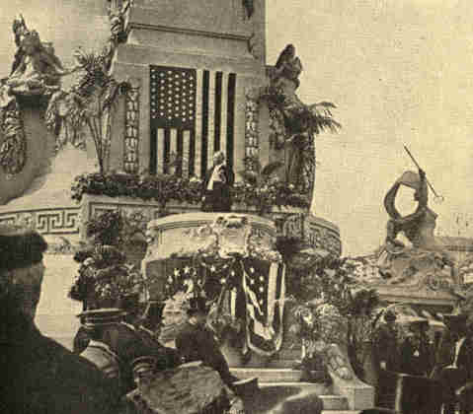
Copyright, 1904. William H. Rau, Philadelphia.
Opening Day at the Louisiana Purchase Exposition.
President D. K. Francis delivering the opening address.

68 PROBLEMS OF THE NEW CENTURY [1904

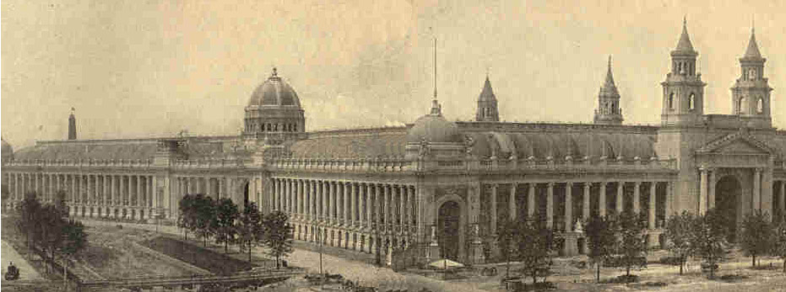
The Varied Industries Building.
THE LOUISIANA PURCHASE EXPOSITION.

The Louisiana Purchase Exposition at St. Louis was opened April 30, 1904, and continued for seven months. It commemorated the acquisition of the Louisiana territory which was consummated April 30, 1803, marking one of the greatest events in American history. Out of this area had been carved thirteen States and two territories wherein over 17,000,000 people were making their homes.
1904] ROOSEVELT'S ADMINISTRATION 69

The design for the exposition represented the work of ten of the most distinguished architects of the country. The buildings, grouped in perfect taste, mostly of noble style, had 128 acres of floor space, far beyond that at the disposal of any preceding fair. The grounds also were unprecedentedly ample and beautifully diversified, containing about 1,200 acres. The total attendance, 18,741,073, fell short of that at Chicago in 1893 by over 8,000,000.
70 PROBLEMS OF THE NEW CENTURY 1904

The general plan of the exposition was intended to symbolize the history of the Louisiana territory representing the successive occupants of the soil--the wild animals; the Indians; the discoverers; the explorers; the hunters; the trappers, and the pioneers.
The aim was to make it one vast educational object lesson. To that end there were extensive exhibits from thirty States and from the chief cities of work done in the primary and secondary schools and in the universities and colleges of the country. This feature culminated in the International Congress of Arts and Sciences. Over 100 of the leading scholars from England, France, Germany, Holland, Italy, Japan, the United States, and a number of other countries made addresses and took part in the various discussions. All the fields of human knowledge were represented by these specialists.
One feature of this exposition was unique: it represented to an unprecedented extent processes in lieu of products or in addition to them. Every day at almost every point something was literally doing, going on. Machinery whizzed, mines were operated, artists were at work, experts showed their craft; Indians, Filipinos, the blind, deaf, and dumb were taught.
CHAPTER III

PRESIDENTIAL ELECTION OF 1904

The Republican convention met at Chicago, June 21, and on June 23 nominated Theodore Roosevelt for President. President Roosevelt's nomination was a certainty from the beginning. This action was demanded by the rank and file of Republicans, for his achievements were popular. Among the problems which he had helped to solve were those growing out of the war with Spain; settlement of the anthracite coal strike; creation of the Department of Commerce and Labor; and the investigation and prosecution of dishonesty in the post-office department.
Plans for the convention had all been matured in advance with the exception of the selection of a candidate for Vice-President. By the time the convention assembled the opinion was general that for geographical reasons some one from Indiana should be named for this office. Charles Warren Fairbanks, a leading lawyer in Indianapolis, who was serving his second term in the United States Senate, was nominated without any real opposition.
72 PROBLEMS OF THE NEW CENTURY [1904

He had served as a member of the Joint High Commission to adjust international questions of moment between the United States and Great Britain. Grover Cleveland and William Jennings Bryan had declared they would not be candidates for the presidency and the Democratic party was in a dilemma.

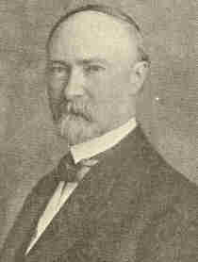
Charles W. Fairbanks,
Vice-President of the United States.

Both the conservative and the radical elements of the party declared they would write the platform and name the candidates. Alton Brooks Parker, Chief Judge of the Court of Appeals of New York, who was supported by Grover Cleveland, came gradually into prominence as the candidate of the conservatives and William Randolph Hearst of the radicals.
73

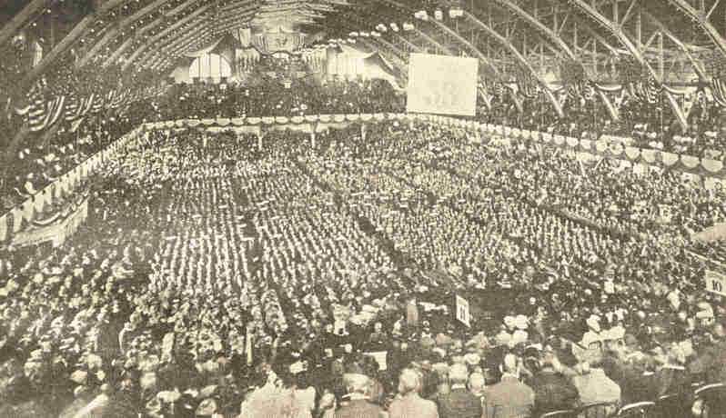
The Republican convention at Chicago, 1904.
74
1904] PRESIDENTIAL ELECTION OF 1904 75

The chief contest came in the Democratic convention of New York. There Judge Parker was supported by David B. Hill, ex-United States senator, and August Belmont, a New York banker. In consequence it was declared by the opposition that Judge Parker was the candidate of the trusts, Wall Street magnates, and a class of politicians of which Hill was the type. This view was taken by Bryan. In spite of the opposition of Tammany leaders and the Hearst faction, twice as many Parker as Hearst delegates were chosen.

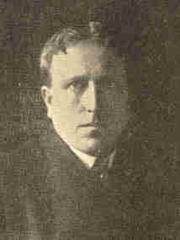
William R. Hearst.

In the convention, which met at St. Louis, July 9, Judge Parker received 658 votes for President on the first ballot, Hearst received 200, and there were a few scattering votes. The requisite two-thirds came to Parker before the result of the ballot was announced. Henry G. Davis, of West Virginia, was named for the office of Vice-President.
76 PROBLEMS OF THE NEW CENTURY [1904

He had served two terms in the United States Senate, had declined the office of Post-Master General under President Cleveland, was very wealthy, and noted for his philanthropy.
Bryan demanded that the platform should be silent on the question of the money standard, but Parker declined the nomination unless it should be understood that he would maintain the gold standard, and his declaration was endorsed by the convention.
There were no distinguishing issues between the two leading parties. The money question had disappeared and both parties were outspoken in their declarations against trusts and combinations of capital.
The Populist party, in a convention made up of delegates from one-half the States, nominated Thomas E. Watson, of Georgia, and Thomas H. Tubbles, of Nebraska, for President and Vice-President, respectively. There were two Socialist conventions: one, that of the Social Democratic party, nominated Eugene V. Debs, of Indiana, for President, and the Socialist Labor party named Charles H. Corregan, of New York, for the same office. The nominees of the Prohibitionist party were Silas C. Swallow, of Pennsylvania, for President, and George W. Carroll, of Texas, for Vice-President.
77

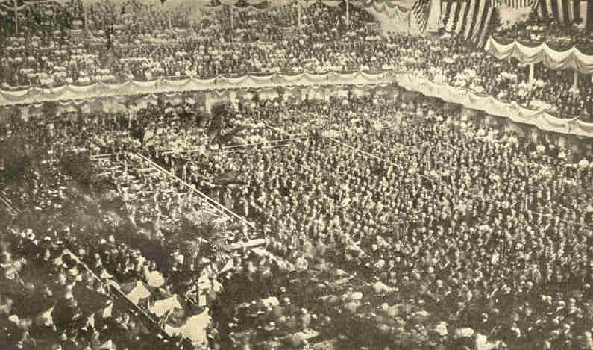
The Democratic convention at St. Louis, 1904.
78
1904] PRESIDENTIAL ELECTION OF 1904 79

The campaign was noteworthy on account of the apathy which was very general. Heated discussions so characteristic of previous political contests were seldom heard, and arguments were addressed to the intelligence of voters rather than to passion and prejudice.
It has been called a reading rather than a speaking campaign. The leading Republican document was a pamphlet containing two notable addresses. One of these was delivered by John Hay at Jackson, Mich., on the occasion of the celebration of the semi-centennial of the founding of the Republican party. He attributed to that party the success in the conduct of public affairs since 1860, and praised President Roosevelt as a man and great administrator. The other speech was similar in content, and was delivered by Elihu Root as temporary chairman of the Republican convention.

80 PROBLEMS OF THE NEW CENTURY [1904

Toward the close of the campaign, the charge was made that the Republicans were endeavoring to win through a wholesale purchase of votes. It was asserted that George B. Cortelyou, manager of the campaign, having obtained secrets of the conduct of some of the great corporations, was using that knowledge to force them to contribute to the Republican fund. A second charge proclaimed that the administration had changed its attitude toward certain corporations and that the magnates of Wall Street, having decided to elect Roosevelt, were contributing generously to the Republican campaign fund.

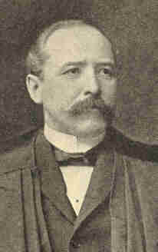
Alton B. Parker.

Shortly before the day for the election, Judge Parker in a series of speeches announced his belief in these reports. President Roosevelt declared that no proof for the statements could be produced, and ended as follows: "The statements made by Mr. Parker are unqualifiedly and atrociously false.

81

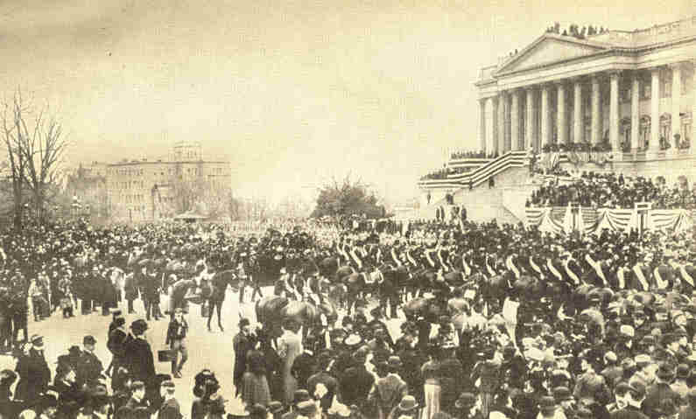
Photograph by Clinedinst, Washington, D. C.
Inauguration of President Roosevelt, March 4. 1905.
82
1904] PRESIDENTIAL ELECTION OF 1904 83

As Mr. Cortelyou has said to me more than once during this campaign, if elected I shall go into the presidency unhampered by any pledge, promise, or understanding of any kind, sort or description, save my promise, made openly to the American people, that so far as in my power lies I shall see to it that every man has a square deal, no less and no more." In his reply, Judge Parker reiterated the charge, but gave no concrete instances of money having been obtained from corporations.
Out of a total vote of 13,544,705, Roosevelt received 7,630,893 votes, or 2,524,244 more than his leading competitor. His majority was 1,717,081. Debs received 397,308 votes; Swallow, 258,039; Watson, 114,306; Corregan, 32,516. Thirty-three States gave Roosevelt majorities and twelve Southern States returned majorities for Parker. In the electoral college Roosevelt received 336 votes and Parker 140.
84 PROBLEMS OF THE NEW CENTURY [1904

A surprising feature of the election was the large number of independent votes cast, as shown by the fact that Minnesota, Massachusetts, Missouri, and Montana, while giving majorities for the Republican candidates, elected Democratic governors, and in several other States a similar tendency was manifest in the divergence between the vote for the national candidates and local candidates.

CHAPTER IV

AMERICA AND THE CHINESE OPEN DOOR

The aggressive policy of President Roosevelt continued throughout the four years succeeding March 4, 1905, when he again took the oath of office as President. In his suggested reforms he continued to be a real leader of the people. John Hay, who for seven years had so efficiently performed his duties as Secretary of State, was continued in that office. William H. Taft, after his return from the Philippine Islands, where he had held the office of first civil governor, succeeded Elihu Root as Secretary of War.
The United States, having become a world power after the war with Spain, assumed leadership in the adjustment of Chinese problems. At the close of the century American manufacturers had built up in China a market for their cotton goods which they desired to extend. At the same time strife arose among some of the European nations for trade advantages in that empire.
86 PROBLEMS OF THE NEW CENTURY [1905

Great Britain, France, Germany, Russia, and Italy were demanding for their citizens concessions, leases, franchises, and special trade privileges in various parts of that country. Gradually, spheres of influence covering certain regions were acquired and it seemed probable that China would be partitioned among the European Powers as Africa had been in the previous decade. This would be a blow to American export trade. Now the acquisition of the Philippine Islands gave us a vantage point from which we could consistently exert influence in Oriental affairs. In September, 1899, John Hay addressed a note to the European Powers interested, asking recognition of the policy of the "open door," which means that no power should exclude the citizens of other nations from equal trade rights, within its sphere of influence, in China. Without winning complete acceptance from all the nations, the justice of this policy was, in the main, approved.
During the following year came the Boxer Rebellion in which there were massacres of Europeans and Americans. When the foreign legations were besieged in Peking, United States troops took part in the expedition which marched to their relief. Seizure of Chinese territory, as indemnity, might have followed, but Secretary Hay brought the influence of this country to bear in securing guarantees of the territorial integrity of China and equal trade rights in its ports.
1905] THE CHINESE OPEN DOOR 87

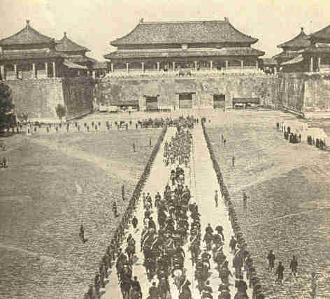
Copyright by Underwood & Underwood, N.Y.
Count Von Waldersee escorted by officers of the allied armies
between lines of U. S. troops toward the Sacred Gate, Peking.

88 PROBLEMS OF THE NEW CENTURY [1905

Friendly relations between the Chinese Empire and the United States were still further strengthened by the liberal attitude of our government relative to the indemnity growing out of the Boxer uprising. The total amount which China had obligated itself to pay the governments, societies, and private individuals was $333,000,000. Of this sum, $24,400,778 was allotted to the United States. As a mark of friendship for China, Congress upon the recommendation of President Roosevelt, 1907, cancelled the obligation of China to pay that part of the stipulated indemnity in excess of $11,655,492, or an amount adequate to cover the actual amount of the claims. This generous conduct prompted the Chinese government to devote the funds thus remitted to the sending of Chinese students to this country for their education. About one hundred of these students have entered our schools and colleges each year since 1907. American institutions will, as a consequence, have a great influence on the progressive development of China.
For some time Russia had been extending her influence over the Chinese tributary province of Manchuria. In 1903 negotiations for a new commercial treaty were begun between China and the United States.
1905] THE CHINESE OPEN DOOR 89

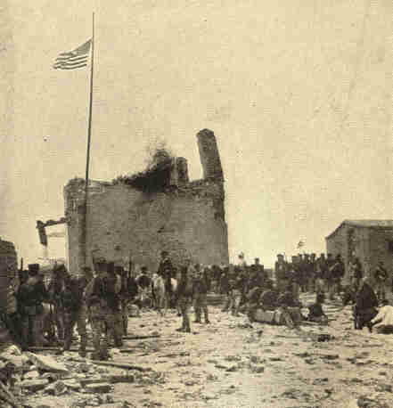
Copyright 1901, by Underwood & Underwood.
American flag raised over battered remnants of South Gate
immediately after city's capture. Battle of Tien-Tsin, China.

90 PROBLEMS OF THE NEW CENTURY [1905

There were numerous delays on account of an agreement relative to opening the Manchurian ports. For a time it seemed probable that the American demand that her trading rights should be restored in Manchuria would bring on serious complications with Russia. Upon the completion of the treaty, however, the request was renewed and China acquiesced by opening the ports of Mukden and Ta Tung Kao to the ships of all nations. At the same time Russia agreed that she would in no way oppose this action.
At the outbreak of the war between Japan and Russia, in 1904, Secretary Hay took another step toward maintaining the administrative entity of the Chinese Empire. At the suggestion of Germany he addressed a note to the powers which had taken part in the treaty of Peking, asking them to pledge themselves to limit the area of the war; keep China from becoming involved, and use their best endeavors to prevent the violation of Chinese interests by either belligerent, provided China should maintain absolute neutrality. These proposals were agreed to by the signatory nations, and both Russia and Japan promised to respect Chinese neutrality.
Meantime a new national spirit had been developing rapidly in China and a greater sensitiveness was manifest toward the treatment of Chinese outside the empire. The strict interpretation of the Chinese Exclusion act had caused many Chinese entering the ports of the United States unwarranted hardships. A crisis was reached in 1905.
1905] THE CHINESE OPEN DOOR 91

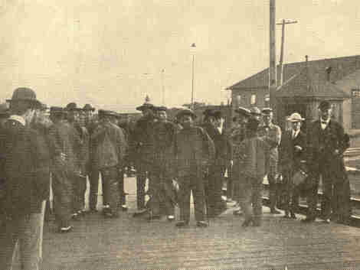
Arrival of Chinamen at Malone, N. Y.,
from Canada, accompanied by officials.
92 PROBLEMS OF THE NEW CENTURY [1905

According to the rules adopted by the Secretary of Commerce and Labor, neither the immigration acts nor the Chinese exclusion acts apply to a Chinese person born in the United States. Under the laws, all Chinese laborers, both skilled and unskilled, are prohibited from entering the United States, but this prohibition does not extend to merchants, teachers, students, and travellers who are to be granted all the rights, privileges, and exemptions accorded the citizens of any other nation. In spite of these rulings, Ju Toy, who claimed to have been born in the United States, was deported. Three Chinamen, with their sister, who had been studying in the English schools came to Boston. Notwithstanding they had a letter from Mr. Choate, former United States ambassador to Great Britain, they were not allowed to land with other passengers, and were otherwise humiliated by the formalities to which they were subjected. Men of influence throughout the Chinese Empire were aroused and a circular was issued, in May, 1905, which was widely disseminated in the chief cities, calling for agreement not to buy any more American goods. Newspapers urged students to leave schools where American teachers were employed or American text-books or supplies were used. At this juncture President Roosevelt was appealed to by the American members of the Chinese Educational Association.
1905] THE CHINESE OPEN DOOR 93

Acting with his accustomed vigor, he issued instructions to the Secretary of Commerce and Labor to send a letter to all immigration officials, instructing them that "any discourtesy shown to Chinese persons by any officials of the Government will be the cause for immediate dismissal from the service." In his message to Congress he declared that it was Chinese laborers alone who are undesirable, and that other Chinamen--students, professional men, merchants--should be encouraged to come to the United States. "We have no right," he wrote, "to claim the open door in China unless we do equity to the Chinese."
CHAPTER V

INTERNATIONAL ARBITRATION

Great progress was made during the nineteenth century toward the settlement of differences between nations through arbitration. The United States was a party to 50 out of the total number of 120 arbitration treaties. Questions settled in this manner, such as boundary, damages inflicted by war or civil disturbances and injuries to commerce, would formerly have led to war. Twenty of these cases have been between the United States and Great Britain, and a settlement was effected when, at times, it seemed as if war could not be averted.
The work of the Hague Peace Conference, which met May 18, 1899, constituted a fitting close to the efforts which were put forth during the century to bring about conciliation through arbitration. The conference assembled in response to an invitation issued by the Czar of Russia "on behalf of disarmament and the permanent peace of the world." One hundred and ten delegates were present, representing twenty-six different powers of which the United States was one. The delegates were divided into three commissions, each having separate subjects for consideration.
1905] INTERNATIONAL ARBITRATION 95

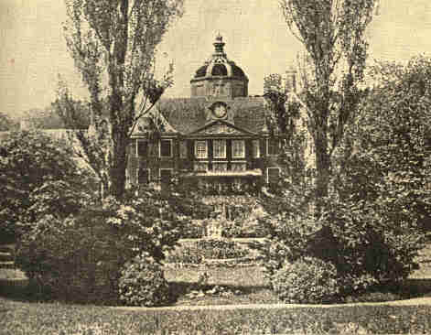
The House in the Woods, The Hague, Holland,
where the first Peace Conference was held.

The first commission adopted unanimously the resolution that "the limitation of the military charges which so oppress the world is greatly to be desired," but agreed that this could not now be accomplished through an international compact.
96 PROBLEMS OF THE NEW CENTURY [1905

In the second commission a revision of the Declaration of Brussels concerning the rules of war was made. It was agreed by the entire conference that a new convention for this purpose should be called, and that the protection offered by the Red Cross, as agreed upon in the Geneva convention, should also be extended to naval warfare.
The proposition expressing the desire that international conflicts might in the future be settled through arbitration was considered by the third commission. Said ex-President Harrison: "The greatest achievement of the Hague conference was the establishment of an absolutely impartial judicial tribunal." Some of the chief features of this permanent court of arbitration were as follows: (1) Each nation which agreed to the plan was to appoint, within three months, four persons of recognized competency in international law, who were to serve for six years as members of the International Court; (2) an International Bureau was established at The Hague for the purpose of carrying on all intercourse between the signatory powers relative to the meetings of the court and to serve also as the recording office, for the court;
1905] INTERNATIONAL ARBITRATION 97

(3) nations in dispute may select from the list of names appointed as above, and submitted to them by the bureau, those persons whom they desire to act as arbitrators; (4) the meetings of the court are to be held at The Hague unless some other place is stipulated by the nations in the controversy.
The permanent International Court of Arbitration was declared to be organized and ready for operation by April, 1901. At that time there were seventy-two judges appointed by twenty-two of the signatory powers, It is readily seen that the advantages of such a court are that unprejudiced arbitrators are selected, rules of procedure are defined, and decisions rendered are more liable to be accepted in future cases and thus a code of law will be formed, So many cases have been submitted to this tribunal that it has been said that a government which will not now try arbitration before resorting to arms is no longer considered respectable. This court was convened for the first time May 18, 1901.
98 PROBLEMS OF THE NEW CENTURY [1905

The first case coming before the tribunal--the Pious Fund Case--was presented by the United States and Mexico, September 15, 1902. Up to 1846 the Mexican government had paid annual interest on some property administered by it but belonging to the Catholic church. Part of it was situated in what is now California. After 1848, when this California estate came under United States jurisdiction, Mexico refused to pay that part of the church outside of Mexico its share. This difference between our Government and Mexico the Hague Tribunal took up.
Agreeably to chapter 3, title 4, of the agreement, each party named two arbitrators, and the latter, acting together, an umpire. In case of an equality of votes a third power, designated by agreement of the parties, was to select the umpire. The arbitrators chosen were M. de Martens, of the Orthodox Greek church; Sir Edward Fry, an English Protestant; M. Asser, a Jew, and M. Savornin-Loman, a Dutch Protestant. Decision was reached within the prescribed thirty days and announced October 14, 1902. It favored the United States contention, giving its proportion of the Mexican payments to the Catholic church in California.
1905] INTERNATIONAL ARBITRATION 99

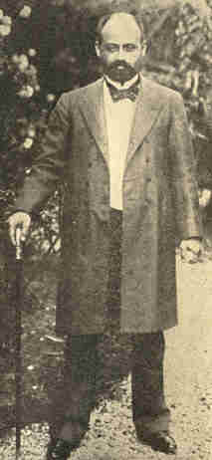
President Castro of Venezuela.

A second case, involving issues of war and peace, arose from the action of Great Britain and Germany against Venezuela in the winter of 1902-1903. Subjects of these as well as of other powers had claims against Venezuela. That country was in financial straits and its creditors pressed. December 9, 1902, British and German war-ships sunk or seized some Venezuelan vessels; next day they landed marines at La Guayra, who took possession of the custom house; the 14th they bombarded and demolished a fort at Puerto Cabello.

100 PROBLEMS OF THE NEW CENTURY [1903

Through the good offices of the United States the matter of debts was referred to the Hague Tribunal. The German claims were decided by two representatives of Germany and two of Venezuela, or, if they disagreed, by an umpire whom the United States selected. So with the other claims. The tribunal fixed the order in which Venezuela should pay the different countries, and the United States was charged with overseeing the payments, a percentage of Venezuelan customs receipts being reserved for that purpose.
In 1903 Andrew Carnegie donated $1,500,000 for the purpose of erecting a "palace of peace," the permanent head-quarters of this court. The deed of trust states: "The establishment of a permanent Court of Arbitration by the treaty of the 29th of July, 1899, is the most important step forward, of a world-wide humanitarian character, that has ever been taken by the joint powers, as it must ultimately banish war, and further, being of opinion that the cause of peace will greatly benefit by the erection of a court house and library for the permanent Court of Arbitration," etc.
1905] INTERNATIONAL ARBITRATION 101

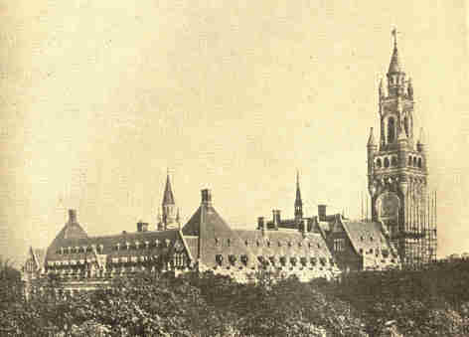
The new Peace Palace, The Hague, Holland.

The site of this building, which will be ready for occupancy in 1912, is near The Hague. Its exterior will resemble some of the old city walls to be seen in Holland. The various governments which were parties to the treaty have contributed materials for the completion of the interior and objects of art for decoration. The United States presented a large marble group of statuary called "Peace Through Justice."
102 PROBLEMS OF THE NEW CENTURY [1905

Two notable congresses were held in the United States during the year 1904, for the purpose of promoting the peace of the world. The Inter-Parliamentary Union held a meeting, the twelfth in its history, in connection with the World's Fair at St. Louis. This organization was founded at Paris in 1888 by thirty members of the French Chamber of Deputies and ten members of the British Parliament, for the purpose of promoting the cause of peace and arbitration. Scoffed at from the beginning, the Union continued to grow until it included parliamentary delegates from every European country having a constitutional form of government.
The meeting of the Union at St. Louis was the first to be held in the United States, for this country took no part in the organization until 1903. Russia and Turkey, having no parliaments, are not represented in the meetings of the Union. It is a noteworthy fact however that the Czar sent an official representative to the meeting in 1896 and that it was due to his report of that meeting, more than to any other cause, that the Czar invited the nations to send representatives to The Hague in 1898.
1905] INTERNATIONAL ARBITRATION 103

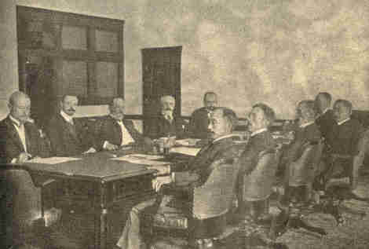
Russian and Japanese Peace Envoys in session at Portsmouth, N. H.

In the congress at St. Louis, representatives from the deliberative bodies of fifteen nations were present. Among these delegates were some of the well-known public men from Great Britain, France, Germany, Austria, Italy, Belgium, The Netherlands, the United States, and various other countries. They were practical men and not dreamers.

104 PROBLEMS OF THE NEW CENTURY [1905

Two important resolutions resulted from the gathering. One of these called upon the powers to intervene and put an end to the war between Russia and Japan. The other invited the President of the United States to call a second peace congress, similar to the Hague conference. The resolution, addressed to President Roosevelt, stated that there were a number of questions left unsettled from the first Hague conference and that new problems had arisen since that time which demanded readjustment, such as the use of wireless telegraphy in the time of war.
On October 3 of the same year an international peace congress was held in Boston. Numerous congresses of this nature have been held from time to time since the meeting of the first one in London in 1843. Since the year 1888, when a congress was held in Paris, an international peace congress has met each year with the exception of 1895, the year of the Boer war, and in 1898 and 1899, on account of the Spanish-American war. The first of these congresses in America was held in conjunction with the Columbian Exposition at Chicago, 1893. There were in attendance at Boston distinguished statesmen, clergymen, scholars, and professional men, and a number of noted women, representing the many peace and arbitration societies in Great Britain, Germany, Austria, and numerous other countries.

1905] INTERNATIONAL ARBITRATION 105

On the Sunday before the opening of the congress, special services were held in many of the Boston churches and the peace movement was discussed by distinguished preachers from Europe and America. In the deliberative sessions, which were held in Faneuil Hall, the Old South Meeting House, and other places, the first session being opened by an address by Secretary of State John Hay, the following topics, among others, were discussed: the work and influence of the Hague Tribunal; the reduction of the armaments of the nations; education and the peace sentiment. But here, as in every previous congress, the two topics to receive primary consideration have been arbitration and disarmament. At all times there has been the urgent appeal to the nations to abandon the brutality and injustice of war and to adopt the humane and just methods of peace.
In response to the resolution adopted at St. Louis, President Roosevelt, on October 20, 1904, invited the nations which had taken part in the first Hague conference to another conference at the same place. But in his message to Congress of that year he defined very clearly his own position, condemning in no uncertain terms the thought of peace at any price. "There are kinds of peace," he said, "which are highly undesirable, which are in the long run as destructive as any war. The peace of tyrannous terror, the peace of craven weakness, the peace of injustice--all these should be shunned as we shun unrighteous war."
106 PROBLEMS OF THE NEW CENTURY [1905

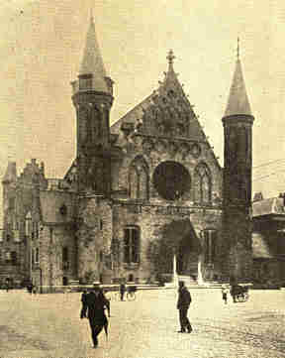
Building where the second Peace Conference
was held, The Hague, Holland.

Favorable replies to the invitation sent by President Roosevelt were received from all the nations. Russia, then in the midst of war with Japan, while approving, stipulated that the conference should not be called until the end of that war.
1905] INTERNATIONAL ARBITRATION 107

When peace was restored, in the summer of 1905, Emperor Nicholas II issued an invitation to fifty-three nations to send representatives to such a conference. For the first time, nearly every independent nation on the globe was represented among the delegates in an international gathering of this nature. It met at The Hague during the summer of 1907.

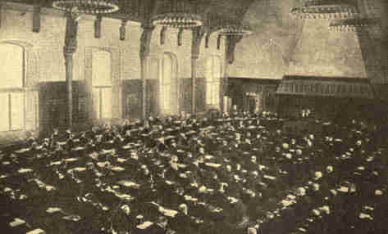
First session of the second Peace Conference, The Hague, Holland.

Delegates from the United States were instructed to favor obligatory arbitration; the establishment of a permanent court of arbitration; the prohibition of force in the collection of contract debts; immunity from seizure of private property at sea; a clearer definition of the rights of neutrals, and the limitation of armaments.
108 PROBLEMS OF THE NEW CENTURY [1905

While belief was reasserted by the conference that there should be the obligatory arbitration of all questions relating to treaties and international problems of a legal nature, the principle was not adopted, although thirty-two nations of the forty-five represented favored it.
The resolution adopted, which provided for the collection of contract debts, is as follows: "In order to avoid between nations armed conflicts of a purely pecuniary origin arising from contractual debts claimed of the government of one country by the government of another country to be due to its nationals, the signatory powers agree not to have recourse to armed force for the collection of such contractual debts. However, this stipulation shall not be applicable when the debtor State refuses or leaves unanswered an offer to arbitrate; or, in case of acceptance, makes it impossible to formulate the terms of submission; or, after arbitration, fails to comply with the award rendered."

1905] INTERNATIONAL ARBITRATION 109

Provision was made for an international prize court, to which appeal might be made from the prize courts of the belligerent powers. The declaration was adopted prohibiting the throwing of projectiles and explosives from balloons.
Before the end of the year 1908, one hundred and thirty-five arbitration treaties had been concluded. The United States was a party to twelve of these. Most of the treaties bind the signatory powers to submit to the Hague Tribunal all differences in so far as they do not affect "the independence, the honor, the vital interests, or the exercise of sovereignty of the contracting countries, and provided it has been impossible to obtain an amicable solution by means of direct diplomatic negotiations or by any other method of conciliation."
CHAPTER VI

THE UNITED STATES AND LATIN AMERICA

Looking toward the completion of the Panama Canal, there has been a revival of interest on the part of the United States in the republics of South America. From the time of the promulgation of the Monroe Doctrine, there has been a distant friendship on our part for these nations. The plan inaugurated by James G. Blaine when Secretary of State is much better understood to-day than in his time. In 1881, with the desire of emphasizing the leadership of the United States in the western hemisphere, he proposed a congress of all the American nations. Nothing came of the proposal at the time, but in 1888 Congress passed a resolution providing for such an international conference. The meeting was in Washington the following year, and Secretary Blaine, as chairman, exercised great influence. While the direct results of the meeting were not great--principally a declaration in favor of the arbitration of all disputes among these nations--the indirect benefits were considerable. In 1901 a second Pan-American congress was held in the city of Mexico.

1905] U. S. AND LATIN AMERICA 111

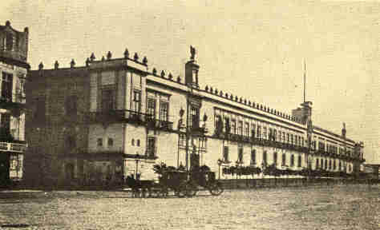
Courtesy of the Pan-American Union.
Federal Palace, where the second Pan-American
Congress was held in the City of Mexico.

In the meantime the trade with these countries has been largely monopolized by England, France, and Germany. During the year 1905, the total exports and imports of the Latin-American countries amounted to $2,000,000,000. Of this foreign trade the United States bought 35 per cent of the exports and sold to these countries only 27 per cent of their imports, producing an unfavorable balance of trade amounting to $200,000,000.
112 PROBLEMS OF THE NEW CENTURY [1905

Of the goods imported from this country, over one-fourth went to Mexico and Cuba. In that year Brazil bought from the United States only 11 per cent of its imports. Argentina, with a larger foreign trade than either Japan or China, bought only 14 per cent of its imports from the United States. With the exception of Mexico, the foreign commerce of the Latin-American states with European countries has increased more rapidly than with the United States. Various reasons have been given for this situation. The sensitive South American resents the air of superiority assumed toward them by the people of the United States. In our newspapers there is a seeming disregard for the real evidences of their national development. Revolutions and boundary disputes have been exaggerated. In general, citizens of the United States have no comprehension of the advancement of these countries within recent times and appreciate but slightly that their economic future is as fully assured as our own. Argentina constitutes an excellent example of this progress.
1906] U. S. AND LATIN AMERICA 113

This country has an area of 1,135,840 square miles. Splendid rivers water the immense plains. The chief of these, the Parana, which flows 2,000 miles through the country, carries a volume of water to the sea one and one-half times that of the Mississippi, and is capable of floating ships having a draught of 18 feet for 600 miles into the interior. Buenos Ayres, with a population of 1,000,000, in 1906 had a volume of foreign trade amounting to $562,000,000, constituting it the twelfth port in the world. In 1905 over 10,000,000 acres of land were cultivated in Argentina, an increase of fourfold within fifteen years. The cereals, cotton, fruits, and meats produced amounted to $350,000,000.
That the volume of trade between this country and the South American states has been so small has been due also to the fact that so few vessels flying the stars and stripes are engaged in this trade. According to the report of Secretary Root, in 1906, there were in the harbor of Rio Janeiro the previous year, 1,785 ships flying the flag of Great Britain; 657 the flag of Germany; 349 the French; 142 the Norwegian, and 7 sailing vessels (two of them in distress) the flag of the United States. The bulk of goods from this country to South America goes by the way of European ports and on foreign ships.
114 PROBLEMS OF THE NEW CENTURY [1906

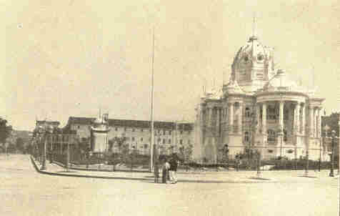
Courtesy of the Pan-American Union.
Monroe Palace, where the third Pan-American
Conference was held in Rio de Janeiro.

July 4, 1906, the third Pan-American conference was opened at Rio Janeiro. Among the leading questions discussed were: (1) the right of creditor nations to enforce by war on the debtor nations contractual obligations, or the right to use gun-boats as collection agents; and (2) those relating to commercial intercourse. Besides the regular delegates from the United States, Elihu Root, Secretary of State, was present at the opening session.
1906] U. S. AND LATIN AMERICA 115

His address at this meeting, together with his visit to the leading cities, served to inaugurate a new understanding between these countries and the United States. The true American policy was set forth by Secretary Root in the following toast: "May the independence, the freedom, and the rights of the least and weakest be ever respected equally with the rights of the strongest, and may we all do our share toward the building up of a sound and enlightened public opinion of the Americas which shall everywhere, upon both continents, mightily promote the reign of peace, of order, and of justice in every American republic." He went as Ambassador Extraordinary representing the President of the United States. In order to emphasize his official position, he travelled on an American war-ship. His addresses made in the various cities were intended to be an official declaration from the government of the United States, and that position was outlined in his formal address before the congress. "We wish for no victories," he said, "but those of peace; for no territory except our own; for no sovereignty except the sovereignty over ourselves.
116 PROBLEMS OF THE NEW CENTURY [1906

We deem the independence and equal rights of the smallest and weakest member of the family of nations entitled to as much respect as those of the greatest empire, and we deem the observance of that respect the chief guaranty of the weak against the oppression of the strong.

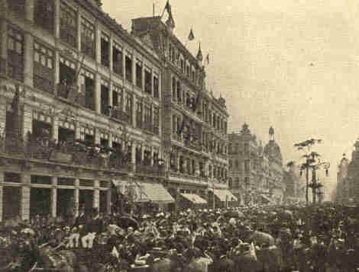
Courtesy of the Pan-American Union.
Arrival of Secretary Root at Rio de Janeiro.

1905] U. S. AND LATIN AMERICA 117

We neither claim nor desire any rights or privileges or powers that we do not freely concede to every American republic. We wish to increase our prosperity, to expand our trade, to grow in wealth, in wisdom, and in spirit, but our conception of the true way to accomplish this is not to pull down others and profit by their ruin, but to help all friends to a common prosperity and a common growth, that we may all become greater and stronger together."
The International Bureau of American Republics was founded as a result of the first Pan-American conference. The original plans of the founders were not carried out owing to a lack of interest on the part of the Department of State as well as in the foreign offices of the South American countries. Secretary Root determined to make this bureau an efficient agency for bringing about better relations between the two continents. He defined the main purpose to be not only to build up trade and commerce among all American nations, but to promote more friendly relations, a better understanding of each other, and the general prosperity and well-being of all the countries of the American continents. Through gifts from Andrew Carnegie and contributions from the different South American states a splendid modern building, costing $1,000,000, was erected in Washington, 1908, as the home of the Bureau of the Pan-American Republics. Besides other enterprises, the Bureau publishes a monthly periodical which contains information on the commerce, new enterprises, and general development of each republic.
118 PROBLEMS OF THE NEW CENTURY [1905

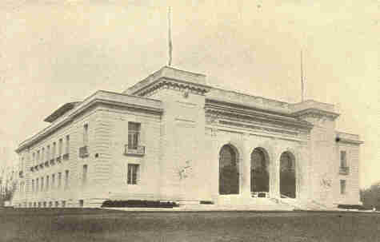
Photograph by Clinedinst.
The Bureau of the Pan-American Republics.

With these new relationships came a new interpretation of the Monroe Doctrine. At various times European nations have engaged in controversies with South American states over the payment of debts due the citizens of the former. The question has then arisen, to what extent shall the United States permit the use of force against the debtor nations?
1905] U. S. AND LATIN AMERICA 119

The wider application of the Monroe Doctrine under President Cleveland looking toward the maintenance of the rights of the weaker American nations, has been followed by recognition of our obligation to secure the performance of duties by those nations. Said President Roosevelt (1905): "We cannot permanently adhere to the Monroe Doctrine unless we succeed in making it evident, in the first place, that we do not intend to treat it in any shape or way as an excuse for aggrandizement on our part at the expense of the republics to the south of us; second, that we do not intend to permit it to be used by any of these republics as a shield to protect that republic from the consequences of its own misdeeds against foreign nations; third, that inasmuch as by this doctrine we prevent other nations from interfering on this side of the water, we shall ourselves in good faith try to help those of our sister republics, which need such help, upward toward peace and order."

120 PROBLEMS OF THE NEW CENTURY [1905

The immediate cause for this statement by President Roosevelt was the problem confronting our government on account of the bankrupt condition of the Republic of Santo Domingo. Debts had accumulated for over thirty years until by the beginning of 1905 they amounted to more than $32,000,000. Each successive ruler became a more reckless borrower and new loans were secured upon harsher terms.
Finally affairs were brought to a crisis on account of the pressure on the part of the French and Italian governments for the payment of the claims of their citizens. The republic was on the verge of dissolution when President Roosevelt intervened. European governments were satisfied, for it signified the payment of their claims. An agreement was signed by representatives of the government of Santo Domingo and of the United States whereby the United States was to undertake the task of collecting and apportioning the revenues of Santo Domingo. The stipulation was made that no plan of annexation, purchase, or permanent control on the part of the United States should ensue. Agents were to be appointed by the United States who should take charge of the customhouses. Forty-five per cent of the total receipts were to be used in carrying on the affairs of the republic and the balance was to go to pay the indebtedness.
1905] U. S. AND LATIN AMERICA 121

In his message, February, 1905, President Roosevelt, pressing upon the Senate the urgent need for the ratification of this agreement, said: "The state of things in Santo Domingo has become hopeless unless the United States or some other strong government shall interpose to bring order out of chaos. . . . If the United States declines to take action and other foreign governments resort to action to secure payment of their claims, the latter would be entitled, according to the decision of the Hague Tribunal in the Venezuela cases, to the preferential payment of their claims; and this would absorb all the Dominican revenues and would be a virtual sacrifice of American claims and interests in the island. If, moreover, any such action should be taken by them, the only method to enable the payment of their claims would be to take possession of the customhouses, and, considering the state of the Dominican finances, this would mean a definite and very possibly permanent occupation of Dominican territory, for no period could be set to the time which would be necessarily required for the payment of their obligations and unliquidated claims." The Senate, in special session, shirked responsibility and refused either to ratify or reject the treaty.

122 PROBLEMS OF THE NEW CENTURY [1905

With the revolutionists on the island growing stronger and the European Powers becoming more insistent, President Roosevelt, disregarding the attitude of the Senate, appointed an American as receiver of customs. The move proved immediately successful. The insurrection died out, trade revived, smuggling ceased, and the people were infused with a new spirit. There was also a remarkable increase in the customs receipts, those of 1906 showing an increase of 44 per cent over the receipts of 1905 and 72 per cent over those of 1904. Although only 45 per cent of the revenues collected were turned over to the Dominican government, this sum was almost double the amount which they had received when they had control of the collection themselves.

1905] U. S. AND LATIN AMERICA 123

After two years of discussion, the treaty was ratified by the Senate, February 25, 1907, and by the Dominican Congress, May 3. The terms were practically those which had been carried out by order of President Roosevelt. The United States, in a sense, became the trustee of Santo Domingo, and thus established a new relation between this country and the smaller republics of the western hemisphere.
CHAPTER VII

CONSERVATION OF NATURAL RESOURCES

Toward the close of the nineteenth century, attention was called to the fact by scientific men that the methods employed in the use of our soil, mines, forests, and water supply were extremely wasteful. During the previous decades the resources of the country were regarded as inexhaustible. As stated by President Roosevelt in 1907: "Hitherto as a nation we have tended to live with an eye single to the present, and have permitted the reckless waste and destruction of much of our national wealth." At the same time the call came for the conservation of our natural resources.
The destruction of the forests first attracted attention. The first national reservation of forests was made in 1891, and in 1898 a marked advance was made by the establishment of a division of Forestry in the Department of Agriculture. Gifford Pinchot, as chief of the division, called attention of the people to the interdependence of the forests and the waterways.
125

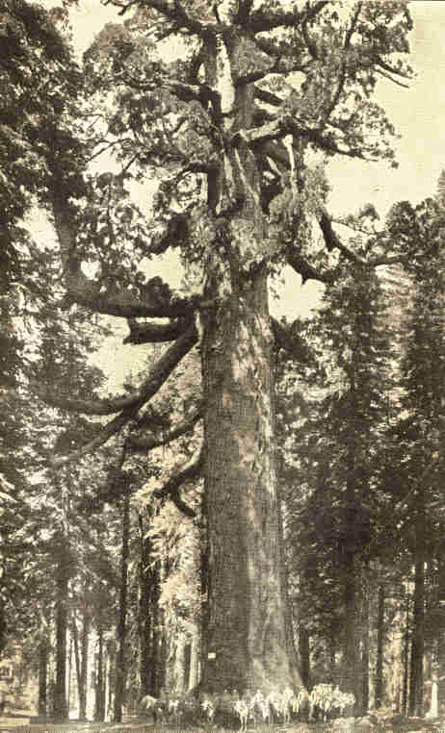
Grizzly Giant, Mariposa Grove, California,
with a squad of cavalry at its base.
126

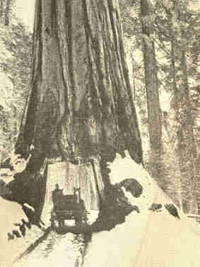
Big tree "Wanona," showing the relative size of other
conifers compared with big trees. Mariposa Grove.
1906] CONSERVATION OF RESOURCES 127

In 1906, after long effort, the famous Mariposa Grove of large trees in California was made a national reservation. During the same year a bill was passed by Congress providing for the preservation of Niagara Falls. Public opinion had been aroused by the campaign of the American Civic Association. Power companies had multiplied so rapidly that it seemed the whole volume of water was about to be used for commercial purposes and that the most famous object of natural scenery in the United States would be destroyed.

128 PROBLEMS OF THE NEW CENTURY [1906

In response to appeals from the people of the interior, President Roosevelt, March 14, 1907, appointed the Inland Waterways Commission. In his letter which created the commission he said: "The time has come for merging local projects and uses of the inland waters in a comprehensive plan designed for the benefit of the entire country. . . . I ask that the Inland Waterways Commission shall consider the relations of the streams to the use of all the great permanent natural resources and their conservation for the making and maintenance of prosperous homes."
This commission while carrying on its investigations discussed the general policy of conservation and suggested to the President the calling of a convention for the purpose of discussing the conservation of the nation's resources. Thus originated the celebrated White House conference of May 13-15, 1908. The opening session presented an impressive scene, for there were assembled in the east room of the White House, upon the invitation of the President, the Vice-President, seven members of the cabinet, all of the justices of the Supreme Court, most of the representatives and senators, thirty-four governors of States together with their advisers, and representatives of the governors of the remaining States, governors of the Territories, representatives of sixty-eight national societies, and numerous special guests.
1906] CONSERVATION OF RESOURCES 129

The opening address of President Roosevelt was a notable effort. "This conference," he said, "on the conservation of natural resources is in effect a meeting of the representatives of all the people of the United States called to consider the weightiest problem now before the nation . . . . We have become great in a material sense because of the lavish use of our resources, and we have just reason to be proud of our growth. But the time has come to inquire seriously what will happen when our forests are gone; when the coal, the iron, the oil, and the gas are exhausted; when the soils shall have been still further impoverished and washed into the streams, polluting the rivers, denuding the fields, and obstructing navigation. These questions do not relate only to the next century or the next generation. One distinguishing characteristic of really civilized men is foresight; we have to, as a nation, exercise foresight for this nation in the future, and if we do not exercise that foresight, dark will be the future!"
130 PROBLEMS OF THE NEW CENTURY [1906

During the meeting numerous addresses were made on the conservation of the minerals, of the soils, of the forests, and of the waters of the country. In his address on the conservation of ores and related minerals, Andrew Carnegie declared that during the three-fourths of a century from 1820 to 1895 nearly 4,000,000,000 tons of coal were mined by methods so wasteful that 6,000,000,000 tons were either destroyed or allowed to remain in the ground forever inaccessible. From 1896 to 1906 as much coal was produced as during the preceding seventy-five years. During this decade 3,000,000,000 tons were destroyed or left in the ground beyond reach for future use. Basing his statements on the investigations of scientists, he showed that at the present rate of increase in production the available coal of the country would be exhausted in two hundred years and the workable iron ore within a century.
131

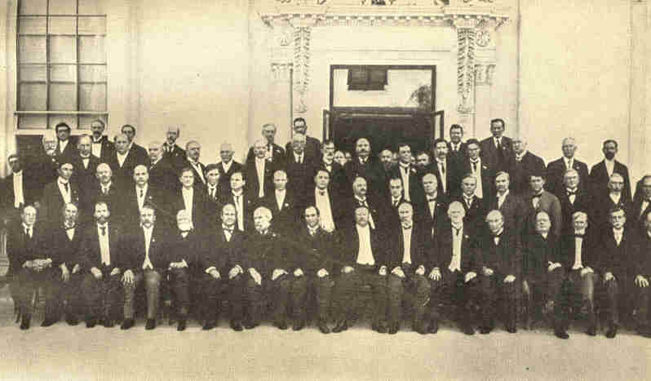
Copyright by Underwood and Underwood.
The President, Governors, and other leading
men at the National Resources Conference,
at the White House, May 13 to 15, 1908.
132
1906] CONSERVATION OF RESOURCES 133

Similarly, James J. Hill demonstrated that the forests of this country are fast disappearing and that from three to four times as much timber was consumed each year as forest growth restored. His statements regarding the tremendous soil waste in our farming methods were likewise astounding. Resolutions were adopted covering the entire subject of conservation as shown in one of them as follows: "We agree that the land should be so used that erosion and soil-wash shall cease; that there should be reclamation of arid and semi-arid regions by means of irrigation, and of swamps and overflowed regions by means of drainage; that the waters should be so conserved and used as to promote navigation, to enable the arid regions to be reclaimed by irrigation, and to develop power in the interests of the people; that the forests which regulate our rivers, support our industries, and promote the fertility and productiveness of the soil should be preserved and perpetuated; that the minerals found so abundantly beneath the surface should be so used as to prolong their utility; that the beauty, healthfulness, and habitability of our country should be preserved and increased; that the sources of national wealth exist for the benefit of the people, and that monopoly thereof should not be tolerated." It was recommended that the States should establish conservation commissions to co-operate with one another and with a similar national commission.
134 PROBLEMS OF THE NEW CENTURY [1906

On June 8, 1908, the first national conservation commission was created by President Roosevelt. Its forty-nine members were men well known in politics, in the industries, and scientific work. Gifford Pinchot was chairman of this commission which submitted its first report at a conference in Washington, December 8-10, 1908. The delegates consisted of governors and other representatives from the States and from national organizations. This report was received with favor and it was recommended that the work of the commission should be continued. Congress declined to make the necessary appropriation of $25,000 for this purpose, although it was strongly endorsed by the President.
In 1901 the National Conservation Association was formed, a voluntary organization of public and scientific men. The purpose of this association is to carry on the movement for conservation in every State. Within seven months after the White House conference, forty-one State conservation commissions were created and fifty-one conservation commissions representing national organizations were formed.
1906] CONSERVATION OF RESOURCES 135

President Roosevelt carried the movement still farther in calling the first North American conservation congress. Representatives to this conference met in Washington, February 18, 1909. They came from Canada, Newfoundland, and Mexico as well as the United States. Broad general principles of conservation applicable to the North American continent were adopted.

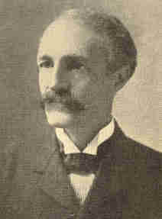
Gifford Pinchot, President
of the Conservation Commission.

The movement was materially strengthened also through the withdrawal of large areas of the public domain from private entry. Thus 148,000,000 acres of forests and 80,000,000 acres of coal land were withdrawn during President Roosevelt's administrations.
136 PROBLEMS OF THE NEW CENTURY [1906

Directly connected with the problems of conservation are those of irrigation. The so-called arid regions constitute two-fifths of the area of the United States, or some 1,200,000 square miles. Of this vast region, it has been estimated that about one-tenth can be irrigated to advantage. By the end of the year 1908, some 13,000,000 acres had been reclaimed, or nearly one-third of the total amount suitable for irrigation purposes. This has brought about the rapid growth of cities and a substantial industrial advance in the former arid regions of the far West. The most notable impulse to this movement was made in 1902 when Congress passed a law, the Reclamation act, providing that the proceeds from the sales of public lands in thirteen States and three Territories should be expended by the National Government in the construction of irrigation works.
The total receipts from the sales of these lands amounted to $28,000,000 by the end of the year 1905, and twenty-three projects, dams, reservoirs, or canals were in different stages of construction. The most important of these undertakings were the Roosevelt Dam, the Shoshone Dam, and the Truckee-Carson Canal.
1906] CONSERVATION OF RESOURCES 137

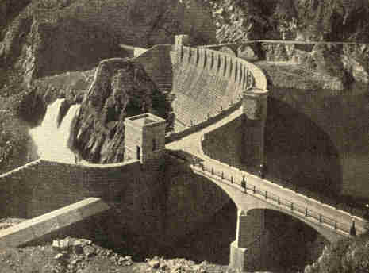
Built by the U. S. Reclamation Service.
Roosevelt Dam from the road.

The Roosevelt Dam is the chief work of construction in what is called the Salt River project. By the completion of this work at least 200,000 acres in the vicinity of Phoenix, Arizona, were reclaimed. This dam is 284 feet high, 1,080 feet long on the crest, and 165 feet thick at the base. The resulting reservoir with a storage area of 16,320 acres will be the largest artificially formed lake in the world.
138 PROBLEMS OF THE NEW CENTURY [1906

It forms a body of water 25 miles long, almost 2 miles broad, and with a maximum depth of 220 feet. The main canals are 119 miles in length and the lateral canals 208 miles. Not only will this structure insure a supply of water in the Salt River valley where, in recent years, orchards and other products have perished, but it will prevent the floods which have devastated that region from time to time. Water-power amounting to 25,000 horse-power has been developed by the construction. This power is used in part for pumping, and another area, estimated at 40,000 acres, outside the territory covered by the canals has been reclaimed. The power is also used for lighting, for manufacturing, and for mining.
It was seen that the Shoshone River, in northwestern Wyoming, during the season of melting snows, carried away more waste water than would be adequate to reclaim many thousands of acres in the arid regions of the lower altitudes. Two million two hundred and fifty thousand dollars were allotted for the construction of the Shoshone Dam which will form a reservoir of water sufficient to irrigate 75,000 acres of land 50 miles farther down the river.
1906] CONSERVATION OF RESOURCES 139

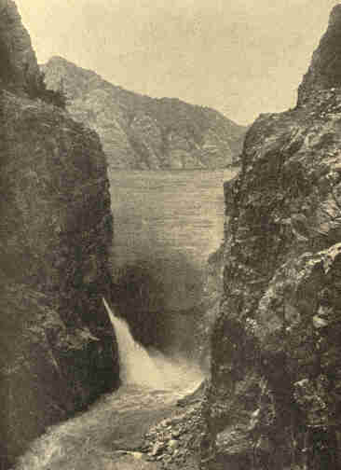
Shoshone Dam, Wyoming.
Highest dam in the world. Height 328.4 feet.

140 PROBLEMS OF THE NEW CENTURY [1906

The Truckee-Carson project provides for the irrigation of 150,000 acres in western Nevada. The water of the Truckee River, which flows out of Lake Tahoe, is distributed by canals having an aggregate length of 670 miles. The main canal was opened in 1905.
By the close of the year 1906, over $39,000,000 had been allotted for works under actual construction, and this amount had increased to $119,500,000 within four years. It has been estimated that the land thus reclaimed will alone be worth $240,000,000. The additional cost of a project is assessed against the land. When the land is sold, the money received is used for the development of new irrigation areas.
Another significant plan outlined by the irrigation congress in its meeting, 1911, provided for bringing about the complete reclamation of all swamp and overflowed land. The swampland area of the United States exceeds 74,500,000 acres, or an amount greater than the area of the Philippine Islands by 1,000,000 acres.
The Mississippi basin has been called the heart and soul of the prosperity of the United States. Two-fifths of the area of the country, comprising one-half the population, is tributary to the Mississippi system, which has over 20,000 miles of navigable waters. This valley produces three-fourths of our foreign exports. The network of railroads covering this territory has for a number of years furnished altogether inadequate transportation facilities, and conditions have grown steadily worse.
1906] CONSERVATION OF RESOURCES 141

Traffic experts throughout the United States have been advising river improvement as a means of relieving the congestion of freight. This situation has led to a revival of interest in the deep waterway from the Lakes to the Gulf which has been talked and written about for nearly three-quarters of a century.

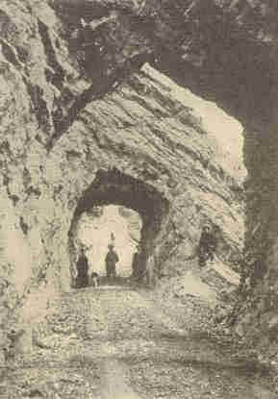
Photograph by Clinedinst.
Shoshone Project. Wyoming Park wagon road,
showing wonderful tunnelling work on the new
wagon road from Cody, Wyo., to the
National Park via the Shoshone Dam.

142 PROBLEMS OF THE NEW CENTURY [1907

Concerted action was not taken until 1907, when the Lakes to the Gulf Deep Waterways Association was formed at St. Louis, having for its object the deepening of the water-way between Lake Michigan and the Gulf. The proposal to construct a canal by the way of the Illinois River to the Mississippi, large enough to carry ships, was declared feasible by government engineers and a route was surveyed.

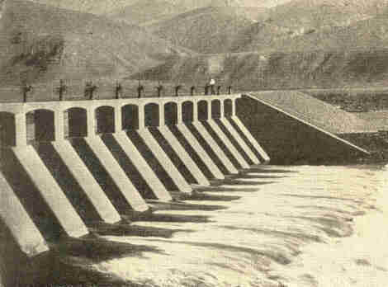
Truckee-Carson reclamation project.
Diversion dam and gates at heading of main canal.

1907] CONSERVATION OF RESOURCES 143

President Roosevelt endorsed the scheme. In his message to Congress, December 3, 1907, he said: "From the Great Lakes to the mouth of the Mississippi there should be a deep water-way, with deep water-ways leading from it to the East and the West.
Such a water-way would practically mean the extension of our coast line into the very heart of our country. It would be of incalculable benefit to our people. If begun at once it can be carried through in time appreciably to relieve the congestion of our great freight-carrying lines of railroad. The work should be systematically and continuously carried forward in accordance with some well-conceived plan . . . . Moreover, the development of our water-ways involves many other important water problems, all of which should be considered as part of the same general scheme."
He appointed an Inland Waterways Commission which was to outline a comprehensive scheme of development along the various lines indicated. Their leading recommendation had to do with the proposal for a deep water-way from Chicago to New Orleans. The completion of the drainage canal by the city of Chicago, at a cost of $55,000,000, really created a deep waterway for forty miles along the intended route. It was reported to Congress by a special board of surveyors that the continuation of such a water-way to St. Louis would cost $31,000,000.
144 PROBLEMS OF THE NEW CENTURY [1907

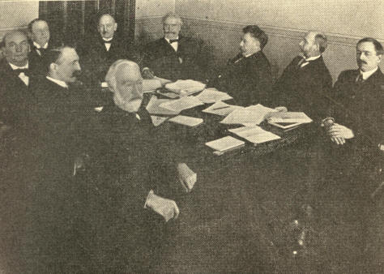
Inland Waterways Commission.

The legislature of Illinois, following the recommendation of Governor Charles S. Deneen, submitted to the people an amendment of the constitution which would enable the State to assume a bonded indebtedness of $20,000,000 for the purpose of constructing a deep waterway from Chicago to St. Louis. The measure was approved by popular vote November 3, 1907. Thereupon, the State Senate passed a bill providing for the construction of the canal. This failed in the House. It was again introduced into the legislature, 1910, but failed to pass.
1903] CONSERVATION OF RESOURCES 145

Among the other important projects submitted by the Inland Waterways Commission are the following: To connect the Great Lakes with the ocean by a twenty-foot channel by the way of the Erie Canal and the Hudson River, an inner channel extending from New England to Florida; to connect the Columbia River with Puget Sound and deepen the Sacramento and the San Joaquin Rivers, so as to bring commerce by water to Sacramento and other interior California cities.
With the hope that New York City might again come into a mastery of the trade with the West, as at the time when the Erie Canal was first completed and because of the inability of the railroads to meet the demands of traffic, the legislature of New York, in 1903, appropriated $100,000,000 for the enlargement of that waterway and the two branch canals, the Oswego and Champlain. The proposed uniform depth is twelve feet and it is otherwise to be large enough for boats of a thousand ton cargo or four times the capacity of boats now on the canal.
CHAPTER VIII

DEVELOPMENT OF THE NEW SOUTH

The term New South signifies the transition which has taken place through energy applied to the opportunities which that section of the United States offers. The South has natural gifts which in themselves will make it a marvel of wealth. The coast line measures 3,000 miles and already the ports of New Orleans and Galveston are among the most important on our seaboard. In 1898 the imports along the Gulf amounted to $13,000,000, and in 1908 they amounted to $59,350,000. In 1898 the exports were valued at $202,000,000; in 1908 they were valued at nearly $400,000,000. The completion of the Panama Canal will certainly increase the importance of the Southern seaboard cities.
There are in the United States navigable streams amounting to 26,410 miles and of these the South has 18,215 miles. Mr. Wilson, Secretary of Agriculture, has estimated that the waterpower facilities of the South equal 5,000,000 horse-power for the six high-water months--five times the amount New England has. By a system of reservoirs this supply could be doubled.
1904] DEVELOPMENT OF THE NEW SOUTH 147

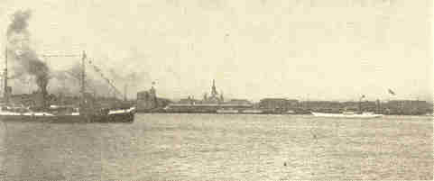
Copyright, 1900, by Detroit Photographic Co,
The port of New Orleans.

Roughly speaking, the country can be divided into three water-power districts: (1) the wholly undeveloped district which lies about Birmingham, Alabama, the centre of the great iron and coal district of the South; (2) a well-exploited district along the Chattahoochee, extending from Atlanta to Columbus, Georgia; (3) a district which lies in the favored agricultural region of northern South Carolina and southern North Carolina. Here about one-third of the easily available power has been developed. To-day New England, poor in raw materials and having an area of only 66,000 square miles, manufactures as much as does the whole South which is rich in raw materials and has an area of 1,000,000 square miles. It is hardly necessary to make forecasts--possibly it is wiser to ask what can possibly hinder the development of this favored section.
148 PROBLEMS OF THE NEW CENTURY [1904

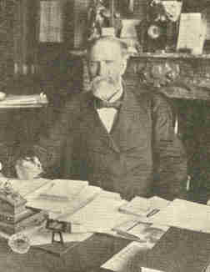
James Wilson, Secretary of Agriculture.

In minerals and forests the South is equally rich. The coal supply, according to the report of the National Conservation Commission, amounts to 611,748,000,000 tons and the riches in iron in the southern Appalachian district are equally enormous. Forty-one per cent of the remaining forest area is in the same country. Unless a system of conservation is put into operation, however, these vast timber resources will pass away, for the forests are being used at a rate of more than three and one-half times the annual growth. Private interests own 125,000,000 acres in the South and practically none of the timber is being handled with the idea of conservation. There are no "State forests"; neither are there adequate laws for the prevention of forest fires.
1904] DEVELOPMENT OF THE NEW SOUTH 149

The economic advancement of the South during the past thirty years has been wonderful. The tide of migration within our country no longer moves Westward as much as Southward and in its wake has followed a flood of capital. The increase of population and capital is necessary to the industrial growth of the South, and in spite of the recent influx the scarcity of laborers remains a serious problem, the solution of which is absolutely necessary for the development of the manufacturing industries as well as agriculture. Immigrants of good standing are constantly sought by the States, and to cope with the problem some individuals have been guilty of operating a system of peonage. Lack of efficiency in the laborers makes the problem still more perplexing. Scientific investigations conducted with the aim of discovering the causes for this general inefficiency have led to the conclusion that the eradication of the mosquito and hook-worm will add greatly to the ability of the wage-earners. A systematic campaign in this direction has been made possible through the recent gift of Mr. Rockefeller.
150 PROBLEMS OF THE NEW CENTURY [1904

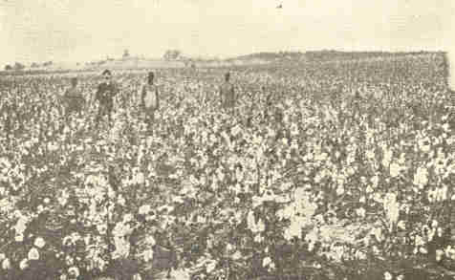
A field of cotton.

The South has always been largely an agricultural section, with the production of cotton as the leading interest. In 1909 the yield was about 13,500,000 bales from about 32,000,000 acres. In value the crop equals about twice the annual output of all the gold mines in the world. The 8,000,000 bales which are exported annually represent an income to the United States of about $400,000,000.
1904] DEVELOPMENT OF THE NEW SOUTH 151

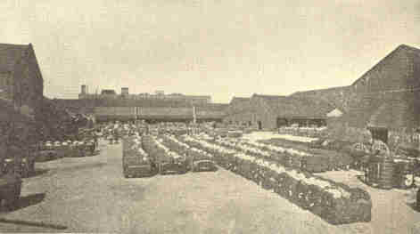
Bales of cotton ready for shipment.
Cotton-press yard, New Orleans.

The problem which has called for the most attention is that the average output per acre has been decreasing for years. During the past few years the white farmers have taken active steps to remedy this weakness. Agricultural experiment stations have conducted investigations and the agricultural press has interpreted these results to the actual farmers and has conducted a systematic agitation for an agricultural revolution. Associations have been formed for the purpose of studying conditions and introducing improved methods in preparing the soil and rotating crops.
152 PROBLEMS OF THE NEW CENTURY [1904

More of the food supply of the South is to be raised at home; better homes and farm buildings are being erected, and better machinery is being used. The invention of a mechanical cotton picker, which has been accomplished, should reduce materially the cost of handling the crop.
Closely connected with this is the problem of roads. Where railroads are scarce good wagon roads are all the more necessary. In the South (excluding Kentucky, Arkansas, and Oklahoma) there are 500,000 miles of public roads serving a population of over 20,000,000 people. In 1908 there were only 17,700 miles of improved road. To help along this work good roads associations have been formed in the various States.
The old methods of financing the plantation system are passing. The planters are breaking away from the credit system which has kept them as borrowers and debtors and, as a result, they have money for investments elsewhere. The great problems connected with cotton culture are the labor supply and proper conservation of the soil. These solved, the friends of the South confidently believe that thirty times as much cotton could be produced as is produced at present. When one learns that only 145,200,000 acres out of 612,000,000 are now under cultivation, the claim does not seem extravagant.
1904] DEVELOPMENT OF THE NEW SOUTH 153

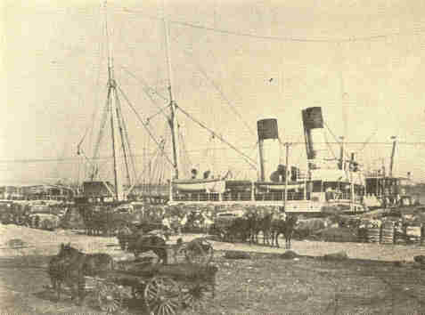
Loading cotton on the levee, New Orleans.

Southern farmers have learned that other products besides cotton pay well. Less than twenty years ago practically no hay was raised for sale in the Gulf States. The red clover and timothy which the planter thought could only be raised in the North are now cultivated in the South.
154 PROBLEMS OF THE NEW CENTURY [1904

Iowa, the greatest hay-growing State in the Union, has for the past ten years averaged 1.58 tons per acre at an average value of $5.45 per ton. Mississippi during the same time has averaged 1.62 tons to the acre valued at over $10 a ton. Alfalfa has been found to be excellent feed for stock and the yield, which averages from four to eight tons per acre, sells for from $10 to $18 a ton. Corn is being cultivated now and it is not uncommon to find yields of 100 bushels to the acre and under the most favorable circumstances even twice that much has been raised on a single acre. The prevailing high prices make the corn crop particularly valuable.
Stock-raising, which has never been indulged in to any extent, now gives excellent returns. The mules which are used so extensively in the South are being raised at home instead of being brought from the North. Beef animals and hogs are increasing in numbers and are being bred more carefully. The great variety of food crops which ripen in rotation make the cost of hog-raising very little--possibly two cents a pound will cover the cost of raising, butchering, and packing. Sheep flourish in the pine regions where they are remarkably free from diseases. They range all the year, needing little attention.
1904] DEVELOPMENT OF THE NEW SOUTH 155

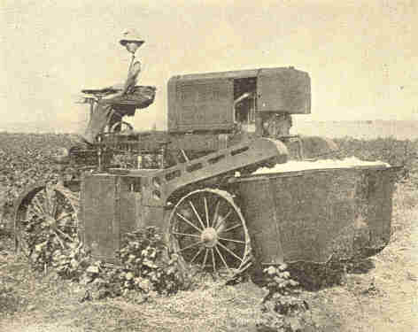
The Price-Campbell cotton-picking machine,
which does the work of fifty persons.

This shift in agricultural pursuits has been due in a measure to the appearance of the boll-weevil which wrought havoc with the cotton crop for some years. It is possible that the change has been decidedly beneficial when one notes that the value of products in 1899 was $705,000,000 and in 1909 about $1,430,000,000.
156 PROBLEMS OF THE NEW CENTURY [1904

Agriculture is not the only interest of the New South. Northern capital has worked wonders along industrial lines. Some communities have changed entirely from agriculture to manufacturing. South Carolina is now second among the States in the manufacture of cotton; North Carolina is third, and Georgia is not far behind. In Alabama Southern tobacco is manufactured. The steel and iron industries, the furniture industry, the cottonseed-oil industry, and others are constantly becoming more important. The effects of this industrial revolution are far reaching. Social lines are shifting; a new society based upon business success and wealth seems to be supplanting or at least breaking in upon the aristocracy of the ante-bellum South, based upon family and public service. The ideal of success is changing and the ambitious young man now goes into business, manufacturing, or engineering as often as into the profession of law and politics. The laboring class has changed also. Years ago this class lived on farms and raised raw materials: now it lives in the cities and fashions raw materials. The same social results are found here as elsewhere, but on account of the conservatism and personal independence of the Southern laborer, who is only a generation removed from the soil, these results are not in evidence so soon.
1904] DEVELOPMENT OF THE NEW SOUTH 157

In the manufacturing districts there is the political unrest characteristic of the North. Labor unions develop here and Socialism has some adherents. This tends to break the political solidarity of the section and it is possible that in the not distant future the "Solid South" may pass away.
The South is enthusiastic; it is alert to its opportunities and it is planning with hope for the future. Through practical education wonders may be worked, and upon this practical education for the rising generation the South bases its hopes. The new generation will make greater strides in the utilization of the great natural gifts than the old one has. The race problem will be solved in time, and the solution must come through the efforts of the Southern people, for the best classes now believe that the South can prosper best when all the people, colored as well as white, are brought to the highest standard of their efficiency.
CHAPTER IX

PRESIDENT ROOSEVELT'S SECOND TERM

On June 1, 1905, an exposition was opened at Portland, Oregon, in commemoration of the Lewis and Clark expedition (1804-1805). Four hundred acres of ground adjoining the principal residence district, overlooking the Willamette River, were set aside for this purpose. There were extensive exhibits by the United States, Great Britain, Canada, Holland, Italy, China, and other European and Asiatic countries. The fair was, in general, the expression of the life and history of the Pacific Northwest and the direct relationship between that region and the Orient. Many national congresses were held in conjunction with it, such as the American Medical Association, National Good Roads Association, and the National Conference of Charities and Correction.
The different interstate commerce acts, beginning with that of 1887 and including the railroad rate bill of 1906, constitute a system of control established by the Federal Government over persons and corporations engaged in interstate or foreign commerce; this includes the carrying of persons and property by either rail or water. Pipe lines, telephone, telegraph, express, and sleeping-car companies are also brought under the same provisions. The administration of these laws was vested in the Interstate Commerce Commission consisting of seven members.
1905] ROOSEVELT'S SECOND TERM 159

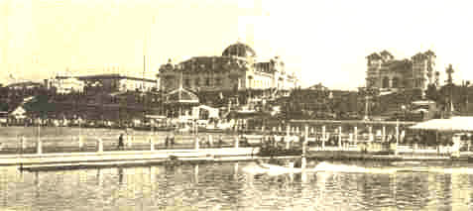
The Lewis and Clark Exposition, Portland, Ore.
General view across the Lagoon.

The important provisions of these laws may be summarized as follows: 1. All charges must be just and reasonable. The commission was given power to fix maximum rates after investigation of a complaint by either party to a dispute over rates.
160 PROBLEMS OF THE NEW CENTURY [1906

2. Pooling agreements were prohibited. 3. It was made unlawful to make discriminations by giving to any particular person, corporation, or locality an unreasonable advantage over others. Granting of passes was prohibited to other than railroad employees, and granting of rebates was forbidden.

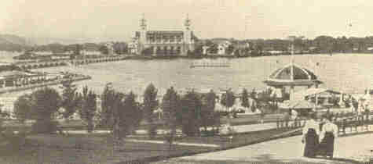
The Lewis and Clark Exposition, Portland, Ore.
The Government Buildings across the Lagoon.

4. By the "long or short haul" clause it was made unlawful for a common carrier to charge more for the transportation of passengers, or the same kind of freight, over a shorter than a longer distance; provided the transportation was under substantially similar circumstances and conditions over the same line and in the same direction.
1906] ROOSEVELT'S SECOND TERM 161

5. All rates were required to be published and posted where they might be consulted by any person. 6. Railroad companies were forbidden to engage in other lines of business. 7. Companies engaged in interstate commerce must have a uniform system of accounting. 8. They are required to make reports to the Interstate Commerce Commission regularly.

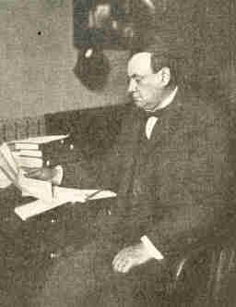
Copyright by Clinedinst, Washington.
Dr. Harvey W. Wiley, many years
Chief of the U. S. Bureau of Chemistry.

This commission was also empowered to receive complaints, hear testimony, make orders correcting abuses, or investigate conditions without previous complaint. It was given the power to suspend the proposed increase of rates until their justice had been determined. Any person objecting to an order of the commission was empowered to appeal to the "Commerce Court," which was created, being made up of five circuit court Justices.
162 PROBLEMS OF THE NEW CENTURY [1906

Nearly all of the States have passed laws relating to the purity of goods sold to the public. Investigation showed, however, that twenty per cent of the articles of food in common use were adulterated. This led to the passing of a far-reaching measure by Congress, 1906, known as the Pure Food and Drugs law. It provides against the manufacture and sale of adulterated or misbranded foods, drugs, medicines, or liquors in the District of Columbia, the Territories, and the insular possessions of the United States, and prohibits the shipment of such goods from one State to another or to a foreign country. To the Department of Agriculture was given the power to enforce the law. Thus the public is protected against adulterated foods and medicines and dishonest and misleading labels, and honest manufacturers are protected against fraudulent competition.
For a number of years some of the European countries condemned American packing-house products. Abuses in the processes of preparing preserved meats were brought vividly before Americans by Upton Sinclair in his novel "The Jungle." The Department of Agriculture took up the problem and a special investigation was ordered by President Roosevelt.
1906] ROOSEVELT'S SECOND TERM 163

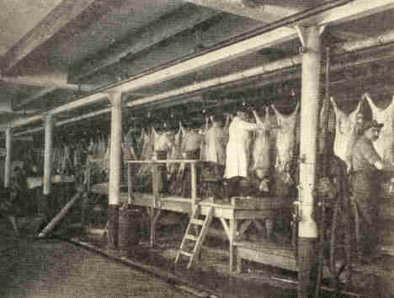
U. S. Government inspection of a packing-house.
Inspector's assistant attaching a "Retained" tag to carcass
marked by inspector on the heading bench. Carcasses so
marked are left intact until they reach the retaining-room.

The report showed the need for more rigid inspection, and the agitation throughout the country forced the House of Representatives, 1906, somewhat reluctantly, to adopt the President's recommendation for a thorough inspection, by government agents, of all processes and methods used in the meat packing-houses.
164 PROBLEMS OF THE NEW CENTURY [1906

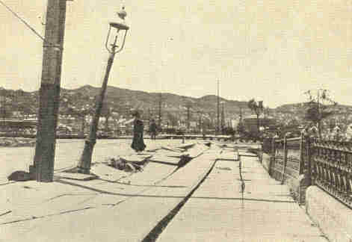
Earthquake at San Francisco, April 18, 1906.
Upheaval of sidewalk at Eighteenth and Capp Streets.

Early in the morning of April 18, 1906, San Francisco was visited by one of the most dreadful disasters of modern times. An earthquake shock destroyed many of the important buildings in the business part of the city. Other cities and towns along the coast and in the Santa Clara Valley suffered greatly and a number of the buildings of Leland Stanford University, thirty miles south of San Francisco, were demolished. Ninety per cent of the loss in San Francisco was due to the conflagration which raged for two days. Fires broke out owing to the crossing of electric wires. The water-mains were old and poorly laid and the force of the earthquake had burst them.
1906] ROOSEVELT'S SECOND TERM 165

Firemen and soldiers fought the advance of the flames by destroying buildings with dynamite. Not until an area three miles in length and two miles in breadth, including all the business and the thickly settled residential sections, had been burned over was the advance of the flames stopped. The estimated loss of life was 1,000, and property valued at $300,000,000 was destroyed. Among the irreparable losses were several libraries, the collections of the California Academy of Sciences, and many works of art. The noted Bancroft Library with its collection of manuscripts was saved.

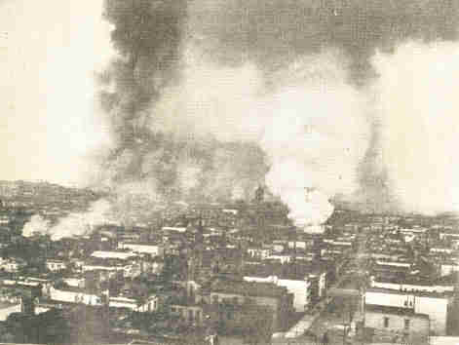
Burning of San Francisco following the earthquake.
166 PROBLEMS OF THE NEW CENTURY [1906

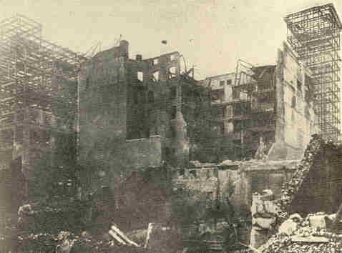
Showing destruction of buildings after the
earthquake and fire in San Francisco.

A quarter of a million people were rendered homeless and were without food and the means of earning a livelihood. The sympathy of the world was aroused and offers of relief came from all quarters. Two million five hundred thousand dollars was voted by Congress, and the total relief fund amounted to $20,000,000. There was little suffering for lack of food and water, owing to the co-operation of representatives of the Red Cross Association, a citizens' committee, and the United States army in distributing supplies.
1906] ROOSEVELT'S SECOND TERM 167

One hundred thousand persons were sheltered in tents in Golden Gate Park. The courage and hopefulness of the people did not desert them, and the rebuilding of the city was immediately begun.

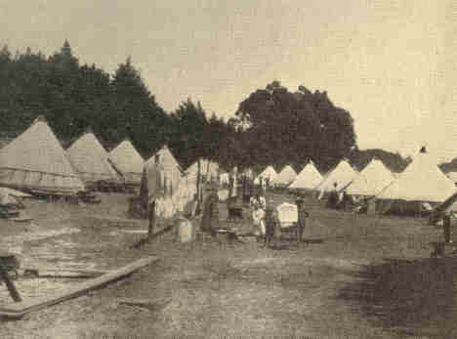
Refugees in Golden Gate Park, San Francisco.

At the end of a year one-half of the burned area had been rebuilt. The old frame and low brick structures were replaced by modern buildings of steel and re-enforced concrete, for this type had survived the earthquake shock. After two years, a new San Francisco, more beautiful and more substantial, had risen on the site of the old.
168 PROBLEMS OF THE NEW CENTURY [1906

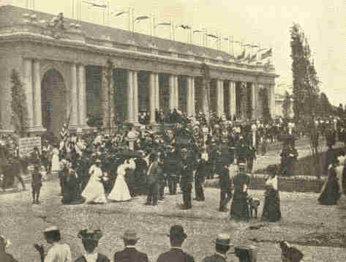
Copyright by Underwood & Underwood, N.Y.
The Jamestown Exposition--Manufactures and
Liberal Arts Building from the Auditorium.

On April 26, 1907, the Jamestown Exposition was opened. It was in commemoration of the first English settlement in America. The southern shore of Hampton Roads, forty miles southeast of old Jamestown, was selected as the site for the buildings. The historic idea was uppermost in the exposition.
1907] ROOSEVELT'S SECOND TERM 169

The colonial type of construction was dominant and good taste and moderation were notable in the arrangement of the grounds and exhibits. Industrial and commercial progress were emphasized. The United States had a special exhibit to illustrate the work of the different departments. In the harbor, one of the finest in the world, was the greatest international naval display ever witnessed. Every variety of war-vessel in existence was on exhibition besides commercial and passenger boats from the great ports of the world.
CHAPTER X

THE FINANCIAL PANIC OF 1907

Popular opinion ascribed three reasons for the panic of 1907. The first of these was the attitude of the President toward certain great corporations. It is true that his attacks bared some of the most deeply rooted evils which have always been at the bottom of our panics--dishonesty in the administration of great aggregations of capital. Great were the lamentations and doleful the predictions of what would happen should the President not change his policy of enforcing the laws. The railway opponents of the President were sure the panic came from the Hepburn Bill, which was passed early in 1906. If this had been dangerous to the welfare of the railroads it is reasonable to assume that foreign capital would have been withdrawn from American railways and that American capitalists interested in railroads would have attempted to avert financial ruin by disposing of their holdings. Neither situation developed, for the European investors increased their holdings and American capitalists continued to plan still greater investments in railways.
1907] THE FINANCIAL PANIC OF 1907 171

The second general explanation was found in the unsound and reckless banking in New York City. The dangers arising from trust companies had been known for several years. It came to be believed that the deposits in these trust companies were being misused by the bank officers for the promotion of various speculating schemes. The disclosures which came with the investigation of the insurance companies fixed these beliefs more firmly in the minds of the people, and the first break in confidence precipitated runs on the New York banks.
The third explanation was that the panic was due to the defects in our American currency system.
These were the popular explanations, but there were deep-seated causes which had worked to bring about the existing conditions. The crisis was world-wide and was felt most in the countries where there was a gold standard. In 1890 the world's supply of gold available for monetary use was hardly $4,000,000,000; in 1907 it was more than $7,000,000,000.
172 PROBLEMS OF THE NEW CENTURY [1907

Along with this went a rapid rise in the average price of commodities in gold-standard countries. Bank deposits in the United States in 1907 were three times as great as they were in 1897. Amidst all this prosperity there were forces which were bound to bring a reaction and among the most important of these was the demand for capital for conversion into fixed forms. Ready capital was also lessened relatively by the great losses experienced as a result of the Spanish-American War, the Boer War, the Japanese-Russian War, the San Francisco earthquake, and the Baltimore fire. These losses, which amounted to $3,000,000,000, came at a time when the world was just entering upon a period of great industrial activity and needed all its capital. Much capital was absorbed in the construction of railroads, industrial plants, development of foreign industries, etc. These conditions brought about a tightening of money rates in Europe and American financial centres; consequently rates of interest went up. Commercial paper which brought three to three and one-half per cent in New York in 1897 brought seven per cent in 1907.
1907] THE FINANCIAL PANIC OF 1907 173

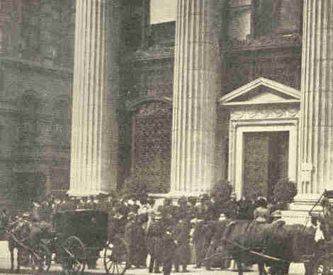
The panic of 1907. Run on the Knickerbocker Trust Company,
34th Street and Fifth Avenue.

Closely allied to this movement was the increase in the number of securities issued by industrial concerns. A few resourceful men, in order to do away with the evils of unrestricted competition, devised a remedy in the form of mergers. Others of less capacity but greater daring saw opportunities for money-making, and a craze for mergers and for the incorporation of private enterprises swept over the country.
174 PROBLEMS OF THE NEW CENTURY [1907

By 1907 there were at least $38,500,000,000 worth of securities in existence. The natural result was speculation. When investors began to fear the soundness of the securities a collapse of credit was due.
The rapid development of trust companies had its effect. The cash reserves held by these companies were small; their investments were not always conservative and the depositors were often suspicious. This free expansion of business with little or no reference to cash reserve or capital gave rise to another cause for the panic, which was not a matter of money. It was a matter of what was in men's minds. There was a period of "muckraking" in which leaders financial and political were severely critcised. Whether or not this criticism was justified by the exposition of the frauds of the insurance companies and the questionable dealings of some other corporations need not be discussed. The criticism created an attitude of mind throughout the nation, and the first weakening of a bank brought on the deluge.
1907] THE FINANCIAL PANIC OF 1907 175

To the ordinary observer the panic of 1907 will date from October 22, when the Knickerbocker Trust Company of New York closed its doors. Earlier in the month the Mercantile National Bank had gotten into difficulties and had appealed to the clearing-house committee for aid, which was given. Soon it was noted that the Knickerbocker Trust Company was in a precarious condition, and the directors, following the example of the other bank, appealed to the same committee. The investigation of the committee showed the company insolvent and aid was refused. When the facts became known, a run on the bank began and it was compelled to close its doors. The lack of confidence in other financial institutions was soon shown by similar runs.

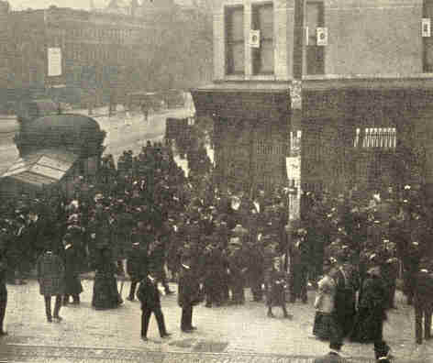
The panic of 1907. Uptown branch of the
Knickerbocker Trust Company, 125th Street.

176 PROBLEMS OF THE NEW CENTURY [1907

No bank could stand the strain unaided. Now the Federal Government stepped in and Secretary of the Treasury Cortelyou came in person to New York and deposited $40,000,000 of the surplus from the United States Treasury to be used for the aid of beleaguered institutions. For more than a week the crowds of depositors sought their money. The lines were not broken at night until the police hit upon the plan of giving to each individual a ticket denoting his place in the line. The Trust Company of America alone paid $34,000,000 across its counters and still crowds thronged the streets. At length the enormous reserve of the Treasury was exhausted and it became necessary to delay and deliberately to make slow payments. Through loans made by other banks the Trust Company of America and the Lincoln Trust Company, which had endured the hardest sieges, were saved and now the panic entered its second stage.
1907] THE FINANCIAL PANIC OF 1907 177

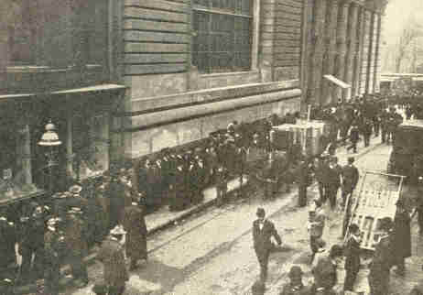
The panic of 1907. Run on the Colonial Trust Company.
Line of depositors in Ann Street waiting their turn.

The country was thoroughly aroused, and to avoid a nation-wide raid upon banking houses the bankers took radical steps. The first measure resorted to was the enforcement of the rule requiring savings-bank depositors, at the option of the institution, to give sixty days' notice before withdrawing deposits. The second expedient was one which had been resorted to during former years of financial unsteadiness. "Emergency currency" was issued.
178 PROBLEMS OF THE NEW CENTURY [1907

This currency took various forms. (1) The clearing-house loan certificates issued in denominations ranging from $500 to $20,000, used for settling inter-bank balances; (2) clearing-house certificates in currency dimensions to be used by banks in paying their customers; (3) clearing-house checks which took the form of checks drawn upon particular banks and signed by the manager of the clearing-house; (4) cashier's checks (in opposition to the National Bank act) secured by approved collateral; (5) New York drafts which were cashier's checks drawn against actual balances in New York banks; (6) negotiable certificates of deposit, and (7) pay checks payable to bearer drawn by bank customers upon their banks in currency denominations. These were guaranteed by the firm which issued them.
Other devices were used to aid the banks and to block the spread of the panic by limiting cash payments by the banks. The governors of Nevada, Oregon, and California declared legal holidays continuously for several weeks, thereby allowing the banks to remain closed. In some places the size of withdrawals was limited to $10 or $25 daily.
The panic was felt to a great degree on the New York Stock Exchange because the banks refused to make loans, but this stringency was relieved by a bankers' pool, headed by J. P. Morgan, which loaned $25,000,000 at the prevailing rate of interest. With the strengthening of the Stock Exchange another stage of the panic passed.
1907] THE FINANCIAL PANIC OF 1907 179

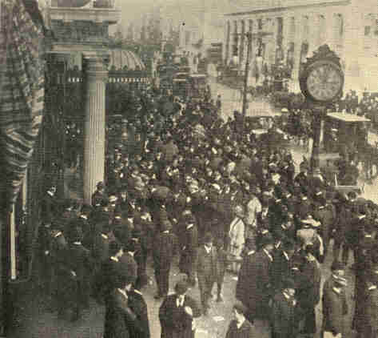
The panic of 1907. Run on the Lincoln
Trust Company, Fifth Avenue entrance.

180 PROBLEMS OF THE NEW CENTURY [1907

In spite of the use of the surplus of the Treasury the banks showed a loss of $50,000,000 in actual cash during the five weeks of the panic. Now demands were made on foreign countries for gold. The Bank of England made no move to block the great withdrawals of gold except to raise the official discount to seven per cent. The flow of gold did much to stay the ebb of confidence.
Some contended for an issue of paper money and after a long discussion by the officials of the Treasury, it was decided to sell $50,000,000 worth of Panama two per cent bonds and $100,000,000 worth of three per cent notes in the hope of calling from its hiding-place the money which was being hoarded. The result of the venture was not satisfactory and the loan operations soon ceased.
Gradually financial affairs righted themselves. The emergency currency was redeemed, the runs on banks ceased, confidence slowly returned, and business picked up, although by the middle of 1908 the volume was scarcely half of what it had been a year before. The number of bank failures had been comparatively small. Only twenty-one banks were obliged to suspend payment, while in 1893 the number was 160.
181

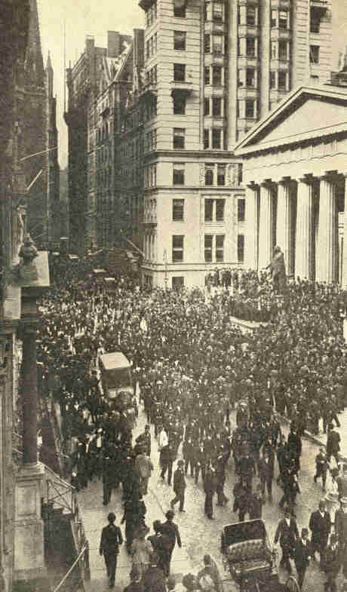
The panic of 1907. Wall Street, in front of the Sub-Treasury Building,
when the run on the Trust Company of America was at its height.
182
1907] THE FINANCIAL PANIC OF 1907 183

Naturally there was much discussion concerning the defects of our financial system, of the needs of elastic currency, of a central bank, etc., when the Sixtieth Congress met in December, 1907. Several bills were offered for the establishment of a central bank; some for the issue of a special currency by the government; others for the legalization of certificates and currency created by clearing-house associations. The aversion of the people to the centralization of the banking business in the hands of a few of the great money powers made the establishment of a central bank out of the question.
The bills which were discussed at any length were the Fowler Bill, the Vreeland Bill, and the Aldrich Bill. The first was discarded, although it had merits, and the two branches of Congress were unable to agree upon either of the others. The result was a compromise measure which became the Aldrich-Vreeland Act.

184 PROBLEMS OF THE NEW CENTURY [1907

The important provisions of this act are as follows: (1) Ten or more national banking associations, each with an unimpaired capital and surplus of not less than twenty per cent and an aggregate capital and surplus of not less than $5,000,000, may form national currency associations. These associations are to have power to render available, for the basis of additional circulation, "any securities, including commercial paper, held by a national banking association."
(2) To obtain this additional circulation, any bank belonging to a national currency association having circulating notes outstanding secured by United States bonds to an amount not less than forty per cent of its capital stock, and having the required unimpaired capital and surplus, may deposit approved securities with the currency association and be empowered by the Secretary of the Treasury to issue additional circulating notes to an amount not to exceed seventy-five per cent of the cash value of the securities. If the securities are State or municipal bonds the issue must not exceed ninety per cent of the market value of the bonds.

1907] THE FINANCIAL PANIC OF I907 185

(3) The banks and assets of all banks belonging to the currency association are liable to the United States for the redemption of this additional currency, and the association may at any time require that additional securities be deposited. All banks are held liable to make good the securities of any bank in the association.

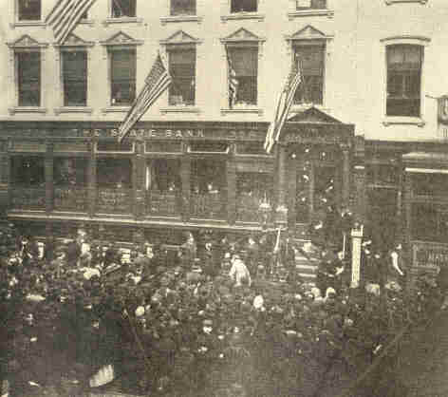
The panic of 1907, Run on the State Bank,
Grand Street, New York.

186 PROBLEMS OF THE NEW CENTURY [1907

(4) The total amount of circulating notes outstanding for any bank shall not at any time exceed the amount of its unimpaired capital and surplus, neither shall the amount of such notes in the United States exceed $500,000,000 at any time. The amount issued in each State shall bear the same relation to the total amount issued in the United States as the unimpaired capital and surplus of the banks of that State bear to the unimpaired capital and surplus of the banks of the United States.
(5) The tax on circulating notes secured by United States bonds bearing two per cent or less shall be one-half of one per cent; if secured by United States bonds bearing more than two per cent, the tax shall be one per cent. If the securities are other than United States bonds, the tax shall be at a rate of five per cent per annum for the first month and afterward an additional tax of one per cent per annum for each month until a tax of ten per cent per annum is reached.
(6) The redemption of the notes may take place by the banks depositing with the Treasurer of the United States lawful money to replace the securities deposited.
(7) The formation of a national monetary commission to inquire into and report to Congress necessary or desirable changes in the banking and currency laws was provided for.
CHAPTER XI

IMMIGRATION AND EMIGRATION

Since the organization of our government nearly 29,000,000 foreigners have come to the United States. The flow of immigration first assumed large proportions during the decade 1831-1840 and since that time one wave after another has reached our shores. The last one, and the one which has caused the greatest alarm, gathered force about 1897 and reached its full tide in the first decade of the twentieth century, when over 8,000,000 aliens landed at our ports.
During this period (1820-1910) the character of immigration has changed. Prior to 1880 the greater part of it came from northern Europe, but since that time the number has constantly fallen off, and the flow from southern Europe has greatly increased. During the decade 1871-1880 Austria-Hungary, Italy, and Russia sent only 181,000 of 2,262,000 aliens who landed in the United States--about eight per cent. During the decade 1901-1910, 8,130,000 immigrants came to our shores, and of these 5,800,000, or over 70 per cent, were from these three countries.
188 PROBLEMS OF THE NEW CENTURY [1907

In 1901 Austria-Hungary sent, 113,400; in 1907 about 338,500, but owing to the passage of the immigration law in 1907 the number fell abruptly, but by 1910 had again increased to 260,000. The same is true of Italy. In 1901 about 136,000 came; in 1907 nearly 286,000, and in 1910 about 215,500. Russia sent 85,000 in 1901, some 260,000 in 1907, and 187,000 in 1910. The numbers from northern Europe do not approach these. The immigration from the British Isles does not reach the 100,000 mark; from Germany only 30,000 come yearly.
Causes for this influx are varied. Many come desirous of owning homes, a pleasure out of reach in their home country on account of high prices. Free institutions attract others. A land which offers free schools to all regardless of race or creed, religious freedom, and the opportunity to play some part in the political life of the state is naturally attractive. Some come to escape military service, others with the idea of making money and returning to their native land. Density of population and the accompanying excessive competition in the struggle for existence also play a part.

1907] IMMIGRATION AND EMIGRATION 189

Hundreds of letters telling of the general prosperity in America and contrasting this with the condition at home, do their work with the disheartened peasants. It is said that half of our immigrants come on tickets paid for by friends in America. The large employers of labor, and even the States themselves, are constantly calling for laborers. Ours is a huge, half-developed country, and the development of our resources, particularly the coal and iron industries, the cotton; rice, cane, and tobacco industries, and the railways demands thousands of helpers.

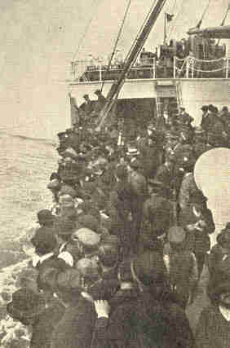
Emigrants bound for America.

190 PROBLEMS OF THE NEW CENTURY [1907

The steamship companies which have found an extremely profitable business in the transportation of immigrants have used various means to increase the numbers. Agents are said to be in all European countries soliciting trade. Associations for the assistance of poor emigrants have been formed in various European cities--this is especially true among the Jews who, by means of societies such as the "Hebrew Shelter" of London, have aided thousands of Roumanian and Russian Jews on their way to America.
Although most of the European countries have placed restrictions upon emigration, these restrictions unfortunately do not retard the emigration of the undesirable classes. As a result America was called upon early to legislate on this problem. The first act was in 1819 and was aimed to regulate the transportation of immigrants. The laws of 1875, 1882, 1891, 1893, and 1903 dealt with the class of immigrants to be admitted. The acts did not accomplish the end for which they were framed, and the question was taken up again by Congress which, after a lengthy discussion, passed the act of 1907.
1907] IMMIGRATION AND EMIGRATION 191

No great change in policy was effected by this law which, for the most part, only revised the wording of the old laws and modified the methods of regulation. The head tax of two dollars, hitherto levied on each alien, was doubled but was made inapplicable to immigrants from our insular possessions or to aliens who had resided for a year either in the British possessions in North America, or in Cuba or Mexico. All aliens suffering from tuberculosis or loathsome diseases or those who were "mentally or physically defective, such mental or physical defect being of a nature which may affect the ability . . . to earn a living," were excluded.

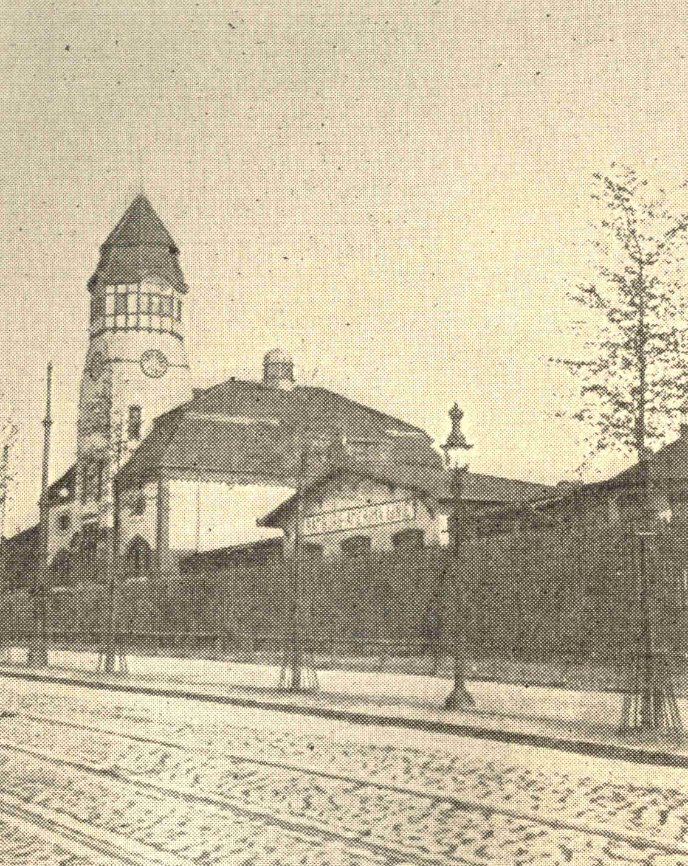
Entrance to Emigrant Station or "model town" in Hamburg.
Built for emigrants waiting to sail.

192 PROBLEMS OF THE NEW CENTURY [1907

Children under sixteen unaccompanied by a parent were excluded. Steamship companies were placed under additional restrictions to insure against their violation of the act. Should an immigrant within a period of three years be found to have entered the country contrary to the terms of the act, he was to be deported and the transportation company responsible for his coming would be held liable for the expense of his deportation.
The effect of the new law can be seen in the immigration statistics--the number of immigrants for the year 1908 is but little more than half as great as the number for 1907. The chief decrease was in the stream from southern Europe. This decrease cannot be attributed entirely to the act of 1907, but must be accounted for in part by the panic of 1907. Observations extending over a long period of years have disclosed the fact that the ebb and flow of the tide of immigration is closely attached to the periods of economic prosperity and depression.
1907] IMMIGRATION AND EMIGRATION 193

When the races of northern Europe contributed the greater part of our immigrants there was a general feeling that this was a decided advantage to us. The people were readily assimilated into our population and were in general intelligent, industrious citizens who soon acquired a patriotic love for America and its institutions. The serious problems came with the increased number of southern Europeans.

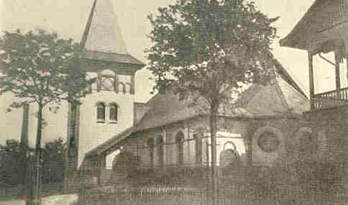
One of several churches built for emigrants of various
faiths in the station or "model town" of the
Hamburg-American Company, for use while waiting to sail.

194 PROBLEMS OF THE NEW CENTURY [1907

For years Italians emigrated to South America, particularly to Brazil and the Argentine Republic, where the climate, race customs, and language were more to their liking than in the north. A diminution of prosperity there has turned part of the tide northward. About eighty per cent of our Italians come from southern Italy, a fact explained by the difference between the industrial conditions in the northern and southern parts of the peninsula. In the south agriculture is the only industry, and it frequently suffers from climatic conditions, the resulting losses bearing heavily upon the population. Conditions are aggravated by an unequal division of taxes between the north and the south. Often the only alternative to starvation is emigration. During the past decade 2,000,000 Italians have come to us and, according to estimates, about two-thirds of them have settled in the cities of the Northern States, a condition detrimental to the foreign and our social organization alike. These Italians, peasants and experts in fruit culture by training, become day laborers, thus losing their greatest productive power. The Italian who keeps away from the city finds his lot more agreeable. Wherever they have settled as farmers they have been uniformly successful. The person who knows only the Italian of the tenements has little sympathy for him, in spite of the fact that many of this race have proved themselves to be quiet, sober, and useful citizens.
195

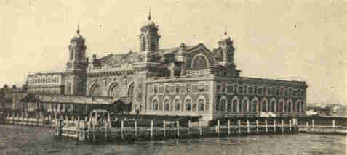
Exterior view of main building.

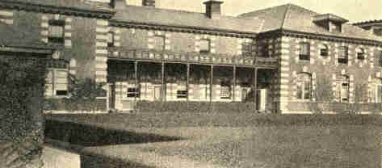
Restaurant. Immigrants dining-room and detention quarters.
Detained immigrants are fed here at the expense of the steamship companies.

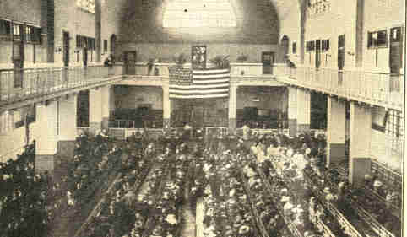
Here all immigrants must present themselves upon arrival for their
first inspection under the law--sometimes as many as 5,000 a day.

U. S. IMMIGRANT STATION, ELLIS ISLAND, N. Y.
196
1907] IMMIGRATION AND EMIGRATION 197

The Slavic immigration since 1880 has been mainly from the more primitive districts out of touch with the civilization of western Europe. These people have come, not as settlers, but as laborers in the mines, factories, and foundries, planning to remain here for a time, earn as much as possible, and return to their native land.
In 1899 statistics began to be compiled by means of which the race and nationality of aliens might be determined. From 1899 to 1907 about seventy-two per cent of the Slavic immigration came from Austria-Hungary. Since 1900 at least 100,000 aliens from this country have come to the United States each year; in 1905, 1906, and 1910 the number exceeded 250,000 each year, and in 1907 it was 340,000. In this crowd came Bohemians Poles, Slovaks, Ruthenians, Slovenians, Croatians, Bulgarians, Servians, Montenegrins, and other allied peoples. They are distributed over various parts of the land. Pennsylvania, on account of its mines, gathers by far the greatest number--in 1906 there were about 500,000 Slavs in the State; New York had nearly 200,000, and Illinois about 134,000.
198 PROBLEMS OF THE NEW CENTURY [1907

The Bohemians and Poles seem inclined to farm, but in the main the Slav laborers have busied themselves in the coal, coke, iron, and steel industries. Very seldom do the Slavs take to petty street traffic, as do the Jews and Italians, but prefer the harder and better paid work in the mines and foundries.
The Russians make the smallest Slavic group in America. Although many Russians are reported among the immigrants, only about five per cent are native born Russians, the rest being Jews, Poles, Finns, and Lithuanians.
About one-eighth of our European immigrants are Jews. By the law of 1769 the Jews in Russia are compelled to live within certain territorial limits known as the Jewish Pale, and about ninety-four per cent comply with the regulation. The law of 1882 has further restricted the places of residence, for Jews are now prohibited from buying or renting lands outside the limits of the cities or incorporated towns. Their educational advantages are limited by law; few are admitted to the bar and few to the other learned professions. To these disabilities the Russian government has added the terror of persecution, which will explain why 150,000 Jews come to America each year. In all there are 1,250,000 here.
1907] IMMIGRATION AND EMIGRATION 199A

"ALIEN PASSENGERS" AND IMMIGRANTS ENTERING THE UNITED STATES FROM EUROPEAN COUNTRIES, 1820-1910

LAST 1820 1831 1841 1851 1861
PERMANENT TO TO TO TO TO
RESIDENCE 1830 1840 1850 1860 1870
----------------- ------ ------ ------ ------- ------
Austria-Hungary 7,800
Belgium 27 22 5,074 4,738 6,734
Denmark 169 1,063 539 3,749 17,094
France 8,497 45,575 77,262 76,358 35,984
Germany 6,761 152,454 434,626 951,667 787,468
Greece
Italy 408 2,253 1,870 9,231 11,728
Netherlands 1,078 1,412 8,251 10,789 9,102
Norway, Sweden 91 1,201 13,903 20,931 109,298
Russia 91 646 656 1,621 4,536
Spain, Portugal 2,622 2,954 2,759 10,353 8,493
Switzerland 3,226 4,821 4,644 25,011 23,286
England 22,167 73,143 263,332 385,643 568,128
Scotland 2,912 2,667 3,712 38,331 38,768
Ireland 50,724 207,381 780,719 914,119 435,778
Europe; unspecified 43 96 155 116 210
----------------- ------ ------ ------ ------- ------
Total 98,816 495,688 1,597,502 2,452,657 2,064,407

199B

1871 1881 1891 1901
TO TO TO TO TOTAL
1880 1890 1900 1910
----------------- ------ ------ ------ ------- ------
Austria-Hungary 72,969 353,717 597,047 2,145,266 3,176,801
Belgium 7,221 20,177 20,062 41,635 105,690
Denmark 31,771 88,132 52,670 65,285 260,472
France 72,206 50,464 36,006 73,379 475,731
Germany 718,182 1,452,970 543,922 341,498 5,389,548
Greece 15,996 167,519 183,515
Italy 55,759 307,309 655,694 2,045,877 3,090,129
Netherlands 16,541 53,701 31,816 48,262 180,952

Norway 211,245 568,362 95,264 190,505 1,691,013
Sweden 230,679 249,534

Russia 52,254 265,088 593,703 1,597,306 2,515,901

Spain 9,893 6,535 6,723 27,935 170,426
Portugal 23,010 69,149

Roumania 14,559 53,008 67,567
Switzerland 28,293 81,988 33,149 34,922 239,340
Turkey in Europe 2,562 118,202 120,764
England 460,479 657,488 271,094 388,017 3,089,491
Scotland 87,564 149,869 60,053 120,469 504,345
Ireland 436,871 655,482 403,496 339,065 4,223,635
Wales 11,186 17,464 28,650
Europe unspecified 656 10,318 4,370 1,719
----------------- ------ ------ ------ ------- ------
Total 2,261,904 4,721,602 3,703,061 8,136,016 25,531,653

Immigrants from British North America and other countries 2,535,810

Estimated number of immigrants prior to October 1, 1819 250,000

[Transcriber's note: Norway/Sweden and Spain/Portugal are combined totals in columns where only one value is given.]
200A
TOTAL NUMBER OF IMMIGRANTS, 1891 TO 1910

Year Total Sex Age
Ended Number Male Female Under 14 14 to 45 45 and over
June 30
1891 560,319 354,059 296,200 95,879 405,843 58,597
1892 623,084 385,781 237,303 89,167 491,839 42,078
1893 502,917 315,845 187,072 57,392 419,701 25,824
1894 314,467 186,247 128,220 41,755 258,162 14,550
1895 279,948 159,924 120,024 33,289 233,543 13,116
1896 343,267 212,466 130,801 52,741 254,519 36,007
1897 230,832 135,107 95,725 38,627 165,181 27,024
1898 229,299 135,775 93,524 38,267 164,905 26,127
1899 311,715 195,277 116,438 43,983 248,187 19,545
1900 448,572 304,148 144,424 54,624 370,382 23,566
1901 487,918 331,055 156,863 62,562 396,516 28,840
1902 648,743 466,369 182,374 74,063 539,254 35,426
1903 857,046 613,146 243,900 102,431 714,053 40,562
1904 812,870 549,100 263,770 109,150 657,155 46,565
1905 1,026,499 724,914 301,585 114,668 855,419 56,412
1906 1,100,735 764,463 336,272 136,273 913,955 50,507
1907 1,285,349 927,976 355,373 138,344 1,100,771 46,234
1908 782,870 506,912 275,958 112,148 630,671 40,051
1909 751,786 519,969 231,817 88,393 624,876 38,517
1910 1,041.570 736,038 305,532 120,509 868,310 52,751

200B

Debarred Returned Returned Able to Read Unable to
from Within Within but not Write Read or Write
Landing One Year Three Years [See note 1] [See note 1]

1892 2,164 637
1893 1,053 577 . . . 59,582 61,038
1894 2,389 417 . . . 16,784 41,614
1895 2,394 189 . . . 2,612 42,302
1896 2,799 238 . . . 5,066 78,130
1897 1,617 263 . . . 1,572 43,008
1898 3,030 199 . . . 1,416 43,057
1899 3,798 263 . . . 1,022 60,446
1900 4,246 356 . . . 2,097 93,576
1901 3,516 363 . . . 3,058 117,587
1902 4,974 465 . . . 2,917 162,188
1903 8,769 547 . . . 3,341 185,667
1904 7,994 300 473 3,953 168,903
1905 11,879 98 747 8,209 230,882
1906 12,371 61 615 4,755 265,068
1907 13,064 70 925 5,829 337,573
1908 10,902 114 1,955 2,310 172,293
1909 10,411 58 2,066 2,431 191,049
1910 24,270 23 2,672 4,571 253,569

Note 1: Prior to 1895 the figures are for persons over 16 years; from 1895 to 1910 for persons 14 years of age and over.
1907] IMMIGRATION AND EMIGRATION 201

The question of Oriental immigration has caused much comment in our Pacific Coast States for several years. Before 1900 the total number of Japanese coming to America seldom reached 1,500 a year. Since that time about 12,000 have come each year, except in 1903 when 20,000 came and 1907 when the number reached 30,000. Seventy per cent of this number, however, went to Hawaii. Over-population and economic depression in their native land have caused this exodus. Most of these immigrants are laborers--skilful, energetic and efficient--who apparently desire to become citizens. Among the better classes are many who have attained eminence in various lines of work in our country. In scientific investigation the names of Takamine, Noguchi, Yatsu, Takami, Asakawa, and Iyenaga are well known. The names of those who have been more than ordinarily successful in business would make a long list.
202 PROBLEMS OF THE NEW CENTURY [1907

The most serious objections to the Japanese arise in the coast States where these immigrants have raised a serious labor problem. The people of these commonwealths also fear a race problem which in gravity will rival the one in the Southern States. It is claimed that even now, when the number of Orientals is small, the enforcement of law is exceedingly difficult in the Chinese quarters, while the control of the Japanese is next to impossible since they do not congregate in certain sections of the cities as do the Chinese. It is claimed that the 2,000,000 whites who live on the Pacific Coast will be swamped and lose control of the government if this Oriental immigration is not entirely prohibited. The Chinese do not cause so much anxiety. Since the passage of the exclusion act thirty years ago, few have come to the United States--scarcely more than 2,000 a year. As laborers they are efficient, patient, and honest in keeping labor contracts.

203

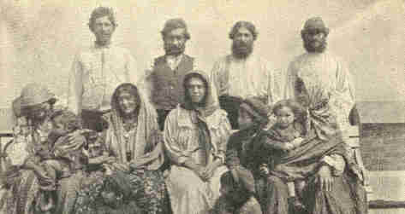
Gypsies excluded and deported as undesirable.

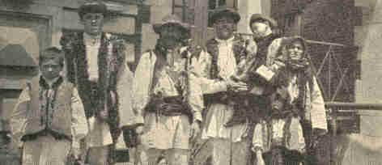
Ruthenian shepherds from Austria, bound out West for farmers.
Considered desirable and qualified to enter.

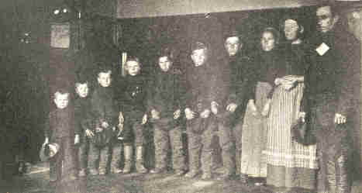
A German family of ten considered desirable and qualified to enter.

GROUPS OF IMMIGRANTS UPON THEIR ARRIVAL AT ELLIS ISLAND
204
1907] IMMIGRATION AND EMIGRATION 205

These swarms of foreigners who come to us each year are causing uneasiness in the minds of the thinking people. Can our foreign population be growing more rapidly than our power to assimilate it? Is this element as dangerous to our civilization as we think? Has criminality increased as a result of increased immigration? Has this element increased labor agitations during the past decade? Some contend that we are rapidly approaching the limit of our power of assimilation and that we are in constant danger of losing the traits which we call American. The immigrants from southern Europe are in too many cases deficient in education. This lack of education may or may not prove a danger. So far it seems to have been the rule that in the second generation these foreigners have shown themselves extremely anxious to take advantage of the opportunities offered by our free schools.
One of the most serious charges made against the Americanized foreigner has been that through him there has developed in our political system a strain of corruption which endangers our institutions. Political corruption did not come with the immigrants: it was known in all its forms years ago. This much can be said, however: the worst class of foreign-born citizens has ever proved to be a support of corrupt political bosses.
206 PROBLEMS OF THE NEW CENTURY [1907

Our city governments have been notoriously corrupt and the cities harbor the great masses of foreigners. The high cost of living in the cities and the relatively low wages force the aliens into poor and crowded quarters which tend to weaken them physically and degrade them morally and socially. Among the Italians of the cities there appears to be a vicious element composed of social parasites who found gambling dens, organize schemes of black-mail, and are the agents of the dreaded Black Hand. It is the class which furnishes aids for the lowest political bosses and furnishes the bad reputation for the Italians.
An investigation of the nationalities in the city of Chicago has been made by Professor Ripley, of Harvard. The results illustrate the wonderful dimensions of the problem which the cities confront in the assimilation of the foreign element. In the case of Chicago, were the foreigners (those not American beyond the third generation) to be eliminated, the population would dwindle from 2,000,000 to about 100,00. In this city fourteen languages are spoken by groups of not less than 10,000 persons each. Newspapers are regularly published in ten different languages and church services conducted in twenty different tongues. Measured by the size of its foreign colonies, Chicago is the second Bohemian city in the world, the third Swedish, the fourth Polish, and the fifth German.
1907] IMMIGRATION AND EMIGRATION 207

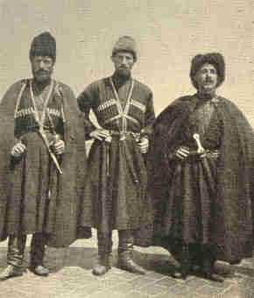
Group of Cossack immigrants considered desirable and qualified to enter.

There is one large factory employing over 4,000 people representing twenty-four nationalities. Here the rules of the establishment are printed in eight languages. So it is with the other cities. New York, for example, has a larger Italian population than Rome, and is the greatest Jewish city, for there are in the city some 800,000 Jews. In all eighty per cent of the population of New York are foreigners or the children of foreigners. In Boston the per cent reaches seventy and in Milwaukee about eighty-six.
208 PROBLEMS OF THE NEW CENTURY [1907

The charge that criminality has increased rapidly with the increased immigration from southern Europe seems to be substantiated by statistics. From 1904 to 1908 the number of aliens charged with committing grave crimes nearly doubled. While this fact will not prove the point, it suggests thought on the question.
It has been truthfully said that the fundamental problem in this question of immigration is most frequently overlooked. Back of the statistics of illiteracy, pauperism, criminality, and the economic value of immigrants lies another one of great proportions. What has been the effect upon our native stock? What has been the expense, to our native stock, of this increase of population and wealth through immigration? The decreasing birth rate of our native population some contend is due to the industrial competition caused by the foreign element. If this be true, the foreigners have supplanted not supplemented the American, and the question arises, how long can the assimilation go on before we lose our American characteristics?
1907] IMMIGRATION AND EMIGRATION 209

The number of Europeans who return to their native lands after living a time in the United States is comparatively small and the loss is not great. The emigration of our farmers to Canada is a more serious thing. Since 1897 the Dominion Government has fostered high-class immigration. Canadian agencies have been established in many of our Western cities with the avowed object of attracting farmers to the Provinces.

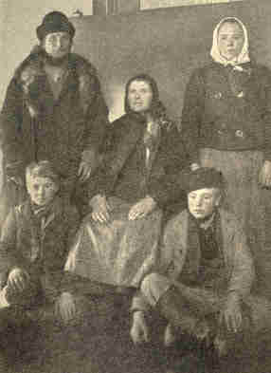
Swedish immigrant family considered desirable and qualified to enter.

210 PROBLEMS OF THE NEW CENTURY [1907

The Canadian Pacific Railway Company has taken up the pioneering business. It sells the land, builds the home and the necessary buildings, breaks the fields, plants the first crop, and hands over to the prospective settler a farm under cultivation. In return the railway demands high-class immigrants and, to insure this, no settler can take possession of a railway farm unless he can show $2,000 in his own right. Between 1897 and the close of 1910 Canada gained by immigration nearly 2,000,000 inhabitants. Of these, 630,000 were from the United States, and it is estimated that those who went from the United States during the past five years took with them $267,000,000 in cash and settlers' effects. The end of the movement has not come, for the railway companies have now gone into the reclamation of arid lands. Since 1908 over 1,000,000 acres of arid land in Alberta have been placed under irrigation, and the work of reclaiming another equally large section has begun. The American farmers who are taking advantage of this opportunity form a class which we cannot afford to lose.
CHAPTER XII

NOTABLE SUPREME COURT DECISIONS

The Northern Securities Company is a corporation, formed under the laws of New Jersey, for the purpose of obtaining control of a majority of the stock of the Northern Pacific Railroad and part of the stock of the Great Northern Railroad. These roads, which parallel each other from Lake Superior to the Pacific, have been held by the courts, in the case of Pearsall vs. the Great Northern Railway, to be competing lines.
The organizers of the Northern Securities Company contended that their ultimate purpose in organizing the company was to control the two railway systems not for the purpose of suppressing competition, but to create and develop a volume of trade among the States of the Northwest and between the Orient and the United States by establishing and maintaining a permanent schedule of cheap transportation rates.
212 PROBLEMS OF THE NEW CENTURY [1907

When the company had completed its organization and the full significance of the organization was known, the State of Minnesota instituted proceedings against the company in the State courts. Later the case was transferred to the federal Circuit Court and eventually carried to the Supreme Court of the United States, where the contentions of the State were overruled.
In March, 1902, a suit was instituted by the United States in the Circuit Court of the eighth federal district. The judges who sat upon the case decided unanimously that the acquisition of the stock of the Northern Pacific and the Great Northern Railways by the Securities Company was a combination for the restraint of trade among the States, and therefore a violation of the Sherman act. A decree was issued by the court prohibiting the company from acquiring any more of the stock of these roads and from exercising any control over either of the roads in question.

213

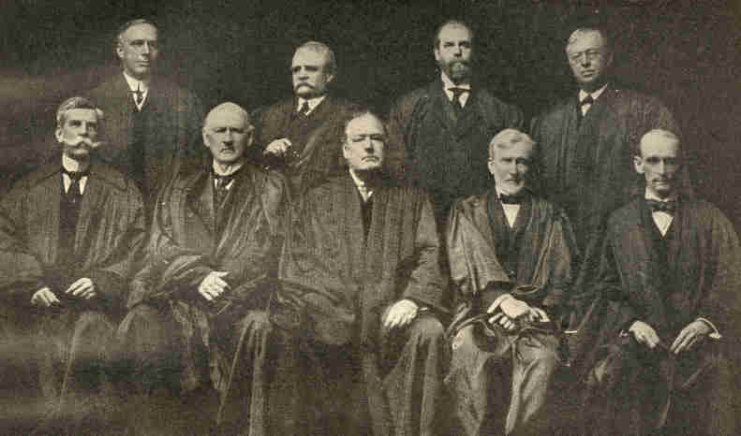
Copyright by Clinedinst. Washington.
W. Van Devanter. H. H. Lurton. C. E. Hughes. J. R. Lamar.
O. W. Holmes. J. M. Harlan. E. D. White. J. E. McKenna W. R. Day.
Justices of the United States Supreme Court who acted upon
the cases of the Standard Oil and American Tobacco Companies.
214
1907] NOTABLE SUPREME COURT DECISIONS 215

The case was carried to the Supreme Court which by a vote of five to four, affirmed the decree of the lower court. In the majority opinion the court took the position that the mere acquisition by the Securities Company of the stock of the two roads was in itself a combination for the restraint of trade. The power to do things made unlawful by the Sherman act had been acquired and this in effect violated that act.
Another point was made clear by the court. The defendants had vigorously denied that the power of Congress over interstate commerce was extended to the regulation of railway corporations organized under State laws, by reason of these corporations engaging in interstate commerce. The court declared that while this was not the intention of the Government, the Government was acting within its rights when it took steps, not prohibited under the Constitution, for protecting the freedom of interstate commerce. Furthermore, it was held that no State corporation could stand in the way of the enforcement of the national will by extending its authority into other States. In substance the court denied the right of any State to endow a corporation of its creation with power to restrain interstate commerce.
216 PROBLEMS OF THE NEW CENTURY [1907

The contention of the defendants, that the Sherman law was intended to prohibit only those restraints which are unreasonable at common law, was dismissed on the ground that this question had been passed upon by the lower court in other cases.
The dissenting opinions were two in number and were written by Justice White and Justice Holmes.
Several conclusions of importance may be drawn from the court's decision.
1. That Congress may forbid transactions of purchase and sale when such transactions confer on an individual or group of individuals the power to destroy competition.
2. No State can create corporations and confer upon them power to interfere with interstate commerce.
3. The Sherman law is not to be interpreted as forbidding the reasonable restraints of trade which are not objectionable at common law.
The Bailey case is one of importance by reason of the fact that the decision handed down by the Supreme Court was an effective blow against the "peonage system," which is an evasion of the constitutional prohibition of slavery. The Alabama law provides, in effect, that the mere act of quitting work on the part of a contract laborer is conclusive evidence that he is guilty of the crime of defrauding his employer.
1907] NOTABLE SUPREME COURT DECISIONS 217

Alonzo Bailey was engaged by a corporation to do farm work and signed a contract for a year, the wages being $12 a month. The company, to bind the contract, paid Bailey $15 down and it was agreed that thereafter he should be paid at the rate of $10.75 a month. After working a month and a few days he left. Instead of suing him for a breach of contract and recovery of damages, the company caused the arrest of Bailey on the charge of an attempt to defraud. No direct evidence could be produced that this was his intention, but the law expressly authorized the jury to find him guilty of fraud, on the ground that he quitted work. The accused was not allowed to testify as to his unexpressed intention. His opportunity to escape prison was to pay back the $15 or to work out the sum. In case neither was done, he was to be fined double the amount paid at the time of making the contract or go to work at hard labor.
218 PROBLEMS OF THE NEW CENTURY [1907

The attorneys for Bailey, wishing to test the constitutionality of the Alabama law, carried the case to the Supreme Court of the United States. The constitutionality of the law was called into question on the following grounds: (1) That it violated the prohibition against involuntary service; (2) it denied the plaintiff in error the right of due process of law; (3) that by laying a burden on the employee and no equivalent burden on the employer, the law denied to the plaintiff the constitutional right of equal protection of the laws.
The decision of the court was not unanimous. Justices Holmes and Lurton upheld the Alabama law, but the majority, in an opinion written by Justice Hughes, declared the law in conflict with the Thirteenth Amendment, which prohibits slavery or involuntary servitude, except as a punishment for crime.
The significance of the decision is this--slavery has been outlawed by our highest court, and one more legal barrier to the progress of the black man has been removed.
The case of Loewe vs. Lawler, probably better known to the public as the Danbury Hatters case, was decided by the Supreme Court in February, 1908, Chief Justice Fuller rendering the decision. The action was brought originally in the United States Circuit Court for the District of Connecticut and, after passing through the Circuit Court of Appeals, reached the Supreme Court late in 1907.
1907] NOTABLE SUPREME COURT DECISIONS 219

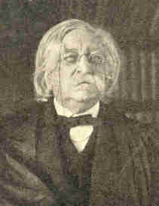
Photograph copyright by Clinedinst, Washington.
Chief Justice Melville W. Fuller.

220 PROBLEMS OF THE NEW CENTURY [1907

The plaintiffs, who were manufacturers of hats, complained that the defendants--members of the United Hatters of North America, an organization which was a part of the American Federation of Labor--were "engaged in a combined scheme and effort to force all manufacturers of fur hats in the United States, including the plaintiffs, against their will and their previous policy of carrying on their business, to organize their workmen . . . into an organization of the said combination known as The United Hatters of North America, or, as the defendants and their confederates term it, to unionize their shops, with the intent thereby to control the employment of labor in, and the operation of, said factories . . . and to carry out such scheme, effort and purpose by restraining and destroying the interstate trade and commerce of such manufacturers by means of intimidation of, and threats made to such manufacturers and their customers in the several States, of boycotting them, their product and their customers . . . until . . . the said manufacturers should yield to the demand to unionize their factories."
These methods had been successfully employed before, as is evidenced by the fact that seventy of the eighty-two manufacturers of fur hats had been compelled to accept the conditions set forth by the American Federation of Labor. The boycott against the Danbury, manufacturers began in July, 1902, and was widened to include the wholesalers who handled the goods of the Danbury concern, the dealers who bought from the wholesalers, and customers who bought from these dealers. Notices to this effect were printed in the official organs of the American Federation of Labor and the United Hatters of North America.
1907] NOTABLE SUPREME COURT DECISIONS 221

To make the feeling against the manufacturers more intense, statements were published to the effect that they were practising an unfair, un-American policy in discriminating against competent union men in favor of the cheap unskilled foreign labor.
The counsel for the defence argued that no case could be set up under the Sherman act, since the defendants were not engaged in interstate commerce, implying that a combination of laborers was not a violation of the act. The court held that an action could be maintained in this case and that the combination as it existed was "in restraint of trade" in the sense designated by the act of 1890. The significance of the decision lies in the fact that the Supreme Court made no distinctions between classes. Records of Congress show that efforts were made to exempt, by legislation, organizations of farmers and laborers from the operation of the act and that their efforts failed. Therefore the court held that every contract, combination, or conspiracy in restraint of trade was illegal and cited a former decision (The United States vs. Workingmen's Amalgamated Council) to show that the law interdicted combinations of workingmen as well as capital.
222 PROBLEMS OF THE NEW CENTURY [1907

The Sherman act was passed by Congress in 1890. It was entitled "An Act to Protect Trade and Commerce against Unlawful Restraints and Monopolies." Since its passage various cases falling under it have been decided, but until the decisions in the Standard Oil Company and the American Tobacco Company cases the extent and intent of this act have not been understood.
In the Standard Oil case the question involved was this: Was the Sherman act violated by the existence and conduct of this corporation, which owned or controlled some eighty corporations originally in competition? The control had been acquired for the purpose of monopolizing the sale and distribution of petroleum products in the United States, and had been acquired by various means of combination with the intent either by fair or unfair methods "to drive others from the field and to exclude them from their right to trade."
1907] NOTABLE SUPREME COURT DECISIONS 223

The proof was that, to destroy competitors, prices had been temporarily reduced in various localities, spies had been used on competitors' business, bogus independent companies operated, and rebates given and taken.
In the case of the American Tobacco Company, there were more than one hundred formerly competing companies united under the control of a single organization and the market in nearly all tobacco products was monopolized. This domination was secured "by methods devised in order to monopolize the trade by driving competitors out of business."
In each case the court found the defendants guilty on the grounds that the agreements and the conduct of the defendants indicated a purpose to destroy competitors and monopolize trade in certain articles. The desired result was accomplished by wrongful means which injured the public as well as the competitors.
The facts in neither case required the consideration of the question as to whether the Sherman act prohibited every unification of formerly competing properties and every restraint of trade, reasonable or unreasonable but, owing to the uncertainty of the public concerning the meaning of the law, the court stated definitely the meaning and scope of the act.
224 PROBLEMS OF THE NEW CENTURY [1907

From appearances the Supreme Court has practically amended the Sherman act by limiting its application to "unreasonable" restraints of trade. The significance of the decisions lies here rather than in the fact that both companies were compelled to dissolve. The best legal authorities believe that the new interpretation of "reasonableness" and "unreasonableness" of restraint of trade has increased rather than decreased the effectiveness of the law, inasmuch as the meaning has always been obscure. The new policy is a notification to combinations of capital that to exist without prosecution they must not resort to any unfair, oppressive, or illegal methods to control competition or crush competitors.
CHAPTER XIII

PRESIDENT ROOSEVELT'S SECOND TERM--CONTINUED

While President Roosevelt advocated peace, he believed that the best means to preserve peace was suitable preparation for war. In his message to Congress, 1904, he said; "There is no more patriotic duty before us as a people than to keep the navy adequate to the needs of this country's position. Our voice is now potent for peace, and is so potent because we are not afraid of war. But our protestations would neither receive nor deserve the slightest attention if we were impotent to make them good." At all times he urged a larger and more efficient navy. For years, before he became Assistant Secretary of the Navy, he had been a student of naval affairs. He found that there was no programme for building ships as in the European countries, and that there was general unpreparedness for war.

226 PROBLEMS OF THE NEW CENTURY [1907

Before the war with Spain, the American navy was so inferior that it was excluded from any table of the principal navies of the world. Had the United States possessed a few more battleships at that time, it is probable that war would not have occurred. Spanish authorities had been told by naval experts that their navy was superior to ours.
Profiting by that experience, plans for a larger navy were projected. By the close of the year 1907 there were about 300 vessels in the navy manned by 35,377 men. In comparative strength it ranked second only to that of Great Britain. Not only was there an increase in the number of vessels but there was great improvement in marksmanship and in the handling of ships. In the battle of Santiago it has been estimated that about five per cent of the shells struck the enemy. During the year 1902 Rear-Admiral Robley D. Evans introduced regular and frequent target practice. So effective was this work that in 1908, at ranges twice as great as at Santiago, gunners throughout the fleet averaged sixty per cent and one vessel scored eighty per cent. Rapidity of fire also was increased nearly fourfold.

1907] ROOSEVELT'S SECOND TERM 227

It was the custom to send the fleet each winter to the Caribbean Sea for manoeuvres, which lasted about four months. In December, 1907, the Atlantic fleet, comprising sixteen battle-ships and a flotilla of torpedo-boats, began a cruise around the world. President Roosevelt steadily adhered to the plan in the face of the most extravagant denunciation on the part of those who declared that it could be considered only as a menace toward Japan. Naval experts claimed, however, that the experience to be gained by this cruise, such as practice in handling ships in all kinds of weather, the renewal of stores and coal, and the meeting of other problems incident to actual warfare, justified the experiment.

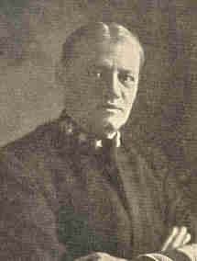
Copyright. 1908. by Harris & Ewing.
Rear-Admiral Robley D. Evans.

228 PROBLEMS OF THE NEW CENTURY [1907

Under command of Rear-Admiral Evans the fleet reached Rio Janeiro on January 12. Unusual honors were tendered the men by the Brazilian government and people. The day of their arrival was made a national festival. In reply to the friendly greeting from the Brazilian government President Roosevelt wrote: "The war-ships on this cruise exist for no other purpose than to protect peace against possible aggression. As between the United States and Brazil these ships are not men-of-war, but messengers of friendship and good-will." There were similar manifestations on the part of Argentina, Chile, and Peru. The visit of the fleet to these countries was regarded as a compliment. They were permitted to see something of the strength of the republic at the north and learned that the Monroe Doctrine might be enforced, if need be, by a navy of the first rank. Notable ceremonies attended the arrival of the fleet at Honolulu, Auckland, Sydney, Melbourne, and Manila. A despatch to a London paper said: "It is beyond question that the United States is no longer a Western but a cosmic power. America is now a force in the world, speaking with authoritative accent, and wielding a dominant influence such as ought to belong to her vast wealth, prosperity, and importance."
229

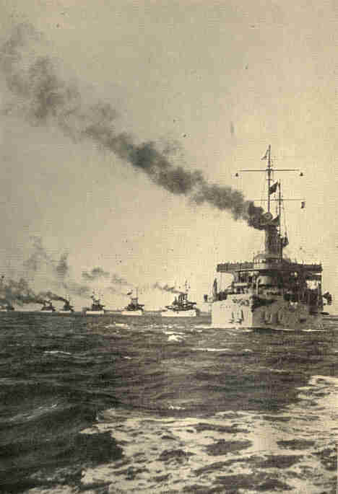
Copyright, 1907. by Underwood & Underwood.
The Atlantic fleet starting on its journey round the world, December, 1907.
230

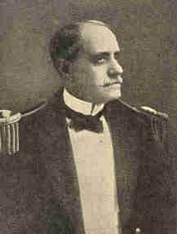
Rear-Admiral Charles S. Sperry.
1907] ROOSEVELT'S SECOND TERM 231

At Auckland Rear-Admiral Evans, who had spent forty-eight years in the navy, having reached the age limit of sixty-two years, was succeeded in command by Rear-Admiral Sperry. Unusual honors were accorded the fleet by Japan. Each American warship was escorted into the harbor of Yokohama by a Japanese vessel of the same class and many other evidences of friendship were manifest during their visit. The fleet then proceeded to China, through the Suez Canal and the Strait of Gibraltar, and at the end of one year and sixty-eight days, after covering 45,000 miles, dropped anchor in Hampton Roads. The accomplishment of this feat, without precedent in naval annals, still farther contributed to the establishment of the prestige of the United States as a great world power.

232 PROBLEMS OF THE NEW CENTURY [1907

In 1889 the government of the United States purchased from the Indians a large irregular tract of land not then occupied by them and erected it into a separate territory under the name of Oklahoma. When it was opened for settlement, April 22, 1889, a horde of settlers who had been waiting on the borders rushed in to take possession of the lands. Cities and towns sprang up as if by magic. The loose system of government exercised by the five civilized tribes became steadily more ineffective when the Indian Territory was thus brought into contact with white settlers. By 1893 affairs had become so confused that Congress decided to take steps toward the ultimate admission of the territory into the Union as a State. A committee of the Senate reported that the system of government exercised by the Indians cannot be continued, that it is not only non-American but it is radically wrong, and a change is imperatively demanded in the interest of the Indians and the whites alike, and such change cannot be much longer delayed, and that there can be no modification of the system. It cannot be reformed; it must be abandoned and a better one substituted.

1907] ROOSEVELT'S SECOND TERM 233

Gradually the five tribes--Cherokee, Choctaw, Creek, Chickasaw, and Seminole--were shorn of their governmental powers. Lands were allotted in severalty, certain coal, oil, and asphalt lands being reserved. A public school system was established and maintained by general taxation.
In his message to Congress, 1905, President Roosevelt recommended the immediate admission of Oklahoma and Indian Territory as one State and Arizona and New Mexico as another. A statehood bill embodying this recommendation was passed by the House, but was amended in the Senate so as to strike out the provision relative to the admission of New Mexico and Arizona. Opposition to the admission of the last two territories as one State came principally from the great mining companies of Arizona supported by the railroad corporations. They were in practical control of the territory with hundreds of millions of dollars in property. They were fearful of the loss of control and an increase of taxation under such a combination. Finally an act was passed by Congress, in 1906, enabling the people of Oklahoma and Indian Territory to form a constitution and State government and be admitted into the Union.
234 PROBLEMS OF THE NEW CENTURY [1907

The enabling act provided that all male persons over the age of twenty-one years who were citizens of the United States or who were members of any Indian nation or tribe in said Oklahoma and Indian Territory, and who had resided within the limits of said proposed State for at least six months next preceding the election, should be entitled to vote for delegate or serve as delegates in a constitutional convention. A number of Indians were delegates in this convention. The constitution, which was adopted by the voters, September 17, 1907, was greatly criticised on account of its radicalism. The new State, the forty-seventh, was formally proclaimed by the President in 1908. It has an area of 70,000 square miles. In 1900 the population was 800,000 which was increased to 1,500,000 by the date of admission. The wonderful climate and fertile soil together with the energy of its population have continued to attract thousands of immigrants each year.

1907] ROOSEVELT'S SECOND TERM 235

The exclusion of Japanese students from the public schools of San Francisco, 1906, seemed for a time to augur grave results. One-half of the ninety Japanese who were in attendance upon these schools were above sixteen years of age and were taught in the classes with little children. The order of the San Francisco school board excluding the Japanese was in harmony with the California law which permitted local school boards to segregate Mongolians in schools apart from those for white children. But this order nullified our treaty with Japan which provided that the subjects of that nation should be granted the same personal rights when in this country that our own citizens enjoy.
President Roosevelt acted with promptness and decision. His attitude was shown in his message to Congress, December, 1907, in which he said: "To shut them out from the public schools is a wicked absurdity . . . . Throughout Japan Americans are well treated and any failure on the part of Americans at home to treat the Japanese with a like courtesy and consideration is by just so much a confession of inferiority in our civilization . . . . I ask fair treatment for the Japanese as I would ask fair treatment for Germans or Englishmen, Frenchmen, Russians, or Italians ....
236 PROBLEMS OF THE NEW CENTURY [1907

In the matter now before me, affecting the Japanese, everything that is in my power to do will be done, and all of the forces, military and civil, of the United States which I may lawfully employ will be so employed."
But the problem was not settled, for early in the year 1909 anti-Japanese resolutions were brought before the legislatures of California, Nevada, Oregon, and two or three other Pacific States. The bills before the legislature of California provided:
1. For the segregation of Japanese and other Orientals in residential quarters at the option of municipalities.
2. That aliens should not own land in California.
3. That aliens should not become directors in California corporations.
4. For separate schools for Japanese students.

1907] ROOSEVELT'S SECOND TERM 237

On February 8, President Roosevelt sent a telegram to the Speaker of the California assembly giving the Government's views on the pending bills. "The policy agreed to by both governments," he said, "aims at mutuality of obligation and behavior. In accordance with it the purpose is that the Japanese shall come here exactly as Americans go to Japan, which is in effect that travellers, students, persons engaged in international business, men who sojourn for pleasure or study, and the like, shall have the freest access from one country to the other, and shall be sure of the best treatment, but that there shall be no settlement in mass by the people of either country in the other." While there is nothing in the Constitution or laws to prevent the President from urging a State legislature to vote for or against certain pending bills, such a course is unusual. It had become a national question, however, and the President's energy in handling the problem is worthy of praise.
According to the census of 1900, there were over 700,000 children under sixteen years of age at work in the mills, mines, factories, and sweat-shops of the United States. Nearly all of the States had child-labor laws, but they were ordinarily poorly enforced and no State was wholly free from the blight of this child slavery. While fourteen years was the minimum in most of the States, a few permitted the employment of children of ten years of age. In the majority of cases there was no legal closing hour after which children might not be employed.

238 PROBLEMS OF THE NEW CENTURY [1907

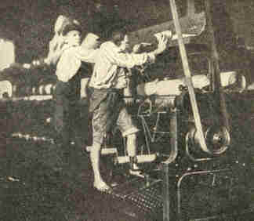
Cotton-mill operatives so small that in order to reach
their work they have to stand upon the machinery.

The subject was given national prominence through the Beveridge-Parsons Bill introduced into the Senate, December, 1907, marking an epoch in the history of federal legislation. This bill proposed to exclude from interstate commerce all products of mines and factories which employ children under the age of fourteen.
239

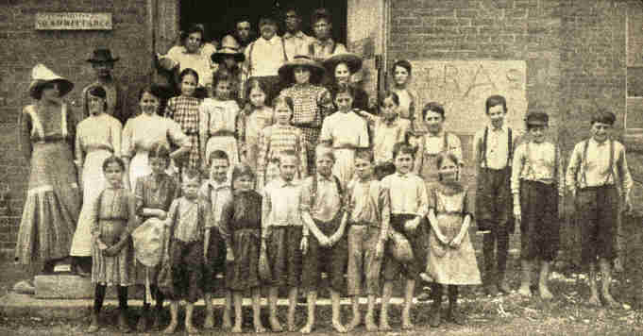
The spinning-room overseer and his flock in a Mississippi cotton-mill.
240
1907] ROOSEVELT'S SECOND TERM 241

The bill was not, however, brought up for discussion. The leading arguments of its opponents were as follows: (1) That the question was local only; (2) there was no reason to believe that federal would be better than State administration; (3) that it was limited in effect since it could not prevent children being employed in the manufacture of goods to be sold within a State. A bill passed both houses and was signed by the President, authorizing the Secretary of Commerce and Labor "to investigate and report on the industrial, social, moral, educational, and physical conditions of woman and child workers of the United States, wherever employed, with special reference to their age, hours of labor, term of employment, health, illiteracy, sanitary and other conditions surrounding their occupation, and the means employed for the protection of their health, persons, and morals." An appropriation of $150,000 was made with which to carry on this investigation. Among the demands of the National Child Labor Committee have been a shorter day's work for children between the ages of fourteen and sixteen, health certificates for factory employment in dangerous trades, and the regulation of children in street trades.
242 PROBLEMS OF THE NEW CENTURY [1908

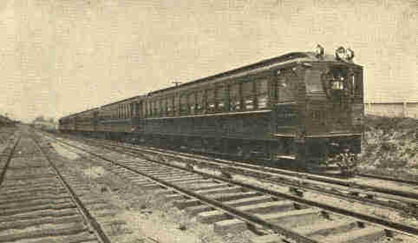
Electric train, Long Island R. R.

The period of Mr. Roosevelt's administrations was notable on account of advances made in various other directions. Electricity was applied to new and larger uses. Power was transmitted to greater distances. Niagara Falls was made to produce an electric current employed leagues away. Electric railways, radiating from cities, converted farms and sand-lots into suburban real estate quickly and easily accessible from the great centres. Telephone service was extended far into country parts, and, with the rural free delivery of mail, brought farmers into quick and inexpensive communication with the outside world, robbing the farm of what was once both its chief attraction and its greatest inconvenience--isolation.
1908] ROOSEVELT'S SECOND TERM 243

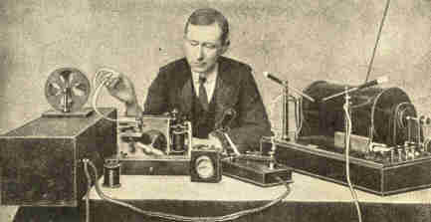
Guglielmo Marconi and his wireless telegraph.

German experiments developed an electric surface car with a speed of two miles a minute. Wireless telegraphy came into use. By means of high masts rigged, with wires diverging to the earth somewhat like the frame of a partly opened umbrella, it was found possible under favorable atmospheric conditions to telegraph hundreds of miles through the air. The most notable use of this invention was to communicate between ships and the shore or between ships at sea, a particularly desirable facility in fog, storm, or darkness, when other signals were useless.
244 PROBLEMS OF THE NEW CENTURY [1908

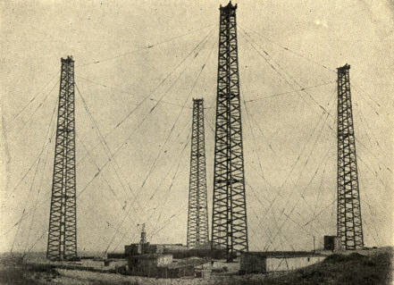
Marconi Transatlantic Station at South Wellfleet, Cape Cod, Mass.

Electricity and the gasolene engine were applied to bicycles, vehicles, and boats, often generating sufficient power to run a small factory. Bicycles somewhat passed from vogue, but automobiles became fashionable, partly for rapid transit, partly for work formerly consigned to heavy teams. Auto-carriages capable of railway speed, varying indefinitely in style and in cost, might be seen upon the smoother roads about cities all the way from Maine to California. They exerted great influence in inducing communities to macadamize roads, for which the passing of the stage-coach and the spread of railroads had diminished the demand.
1908] ROOSEVELT'S SECOND TERM 245

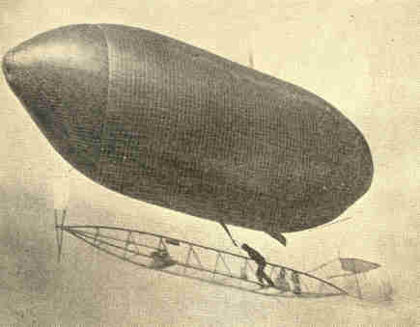
Courtesy of Scientific American.
The "Arrow" getting under way.

Effort with flying machines was incessant but only partially successful. No air-ship had thus far been devised which could undertake a definite voyage of length with any certainty of reaching its destination. The best feat yet was that of the air-ship Arrow, which, October 25, 1904, at St. Louis, made a ten-mile trip. On the other hand, the development of boats able to carry life for hours beneath the surface of the sea added a new form of attack and defence against the well-nigh impenetrable sides and enormously powerful guns of modern naval ships.
246 PROBLEMS OF THE NEW CENTURY [1908

About 1890 the use of the Australian ballot system became general, and thus the purchase of votes became more difficult. But this reform did not eliminate the evils of machine politics. State laws were extended to the control of party affairs, with severer punishments for corrupt practices, the control of lobbying, and the requirement of publicity for campaign expenses. In a few States the primary election system was put into operation. Public officers won popular approval in numerous States and cities by their activity in revealing "graft" and by their fearless enforcement of the law.
These reforms were made possible by the increase of independent voting in State and city politics. Politicians must reckon, as never before, with the demand of the average citizen for honesty in public service. The influence of corporations in governmental affairs received a check, and there came to be a growing demand for the more complete control of public utilities, and for the public ownership of them in cities.
1908] ROOSEVELT'S SECOND TERM 247

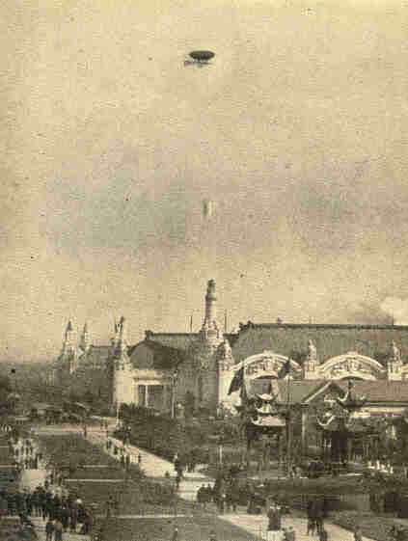
Courtesy of Scientific American
Baldwin's airship "Arrow" at a height of 600 feet over
the Exposition Palaces, St. Louis, October 25, 1904.

248 PROBLEMS OF THE NEW CENTURY [1905

The prominence of the moral element in the business and political reforms mentioned above characterizes this as an era of "awakened civic conscience." Both moral and economic considerations may be seen in the protest against the excessive use of alcoholic liquors that has resulted in the prohibition of liquor selling in a number of States and parts of States, especially in the South. Educationally, the period showed increased attention to the industrial and practical aspects of school work. Courses in manual training came to be regarded as necessary for the complete development of mind and body. Physical education received greater attention. The establishment of public libraries, aided by the munificent gifts of Andrew Carnegie, was rapid.
Millions of dollars, also, were contributed to the cause of education and research. Among the most notable of these gifts were those by Mr. Carnegie for the establishment of the Carnegie Institution and the Carnegie Foundation, and the contribution to the General Education Board by John D. Rockefeller. In 1902 the Carnegie Institution at Washington was established by a gift of $10,000,000 by Andrew Carnegie. This sum he afterward increased to $25,000,000.
249

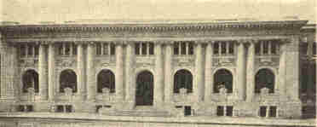
Atlanta, Ga.

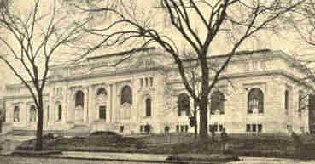
Washington, D. C.

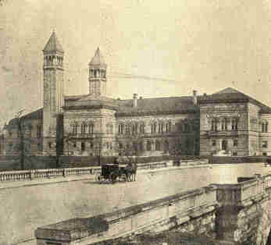
Pittsburgh, Pa.
CARNEGIE FREE PUBLIC LIBRARIES.
250
1907] ROOSEVELT'S SECOND TERM 251

The work of the institution is to carry on scientific study and research. Material is being collected for the economic history of the United States, and students of American history have been aided by the catalogues showing the location of documentary and other source material. While the head-quarters of the Institution is in Washington, important departments are located elsewhere throughout the country. There is a laboratory at Tucson, Arizona, for the study of desert plant life; a biological laboratory at Cold Spring Harbor, Long Island; a marine biological laboratory at Tortugas, off the Florida coast, and an astronomical observatory at Mount Wilson, California.
May 6, 1905, the announcement was made of a gift of $10,000,000 for the purpose of providing retiring pensions for the teachers of colleges, universities, and technical schools in the United States, Canada, and Newfoundland. In making the gift Mr. Carnegie wrote: "I hope this fund may do much for the cause of higher education and to remove a source of deep and constant anxiety to the poorest paid and yet one of the highest of all professions."
252 PROBLEMS OF THE NEW CENTURY [1907

The fund was to be applied without regard to age, sex, creed, or color. Sectarian institutions, so-called, or those which require a majority of their trustees, officers, faculty, or students to belong to a specified sect, or which impose any theological test whatever, were excluded by the terms of the gift. Universities supported by State taxation were at first excluded, but a supplementary gift by Mr. Carnegie of $5,000,000, in 1908, extended the privileges of the foundation to these universities.
In February, 1907, John D. Rockefeller increased the money at the disposal of the General Education Board by a gift of $32,000,000. This fund, which had been originally established by him, amounting to $11,000,000, had been used chiefly for the improvement of education in the South. Common schools were aided, high-schools established, and instruction in agriculture fostered. The additional sum was to be devoted to lending assistance to certain selected colleges, with the stipulation that the college was to raise three times the amount of money granted it by the Board.
CHAPTER XIV

THE PRESIDENTIAL CAMPAIGN OF 1908

In spite of the oft-repeated statement made by President Roosevelt that he would not be a candidate for nomination on the Republican national ticket in 1908, the party leaders seemed to fear a stampede in the Chicago convention. Plans had been laid carefully by the party leaders to prevent this possibility, and when William H. Taft, of Ohio, received the nomination on the first ballot, delegates and spectators gave vent to their feelings by prolonged applause. Out of a total of 980 ballots cast Mr. Taft received 702. As Secretary of War in President Roosevelt's cabinet he had been chosen by the President to succeed him, for it was believed that through training and sympathy he was best fitted to carry out the policies of the administration.
254 PROBLEMS OF THE NEW CENTURY [1908

Other candidates for nomination had appeared during the summer and each had a following of more or less strength. Senator La Follette, of Wisconsin; Governor Hughes, of New York, and Speaker Cannon, of Illinois, each received some support in the convention. Throughout the land no surprise was occasioned, however, by the nomination of Mr. Taft. Apparently the nomination of James S. Sherman, of New York, for the office of Vice-President was the result of political expediency; he was a good organization man; he had enjoyed considerable experience in public affairs and had been a member of Congress for twenty years. Moreover, the fact that he came from New York made it a wise move, politically, to give him a place on the ticket.

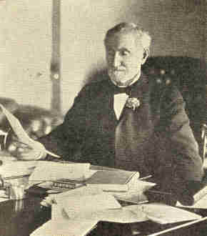
Copyright by Clinedinst, Washington.
Joseph G. Cannon.

1908] PRESIDENTIAL CAMPAIGN OF 1908 255

To outside observers the convention was a harmonious one, ready and anxious to adopt and indorse the Roosevelt policies and to accord a most hearty support to the candidate who best represented these policies. The platform which was drawn up was a strong political document which not only stated the Republican policies clearly but was also a piece of campaign literature of some note from the stand-point of literary worth.

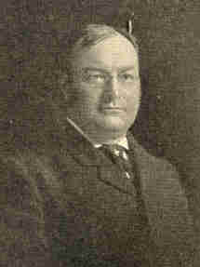
Photograph by C. M. Ball, Washington.
James S. Sherman, nominated for Vice-President.

Throughout the months preceding the assembling of the Democratic convention, in Denver, there was some uncertainty as to who would control it. Governor Folk, of Missouri, had been much in the public eye through his war on graft and on account of his successful administration of the gubernatorial office. Judge Gray, of Delaware, who had served his State in the United States Senate and had acquired an enviable reputation as a justice of the United States Circuit Court, was also a strong candidate. Judson Harmon, of Ohio, Attorney-General under President Cleveland, and Governor Johnson, of Minnesota, had numerous supporters.
256 PROBLEMS OF THE NEW CENTURY [1908

When the voting began in the convention the result was not long in doubt. William Jennings Bryan was for the third time accorded the honor of leading the Democratic party. On the first ballot Mr. Bryan received 892-1/2 votes; Judge Gray, his chief opponent, received 59-1/2. The cheers which followed the announcement of the vote showed that two defeats had not dampened the loyalty of the Western Democrats. Mr. Kern, of Indiana, was nominated by acclamation for the Vice-Presidency. The committee on the formation of the platform seemed to have some difficulty in determining the final form of some of the planks.
Both parties in their platforms favored tariff revision. The Republican party declared for the protective system and reciprocity and promised a special session of Congress to treat the whole tariff question. The Democratic party adhered to the old principle of "tariff for revenue" and pledged itself to return to that basis as soon as practicable.
1908] PRESIDENTIAL CAMPAIGN OF 1908 257

Furthermore, it pledged itself to bring about immediately such reductions as would put trust-controlled products upon the free list and to lower the duties on the necessaries of life, particularly upon those which were sold more cheaply abroad than at home. Lumber was to go on the free list. Any deficiency in the revenues which might arise from this policy was to be made up through the medium of an income tax.
Both platforms declared for reform in the currency laws, but neither one advanced any plan for revision. The Democratic platform condemned as criminal the large expenditures of the recent administration, but showed some inconsistency by favoring such policies as a large navy, generous pensions, large expenditures for the improvement of rivers and harbors which would necessitate the expenditure of great sums.
The regulation of railways and corporations was demanded by both parties. The difference between the demands lay in the means to be employed. The Democratic platform declared for State control of this question as well as that relating to the conservation of our natural resources. The Republicans took the stand that both questions should be solved by the Federal Government.
258 PROBLEMS OF THE NEW CENTURY [1908

In treating the problem of the alien races the Republican document referred to the negro race by name, demanded equal justice for all men, and condemned the devices used by some States for disfranchising the negro. Nothing was said concerning Chinese and Japanese immigration. The Democratic platform was silent on the negro question and declared against the admission of Orientals into our country.
Arbitration was favored by the Republicans, but was not mentioned in the opposition platform. On the Philippine question there was a division. The Republicans favored a gradual development of home-rule; the Democrats for early independence under an American protectorate.
Three things in the Democratic platform are worthy of note: (I) The demand for a federal law compelling publicity of campaign contributions; (2) the election of senators by direct vote, and (3) the adoption of such parliamentary rules as would make the House of Representatives a deliberative body.
1908] PRESIDENTIAL CAMPAIGN OF 1908 259

The Socialist convention, which assembled in Chicago, nominated Eugene V. Debs for President and Ben Hanford for Vice-President.
Two tendencies of political thought were displayed in the Socialist platform as framed by the committee. First, a tendency away from individual ownership of productive property and the individual administration of industry, and toward the collective ownership of productive property and the collective administration of industry. This was illustrated by the demands made for the collective ownership of all railways, steamship lines, and other means of transportation, as well as telephones, telegraphs, etc. It was further evidenced by the demand that the public domain be made to include mines, quarries, oil wells, water-power, reclaimed and reforested lands. The second tendency was away from a form of government of checks and balances toward one by the unrestrained majority. This was shown by the demands for the abolition of (I) the Senate, (2) the veto power of the President, (3) the power of the Supreme Court to pass on the constitutionality of legislation.
260 PROBLEMS OF THE NEW CENTURY [1908

Industrial demands were made. There should be a more effective inspection of workshops and factories; there should be no employment of children under sixteen years of age; interstate transportation of the products of child labor or convict labor should be forbidden; compulsory insurance against unemployment, illness, accidents, old age, and death should be adopted.
Among the political reforms demanded were inheritance and income taxes, equal suffrage for men and women, the initiative and referendum, proportional representation, and the right of recall. The Federal Constitution was to be amended by majority vote. Judges were to be elected for short terms.
The nominees of the Prohibition party were Eugene W. Chapin, of Illinois, for President, and Aaron S. Watkins, of Ohio, for Vice-President. In the platform framed there were the usual declarations against the liquor traffic, but there were also planks demanding reforms.
1908] PRESIDENTIAL CAMPAIGN OF 1908 261

The election of senators by direct vote; the passage of inheritance and income taxes; the establishment of postal savings banks; the guaranty of bank deposits; the creation of a permanent tariff commission; the conservation of natural resources; an equitable and constitutional employers' liability act, and legislation basing suffrage only upon intelligence and ability to read and write the English language, were the chief planks. Beyond any doubt this platform--the shortest of all--shows that the men who constructed it were not dreamers. It is possible that the delegates may have been looked upon as visionaries, for there were few among them who could be called "practical politicians," but, as one writer of note has said, the delegates were "typical of that class of society on which the nation ever depends in a great crisis, the sort from which all moral movements spring . . . . "
It has often been said that the excitement of presidential campaigns is detrimental to the nation. This could hardly be said of the campaign of 1908. To produce political excitement there must be debatable questions termed, by the politicians as "issues." Just what the issues were in the campaign few people could determine. There were no issues which involved foreign affairs. The Democratic party did not criticise the sending of the fleet around the world, the administration's policy in Cuba, the policy concerning the Panama Canal, nor even the policy pursued in the Philippines.
262 PROBLEMS OF THE NEW CENTURY [1908

As regards military and naval matters, pensions to veterans, the development of internal waterways, the conservation of resources, etc., there were no issues simply because the people had practically the same views about them. Consequently issues had to be made, and, generally speaking, the Republican leaders appealed to the people along the lines of the personal fitness of the candidates.
It was pointed out that President Roosevelt had indicated his Secretary of War as the best man to carry out the policy inaugurated by the administration of subduing and controlling influential law-breakers. The chief officer of the government has vested in himself powers of wide range--the appointment of the judiciary, the superintendence of the administration of the business affairs of the nation, the guidance of our international affairs. Therefore the President must be a keen judge of men capable of distinguishing the honest, efficient servant of the nation from the self-seeking politician; he must resist political pressure; he must be national in his patriotism and breadth of vision; he must know our foreign relations intimately, that the continuity of policies may not be broken and the efficiency of our foreign service weakened thereby. He must have the capacity to work long hours, with skill, care, and rapidity. In short, the chief executive must be a man who is fit mentally and physically.
1908] PRESIDENTIAL CAMPAIGN OF 1908 263

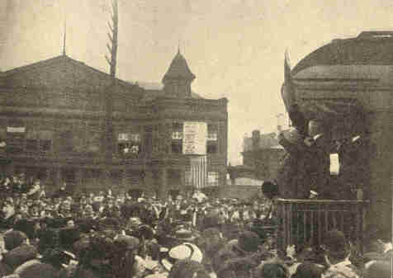
William H. Taft on his trip, stumping for the nomination.

264 PROBLEMS OF THE NEW CENTURY [1908

Some of these essential qualities the candidates of the two great parties possessed in a high degree. They were honest and sincere; they were familiar with the desires and needs of the various sections of the nation; they were national in the breadth of their policies. But they were different in temperament, equipment, and experience, and upon this difference the Republican leaders made their appeal to the voters.
The Democratic nominee was essentially an orator--he swayed the masses by his denunciation of the perils which threatened the nation through the concentration of wealth which had gone on under the Republican rule. His opponents admitted that a man of his stamp was invaluable to the American people, but they contended that his place was in the editor's chair, in the pulpit, or upon the lecture platform, not as the chief executive of the nation. Furthermore, it was said that this great orator had views on political, social, and economic questions which bordered on the visionary, and that any man who had openly supported free silver, anti-imperialism, or even the guaranty of bank deposits, could not be safely trusted with the guidance of the nation's destinies.
1908] PRESIDENTIAL CAMPAIGN OF 1908 265

The Republican candidate had none of the qualifications of an orator; he was rather a teacher. He did not cater to the desires of his audience; he struck at the abuses most prevalent in the section where he spoke. It was his business to point out weaknesses; to find remedies for them; to educate, not sway, his audiences. His mind was constructive; his training had been along the lines of constructive political thought; he had proven his ability by his organization of a civil government for the Philippines and by his solution of the vexed question of Cuba. So it was argued that the best test of his ability and guaranty of efficiency was the work he had already done.
The campaign was lacking in life and enthusiasm simply because there were no clearly defined issues. The candidates went through the usual performances of "swinging around the political circuit." Mr. Taft was accorded a warm welcome on his trip, for the people wished to get acquainted with President Roosevelt's choice as much as to hear him discuss the Republican policies. Mr. Bryan, who conducted a great speaking campaign, confined his attention to advocating the bank guaranty plan and to attacking the evils of private monopoly. Political enthusiasm was at a low ebb. Few people took matters seriously and the campaign was aptly characterized as the "Era of No Feeling."
266 PROBLEMS OF THE NEW CENTURY [1908

The vote cast for presidential electors was primarily an expression of popular confidence in the Roosevelt administration. For nearly half a century the situation in the nation had been becoming more and more a source of anxiety to the thinking men of the land. Our economic development had taken place so rapidly that the great aggregations of capital and the great corporations had gotten beyond control and had shown dangerous tendencies toward lawlessness and political corruption. The feeling that the great corporations were not only beyond the control of law but even controlled the government in the interests of a few, led to a belief that the government was passing out of the hands of the people, and that the function of our republican government was being arrested. The radical and the agitator were getting the ear of the nation, for the faith of the nation was shaken.

267

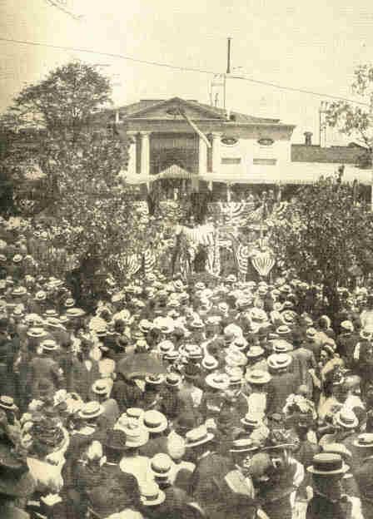
Copyright, 1908, by Young & Carl, Cincinnati, Ohio.
Mr. Taft formally accepting the Republican nomination for the Presidency, on the veranda of the residence of his brother, Mr. Charles P. Taft, of Cincinnati, Ohio.
268
1908] PRESIDENTIAL CAMPAIGN OF 1908 269

Then came President Roosevelt to take up a task of greatest difficulty, and for nearly eight years, amidst the applause of the plain people, he administered the affairs of the nation firmly, honestly, and with efficiency. The Republican convention in Chicago by its nomination of Mr. Taft had put the stamp of its approval upon the Roosevelt administration, and turned to appeal to the voters.
In round numbers Taft received 7,680,000 votes and Bryan 6,410,000. The electoral vote stood 321 for the Republican candidate and 162 for the Democratic candidate. Thirty States elected Republican presidential electors; eighteen elected Democratic electors. With the exception of Nebraska, Nevada, and Colorado, which together contributed sixteen electoral votes, all the States carried by the Democratic nominee were Southern States. The nation had approved the Roosevelt policy, but the great popular vote for Mr. Bryan showed clearly the loyalty of millions of voters. These men believed that their leader stood for the plain people--for the unprivileged. There were many who had feared Mr. Bryan's policies in 1896, who voted for him in 1908 because they believed that twelve years of public life and the study of national problems had changed and bettered his ideals.
270 PROBLEMS OF THE NEW CENTURY [1908

Some Republican writers professed to believe that the popular vote indicated that a majority of people adhered to the policy of protection. To others it appeared that the voters were willing to accept the protective policy with a promise for honest tariff revision in order to obtain a continuation of the Roosevelt policies.
The popular vote is interesting mainly for what it showed concerning the changed strength of the small parties, During the period 1904 to 1908 the drift had evidently been away from them. The Socialist vote was nearly as large in 1908 as in 1904, which was a consolation to Socialists, for they had held the ground gained by the heavy vote in 1904. The Prohibition vote fell off about ten per cent from that polled in 1904 and the Independence party polled only 82,000 votes,
In the House of Representatives the Sixty-first Congress had 219 Republicans and 172 Democrats; the Senate 60 Republicans and 32 Democrats,
CHAPTER XV

THE ADMINISTRATION OF PRESIDENT TAFT

On March 4, 1909, the date of the inaugural ceremonies, Washington was visited by a heavy snow-storm, and Mr. Taft, departing from the custom of delivering his inaugural address at the east end of the Capitol, spoke in the Senate chamber. Many trains bearing visitors to Washington, from various parts of' the country, were blockaded, This condition served to emphasize the call, many times made, for the transfer of the date of these services to April 30, the day on which President Washington took the oath of office.
President Taft's inaugural address was wise and temperate and satisfactory to the country at large. He asserted that the most important feature of his administration would be the maintenance and enforcement of the reforms inaugurated by President Roosevelt. He justified appropriations, as his predecessor had done, for maintaining a suitable army and navy; advocated the conservation of our natural resources, the establishment of postal savings banks, and direct lines of steamers between North and South America.

272 PROBLEMS OF THE NEW CENTURY [1909

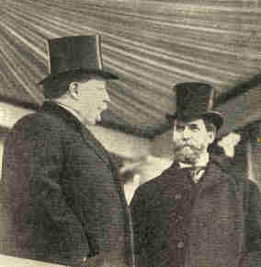
Copyright by Clinedinst, Washington.
President William H. Taft and Governor Hughes
on the reviewing stand at the inauguration, March 4,1909.

The cabinet was made up of men largely gathered from private life, a majority of them being comparatively unknown to the public. Philander C. Knox was United States senator from Pennsylvania when he was appointed Secretary of State. He had served as Attorney-General in President McKinley's cabinet. Franklin MacVeagh, of Illinois, who was made Secretary of the Treasury, had been prominent as a merchant in Chicago and active in public affairs. Mr. MacVeagh and Jacob M. Dickinson, who became Secretary of War, were both members of the Democratic party.
273

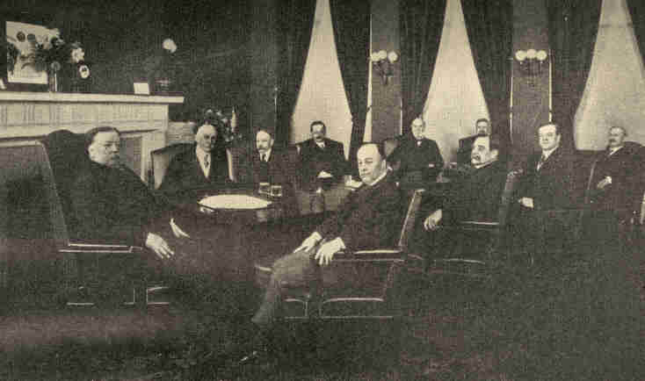
Copyright, 1909, by Brown Bros., N. Y.
Reading from left to right: President Taft, Frankin MacVeagh, Sec'y of the Treasury. George W. Wickersham, Attorney-General. George von L. Meyer, Sec'y of the Navy, Philander C. Knox, Sec'y of State, James Wilson, Sec'y of Agriculture. Charles Nagel, Sec'y of Commerce and Labor( above). Jacob M. Dickinson, Sec'y of War (below). Frank H. Hitchcock, postmaster-General. Richard A. Ballinger, Sec'y of the Interior.
President Taft and Cabinet, 1909.
274
1909] TAFT'S ADMINISTRATION 275

By inviting Democrats to become members of his political family, President Taft desired to give recognition to the fact that he had been elected by Democratic votes and had received substantial support in parts of the South. Mr. Dickinson was also from Chicago. The Secretary of the Navy, George von L. Meyer, of Massachusetts, had served as ambassador to Russia, and later as Postmaster-General during Mr. Roosevelt's administration. Frank H. Hitchcock, of Ohio, who was made Postmaster-General, had served as First Assistant Postmaster-General. George W. Wickersham, an attorney of good standing in New York City, was appointed Attorney-General. Richard A. Ballinger, of Seattle, who had been Commissioner of the General Land Office, 1907-1909, was appointed Secretary of the Interior. James Wilson, of Iowa, who had served as Secretary of Agriculture since 1897, was continued in that office. Charles Nagel, a noted lawyer of St. Louis, was made Secretary of Commerce and Labor.
With the beginning of the new administration the President's salary was increased to $75,000 a year; that of the Vice-President to $12,000; and members of the cabinet to $12,000.
276 PROBLEMS OF THE NEW CENTURY [1909

From June 1 to October 15 there was held at Seattle the Alaska-Yukon-Pacific Exposition. The rapid growth of Seattle has been due in no small degree to the fostering of trade with Alaska. The exhibits served to demonstrate the wisdom of the purchase of the territory, which at that time was characterized as Seward's "folly." Alaska has for some years been recognized as a country of wealth and opportunity. The gold output each year is more than three times the sum paid Russia for the territory. About one-fifth of the gold produced in the United States comes from Alaskan mines. Products amounting to $33,500,000 were shipped to the States from Alaska during the year 1907, and the return trade for that year amounted to $19,500,000. The value of the fishery products is five-sevenths as great as the output of the gold mines. Alaskan coal-fields are estimated to be even richer than her gold deposits. Other productions of the territory are silver, tin, lead, quicksilver, graphite, marble, lumber, grains, vegetables, and fruits.
1909] TAFT'S ADMINISTRATION 277

The purpose of the exposition was declared to be "to exploit the resources and potentialities of the Alaskan and Yukon territories; to make known and foster the vast importance of the trade of the Pacific Ocean and of the countries bordering thereon, and to demonstrate the marvellous progress of Western America." The energy and determination of the men of the new Northwest was well shown in the preparation made for the exposition. No financial assistance was asked from the federal government.

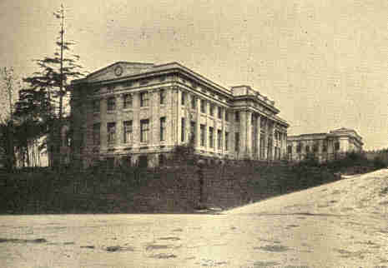
The Alaska-Yukon-Pacific Exposition, Seattle.
The Palace of Fine Arts.

278 PROBLEMS OF THE NEW CENTURY [1909

The necessary $10,000,000 were contributed almost entirely in Seattle and the State of Washington. One million dollars were expended by Seattle, as a preparatory step, on her municipal improvements.
The site of the exposition was the campus of the State University, between Lakes Washington and Union. From the grounds, notable for their natural beauty, were visible in the distance Mount Rainier, the loftiest peak in the United States, the snow-covered Olympics to the west, and the Cascade range to the east.
Three permanent buildings were erected by the State of Washington with the understanding that they were afterward to be used by the university. Most of the structures followed the French Renaissance design. In the forestry building, which was 320 feet long and 140 feet broad, and built of logs in the rough, there were displayed the timber resources of Alaska and the Northwest. An out-door farm illustrated the agricultural resources of the region. The Japanese exhibit was second only in interest to that of Alaska. The exposition served to demonstrate, as it was intended to do, the possibilities for the investment of capital in the Northwest and the opportunities for those seeking new homes.
1909] TAFT'S ADMINISTRATION 279

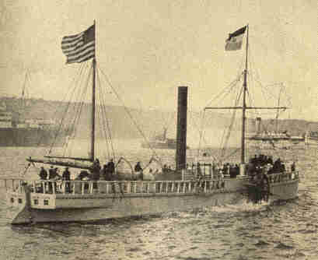
The Hudson-Fulton Celebration.
The Clermont proceeding up the
Hudson River under her own steam.

Beginning with September 25 and continuing throughout the first week of October, there was a notable celebration in New York City, and in other cities on the Hudson, commemorative of the discovery of that river by Henry Hudson three centuries before and the trip up the river by Robert Fulton's steamboat in 1807.
280 PROBLEMS OF THE NEW CENTURY [1909

The leading feature of the pageant was the assembling in the harbor of the largest fleet of international character ever brought together at one time, and the cruise up the Hudson as far as Newburg of eighty war vessels selected from the navies of the United States, Great Britain, Germany, France, and other powers. These huge vessels were in striking contrast to the two small ones which were given the place of honor in the pageant, the replicas of the Half Moon and the Clermont. The land parades were likewise spectacular in their effects.
In October, 1909, Commander Robert E. Peary and Dr. Frederick A. Cook, two American travellers, returned to the United States, both making claims to having discovered the north pole. The accomplishment of this task, which had baffled so many arctic explorers, was hailed as a triumph throughout the civilized world. Ardent supporters of each of these men began to champion the right of their favorite to the great honor. It was shown that Commander Peary had for twenty-three years been engaged in arctic exploration. His first voyage was made to Greenland in 1886, and in his numerous expeditions to the frozen north since that time he had secured much scientific data relating to the glaciology, geology, and ethnology of those regions.
1909] TAFT'S ADMINISTRATION 281

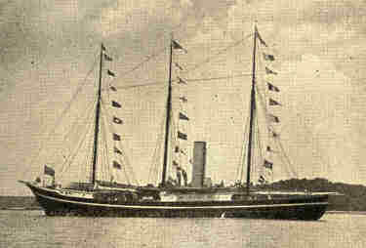
Commander Peary's ship, The Roosevelt.

When Commander Peary left the Roosevelt, the ship which bore him as far north as navigation permitted, on February 22, 1909, his expedition consisted of 8 white men, 59 Eskimos, 140 dogs, and 23 sledges, with the necessary equipment for arctic travel. Upon returning to the United States after overcoming the many dangers incident to such exploration, he submitted his records to the National Geographical Society. A committee of that body, after passing upon these documents, declared unanimously that it was their opinion that Peary had reached the north pole, April 6, 1909. This report further commended him for his organization and management of this expedition and for his contributions to scientific knowledge.
282 PROBLEMS OF THE NEW CENTURY [1909

Before his return to America, Dr. Cook had been hailed as the discoverer of the north pole by European scientists, especially those of Denmark, who accepted his story of the accomplishment of this task in April, 1908, one year earlier than the date of Peary's discovery. Many honors were conferred upon him when he reached Copenhagen, September 4, 1909. He was met by the Crown Prince of Denmark and the American minister, and by explorers, professors, and scientists from various European countries. He was greatly honored also upon his return to New York City.
Commander Peary declared that the claims made by Dr. Cook were without foundation. His decision was based on the evidence given by two Eskimos who had accompanied Dr. Cook, and who asserted that the party went only a two days' journey north from Cape Hubbard and were never beyond the land ice. Further evidence of deception by Dr. Cook was set forth by Edward M. Barrill, who had accompanied him on his ascent of Mount McKinley in 1906.
1909] TAFT'S ADMINISTRATION 283

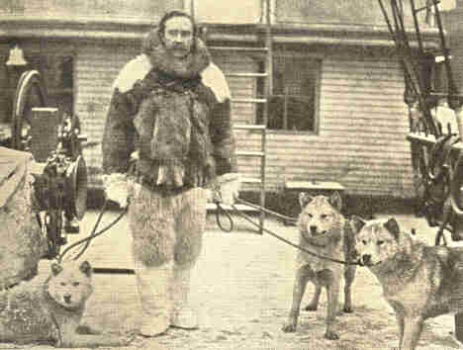
Commander Robert E. Peary, and three
of his Eskimo dogs, on The Roosevelt.

This guide declared that Dr. Cook had not reached the summit of that mountain as claimed, but that the records had been falsified. Later, a commission was appointed by the University of Copenhagen to examine the notes and memoranda submitted to them by Dr. Cook. After a careful examination of these documents, the commission reported that they found no evidence sufficient to warrant the belief that Dr. Cook actually reached the north pole.

284 PROBLEMS OF THE NEW CENTURY [1909

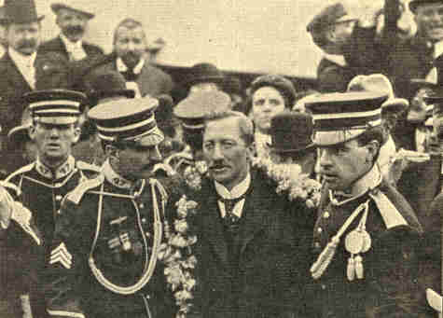
Photograph by Brown Bros., N.Y.
Dr. F. A. Cook on his arrival in
New York, September 21, 1909.

By vote of Congress, June 20, 1910, the territories of Arizona and New Mexico were granted permission to form State constitutions. The constitutions which were framed in their conventions and passed by majorities of the people contained some unusual provisions. The Arizona constitution included the initiative, referendum, and recall of all elective officers, including judges. The New Mexico constitution contains a referendum clause, but the clause providing for initiative was rejected.
1909] TAFT'S ADMINISTRATION 285

The constitution of Arizona was attacked in Congress and opposed by President Taft on account of the provision for the recall of judges. The chief objection to the constitution of New Mexico was the unsatisfactory method provided for its amendment. This constitution, however, was approved by President Taft and by the House of Representatives, but the Senate failed to take any action.

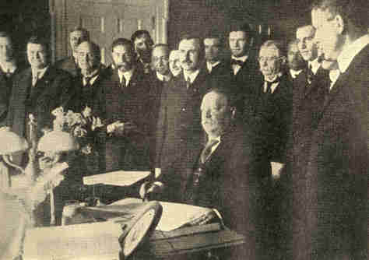
Copyright by Clinedinst, Washington.
President Taft signing the proclamation making
Arizona the forty-eighth State of the Union,
at the White House, February 14, 1912.
286 PROBLEMS OF THE NEW CENTURY [1909

In August, 1911, the President vetoed a joint resolution to admit the territories of New Mexico and Arizona as States into the Union. He stated his attitude as follows: "The resolution admits both territories to statehood with their constitutions on condition that at the time of the election of State officers New Mexico shall submit to its electors an amendment to its new constitution altering and modifying its provisions for future amendments, and on the further condition that Arizona shall submit to its electors at the time of the election of its State officers a proposed amendment to its constitution by which judicial officers shall be excepted from the section permitting a recall of all elective officers. If I sign this joint resolution, I do not see how I can escape responsibility for the judicial recall of the Arizona constitution. The joint resolution admits Arizona with the judicial recall, but requires the submission of the question of its wisdom to the voters. In other words, the resolution approves the admission of Arizona with the judicial recall, unless the voters themselves repudiate it. . . . This provision of the Arizona constitution in its application to county and State judges seems to me pernicious in its effect, so destructive of independence in the judiciary, so likely to subject the rights of the individual to the possible tyranny of a popular majority, and therefore to be so injurious to the cause of free government that I must disapprove a constitution containing it."
1909] TAFT'S ADMINISTRATION 287

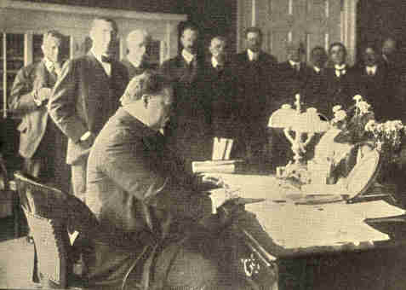
Photograph, Copyright, by Clinedinst. Washington.
President Taft signing the proclamation making New Mexico a State,
January 6, 1912.

January 6, 1912, New Mexico, having complied with all conditions, was formally admitted into the Union as the forty-seventh State.
288 PROBLEMS OF THE NEW CENTURY [1909

Arizona, having an area of 113,000 square miles, was organized as a territory in 1863 and appeared in the federal census reports for the first time in 1870 with a population of 9,658. From 1870 to 1890 its growth in population was rapid, increasing a little more than four times during the decade 1870-1880 and doubling during the succeeding ten years. The population in 1900 was 122,931 and in 1910 it was 204,354. During the last decade, therefore, the increase in population has been 66.2 per cent, while the percentage of increase in the United States as a whole has been only 21 per cent. According to the thirteenth census, Arizona contained eight cities with an aggregate population of 58,414. The largest cities were Tucson, with a population of 13,193, and Phoenix with 11,134.
Arizona produces more copper than any other State in the Union. Of the total copper ore mined in the United States (1909) 27.7 per cent was from Arizona. There are also good mines of gold and silver. Coal-mining, marble-quarrying, lumbering, raising cattle, sheep, and ostriches are also important industries in Arizona. Through the efforts of the Reclamation service in completing the Roosevelt Dam and a dam at Parker, and by the use of pumps, it is estimated that 1,000,000 acres of fertile land will become available for cultivation. Other large areas are also susceptible of irrigation.
1909] TAFT'S ADMINISTRATION 289

In 1850 the territory of New Mexico was organized and in 1863 it was reduced to its present limits with an area of 122,000 square miles. The population of New Mexico in 1900 was 195,310 and in 1910 was 327,301 an increase of 67.6 per cent. Albuquerque, with a population of 11,020, and Rosewell with 6,172 were the two largest cities. Like Arizona, New Mexico possesses great wealth in mines and forests, but the foundation for her future industrial progress lies in her farms. In 1910 New Mexico possessed 500,000 acres of irrigated land. It was estimated that 3,000,000 acres more were amenable to artificial watering and the government is expending millions of dollars on projects which will fertilize vast areas of this land.

290 PROBLEMS OF THE NEW CENTURY [1909

During the year 1911 the world was astounded at the unparalleled exhibitions of the possibilities of the aeroplane. The dream of centuries had been realized, and American genius was responsible for the achievement. In 1896, a model machine which had been constructed under the direction of Professor Langley, secretary of the Smithsonian Institution, driven by a one horse-power steam-engine, made three flights of a mile each near Washington. Congress appropriated $50,000 for the construction of a complete machine, but after two unsuccessful attempts to fly, with an operator, the project was abandoned.
Wilbur Wright and his brother Orville, bicycle manufacturers of Dayton, Ohio, did not share in the general ridicule which followed this failure, and after three years of experimentation demonstrated that the principles upon which Professor Langley had constructed his machine were, in the main, sound. The first successful flight of a few seconds by one of their machines weighing 750 pounds was made in 1903. Two years afterward a flight of 24 miles was made at the rate of 38 miles an hour. Other successful experiments followed, and the claim of the Wrights to be considered the inventors of the first successful man-carrying flying machine was established. French inventors at about the same time were carrying on successful experiments with machines similarly constructed.
291

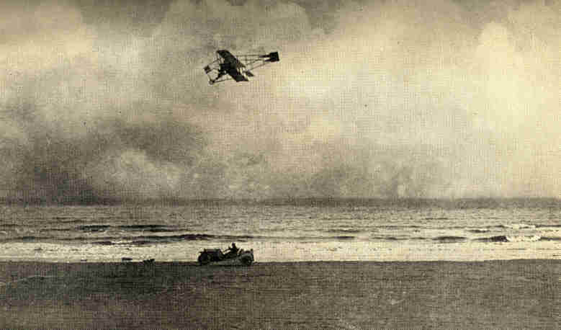
From a photograph by H. H. Morris.
Charles K. Hamilton racing an automobile on the beach at Galveston, Texas.
292

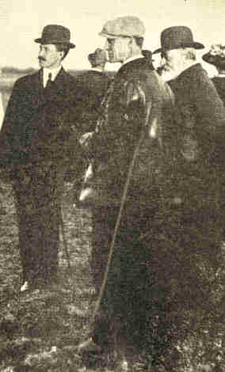
Photograph by Brown Bros., N.Y.
Wilbur and Orville Wright, and the late King Edward of England.
1909] TAFT'S ADMINISTRATION 293

September 16, 1908, Wilbur Wright, at Le Mans, France, demonstrated that his machine could remain in the air for over an hour and at the same time fly across country at a high speed. In that year, also, Orville Wright, in a government test at Fort Myer, Virginia, not only made flights lasting over an hour, but carried a companion with him. During July, 1909, a French aviator, Bleriot, flew across the English Channel, a distance of 32 miles. That year, also, Orville Wright ascended to the height of 1,600 feet; with a passenger, made a record flight of 1 hour, 12 minutes and 36 seconds; and flew across country with a companion for 10 miles at the rate of 42 miles an hour. Thus it was shown that a machine had at last been constructed which would not only fly, but would remain in the air at the will of its pilot and subject to his guidance.

294 PROBLEMS OF THE NEW CENTURY [1909

In the aviation meet at Los Angeles, January 10, 1910, Louis Paulhan, a Frenchman, established the record of 4,000 feet for height and Glenn H. Curtiss with a passenger set a new world's record of 55 miles.
Shortly afterward Curtiss demonstrated for the first time that it was possible for an aeroplane, especially constructed, to rise from the surface of water, make a flight in the air, return to the starting-point, and again alight on the water.
The great possibilities as well as the dangers connected with aviation were brought out in the meet at Chicago during August, 1911, where two aviators lost their lives. C. P. Rodgers, in a Wright machine, remained in the air twenty-six and one-half hours out of the possible thirty-one and one-half hours. Lincoln Beachey set a new world's record by ascending 11,642 feet. This record was again surpassed within a month by Ronald G. Garros, a French aviator, who ascended 13,943 feet.
1911] TAFT'S ADMINISTRATION 295

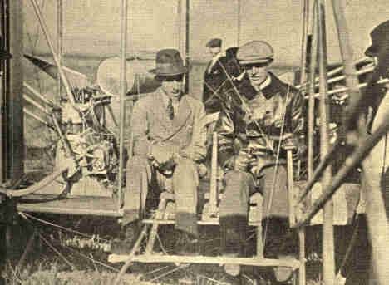
Wilbur Wright in his aeroplane at Pau, France, with King Alfonso of Spain.

Harry K. Atwood flew from St. Louis to Chicago in one day, a distance of 315 miles. He continued his flight to New York, and in eleven days reached that city. He had travelled 1,265 miles in the actual flying time of 28 hours. C. P. Rodgers eclipsed all records for long-distance aeroplane flying by crossing the continent from Sheepshead Bay, New York, to Pasadena, Cal., a distance of 4,231 miles. He accomplished this feat in the total time of 49 days, September 17 to November 5, 1911. His actual flying time was 82 hours.
296 PROBLEMS OF THE NEW CENTURY [1911

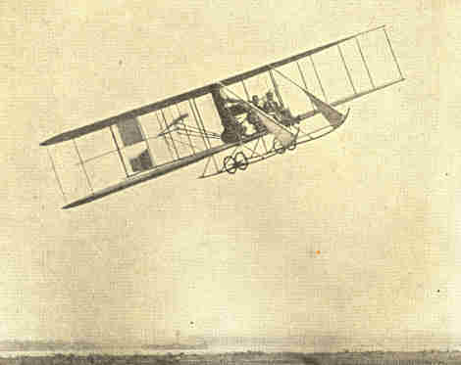
Harry K. Atwood with Lieut. Fickle flying over Governor's Island, N. Y.,
after completing his flight from St. Louis to New York.

These flights served to demonstrate that the permanent triumphs of aeronautics are to be won by steadiness and efficiency and not by recklessness.
1911] TAFT'S ADMINISTRATION 297

Among the significant legislation of the Sixty-second Congress, the passing of the "publicity law," August, 1911, is deserving of especial commendation. The Democratic platform, 1908, demanded publicity of campaign contributions, and Mr. Bryan announced that no funds would be received from corporations. According to a New York statute, all campaign receipts and expenditures must be filed. The Republican campaign committee agreed to apply this law in the presidential contest.
According to the federal Publicity law no candidate for member of the House of Representatives may spend more than $5,000 in his campaign for nomination or election, and no candidate for United States senator may spend, legally, more than $10,000 in his campaign, Candidates are prohibited from making promises of office or other promises in order to obtain votes, and no candidate for senator may aid in the election of members of the legislature that is to fill a senatorial vacancy. At the time, two United States senators were under indictment for the purchase of their seats, and one of them acknowledged that he had expended nearly $100,000 in his primary campaign.
298 PROBLEMS OF THE NEW CENTURY [1911

In partial fulfilment of the declaration that his policy was to bring about legislation for the benefit of the whole country, President Taft in his message to Congress, December, 1911, asked that the appointment of local federal officers throughout the country should be placed under the classified service. "I wish," he wrote, "to renew again my recommendation that all the local officers throughout the country, including collectors of internal revenue, collectors of customs, postmasters of all four classes, immigration commissioners, and marshals should be by law carried into the classified service, the necessity for confirmation by the Senate be removed, and the President and the others, whose time is now taken up in distributing this patronage, under the custom that has prevailed since the beginning of the Government in accordance with the recommendation of the senators and congressmen of the majority party, should be relieved from this burden. I am confident that such a change would greatly reduce the cost of administering the government and that it would add greatly to its efficiency. It would take away the power to use the patronage of the government for political purposes."

1911] TAFT'S ADMINISTRATION 299

President Taft took an advance position also in his advocacy of the substitution of the appeal to reason for the appeal to force in the settlement of all international difficulties. The treaties of arbitration which were agreed upon during the summer of 1911 between Secretary Knox and the representatives of Great Britain and France illustrate the general type of treaty which the President hoped would be negotiated with other nations. Heretofore, the treaties to which the United States has been a party have accepted as suitable for arbitration all questions save those which concerned "vital interests and national honor." It was a great step forward, therefore, when the agreement was reached between the powers that all disputes that are justiciable and cannot be settled by diplomacy are to be submitted to arbitration.

300 PROBLEMS OF THE NEW CENTURY [1911

In case of a difference on whether the dispute were justiciable or not, it was to be submitted to a commission of inquiry for decision. If the commission found it was justiciable the question in dispute must be submitted to arbitration. Should the commission find it was not justiciable there would still exist the possibility of war. But either nation has the power to delay the findings a year during which time diplomatic action may be resumed. The arguments against the ratification of these facts in the Senate were based on the plea that they provided for compulsory arbitration and thus tended to deprive the Senate of its constitutional prerogative. The wording was so greatly modified in the Senate that the form of treaty which was finally ratified differed but little from the arbitration treaties of 1908.
CHAPTER XVI

THE THIRTEENTH CENSUS, 1910

After many years of urging on the part of statisticians and public men, Congress, in 1902, passed a bill which was signed by the President providing for a permanent census bureau connected with the Department of Commerce and Labor. This bureau, as shown in the taking of the thirteenth census, serves to promote both efficiency and economy in the collection of statistics associated with the census work. Heretofore the Director of the Census had enormous patronage at his disposal which he farmed out among congressmen and other political leaders.
E. Dana Durand, a trained statistician of wide experience, was appointed Director of the Census. He announced that so far as possible the 65,000 enumerators would be selected under civil service rules and for supervisors of the census he selected men on the basis of their special fitness for the work. President Taft was in complete agreement with this programme and insisted that local enumerators were to be appointed for the purpose of getting the work properly done and not to assist any would-be dispensers of local patronage.
302 PROBLEMS OF THE NEW CENTURY [1911

On April 15 the enumerators began their work of gathering statistics. The usual inquiries were made on population, mortality, agriculture, manufactures, etc. Prior to April 15, an advance schedule was sent to practically every farmer in the country, and he was asked to fill it out before the coming of the enumerator. Similarly, in the cities, the enumerators distributed advance population schedules which the head of the family was requested to fill out before the official visit of the enumerator. In taking the thirteenth census, greater attention was given than ever before to perfecting the schedules and weighing each question with regard to its precise significance and scientific value. To that end a group of trained investigators, familiar with the various topics which the census would cover, spent several months on a preliminary study of the character of these questions. In addition to the nationality of each person as determined by the mother tongue of the foreign-born inhabitants, additional inquiries were made relative to the industry in which each person was employed and whether the person was out of work on April 15.
1911] THE THIRTEENTH CENSUS, 1910 303

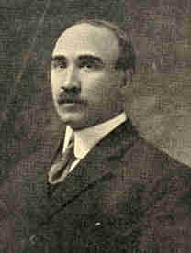
Copyright by Clinedinst. Washington.
E. Dana Durand, Director of the Census.

Population schedules in the cities and large towns were required to be completed within two weeks and in the rural districts within thirty days. The enormous labor of tabulating and classifying these answers was then begun by the 3,500 clerks in the Census Office at Washington. Much of this labor was performed by machines each capable of making 25,000 tabulations a day. Results of the first tabulation of the population in the cities were made known about June 1 and the count of the principal cities was completed by April 15. During September the population of the entire country was made known. Within two years the leading facts in the census were compiled and published as special bulletins. The entire cost of the census was about $13,000,000.
304 PROBLEMS OF THE NEW CENTURY [1911

The total population of the United States, including our territorial possessions and dependencies, was found to be about 101,000,000, thus for the first time passing the hundred million mark. The population of the United States proper was 91,972,266; of Alaska, 64,356; Porto Rico, 1,118,012; Hawaii. 191,909; Guam and Samoa, 15,100; the Philippine Islands about 7,700,000. These numbers indicate an increase in the population of continental United States of 21 per cent in the decade, or a slightly larger growth than the 20.7 per cent made during the preceding ten years.
One of the striking facts brought out in the census is the absolute decline in the percentage of population compared with the previous decade in a number of the States of the East, South, and Middle West, and an increase of this percentage in the other States, especially among those of the Rocky Mountains and the Pacific Coast.
1911] THE THIRTEENTH CENSUS, 1910 305

The percentage of total increase of population in Alabama was 16.9 and the increase, according to the twelfth census, was 20.8; in Illinois, 16.9 as against 26 for the preceding census; Indiana, 7.3 against 14.8; Kentucky, 6.6 against 15.5; Massachusetts, 20 against 25.3; Minnesota, 18.5 against 33.7; Texas, 27.8 against 36.4; Montana, 54.5 against 70. Iowa showed an actual loss of three-tenths per cent of her inhabitants, while according to the preceding census there was a gain of 16.7 per cent in that State. In the following States the gains in percentages were as follows: North Dakota, 80.8 against 67.1 for 1900; South Dakota, 45.4 and 15.2; Kansas, 15 and 3; Nebraska, 11.8 and 0.3; Colorado, 48 and 30.6; Oklahoma, 109.7; Utah, 34.9 and 31.3; Nevada, 93.4 and 10.6; Idaho, 101.3 and 82.7; Washington, 120.4 and 45; Oregon, 62.7 and 30.2, and California, 60.1 and 22.4.
In numerical advance, New York, Pennsylvania, California, Texas, and Illinois led. The increase in New York was nearly 2,000,000, in Pennsylvania over 1,000,000, and in the other three States nearly 900,000 each.
306 PROBLEMS OF THE NEW CENTURY [1911

Another notable fact brought out by the thirteenth census was that the growth of the cities was greater than during the preceding ten years. The rate of growth of the medium-sized cities was more rapid than that of the large cities. This was not the case during the preceding decade. Of the total population of continental United States, 46.3 per cent were urban. That is, 42,623,383 of the inhabitants resided in cities and towns having a population of 2,500 or more. The same territory in 1900 and 1890, similarly classified as urban, contained 40.5 and 36.1 per cent, respectively, of the total population of the country. In all but two States, Montana and Wyoming, the urban population has increased faster than the rural population. The increase, since 1900, in the population living in urban territory was 11,035,841 or 34.9 per cent, while the increase in population living in rural territory during the same period was 4,941,850 or 11.1 per cent. For the United States as a whole, therefore, the rate of increase for the population of urban areas was three times that for the population living in rural territory. In the States of the east north-central division, including Ohio, Indiana, Illinois, Michigan, Wisconsin, the urban gain was 31.2 per cent, but there was a decrease in rural population of 0.2 per cent.
307

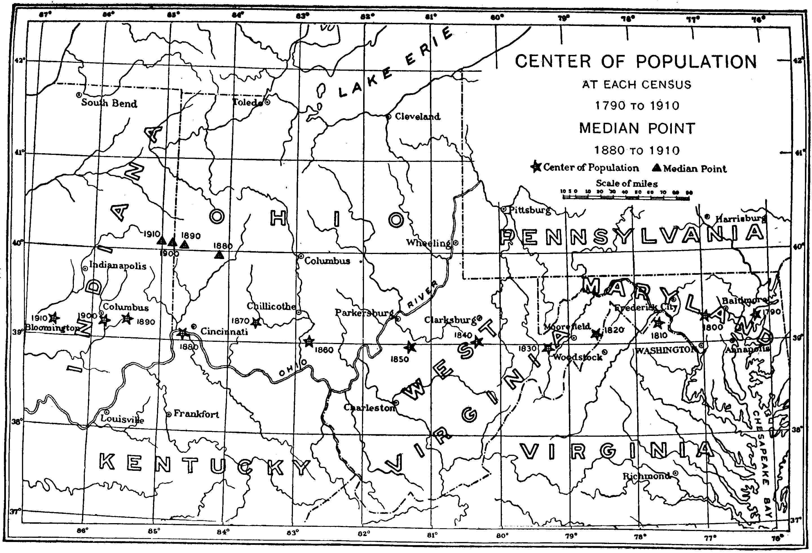
CENTER OF POPULATION
AT EACH CENSUS 1790 TO 1910
MEDIAN POINT 1880 TO 1910
[Transcriber's Note: Location is within a few miles of latitude 39 degrees. The longitude is approximately: 1790, 76.2; 1800, 77.0; 1810, 77.6; 1820, 78.6; 1830, 79.3; 1840, 80.4; 1850, 81.3; 1860, 82.8; 1870 83.7; 1880, 84.7; 1890, 85.5; 1900, 85.8; 1910, 86.5 ]

308 PROBLEMS OF THE NEW CENTURY 1911

The urban increase of Illinois was 31.2 per cent, but the rural territory of the State showed a loss of 7.5 per cent. The rural loss in Indiana was 5.5 per cent, and in Ohio 1.3 per cent. Michigan's rural gain was 2 per cent and Wisconsin's 5.7. per cent. There were fourteen States in which more than one-half of the population in 1910 were living in urban territory. Among these States were Massachusetts, Rhode Island, and Connecticut with nine-tenths of their population urban; Illinois with 62 per cent, and Ohio with 56 per cent.
The rapid growth of our industrial and manufacturing interests during the past quarter of a century is shown by the fact that 22 per cent of the people of the country are massed in cities of 100,000 inhabitants and over. In the three largest cities alone--New York, Chicago, and Philadelphia--there are almost one-tenth the population of the whole country. There were five cities with populations between 500,000 and 1,000,000; eleven between 250,000 and 500,000; 31 between 100,000 and 250,000; 59 between 50,000 and 100,000; 120 between 25,000 and 50,000; 374 between 10,000 and 20,000; 629 between 5,000 and 10,000, and 1,173 between 2,500 and 5,000.
1901 THE THIRTEENTH CENSUS, 1910 309

The thirteenth census revealed but slight change in the location of the centre of population. In computing its position, no account of the population of Alaska and of our insular possessions was taken into consideration. It had moved west about 39 miles and northward seven-tenths of a mile and was located at Bloomington in southern Indiana. The westward movement from 1900 to 1910 was nearly three times as great as from 1890 to 1900, but was less than that for any decade between 1840 and 1890. This advance of the centre of population toward the West was due to the increase in the population of the Pacific Coast States. The large increase in the population of New York, Pennsylvania, Illinois, and other States north of the thirty-ninth parallel served as a balance to the increase in Texas, Oklahoma, and southern California.

310 PROBLEMS OF THE NEW CENTURY [1911

During the past fifteen years there has been a steady migration from the rural portions of the United States to the western provinces of Canada, not less than 650,000 immigrants having crossed the border within that period. Most of them have become naturalized Canadians. It has been estimated that these immigrants took with them, on an average, $1,000.
According to the congressional reapportionment act following the twelfth census, there were to be 386 members in the House of Representatives or one representative to 194,182 of the population. The House of Representatives actually contained. 391 members after the admission of Oklahoma. By the census of 1910, several States were entitled to additional members, but in order that no State should be reduced in the number of its representatives, the House of Representatives passed a bill providing for an increase of 42 members. The new ratio of representation would then be one representative to 211,877 inhabitants. Effort was made to prevent this increase, for it was argued that the House had already become unwieldy, requiring great effort on the part of members to make themselves heard. The bill failed to pass the Senate at the regular session, but subsequently, at the special session, it became a law.
1911] THE THIRTEENTH CENSUS, 1910 311

Party lines were closely drawn in the Senate, for, on account of this increase, the Republicans would probably gain 32 new congressmen and the Democrats only 10. By this reapportionment the northeastern part of the country and the extreme western and southwestern portions gained in their representation. New York gained six representatives; Pennsylvania, four; California and Oklahoma, three each; Illinois, Massachusetts, Washington, and Texas each gained two, and sixteen other States each gained one.
The number of farms, according to the thirteenth census, were 6,340,357 or an increase of about 10 per cent over the number reported in 1900. There was an increase of 63,000,000 acres devoted to farming during the decade. About 60 per cent of the farms of the country were operated by their owners and two-thirds of these farms were free from mortgages. Two million three hundred and forty-nine thousand two hundred and fifty-four farms were worked by tenants and 57,398 were in charge of managers. The tenant system was shown to be far more common in the South than at the North or West.
312 PROBLEMS OF THE NEW CENTURY [1911

In the south central group of States, which includes a large part of the cotton area, the tenants numbered 1,024,265 and the owners 949,036. In the south Atlantic States there were 591,478 owners and 118,678 tenants; in north Central States, 1,563,386 owners and 644,493 tenants, and in the Western States, 309,057 owners and 52,164 tenants.
Our foreign commerce for the year 1910 amounted in the aggregate to about $3,500,000,000, or over $1,250,000,000 more than in 1900. Our exports were valued at $2,000,000,000.
CHAPTER XVII

THE PROGRESSIVE MOVEMENT

From time to time it has been charged that "government by the people" has become fiction in our country. Little had been done to remedy this condition until the opening of the last decade. Trouble then came for the supporters of the regular political order, manifesting itself in conventions and legislatures. Laws abolishing nominations by the convention method were passed in some States; and publicity of campaign expenses was insisted upon in others. The movement was widespread and arose from various causes, but generally tended toward a single end--a government according to popular will. The Western States have been the centre of the more radical movement.
The Senate has always been considered as the stronghold of the most conservative element in our country and has often been accused of being the stronghold of privilege. It is interesting to note the success of the progressive or insurgent movement in this body.
314 PROBLEMS OF THE NEW CENTURY [1911

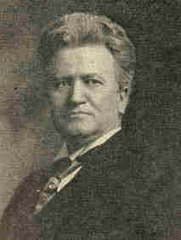
Copyright by Harris & Ewing,
Washington.
Robert M. La Follette.

The first progressive, Robert M. La Follette, of Wisconsin, appeared in the United States Senate in 1905. He had done much, as governor, to gain the confidence of the people of his own State, and he was sent to Washington to carry his fight for reform into the national legislature. Here his reception was not cordial. He was looked upon as a radical, possibly a visionary reformer, but not exceedingly dangerous, for he was alone. He stood alone until the election of 1908, when nine more progressives took their seats; in 1910 the number jumped to sixteen. Here a change came which probably caused the conservatives in the Senate some worry. The tariff of 1909 had been passed by a Republican Congress.
1911] THE PROGRESSIVE MOVEMENT 315

The results of the elections of 1910 made it appear that the people were not convinced that this act was an honest redemption of the Republican campaign promises, for in the Senate which assembled in April, 1911, there were twenty-nine thorough-going progressives and five other members who were more progressive than conservative in their views. They represented twenty-five States. Six of the thirty-four came from the South; three came from the East, and the remaining twenty-five from the West. Of the conservatives only eighteen came from the West.
The same changes may be found in the House of Representatives. These changes are not so important as the change which must come in the sentiment of the federal judiciary. From 1901 to 1909 the Executive was in the control of the progressives and the President was able to get some important laws passed by a reactionary Congress, but in some instances the courts annulled these laws.

316 PROBLEMS OF THE NEW CENTURY [1911

The appointment of justices of the district courts of the United States is to a degree influenced by the senators in the district in which the appointment is to be made. When these senators are conservative it is natural that the candidates recommended by them should be conservative and should entertain no legal theories interfering with the exalted position of property rights. Should the various States be represented by progressives, different recommendations will naturally follow and probably an interpretation of the Constitution which will accord a new standing to personal rights.
In the early part of 1911 the movement crystallized into a regular political organization which called itself The National Progressive Republican League, with the following platform:
(1) direct primaries; (2) popular election of delegates to the national convention; (3) election of senators by direct vote of the people; (4) initiative, referendum, and recall; (5) an effective corrupt practices act.
These points were not new; most of them are incorporated into the body of law of the State of Oregon. Most progressive Democrats as well as Republicans seem willing to support these principles. In almost every State the movement for the direct primaries has met studied opposition.
1911] THE PROGRESSIVE MOVEMENT 317

The "practical politician" or the professional politician seems to hate to see the old convention system of nominations go. There are many who object to the election of senators by direct vote, claiming that the people are not capable of choosing wisely in such cases. The direct election of delegates to the national conventions is no more than the prerogative now exercised by the voter when he casts his vote for the presidential electors. To his mind it means that he is voting for the candidates themselves. In the vote for delegates to the conventions the voter is accorded the right to express his preference for men to be candidates. The corrupt practices plank deserves commendation. It cannot be made too strong, for every attempt to do away with the irregular, vicious methods used is a step toward good government.
The plank which arouses the greatest opposition is that which incorporates the initiative, referendum, and recall. All three are devices to make the machinery of popular government more directly respondent to the popular will. The "initiative" is a process by which laws are proposed on the petition of a certain specified number of voters for action either by the legislature or by the direct vote of the people through a referendum.
318 PROBLEMS OF THE NEW CENTURY [1911

The "referendum" allows a popular vote upon acts passed by the legislature--that is, a bill passed by the legislature may not become a law unless sanctioned by a popular vote, if a vote is called for by a specified number of voters. The "recall" gives the voters an opportunity to relieve a man of his office if by a regular vote it is demonstrated that such an officer has not performed the duties of his office to the satisfaction of his constituents. These expedients are still in the experimental stage, and it is doubtful whether they are so fraught with danger as their opponents seem to believe or so efficacious as their adherents insist. Much of their success depends upon the cases to which they are applied and upon the popular interest displayed. The Oregon experiments apparently have been very successful.
The question of the "recall" is a serious one. In some municipalities--Los Angeles, for example--it has operated well. How it will work in the national government, where it will affect the judiciary, is a problem.
1911] THE PROGRESSIVE MOVEMENT 319

The veto of the Statehood Bill (Arizona and New Mexico) on account of the presence of the "recall" for judges in the constitution of Arizona shows that President Taft is a stout opponent. It seems well that any such step should be taken with extreme caution.
The progressive senators were active in their opposition to the Payne-Aldrich Tariff Bill of 1909. For a period of twelve years there had been no tariff legislation. The great industrial changes which went on during that time made a revision of the Dingley Tariff imperative. Although there has been a constant demand for revision, the tariff played no part in the campaigns of 1900 and 1904. The demand has become insistent, however, during recent years, and may be attributed in part to the increased cost of living. This demand, made chiefly by the wage-earners and salaried men, has been seconded from another quarter. The attitude of foreign nations toward our goods has made it increasingly difficult for American manufacturers to dispose of their surplus. Wages have risen; the price of raw material is higher, and both affect the manufacturer. Foreign nations have refused to accept our high tariffs without retaliation, and this has made the manufacturer insist that Congress revise the objectionable Dingley act.
320 PROBLEMS OF THE NEW CENTURY [1911

The agitation took definite form during the session of 1907-8 when the National Manufacturers' Association undertook to secure legislation designed to create a tariff commission composed of experts whose business it should be to ascertain the facts concerning the condition of manufacturers and the necessity of a new tariff. Pursuant to this the Beveridge Tariff Commission Bill was introduced into the Senate, but the leaders of both houses--Cannon, Aldrich, Payne, and others--said bluntly that it was bad politics to take the question up just before a presidential campaign, and nothing was done. The demand grew more insistent, and the wary leaders learned in time that it would be good politics at least to declare for tariff revision, and this was done by Chairman Payne of the Ways and Means committee of the House. Just when the revision would come was not stated--some time after election, provided the nation would return the Republicans to power.

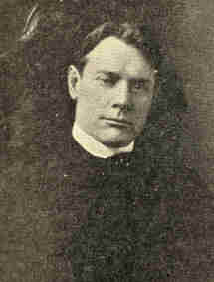
Copyright by Clinedinst. Washington.
Albert J. Beveridge. Senator from Indiana.

1911] THE PROGRESSIVE MOVEMENT 321

When the session closed Chairman Payne set on foot a series of investigations ostensibly to gain information to be used in the coming revision. It is possible that this was also an attempt to end the criticism aimed at the leaders who had opposed the appointment of a commission. Both the Democratic and Republican platforms of 1908 promised tariff revision, but of course in different ways. The Republican leaders said the policy of the party would be to fix the duties at a point which would not only offset the higher cost of production in this country, but would also guarantee to the manufacturers a fair profit. The election put the conservatives of the Republican party in control of all branches of the government, and when the principal committees of both houses of Congress fell under the control of men fully committed to the dogma of protection, the chance for a revision downward seemed slight. A special session was called soon after President Taft's inauguration, and the Payne Bill, which it was claimed aimed to decrease duties and increase the revenue, passed the House by a vote of 217 to 161.
322 PROBLEMS OF THE NEW CENTURY [1911

The Finance Committee of the Senate, to which the bill was referred when it reached the Senate, instead of reporting it, reported a substitute measure--the Aldrich Bill. This the House refused to accept and the usual conference committee was organized, out of which committee came the compromise Payne-Aldrich Bill, destined to become law through the President's signature, August 5, 1909.
The debate in the Senate was a noteworthy one. The progressive senators of the Middle West, led by Dolliver, of Iowa, and La Follette, of Wisconsin, fought the measure sturdily, but with little success. "Jokers" slipped in here and there, and more than one critic has charged that the Senate was less solicitous for the rights of the consumers than for the rights of the "interests."

1911] THE PROGRESSIVE MOVEMENT 323

Several schedules have come in for the most severe kind of criticism. In the cotton schedule the increased rates laid upon certain classes of cotton goods seem to have been imposed for the benefit of New England manufacturers. These rates affect articles used by every person in the United States. Most of these articles are manufactured from raw material produced in America, and the cost of manufacturing the staple articles is but slightly higher than in any of the important competing countries. The average rate imposed by the Dingley Tariff, according to the Bureau of Statistics, was 38 per cent on cotton cloth and similar rates on other cotton goods. Since 1897 the "infant industries" have grown, and some have in recent years declared dividends of 66 per cent per annum. The Payne-Aldrich Bill increased the average rate on cotton goods from 44.84 per cent in the Dingley Tariff to 50.62 per cent. The increases are not so much on the high-priced goods as on the cheaper grades.
In the case of the wool schedule the object of criticism has been the discrimination against the carded woollen industry, which produces the poor man's cloth, in favor of the worsted industry. This is due to the imposition of a uniform duty of eleven cents per pound on raw, unwashed wool, by which the cheaper woollens are taxed as high as 500 per cent, and frequently amounts to less than 25 per cent on the finer grades.
324 PROBLEMS OF THE NEW CENTURY [1911

Based on this system of duties is a graded scale in which the rates rise in an inverse ratio with the value of the goods. Some duties have been lowered, but the change has been slight. The schedule remains nearly the same, but the burden has been shifted.

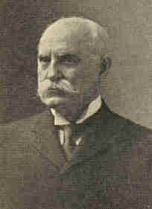
Photograph by Clinedinst, Washington.
Senator Nelson W. Aldrich.

1911] THE PROGRESSIVE MOVEMENT 325

There are reductions--more, numerically, than increases--but the reductions are effectively modified by shifted classifications.
One thinker of note has termed the "maximum and minimum" clause as "the highest practical joke of the whole bill." Little has been said of this clause except in connection with the "minimum." It must be remembered that there is also a "maximum," and it does not augur well for the consumer. Suppose a foreign nation discriminates against our goods; we, acting on the "maximum" theory, discriminate against theirs, and the result is that the consumer pays the value of the article plus the amount of the tariff of discrimination, since it has ever been true that the limit in price is the top of the tariff wall.
A noteworthy feature of the bill is the provision for the formation of a Tariff Board, composed of experts, who shall conduct investigations with the view of evolving a scientific tariff. The board has little power save that of advising the President in the application of the "maximum and minimum" clause.
That the tariff has not been deemed an honest redemption of Republican campaign pledges is shown by the recent elections. In the Sixty-first Congress there were 219 Republicans in the House of Representatives and 172 Democrats; to the Sixty-second Congress there were returned 162 Republicans and 228 Democrats.
326 PROBLEMS OF THE NEW CENTURY [1911

The Democrats at once began a revision of the tariff. Allied with the progressives in the Senate, revisions of the wool and cotton schedules were brought about. The Farmers' Free List Bill, which admitted free of duty agricultural implements, sewing-machines, boots, shoes, fence wire, and other things useful to farmers, was passed as an offset to the Reciprocity Bill which was deemed by some to be disadvantageous to them. The President vetoed all of these measures upon the ground that, since the Tariff Board was to make its report within a very short time, it would be wiser to defer action on the tariff until the report could be used.
The Reciprocity Bill, which met the approval of the President, provided that our markets should be free to Canada's leading agricultural products, live-stock, fish, lumber, etc. Print paper and wood pulp were also to be admitted as soon as the Canadian provincial governments should withdraw the restrictions upon the exportation of these products. The duties on some other products--iron are, for example--were to be reduced.
1911] THE PROGRESSIVE MOVEMENT 327

Canada was asked to admit free our agricultural products, live-stock, etc., and to reduce the duties on coal, agricultural implements, and some other manufactured goods. The September elections in Canada, however, showed that the reciprocity treaty was not acceptable, for the Conservative party, which was strongly opposed to the plan, gained a decisive victory. The act as passed by Congress still remains law in the United States, and stands as a constant invitation to our Canadian neighbors to join us in developing commercial relations on the western continent.
What effect will this Progressive movement have upon party organization? As matters stand at present there are in reality four parties within the bonds of the two old parties--(1) the Conservative Republicans of the East; (2) the Conservative Democrats of the South; (3) the Progressive Republicans of the West; (4) the Progressive Democrats of the West. Out of this tangle it appears that either a new party will be formed by the combination of the Progressives of both old parties, or this Progressive movement must gain control of one or the other of these parties. Should the former happen, we may see the peculiar alliance of New England and the South.
328 PROBLEMS OF THE NEW CENTURY [1912

President Taft, it is maintained by many of his supporters, is himself a Progressive, and they point to his attitude toward the great questions of the hour. He urged, they say, reciprocity with Canada; called for revision of the tariff in the light of facts and scientific tests; proclaimed unlimited arbitration; advocated the conservation of our natural resources, income taxation, extension of civil service reform, employers' liability, and economy in the administration of governmental affairs.
In answer it is asserted that President Taft declared the Payne-Aldrich tariff law to be the best ever passed upon the subject, and that his advisers and supporters in all of the congressional contests over vital measures were the senators and representatives known as reactionaries or standpatters.
President Taft himself, a few months before the convening of the Republican convention called to meet in Chicago, June 16, 1912, stated his honesty of intention in the following words:

1912] THE PROGRESSIVE MOVEMENT 329

"I am very grateful for the honors the people have given me. I do not affect to deny the satisfaction I should feel if, after casting up the totals pro and con and striking a balance, they should decide that my first term had been fruitful enough of good to warrant their enlisting me for another. Any man would be proud of such a verdict. But I have not been willing, nor shall I be, to purchase it at the sacrifice of my freedom to do my duty as I see it. My happiness is not dependent on holding any office, and I shall go back to private life with no heartburnings if the people, after an unprejudiced review of my administration, conclude that some one else can serve them to their greater advantage."
One thing is certain: the idea of government by the people has come into our national politics to stay. It now controls one-third of the votes in the Senate and has affected the laws of two-thirds of the States. The end sought is good government responsible to popular rule.
330 PROBLEMS OF THE NEW CENTURY [1912

Through this rule justice for all is sought; equality of opportunity in political and industrial life; the safeguarding of the interests and well-being of all; and through this rule an honest attempt is being made to establish a government which will render the best service for the community, guaranteeing to each individual all his rights, but no more than his rights.
APPENDIX
332
I

CONSTITUTION OF THE UNITED STATES OF AMERICA

We the people of the United States, in order to form a more perfect union, establish justice, insure domestic tranquillity, provide for the common defense, promote the general welfare, and secure the blessings of liberty to ourselves and our posterity, do ordain and establish this CONSTITUTION for the United States of America.

ARTICLE I

SECTION 1. All legislative powers herein granted shall be vested in a Congress of the United States, which shall consist of a Senate and a House of Representatives.
SECT. II. 1. The House of Representatives shall be composed of members chosen every second year by the people of the several States, and the electors in each State shall have the qualifications requisite for electors of the most numerous branch of the State Legislature.
2. No person shall be a Representative' who shall not have attained to the age of twenty-five years, and been seven years a citizen of the United States, and who shall not, when elected, be an inhabitant of that State in which he shall be chosen.
3. Representatives and direct taxes shall be apportioned among the several States which may be included within this Union, according to their respective numbers, which shall be determined by adding to the whole number of free persons, including those bound to service for a term of years, and excluding Indians not taxed, three fifths of all other persons. The actual enumeration shall be made within three years after the first meeting of the Congress of the United States, and within every subsequent term of ten years, in such manner as they shall by law direct.

333
334 APPENDIX

The number of Representatives shall not exceed one for every thirty thousand, but each State shall have at least one representative; and until such enumeration shall be made, the State of New Hampshire shall be entitled to choose three, Massachusetts eight, Rhode Island and Providence Plantations one, Connecticut five, New York six, New Jersey four, Pennsylvania eight, Delaware one, Maryland six, Virginia ten, North Carolina five, South Carolina five, and Georgia three.
4. When vacancies happen in the representation from any State, the Executive authority thereof shall issue writs of election to fill such vacancies.
5. The House of Representatives shall choose their Speaker and other officers; and shall have the sole power of impeachment.
SECT. III. 1. The Senate of the United States shall be composed of two Senators from each State, chosen by the legislature thereof, for six years; and each Senator shall have one vote.
2. Immediately after they shall be assembled in consequence of the first election, they shall be divided as equally as may be into three classes. The seats of the Senators of the first class shall be vacated at the expiration of the second year, of the second class at the expiration of the fourth year, and of the third class at the expiration of the sixth year, so that one third may be chosen every second year; and if vacancies happen by resignation or otherwise, during the recess of the legislature of any State, the Executive thereof may make temporary appointments until the next meeting of the legislature, which shall then fill such vacancies.
3. No person shall be a Senator who shall not have attained to the age of thirty years, and been nine years a citizen of the United States, and who shall not, when elected, be an inhabitant of that State for which he shall be chosen.

APPENDIX 335

4. The Vice-President of the United States shall be President of the Senate, but shall have no vote, unless they be equally divided.
5. The Senate shall choose their other officers, and also a President pro tempore, in the absence of the Vice-President, or when he shall exercise the office of President of the United States.
6. The Senate shall have the sole power to try all impeachments. When sitting for that purpose, they shall be on oath or affirmation. When the President of the United States is tried, the Chief Justice shall preside: and no person shall be convicted without the concurrence of two thirds of the members present.
7. Judgment in cases of impeachment shall not extend further than to removal from office, and disqualification to hold and enjoy any office of honor, trust or profit under the United States: but the party convicted shall nevertheless be liable and subject to indictment, trial, judgment and punishment, according to law.
SECT. IV. 1. The times, places and manner of holding elections for Senators and Representatives shall be prescribed in each State by the legislature thereof; but the Congress may at any time by law make or alter such regulations, except as to the places of choosing Senators.
2. The Congress shall assemble at least once in every year, and such meeting shall be on the first Monday in December, unless they shall by law appoint a different day.
SECT. V. 1. Each house shall be the judge of the elections, returns and qualifications of its own members, and a majority of each shall constitute a quorum to do business; but a smaller number may adjourn from day to day, and may be authorized to compel the attendance of absent members, in such manner, and under such penalties, as each house may provide.
2. Each house may determine the rules of its proceedings, punish its members for disorderly behavior, and with the concurrence of two thirds, expel a member.
3. Each house shall keep a journal of its proceedings, and from time to time publish the same, excepting such parts as may in their judgment require secrecy; and the yeas and nays of the members of either house on any question shall, at the desire of one fifth of those present, be entered on the journal.
336 APPENDIX

4. Neither house, during the session of Congress, shall, without the consent of the other, adjourn for more than three days, nor to any other place than that in which the two houses shall be sitting.
SECT. VI. 1. The Senators and Representatives shall receive a compensation for their services, to be ascertained by law and paid out of the treasury of the United States. They shall, in all cases except treason, felony and breach of the peace, be privileged from arrest during their attendance at the session of their respective houses, and in going to and returning from the same; and for any speech or debate in either house, they shall not be questioned in any other place.
2. No Senator or Representative shall, during the time for which he was elected, be appointed to any civil office under the authority of the United States, which shall have been created, or the emoluments whereof shall have been increased, during such time; and no person holding any office under the United States shall be a member of either house during his continuance in office.
SECT. VII. 1. All bills for raising revenue shall originate in the House of Representatives; but the Senate may propose or concur with amendments as on other bills.
2. Every bill which shall have passed the House of Representatives and the Senate, shall, before it become a law, be presented to the President of the United States; if he approve he shall sign, it, but if not he shall return it with his objections to that house in which it shall have originated, who shall enter the objections at large on their journal, and proceed to reconsider it. If after such reconsideration two thirds of that house shall agree to pass the bill, it shall be sent, together with the objections, to the other house, by which it shall likewise be reconsidered, and, if approved by two thirds of that house, It shall become a law.

APPENDIX 337

But in all such cases the votes of both houses shall be determined by yeas and nays, and the names of the persons voting for and against the bill shall be entered on the journal of each house respectively. If any bill shall not be returned by the President within ten days (Sundays excepted) after it shall have been presented to him, the same shall be a law, in like manner as if he had signed it, unless the Congress by their adjournment prevent its return, in which case it shall not be a law.
3. Every order, resolution, or vote to which the concurrence of the Senate and House of Representatives may be necessary (except on a question of adjournment) shall be presented to the President of the United States; and before the same shall take effect, shall be approved by him, or being disapproved by him, shall be repassed by two thirds of the Senate and House of Representatives, according to the rules and limitations prescribed in the case of a bill.
SECT. VIII. The Congress shall have power
1. To lay and collect taxes, duties, imposts, and excises, to pay the debts and provide for the common defense and general welfare of the United States; but all duties, imposts and excises shall be uniform throughout the United States;
2. To borrow money on the credit of the United States;
3. To regulate commerce with foreign nations, and among the several States, and with the Indian tribes;
4. To establish an uniform rule of naturalization, and uniform laws on the subject of bankruptcies throughout the United States;
5. To coin money, regulate the value thereof, and of foreign coin, and fix the standard of weights and measures;
6. To provide for the punishment of counterfeiting the securities and current coin of the United States;
7. To establish post offices and post roads;
8. To promote the progress of science and useful arts by securing for limited times to authors and inventors the exclusive right to their respective writings and discoveries;
338 APPENDIX

9. To constitute tribunals inferior to the Supreme Court;
10. To define and punish piracies and felonies committed on the high seas and offences against the law of nations;
11. To declare war, grant letters of marque and reprisal, and make rules concerning captures on land and water;
12. To raise and support armies, but no appropriation of money to that use shall be for a longer term than two years;
13. To provide and maintain a navy;
14. To make rules for the government and regulation of the land and naval forces;
15. To provide for calling forth the militia to execute the laws of the Union, suppress insurrections, and repel invasions;
16. To provide for organizing, arming and disciplining the militia, and for governing such part of them as may be employed in the service of the United States, reserving to the States respectively the appointment of the officers, and the authority of training the militia according to the discipline prescribed by Congress;
17. To exercise exclusive legislation in all cases whatsoever, over such district (not exceeding ten miles square) as may, by cession of particular States, and the acceptance of Congress, become the seat of government of the United States, and to exercise like authority over all places purchased by the consent of the legislature of the State, in which the same shall be, for the erection of forts, magazines, arsenals, dockyards, and other needful buildings;
--and
18. To make all laws which shall be necessary and proper for carrying into execution the foregoing powers, and all other powers vested by this Constitution in the government of the United States, or in any department or office thereof.
SECT. IX. 1. The migration or importation of such persons as any of the States now existing shall think proper to admit shall not be prohibited by the Congress prior to

APPENDIX 339

the year one thousand eight hundred and eight; but a tax or duty may be imposed on such importation, not exceeding ten dollars for each person.
2. The privilege of the writ of habeas corpus shall not be suspended, unless when in cases of rebellion or invasion the public safety may require it.
3. No bill of attainder or ex post facto law shall be passed.
4. No capitation, or other direct, tax shall be laid, unless in proportion to the census or enumeration herein before directed to be taken.
5. No tax or duty shall be laid on articles exported from any State.
6. No preference shall be given by any regulation of commerce or revenue to the ports of one State over those of another: nor shall vessels bound to, or from, one State, be obliged to enter, clear, or pay duties in another.
7. No money shall be drawn from the treasury, but in consequence of appropriations made by law; and a regular statement and account of the receipts and expenditures of all public money shall be published from time to time.
8. No title of nobility shall be granted by the United States: and no person holding any office of profit or trust under them, shall, without the consent of the Congress, accept of any present, emolument, office, or title, of any kind whatever, from any king, prince, or foreign state.
SECT. X. 1. No State shall enter into any treaty, alliance, or confederation; grant letters of marque and reprisal; coin money; emit bills of credit; make anything but gold and silver coin a tender in payment of debts; pass any bill of attainder, ex post facto law, or law impairing the obligation of contracts, or grant any title of nobility.
2. No State shall, without the consent of the Congress, lay any imposts or duties on imports or exports, except what may be absolutely necessary for executing its inspection laws: and the net produce of all duties and imposts, laid by any State on imports or exports, shall be for the use of the treasury of the United States; and all such laws shall be subject to the revision and control of the Congress.
340 APPENDIX

3. No State shall, without the consent of Congress, lay any duty of tonnage, keep troops, or ships of war in time of peace, enter into any agreement or compact with another State, or with a foreign power, or engage in war, unless actually invaded, or in such imminent danger as will not admit of delay.

ARTICLE II
SECTION 1. 1. The executive power shall be vested in a President of the United States of America. He shall hold his office during the term of four years, and together with the Vice-President, chosen for the same term, be elected as follows:
2. Each State shall appoint, in such manner as the legislature thereof may direct, a number of electors, equal to the whole number of Senators and Representatives to which the State may be entitled in the Congress; but no Senator or Representative, or person holding an office of trust or profit under the United States, shall be appointed an elector.
[The electors shall meet in their respective States, and vote by ballot for two persons, of whom one at least shall not be an inhabitant of the same State with themselves. And they shall make a list of all the persons voted for, and of the number of votes for each; which list they shall sign and certify, and transmit sealed to the seat of government of the United States, directed to the President of the Senate. The President of the Senate shall, in the presence of the Senate and House of Representatives, open all the certificates, and the votes shall then be counted. The person having the greatest number of votes shall be the President, if such number be a majority of the whole number of electors appointed; and if there be more than one who have such majority, and have an equal number of votes, then the House of Representatives shall immediately choose by ballot one of them for President; and if no person have a majority, then from the five highest on the list the said house shall in like manner choose the President.

APPENDIX 341

But in choosing the President the votes shall be taken by States, the representation from each State having one vote; a quorum for this purpose shall consist of a member or members from two thirds of the States, and a majority of all the States shall be necessary to a choice. In every case, after the choice of the President, the person having the greatest number of votes of the electors shall be the Vice-President. But if there should remain two or more who have equal votes, the Senate shall choose from them by ballot the Vice-President.]
3. The Congress may determine the time of choosing the electors, and the day on which they shall give their votes; which day shall be the same throughout the United States.
4. No person except a natural born citizen, or a citizen of the United States, at the time of the adoption of this Constitution, shall be eligible to the office of President; neither shall any person be eligible to that office who shall not have attained to the age of thirty-five years, and been fourteen years a resident within the United States.
5. In case of the removal of the President from office or of his death, resignation, or inability to discharge the powers and duties of the said office, the same shall devolve on the Vice-President, and the Congress may by law provide for the case of removal, death, resignation, or inability, both of the President and Vice-President, declaring what officer shall then act as President, and such officer shall act accordingly, until the disability be removed, or a President shall be elected.
6. The President shall, at stated times, receive for his services, a compensation, which shall neither be increased nor diminished during the period for which he shall have been elected, and he shall not receive within that period any other emolument from the United States, or any of them.
342 APPENDIX

7. Before he enter on the execution of his office, he shall take the following oath or affirmation:--"I do solemnly swear (or affirm) that I will faithfully execute the office of President of the United States, and will, to the best of my ability, preserve, protect and defend the Constitution of the United States."
SECT. II. 1. The President shall be commander in chief of the army and navy of the United States, and of the militia of the several states, when called into the actual service of the United States; he may require the opinion, in writing, of the principal officer in each of the executive departments, upon any subject relating to the duties of their respective offices, and he shall have power to grant reprieves and pardons for offences against the United States, except in cases of impeachment.
2. He shall have power, by and with the advice and consent of the Senate, to make treaties, provided two thirds of the Senators present concur; and he shall nominate, and by and with the advice and consent of the Senate, shall appoint ambassadors, other public ministers and consuls, judges of the Supreme Court, and all other officers of the United States, whose appointments are not herein otherwise provided for, and which be established by law: but the Congress may by law vest the appointment of such inferior officers, as they think proper, in the President alone, in the courts of law, or in the heads of departments.
3. The President shall have power to fill up all vacancies that may happen during the recess of the Senate, by granting commissions which shall expire at the end of their next session.
SECT. III. He shall from time to time give to the Congress information of the state of the Union, and recommend to their consideration such measures as he shall judge necessary and expedient; he may, on extraordinary occasions, convene both houses, or either of them, and in case of disagreement between them, with respect to the time of adjournment, he may adjourn them to such time as he shall think proper; he shall receive ambassadors and other public ministers; he shall take care that the laws be faithfully executed, and shall commission all the officers of the United States.

APPENDIX 343

SECT. IV. The President, Vice-President and all civil officers of the United States, shall be removed from office on impeachment for, and conviction of, treason, bribery, or other high crimes and misdemeanors.

ARTICLE III
SECTION I. The judicial power of the United States, shall be vested in one Supreme Court, and in such inferior courts as Congress may from time to time ordain and establish. The judges, both of the Supreme and inferior courts, shall hold their offices during good behavior, and shall, at stated times, receive for their services, a compensation, which shall not be diminished during their continuance in office.
SECT. II. 1. The judicial power shall extend to all cases, in law and equity, arising under this Constitution, the laws of the United States, and treaties made or which shall be made, under their authority;--to all cases affecting ambassadors, other public ministers and consuls;-- to all cases of admiralty jurisdiction;--to controversies to which the United States shall be a party;--to controversies between two or more States;--between a State and citizens of another State;--between citizens of different States;--between citizens of the same State claiming lands under grants of different States, and between a State, or the citizens thereof, and foreign states, citizens or subjects.
2. In all cases affecting ambassadors, other public ministers and consuls, and those in which a State shall be a party, the Supreme Court shall have original jurisdiction. In all the other cases before mentioned, the Supreme Court shall have appellate jurisdiction, both as to law and fact, with such exceptions, and under such regulations as the Congress shall make.
3. The trial of all crimes, except in cases of impeachment, shall be by jury; and such trial shall be held in the State where the said crimes shall have been committed; but when not committed within any State, the trial shall be at such place or places as the Congress may by law have directed.
344 APPENDIX

SECT. III. 1. Treason against the United States shall consist only in levying war against them, or in adhering to their enemies, giving them aid and comfort. No person shall be convicted of treason unless on the testimony of two witnesses to the same overt act, or on confession in open court.
2. The Congress shall have power to declare the punishment of treason, but no attainder of treason shall work corruption of blood, or forfeiture except during the life of the person attainted.

ARTICLE IV
SECTION I. Full faith and credit shall be given in each State to the public acts, records, and judicial proceedings of every other State. And the Congress may by general laws prescribe the manner in which such acts, records, and proceedings shall be proved, and the effect thereof.
SECT. II. 1. The citizens of each State shall be entitled to all privileges and immunities of citizens in the several States.
2. A person charged in any State with treason, felony, or other crime, who shall flee from justice, and be found in another State, shall on demand of the executive authority of the State from which he fled, be delivered up, to be removed to the State having jurisdiction of the crime.
3. No person held to service or labor in one State, under the laws thereof, escaping into another, shall, in consequence of any law or regulation therein, be discharged from such service or labor, but shall be delivered up on claim of the party to whom such service or labor may be due.
SECT. III. 1. New States may be admitted by the Congress into this Union; but no new State shall be formed or erected within the jurisdiction of any other State; nor any State be formed by the junction of two or more States, or parts of States, without the Consent of the legislatures of the States concerned as well as of the Congress.

APPENDIX 345

2. The Congress shall have power to dispose of and make all needful rules and regulations respecting the territory or other property belonging to the United States; and nothing in this Constitution shall be so construed as to prejudice any claims of the United States, or of any particular State.
SECT. IV. The United States shall guarantee to every State in this Union a republican form of government, and shall protect each of them against invasion; and on application of the legislature, or of the executive (when the legislature cannot be convened) against domestic violence.

ARTICLE V
The Congress, whenever two thirds of both houses shall deem it necessary, shall propose amendments to this Constitution, or, on the application of the legislatures of two thirds of the several States, shall call a convention for proposing amendments, which, in either case shall be valid to all intents and purposes, as part of this Constitution, when ratified by the legislatures of three fourths of the several States, or by conventions in three fourths thereof, as the one or the other mode of ratification may be proposed by the Congress; provided that no amendments which may be made prior to the year one thousand eight hundred and eight shall in any manner affect the first and fourth clauses in the ninth section of the first article; and that no State, without its consent, shall be deprived of its equal suffrage in the Senate.

ARTICLE VI
I. All debts contracted and engagements entered into, before the adoption of this Constitution, shall be as valid against the United States under this Constitution, as under the Confederation.
346 APPENDIX

2. This Constitution, and the laws of the United States which shall be made in pursuance thereof; and all treaties made, or which shall be made, under the authority of the United States, shall be the supreme law of the land; and the judges in every State shall be bound thereby, anything in the Constitution or laws of any State to the contrary notwithstanding.
3. The Senators and Representatives before mentioned, and the members of the several State legislatures, and all executive and judicial officers, both of the United States and of the several States, shall be bound by oath or affirmation, to support this Constitution; but no religious test shall ever be required as a qualification to any office or public trust under the United States.

ARTICLE VII
The ratification of the conventions of nine States, shall be sufficient for the establishment of this Constitution between the States so ratifying the same.

Done in Convention by the unanimous consent of the States present, the seventeenth day of September in the year of our Lord one thousand seven hundred and eighty-seven and of the Independence of the United States of America the twelfth. In witness whereof we have hereunto subscribed our names.
[Signed by]
GO. WASHINGTON, Presidt and Deputy from Virginia.
NEW HAMPSHIRE, John Langdon, Nicholas Gilman.
MASSACHUSETTS,Nathaniel Gorham, Rufus King.
CONNECTICUT, Wm. Saml. Johnson, Roger Sherman.
NEW YORK, Alexander Hamilton.
NEW JERSEY, Wil: Livingston, David Brearley, Wm: Paterson, Jona: Dayton.
PENNSYLVANIA.
B Franklin, Thomas Mifflin, Robt. Morris, Geo. Clymer,
Tho. Fitz Simons, Jared Ingersoll, James Wilson, Gouv Morris.
APPENDIX 347

DELAWARE.
Geo: Read, Gunning Bedford, Jun, John Dickinson,
Richard Bassett, Jaco: Broom.
MARYLAND.
James McHenry, Dan of St. Thos. Jenifer, Danl Carroll.
VIRGINIA.
John Blair, James Madison, Jr.
NORTH CAROLINA.
Wm. Blount, Richd. Dobbs Spaight, Hu Williamson.
SOUTH CAROLINA.
J. Rutledge, Charles Cotesworth Pinckney,
Charles Pinckney, Pierce Butler.
GEORGIA.
William Few, Abr Baldwin.

Attest:
William Jackson, Secretary.

ARTICLES IN ADDITION TO AND AMENDMENT OF THE CONSTITUTION OF THE UNITED STATES OF AMERICA, PROPOSED BY CONGRESS, AND RATIFIED BY THE LEGISLATURES OF THE SEVERAL STATES, PURSUANT TO THE FIFTH ARTICLE OF THE ORIGINAL CONSTITUTION.

ARTICLE I.--Congress shall make no law respecting an establishment of religion, or prohibiting the free exercise thereof; or abridging the freedom of speech, or of the press; or the right of the people peaceably to assemble and to petition the government for a redress of grievances.
ARTICLE II.--A well-regulated militia, being necessary to the security of a free State, the right of the people to keep and bear arms, shall not be infringed.
348 APPENDIX

ARTICLE III.--No soldier shall, in time of peace be quartered in any house without the consent of the owner, nor in time of war, but in a manner to be prescribed by law.
ARTICLE IV.--The right of the people to be secure in their persons, houses, papers, and effects, against unreasonable searches and seizures, shall not be violated, and no warrants shall issue but upon probable cause, supported by oath or affirmation, and particularly describing the place to be searched, and the persons or things to be seized.
ARTICLE V.--No person shall be held to answer for a capital, or otherwise infamous crime, unless on a presentment or indictment of a grand jury, except in cases arising in the land or naval forces, or in the militia, when in actual service in time of war or public danger; nor shall any person be subject for the same offense to be twice put in jeopardy of life or limb; nor shall be compelled in any criminal case to be a witness against himself, nor be deprived of life, liberty, or property, without due process of law; nor shall private property be taken for public use without just compensation.
ARTICLE VI.--In all criminal prosecutions the accused shall enjoy the right to a speedy and public trial, by an impartial jury of the State and district wherein the crime shall have been committed, which district shall have been previously ascertained by law, and to be informed of the nature and cause of the accusation; to be confronted with the witnesses against him; to have compulsory process for obtaining witnesses in his favor, and to have the assistance of counsel for his defense.
ARTICLE VII.--In suits at common law, where the value in controversy shall exceed twenty dollars, the right of trial by jury shall be preserved, and no fact tried by a jury shall be otherwise reexamined in any court of the United States, than according to the rules of the common law.
ARTICLE VIII. - Excessive bail shall not be required, nor excessive fines imposed, nor cruel and unusual punishments inflicted.

APPENDIX 349

ARTICLE IX.--The enumeration in the Constitution, of certain rights, shall not be construed to deny or disparage others retained by the people.
ARTICLE X.--The powers not delegated to the United States by the Constitution, nor prohibited by it to the States, are reserved to the States respectively, or to the people.
ARTICLE XI.--The judicial power of the United States shall not be construed to extend to any suit in law or equity, commenced or prosecuted against one of the United States by citizens of another State, or by citizens or subjects of any foreign State.
ARTICLE XII.--Section 1. The electors shall meet in their respective States, and vote by ballot for President and Vice-President, one of whom, at least, shall not be an inhabitant of the same State with themselves; they shall name in their ballots the person voted for as President, and in distinct ballots the person voted for as Vice-President, and they shall make distinct lists of all persons voted for as President, and of all persons voted for as Vice-President, and of the number of votes for each, which lists they shall sign and certify, and transmit sealed to the seat of government of the United States, directed to the President of the Senate;--the President of the Senate shall, in the presence of the Senate and House of Representatives, open all the certificates and the votes shall then be counted;--the person having the greatest number of votes for President shall be the President, if such number be a majority of the whole number of electors appointed; and if no person have such majority, then from the persons having the highest numbers not exceeding three on the list of those voted for as President, the House of Representatives shall choose immediately, by ballot, the President. But in choosing the President, the votes shall be taken by States, the representation from each State having one vote; a quorum for this purpose shall consist of a member or members from two thirds of the States, and a majority of all the States shall be necessary to a choice. And if the House of Representatives shall not choose a President whenever the right of choice shall devolve upon them, before the fourth day of March next following, then the Vice-President shall act as President, as in the case of the death or other constitutional disability of the President.
350 APPENDIX

Section 2. The person having the greatest number of votes as Vice-President, shall be the Vice-President, if such number be a majority of the whole number of electors appointed, and if no person have a majority, then from the two highest numbers on the list, the Senate shall choose the Vice-President; a quorum for the purpose shall consist of two thirds of the whole number of Senators, and a majority of the whole number shall be necessary to a choice. But no person constitutionally ineligible to the office of President shall be eligible to that of Vice-President of the United States.
ARTICLE XIII.--Section 1. Neither slavery nor involuntary servitude, except as a punishment for crime whereof the party shall have been duly convicted, shall exist within the United States, or any place subject to their jurisdiction.
Section 2. Congress shall have power to enforce this article by appropriate legislation.
ARTICLE XIV.--Section 1. All persons born or naturalized in the United States, and subject to the jurisdiction thereof, are citizens of the United States and of the State wherein they reside. No State shall make or enforce any law which shall abridge the privileges or immunities of citizens of the United States; nor shall any State deprive any person of life, liberty, or property, without due process of law; nor deny to any person within its jurisdiction the equal protection of the laws.
Section 2. Representatives shall be apportioned among the several States according to their respective numbers, counting the whole number of persons in each State, excluding Indians not taxed. But when the right to vote at any election for the choice of Electors for President and Vice-President of the United States, Representatives in Congress, the executive and judicial officers of a State, or the members of the legislature thereof, is denied to any of the male inhabitants of such State, being twenty-one years of age and citizens of the United States, or in any way abridged, except for participation in rebellion, or other crime, the basis of representation therein shall be reduced in the proportion which the number of such male citizens shall bear to the whole number of male citizens twenty-one years of age in such State.

APPENDIX 351

Section 3. No person shall be a Senator or Representative in Congress, or Elector of President and Vice-President, or hold any office, civil or military, under the United States, or under any State, who, having previously taken an oath, as a member of Congress, or as an officer of the United States, or as a member of any State legislature, or as an executive or judicial officer of any State, to support the Constitution of the United States, shall have engaged in insurrection or rebellion against the same, or given aid or comfort to the enemies thereof. But Congress may by a vote of two thirds of each house, remove such disability.
Section 4. The validity of the public debt of the United States, authorized by law, including debts incurred for payment of pensions and bounties for services in suppressing insurrection or rebellion, shall not be questioned. But neither the United States nor any State shall assume or pay any debt or obligation incurred in aid of insurrection or rebellion against the United States, or any claim for the loss or emancipation of any slave; but all such debts, obligations, and claims shall be held illegal and void.
Section 5. The Congress shall have power to enforce by appropriate legislation the provisions of this article.
ARTICLE XV.--Section 1. The right of citizens of the United States to vote shall not be denied or abridged by the United States or any State on account of race, color, or previous condition of servitude.
Section 2. The Congress shall have power to enforce this article by appropriate legislation.
II

ARTICLES OF CONFEDERATION

Articles of Confederation and Perpetual Union between the States of New Hampshire, Massachusetts Bay, Rhode Island and Providence Plantations, Connecticut, New York, New Jersey, Pennsylvania, Delaware, Maryland, Virginia, North Carolina, South Carolina, and Georgia.

ARTICLE 1. --The style of this Confederacy shall be, "The United States of America."
ART. II.--Each State retains its sovereignty, freedom, and independence, and every power, jurisdiction, and right, which is not by this Confederation expressly delegated to the United States in Congress assembled.
ART. III.--The said States hereby severally enter into a firm league of friendship with each other, for their common defense, the security of their liberties, and their mutual and general welfare, binding themselves to assist each other against all force offered to, or attacks made upon them, or any of them, on account of religion, sovereignty, trade, or any other pretense whatever.
ART. IV.--The better to secure and perpetuate mutual friendship and intercourse among the people of the different States in this Union, the free inhabitants of each of these States, paupers, vagabonds, and fugitives from justice excepted, shall be entitled to all privileges and immunities of free citizens in the several States; and the people of each State shall have free ingress and egress to and from any other State, and shall enjoy therein all the privileges of trade and commerce subject to the same duties, impositions, and restrictions as the inhabitants thereof respectively; provided that such restrictions shall not extend so far as to prevent the removal of property imported into any State to any other State of which the Owner is an inhabitant; provided also, that no imposition, duties, or restriction shall be laid by any State on the property of the United States or either of them.
APPENDIX 353

If any person guilty of, or charged with, treason, felony, or other high misdemeanor in any State shall flee from justice and be found in any of the United States, he shall, upon demand of the governor or executive power of the States from which he fled, be delivered up and removed to the State having jurisdiction of his offense. Full faith and credit shall be given in each of these States to the records, acts, and judicial proceedings of the courts and magistrates of every other State.
ART. V.--For the more convenient management of the general interests of the United States, delegates shall be annually appointed in such manner as the Legislature of each State shall direct, to meet in Congress on the first Monday in November in every year with a power reserved to each State to recall its delegates, or any of them, at any time within the year, and to send others in their stead for the remainder of the year. No State shall be represented in Congress by less than two, nor by more than seven members; and no person shall be capable of being a delegate for more than three years in any term of six years; nor shall any person, being a delegate, be capable of holding any office under the United States for which he, or another for his benefit, receives any salary, fees, or emolument of any kind. Each State shall maintain its own delegates in any meeting of the States and while they act as members of the Committee of the States. In determining questions in the United States in Congress assembled, each State shall have one vote. Freedom of speech and debate in Congress shall not be impeached or questioned in any court or place out of Congress; and the members of Congress shall be protected in their persons from arrest and imprisonment during the time of their going to and from, and attendance on, Congress, except for treason, felony, or breach of the peace.
354 APPENDIX

ART. VI.--No State, without the consent of the United States, in Congress assembled, shall send any embassy to, or receive any embassy from, or enter into any conference, agreement, alliance, or treaty with any king, prince, or state; nor shall any person holding any office of profit or trust under the United States, or any of them, accept of any present, emolument, office, or title of any kind whatever from any king, prince, or foreign state; nor shall the United States, in Congress assembled, or any of them, grant any title of nobility.
No two or more States shall enter into any treaty, confederation, or alliance whatever between them, without the consent of the United States, in Congress assembled, specifying accurately the purposes for which the same is to be entered into, and how long it shall continue.
No State shall lay any imposts or duties which may interfere with any stipulations in treaties entered into by the United States, in Congress assembled, with any king, prince, or state, in pursuance of any treaties already proposed by Congress to the courts of France and Spain.
No vessels of war shall be kept up in time of peace by any State, except such number only as shall be deemed necessary by the United States, in Congress assembled, for the defense of such State or its trade, nor shall any body of forces be kept up by any State in time of peace, except such number only as, in the judgment of the United States, in Congress assembled, shall be deemed requisite to garrison the forts necessary for the defense of such State; but every State shall always keep up a well-regulated and disciplined militia, sufficiently armed and accoutered, and shall provide and constantly have ready for use in public stores a due number of field-pieces and tents, and a proper quantity of arms, ammunition, and camp equipage.
No State shall engage in any war without the consent of the United States, in Congress assembled, unless such State be actually invaded by enemies, or shall have received certain advice of a resolution being formed by some nation of Indians to invade such State, and the danger is so imminent as not to admit of a delay till the United States, in Congress assembled, can be consulted;

APPENDIX 355

nor shall any State grant commissions to any ships or vessels of war, nor letters of marque or reprisal, except it be after a declaration of war by the United States, in Congress assembled, and then only against the kingdom or state, and the subjects thereof, against which war has been so declared, and under such regulations as shall be established by the United States, in Congress assembled, unless such State be infested by pirates, in which case vessels of war may be fitted out for that occasion, and kept so long as the danger shall continue, or until the United States, in Congress assembled, shall determine otherwise.
ART. VII.--When land forces are raised by any State for the common defense, all officers of or under the rank of Colonel shall be appointed by the Legislature of each State respectively by whom such forces shall be raised, or in such manner as such State shall direct, and all vacancies shall be filled up by the State which first made the appointment.
ART. VIII.--All charges of war, and all other expenses that shall be incurred for the common defense, or general welfare, and allowed by the United States, in Congress assembled, shall be defrayed out of a common treasury, which shall be supplied by the several States in proportion to the value of all land within each State, granted to, or surveyed for, any person, as such land and the buildings and improvements thereon shall be estimated, according to such mode as the United States, in Congress assembled, shall, from time to time, direct and appoint. The taxes for paying that proportion shall be laid and levied by the authority and direction of the Legislatures of the several States, within the time agreed upon by the United States, in Congress assembled.

356 APPENDIX

ART. IX.--The United States, in Congress assembled, shall have the sole and exclusive right and power of determining on peace and war, except in the cases mentioned in the sixth Article; of sending and receiving ambassadors; entering into treaties and alliances, provided that no treaty of commerce shall be made, whereby the legislative power of the respective States shall be restrained from imposing such imposts and duties on foreigners as their own people are subjected to, or from prohibiting the exportation or importation of any species of goods or commodities whatever; of establishing rules for deciding, in all cases, what captures on land and water shall be legal, and in what manner prizes taken by land or naval forces in the service of the United States shall be divided or appropriated; of granting letters of marque and reprisal in times of peace; appointing courts for the trial of piracies and felonies committed on the high seas; and establishing courts for receiving and determining finally appeals in all cases of captures; provided that no member of Congress shall be appointed a judge of any of the said courts.
The United States, in Congress assembled, shall also be the last resort on appeal in all disputes and differences now subsisting, or that hereafter may arise between two or more States concerning boundary, jurisdiction, or any other cause whatever; which authority shall always be exercised in the manner following: Whenever the legislative or executive authority, or lawful agent of any State in controversy with another, shall present a petition to Congress, stating the matter in question, and praying for a hearing, notice thereof shall be given by order of Congress to the legislative or executive authority of the other State in controversy, and a day assigned for the appearance of the parties by their lawful agents, who shall then be directed to appoint, by joint consent, commissioners or judges to constitute a court for hearing and determining the matter in question; but if they cannot agree, Congress shall name three persons out of each of the United States, and from the list of such persons each party shall alternately strike out one, the petitioners beginning, until the number shall be reduced to thirteen; and from that number not less than seven nor more than nine names, as Congress shall direct, shall, in the presence of Congress, be drawn out by lot; and the persons whose names shall be so drawn, or any five of them, shall be commissioners or judges, to hear and finally determine the controversy, so always as a major part of the judges who shall hear the cause shall agree in the determination;

APPENDIX 357

and if either party shall neglect to attend at the day appointed, without showing reasons which Congress shall judge sufficient, or being present, shall refuse to strike, the Congress shall proceed to nominate three persons out of each State, and the secretary of Congress shall strike in behalf of such party absent or refusing; and the judgment and sentence of the Court, to be appointed in the manner before prescribed, shall be final and conclusive; and if any of the parties shall refuse to submit to the authority of such Court, or to appear or defend their claim or cause, the court shall nevertheless proceed to pronounce sentence or judgment, which shall in like manner be final and decisive; the judgment or sentence and other proceedings being in either case transmitted to Congress, and lodged among the acts of Congress for the security of the parties concerned; provided, that every commissioner, before he sits in judgment, shall take an oath, to be administered by one of the judges of the supreme or superior court of the State where the cause shall be tried, "well and truly to hear and determine the matter in question, according to the best of his judgment, without favor, affection, or hope of reward." Provided, also, that no State shall be deprived of territory for the benefit of the United States.
All controversies concerning the private right of soil claimed under different grants of two or more States, whose jurisdictions, as they may respect such lands, and the States which passed such grants are adjusted, the said grants or either of them being at the same time claimed to have originated antecedent to such settlement of jurisdiction, shall, on the petition of either party to the Congress of the United States, be finally determined, as near as may be, in the same manner as is before prescribed for deciding disputes respecting territorial jurisdiction between different States.
358 APPENDIX

The United States, in Congress assembled, shall also have the sole and exclusive right and power of regulating the alloy and value of coin struck by their own authority, or by that of the respective States; fixing the standard of weights and measures throughout the United States; regulating the trade and managing all affairs with the Indians, not members of any of the States; provided that the legislative right of any State, within its own limits, be not infringed or violated; establishing and regulating post offices from one State to another, throughout all the United States, and exacting such postage on the papers passing through the same as may be requisite to defray the expenses of the said office; appointing all officers of the land forces in the service of the United States, excepting regimental officers; appointing all the officers of the naval forces, and commissioning all officers whatever in the service of the United States; making rules for the government and regulation of the said land and naval forces, and directing their operations.
The United States, in Congress assembled, shall have authority to appoint a committee, to sit in the recess of Congress, to be denominated "A Committee of the States," and to consist of one delegate from each State, and to appoint such other committees and civil officers as may be necessary for managing the general affairs of the United States under their direction; to appoint one of their number to preside; provided that no person be allowed to serve in the office of president more than one year in any term of three years; to ascertain the necessary sums of money to be raised for the service of the United States, and to appropriate and apply the same for defraying the public expenses; to borrow money or emit bills on the credit of the United States, transmitting every half year to the respective States an account of the sums of money so borrowed or emitted; to build and equip a navy; to agree upon the number of land forces, and to make requisitions from each State for its quota, in proportion to the number of white inhabitants in such State, which requisition shall be binding; and thereupon the Legislature of each State shall appoint the regimental officers, raise the men, and clothe, arm, and equip them in a soldier-like manner, at the expense of the United States;

APPENDIX 359

and the officers and men so clothed, armed, and equipped shall march to the place appointed, and within the time agreed on by the United States, in Congress assembled; but if the United States, in Congress assembled, shall, on consideration of circumstances, judge proper that any State should not raise men, or should raise a smaller number than its quota, and that any other State should raise a greater number of men than the quota thereof, such extra number shall be raised, officered, clothed, armed, and equipped in the same manner as the quota of such State, unless the Legislature of such State shall judge that such extra number can not be safely spared out of the same, in which case they shall raise, officer, clothe, arm, and equip as many of such extra number as they judge can be safely spared, and the officers and men so clothed, armed, and equipped shall march to the place appointed, and within the time agreed on by the United States, in Congress assembled.
The United States, in Congress assembled, shall never engage in a war, nor grant letters of marque and reprisal in time of peace, nor enter into any treaties or alliances, nor coin money, nor regulate the value thereof, nor ascertain the sums and expenses necessary for the defense and welfare of the United States, or any of them, nor emit bills, nor borrow money on the credit of the United States, nor appropriate money, nor agree upon the number of vessels of war to be built or purchased, or the number of land or sea forces to be raised, nor appoint a commander in chief of the army or navy, unless nine States assent to the same, nor shall a question on any other point, except for adjourning from day to day, be determined, unless by the votes of a majority of the United States, in Congress assembled.
The Congress of the United States shall have power to adjourn to any time within the year, and to any place within the United States, so that no period of adjournment be for a longer duration than the space of six months, and shall publish the journal of their proceedings monthly, except such parts thereof relating to treaties, alliances, or military operations as in their judgment require secrecy;
360 APPENDIX

and the yeas and nays of the delegates of each State, on any question, shall be entered on the journal when it is desired by any delegate; and the delegates of a State, or any of them, at his or their request, shall be furnished with a transcript of the said journal except such parts as are above excepted, to lay before the Legislatures of the several States.
ART. X.--The Committee of the States, or any nine of them, shall be authorized to execute, in the recess of Congress, such of the powers of Congress as the United States, in Congress assembled, by the consent of nine States, shall, from time to time, think expedient to vest them with; provided that no power be delegated to the said Committee, for the exercise of which, by the Articles of Confederation, the voice of nine States in the Congress of the United States assembled is requisite.
ART. XI.--Canada, acceding to this Confederation, and joining in the measures of the United States shall be admitted into, and entitled to all the advantages of this Union; but no other colony shall be admitted into the same, unless such admission be agreed to by nine States.
ART. XII.--All bills of credit emitted, moneys borrowed, and debts contracted by or under the authority of Congress, before the assembling of the United States, in pursuance of the present Confederation, shall be deemed and considered as a charge against the United States, for payment and satisfaction whereof the said United States and the public faith are hereby solemnly pledged.
ART. XIII.--Every State shall abide by the determinations of the United States, in Congress assembled, on all questions which by this Confederation are submitted to them. And the Articles of this Confederation shall be inviolably observed by every State, and the Union shall be perpetual; nor shall any alteration at any time hereafter be made in any of them, unless such alteration be agreed to in a Congress of the United Stares, and be afterwards confirmed by the Legislatures of every State.
APPENDIX 361

AND WHEREAS it hath pleased the great Governor of the world to incline the hearts of the Legislatures we respectively represent in Congress to approve of, and to authorize us to ratify, the said Articles of Confederation and perpetual Union, know ye, that we, the undersigned delegates, by virtue of the power and authority to us given for that purpose, do, by these presents, in the name and in behalf of our respective constituents, fully and entirely ratify and confirm each and every of the said Articles of Confederation and perpetual Union, and all and singular the matters and things therein contained. And we do further solemnly plight and engage the faith of our respective constituents, that they shall abide by the determinations of the United States, in Congress assembled, on all questions which by the said Confederation are submitted to them; and that the Articles thereof shall be inviolably observed by the States we respectively represent, and that the Union shall be perpetual. In witness whereof, we have hereunto set our hands in Congress. Done at Philadelphia, in the State of Pennsylvania, the ninth day of July, in the year of our Lord 1778, and in the third year of the Independence of America.
III

THE DECLARATION OF INDEPENDENCE
IN CONGRESS, JULY 4, 1776

THE following preamble and specifications, known as the Declaration of Independence, accompanied the resolution of Richard Henry Lee, which was adopted by Congress on the 2d day of July, 1776. This declaration was agreed to on the 4th, and the transaction is thus recorded in the Journal for that day:
"Agreeably to the order of the day, the Congress resolved itself into a committee of the whole, to take into their further consideration the Declaration; and, after some time, the president resumed the chair, and Mr. Harrison reported that the committee have agreed to a Declaration, which they desired him to report. The Declaration being read, was agreed to as follows:"

A DECLARATION BY THE REPRESENTATIVES OF THE UNITED STATES OF AMERICA, IN CONGRESS ASSEMBLED.

When, in the course of human events, it becomes necessary for one people to dissolve the political bands which have connected them with another, and to assume, among the powers of the earth, the separate and equal station to which the laws of nature and of nature's God entitle them, a decent respect to the opinions of mankind requires that they should declare the causes which impel them to the separation.
We hold these truths to be self-evident--that all men are created equal; that they are endowed by their Creator with certain inalienable rights; that among these are life, liberty, and the pursuit of happiness.

APPENDIX 363

That, to secure these rights, governments are instituted among men, deriving their just powers from the consent of the governed; that, whenever any form of government becomes destructive of these ends, it is the right of the people to alter or abolish it, and to institute a new government, laying its foundations on such principles, and organizing its powers in such form, as to them shall seem most likely to effect their safety and happiness. Prudence, indeed, will dictate that governments long established should not be changed for light and transient causes; and, accordingly, all experience hath shown that mankind are more disposed to suffer, while evils are sufferable, than to right themselves by abolishing the forms to which they are accustomed. But when a long train of abuses and usurpations, pursuing invariably the same object, evinces a design to reduce them under absolute despotism, it is their right, it is their duty, to throw off such government, and to provide new guards for their future security. Such has been the patient sufferance of these colonies, and such is now the necessity which constrains them to alter their former systems of government. The history of the present king of Great Britain is a history of repeated injuries and usurpations, all having in direct object the establishment of an absolute tyranny over these States. To prove this, let facts be submitted to a candid world.
1. He has refused his assent to laws the most wholesome and necessary for the public good.
2. He has forbidden his governors to pass laws of immediate and pressing importance, unless suspended in their operations till his assent should be obtained; and, when so suspended, he has utterly neglected to attend to them.
3. He has refused to pass other laws for the accommodation of large districts of people, unless those people would relinquish the right of representation in the Legislature--a right inestimable to them, and formidable to tyrants only.
4. He has called together legislative bodies at places unusual, uncomfortable, and distant from the repository of their public records, for the sole purpose of fatiguing them into compliance with his measures.
364 APPENDIX

5. He has dissolved representative houses repeatedly, for opposing, with manly firmness, his invasions on the rights of the people.
6. He has refused, for a long time after such dissolutions, to cause others to be elected, whereby the legislative powers, incapable of annihilation, have returned to the people at large for their exercise; the State remaining, in the meantime, exposed to all the dangers of invasions from without, and convulsions within.
7. He has endeavored to prevent the population of these States; for that purpose obstructing the laws for the naturalization of foreigners; refusing to pass others to encourage their migration hither, and raising the conditions of new appropriations of lands.
8. He has obstructed the administration of justice, by refusing his assent to laws for establishing judiciary powers.
9. He has made judges dependent on his will alone for the tenure on their offices, and the amount and payment of their salaries.
10. He has erected a multitude of new offices, and sent hither swarms of officers, to harass our people and eat out their substance.
11. He has kept among us in times of peace, standing armies, without the consent of our Legislatures.
12. He has affected to render the military independent of, and superior to, the civil power.
13. He has combined with others to subject us to a jurisdiction foreign to our constitutions, and unacknowledged by our laws; giving his assent to their acts of pretended legislation;
14. For quartering large bodies of armed troops among us;
15. For protecting them, by a mock trial, from punishment for any murders which they should commit on the inhabitants of these States;
- For cutting off our trade with all parts of the world;
- For imposing taxes on us without our consent;
- For depriving us, in many cases, of the benefits of a trial by jury;

APPENDIX 365

19. For transporting us beyond seas, to be tried for pretended offenses;
20. For abolishing the free system of English laws in a neighboring province, establishing therein an arbitrary government, and enlarging its boundaries, so as to render it at once an example and fit instrument for introducing the same absolute rule into these colonies.
21. For taking away our charters, abolishing our most valuable laws, and altering, fundamentally, the forms of our governments.
22. For suspending our own Legislatures, and declaring themselves invested with power to legislate for us in all cases whatsoever.
23. He has abdicated government here, by declaring us out of his protection, and waging war against us.
24. He has plundered our seas, ravaged our coasts, burned our towns, and destroyed the lives of our people.
25. He is at this time transporting large armies of foreign mercenaries to complete the works of death, desolation and tyranny, already begun with circumstances of cruelty and perfidy scarcely paralleled in the most barbarous ages, and totally unworthy the head of a civilized nation.
26. He has constrained our fellow-citizens, taken captive on the high seas, to bear arms against their country, to become the executioners of their friends and brethren, or to fall themselves by their hands.
27. He has excited domestic insurrection among us, and has endeavored to bring on the inhabitants of our frontiers the merciless Indian savages, whose known rule of warfare is an undistinguished destruction of all ages, sexes, and conditions.
In every stage of these oppressions we have petitioned for redress in the most humble terms; our repeated petitions have been answered only by repeated injury. A prince whose character is thus marked by every act which may define a tyrant, is unfit to be the ruler of a free people.

366 APPENDIX

Nor have we been wanting in our attentions to our British brethren. We have warned them, from time to time, of attempts by their legislature to extend an unwarrantable jurisdiction over us. We have reminded them of the circumstances of our emigration and settlement here. We have appealed to their native justice and magnanimity, and we have conjured them by the ties of our common kindred to disavow these usurpations, which would inevitably interrupt our connections and correspondence. They, too, have been deaf to the voice of justice and of consanguinity. We must, therefore, acquiesce in the necessity which denounces our separation, and hold them as we hold the rest of mankind --enemies in war; in peace, friends.
We, therefore, the representatives of the United States of America in general Congress assembled, appealing to the Supreme Judge of the world for the rectitude of our intentions, do, in the name and by the authority of the good people of these colonies, solemnly publish and declare that these united colonies are, and of right ought to be, free and independent States; that they are absolved from all allegiance to the British crown, and that all political connection between them and the state of Great Britain is, and ought to be, totally dissolved, and that, as free and independent States, they have full power to levy war, conclude peace, contract alliances, establish commerce, and do all other acts and things which independent Stales may of right do. And for the support of this Declaration, with a firm reliance on the protection of Divine Providence, we mutually pledge to each other our lives, our fortunes, and our sacred honor.
The foregoing declaration was, by order of Congress, engrossed, and signed by the following members:
JOHN HANCOCK.

NEW HAMPSHIRE.
Josiah Bartlett, William Whipple, Matthew Thornton.

MASSACHUSETTS BAY.
Samuel Adams, John Adams, Robert Treat Paine, Elbridge Gerry.

RHODE ISLAND.
Stephen Hopkins, William Ellery.
APPENDIX 367

CONNECTICUT.
Roger Sherman, Samuel Huntington, William Williams, Oliver Wolcott.

NEW YORK.
William Floyd, Philip Livingston, Francis Lewis, Lewis Morris.

NEW JERSEY.
Richard Stockton, John Witherspoon, Francis Hopkinson, John Hart,
Abraham Clark.

PENNSYLVANIA.
Robert Morris, Benjamin Rush, Benjamin Franklin, John Morton, George Clymer,
James Smith, George Taylor, James Wilson, George Ross.

DELAWARE.
Caesar Rodney, George Read, Thomas M'Kean.

MARYLAND.
Samuel Chase, William Paca, Thomas Stone, Charles Carroll, of Carrollton.

VIRGINIA.
George Wythe, Richard Henry Lee, Thomas Jefferson, Benjamin Harrison, Thomas Nelson, Jun., Francis Lightfoot Lee, Carter Braxton.

NORTH CAROLINA.
William Hooper, Joseph Hewes, John Penn.

SOUTH CAROLINA.
Edward Rutledge, Thomas Heyward, Jun., Thomas Lynch, Jun., Arthur Middleton.

GEORGIA.
Button Gwinnett, Lyman Hall, George Walton.
368 IV-PRESIDENTS OF THE UNITED STATES

NAMES STATE PARTY YEARS VICE-PRESIDENTS
1 George Washington Virginia All Parties 1789-1797 John Adams
2 John Adams Massachusetts Federalist 1797-1801 Thomas Jefferson
3 Thomas Jefferson Virginia Republican 1801-1809 Aaron Burr
George Clinton
4 James Madison Virginia Republican 1809-1817 George Clinton
Elbridge Gerry
5 James Monroe Virginia Republican 1817-1825 Daniel D. Tompkins
6 John Quincy Adams Massachusetts Republican 1825-1829 John C. Calhoun
7 Andrew Jackson Tennessee Democratic 1829-1837 John C. Calhoun Martin Van Buren
8 Martin Van Buren New York Democratic 1837-1841 Richard M. Johnson
9 William H. Harrison Ohio Whig 1841-1841 John Tyler
10 John Tyler Virginia (Whig) 1841-1845
11 James K. Polk Tennessee Democratic 1845-1849 George M. Dallas
12 Zachary Taylor Louisiana Whig 1849-1850 Millard Fillmore
13 Millard Fillmore New York Whig 1850-1853
14 Franklin Pierce New Hampshire Democratic 1853-1857 William R. King
15 James Buchanan Pennsylvania Democratic 1857-1861 J. C. Breckenridge
16 Abraham Lincoln Illinois Republican 1861-1865 Hannibal Hamlin
Andrew Johnson
17 Andrew Johnson Tennessee (Republican) 1865-1869
18 Ulysses S. Grant Illinois Republican 1869-1877 Schuyler Colfax
Henry Wilson
19 Rutherford B. Hayes Ohio Republican 1877-1881 William A. Wheeler
20 James A. Garfield Ohio Republican 881-1881 Chester A. Arthur
21 Chester A. Arthur New York Republican 1881-1885
22 Grover Cleveland New York Democratic 1885-1889 Thomas A. Hendricks
23 Benjamin Harrison Indiana Republican 1889-1893 Levi P. Morton
24 Grover Cleveland New York Democratic 1893-1897 Adlai E. Stevenson
25 William McKinley Ohio Republican 1897-1901 Garret A. Hobart
Theodore Roosevelt
26 Theodore Roosevelt New York Republican 1901-1909 Charles W. Fairbanks
27 William H. Taft Ohio Republican 1909-1913 James S. Sherman
APPENDIX 369A

V--STATES ADMITTED INTO THE UNION

RATIFIED THE CONSTITUTION
1. Delaware December 7,1787
2. Pennsylvania December 12, 1787
3. New Jersey December 18, 1787
4. Georgia January 2, 1788
5. Connecticut January 9, 1788
6. Massachusetts February 6, 1788
7. Maryland April 28, 1788
8. South Carolina May 23,1788
9. New Hampshire June 21,1788
10. Virginia June 25,1788
11. New York July 26,1788
12. North Carolina November 21,1789
13. Rhode Island May 29, 1790

ADMITTED INTO THE UNION

14. Vermont March 4, 1791
15. Kentucky June 1, 1792
16. Tennessee June 1, 1796
17. Ohio November 29, 1802
18. Louisiana April 30, 1812
19. Indiana December 11, 1816
20. Mississippi December 10, 1817
21. Illinois December 3, 1818
22. Alabama December 14, 1819
23. Maine March 15, 1820
24. Missouri August 10, 1821
25. Arkansas June 15, 1836
26. Michigan January 26, 1837
27. Florida March 3, 1845
28. Texas December 29, 1845
29. Iowa December 28, 1846
30. Wisconsin May 29, 1848
31. California September 9, 1850
32. Minnesota May 11, 1858
33. Oregon February 14, 1859
34. Kansas January 29, 1861
35. West Virginia June 19, 1863
36. Nevada October 31, 1864
37. Nebraska March 1, 1867
38. Colorado August 1, 1876
39. North Dakota November 3, 1889
40. South Dakota November 3, 1889
41. Montana November 8, 1889
42. Washington November 11, 1889
43. Idaho July 3, 1890
44. Wyoming July 10, 1890
45. Utah January 4, 1896
46. Oklahoma 1908
47. New Mexico 1912
48. Arizona 1912
370 APPENDIX

VI--AREA OF THE UNITED STATES

ACCESSION GROSS AREA (SQUARE MILES)
Continental United States 3,026,789
Area, 1790 892,135
Louisiana Purchase, 1803 827,987
Florida Purchase, 1819 58,666
Treaty with Spain, 1819 13,435
Texas, 1845 389,166
Oregon, 1846 286,541
Mexican Cession, 1848 529,189
Gadsden Purchase, 1853 29,670

Outlying Possessions 716,517
Alaska, 1867 590,884
Hawaii, 1898 6,449
Philippine Islands, 1899 115,026
Porto Rico, 1899 3,435
Guam, 1899 210
Samoa, 1900 77
Panama Canal Zone, 1904 436
APPENDIX 371

AREA OF THE UNITED STATES (CONTINUED)

STATE RANK IN AREA
AREA (SQUARE MILES)
Texas 1 265,896
California 2 158,297
Montana 3 146,997
New Mexico 4 122,634
Arizona 5 113,956
Nevada 6 110,690
Colorado 7 103,948
Wyoming 8 97,914
Oregon 9 96,699
Utah 10 84,990
Minnesota 11 84,682
Idaho 12 83,888
Kansas 13 82,158
South Dakota 14 77,615
Nebraska 15 77,520
North Dakota 16 70,837
Oklahoma 17 70,057
Missouri 18 69,420
Washington 19 69,127
Georgia 20 59,265
Florida 21 58,666
Michigan 22 57,980
Illinois 23 56,665
Iowa 24 56,147
Wisconsin 25 56,066
Arkansas 26 53,335
North Carolina 27 52,426
Alabama 28 51,998
New York 29 49,204
Louisiana 30 48,506
Mississippi 31 46,865
Pennsylvania 32 45,126
Virginia 33 42,627
Tennessee 34 42,022
Ohio 35 41,040
Kentucky 36 40,598
Indiana 37 36,354
Maine 38 33,040
South Carolina 39 30,989
West Virginia 40 24,170
Maryland 41 12,327
Vermont 42 9,564
New Hampshire 43 9,341
Massachusetts 44 8,266
New Jersey 45 8,224
Connecticut 46 4,965
Delaware 47 2,370
Rhode Island 48 1,248
District of Columbia 49 70
372 APPENDIX

VII--POPULATION OF CONTINENTAL UNITED STATES
BY DECADES, 1790-1910
INCREASE OVER
CENSUS POPULATION PRECEDING CENSUS PER CENT
YEAR
NUMBER
1910 91,972,266 15,977,691 21.0
1900 75,994,575 13,046,861 20.7
1890 62,947,714 12,791,931 25.5
1880 50,155,783 11,597,412 30.1
1870 38,558,371 7,115,050 22.6
1860 31,443,321 8,251,445 35.6
1850 23,191,876 6,122,423 35.9
1840 17,069,453 4,203,433 32.7
1830 12,866,020 3,227,567 33.5
1820 9,638,453 2,398,572 33.1
1810 7,239,881 1,931,398 36.4
1800 5,308,483 1,379,269 35.1
1790 3,929,214

VIII-APPROXIMATE POPULATION UNDER THE AMERICAN FLAG, 1910

United States, proper 91,972,266
Alaska 64,356
Hawaii 191,909
Porto Rico 1,118,012
Persons in military and naval service 55,608
Philippine Islands [1903] 7,635,426
Guam 9,000
Samoa 6,100
Panama Zone 50,000
Total population of the United States 101,102,677
APPENDIX 373A

IX--POPULATION OF THE UNITED STATES 1910, 1900, AND 1890
From Bulletin of the Thirteenth Census, 1910.

POPULATION PER CENT
OF INCREASE
1910 1900 1890 1900 TO 1890 TO
19l0 1900
Alabama 2,138,093 1,828,697 1,513,401 16.9 20.8
Arizona 204,354 122,931 88,243 66.2 39.3
Arkansas 1,574,449 1,311,564 1,128,211 20.0 16.3
California 2,377,549 1,485,053 1,213,398 60.1 22.4
Colorado 799,024 539,700 413,249 48.0 30.6
Connecticut 1,114,756 908,420 746,258 22.7 21.7
Delaware 202,322 184,735 168,493 9.5 9.6
Dist. of Columbia 331,069 278,718 230,392 18.8 21.0
Florida 752,619 528,542 391,422 42.4 35.0
Georgia 2,609,121 2,216,331 1,837,353 17.7 20.6
Idaho 325,594 161,772 88,548 101.3 82.7
Illinois 5,638,591 4,821,550 3,826,352 16.9 26.0
Indiana 2,700,876 2,516.462 2,192,404 7.3 14.8
Iowa 2,224,771 2,231,853 1,912,297 -0.3 16.7
Kansas 1,690,949 1,470,495 1,428,108 15.0 3.0
Kentucky 2,289,905 2,147,174 1,858,635 6.6 15.5
Louisiana 1,656,388 1,381,625 1,118,588 19.9 23.5
Maine 742,371 694,466 661,086 6.9 5.0
Maryland 1,295,346 1,188,044 1,042,390 9.0 14.0
Massachusetts 3,366,416 2,805,346 2,238,947 20.0 25.3
373B

Michigan 2,810,l73 2,420.982 2,093,890 16.1 15.6
Minnesota 2,075,708 1,751,394 1,310,283 18.5 33.7
Mississippi 1,797,114 1,551,270 1,289,600 15.8 20.3
Missouri 3,293,335 3,106,665 2,679,185 6.0 16.0
Montana 376,053 243,329 142,924 54.5 70.3
Nebraska 1,192,214 1,066,300 1,062,656 11.8 0.3
Nevada 81,875 42,335 47,355 93.4 -10.6
New Hampshire 430,572 411,588 376,530 4.6 9.3
New Jersey 2,537,167 1,883,669 1,444,933 34.7 30.4
New Mexico 327,301 195,310 160,282 67.6 21.9
New York 9,113,614 7,268,894 6,003,174 25.4 21.1
North Carolina 2,206,287 l,893,810 1,617,949 16.5 17.1
North Dakota 577,056 319,146 190,983 80.8 67.1
Ohio 4,767,121 4,157,545 3,672,329 14.7 13.2
Oklahoma 1,657,155 1,414,177 790,391 17.2 109.7
Oregon 672,765 413,536 317,704 62.7 30.2
Pennsylvania 7,665,111 6,302,115 5,258,113 21.6 19.9
Rhode Island 542,610 428,556 345,506 26.6 24.0
South Carolina 1,515,400 1,340,316 1,151,149 13.1 16.4
South Dakota 583,888 401,570 348,600 45.4 15.2
Tennessee 2,184,789 2,020,616 1,767,518 8.1 14.3
Texas 3,896,542 3,048,710 2,235,527 27.8 36.4
Utah 373,351 276,749 210,779 34.9 31.3
Vermont 355,956 343,641 332,422 3.6 3.4
Virginia 2,061,612 1,854,184 1,655,980 11.2 12.0
Washington 1,141,990 518,103 357,232 120.4 45.0
West Virginia 1,221,119 958,800 762,794 27.4 25.7
Wisconsin 2,333,860 2,069,042 1,693,330 12.8 22.2
Wyoming 145,965 92,531 62,555 57.7 47.9
374
X--NUMBER OF MEMBERS IN THE HOUSE OF REPRESENTATIVES
AFTER EACH APPORTIONMENT

1910 1900 1890 1880 1870 1860 1850 1840 1830 1820 1810 1800 1790 1780
Ratio 211,877 194,182 173,901 151,.911 131,425 127,381 93,423 70,680 47,700 40,000 35,000 33,000 33,000 30,000
Total under
apportionment 433 386 356 325 292 241 234 223 240 213 181 141 105 65
Assigned new
States 2 5 1 7 1 2 3 9 2 … 5 1 1
Alabama 10 9 9 8 8 6 7 7 5 3
Arizona 1
Arkansas 7 7 6 5 4 3 2 1 1
California 11 8 7 6 4 3 2 2
Colorado 4 3 2 1 1
Connecticut 5 5 4 4 4 4 4 4 6 6 7 7 7 5
Delaware 1 1 1 1 1 1 1 1 1 1 2 1 1 1
Florida 4 3 2 2 2 1 1 1
Georgia 12 11 11 10 9 7 8 8 9 7 6 4 2 3
Idaho 2 1 1 1
Illinois 27 25 22 20 19 14 9 7 3 1 1
Indiana 13 13 13 13 13 11 11 10 7 3 1
Iowa 11 11 11 11 9 6 2 2
Kansas 8 8 8 7 3 1
Kentucky 11 11 11 11 10 9 10 10 13 12 10 6 2
Louisiana 8 7 6 6 6 5 4 4 3 3 1
Maine 4 4 4 4 5 5 6 7 8 7 7
Maryland 6 6 6 6 6 5 6 6 8 9 9 9 8 6
Massachusetts 16 14 13 12 11 10 11 10 12 13 13 17 14 8
Michigan 13 12 12 11 9 6 4 3 1
Minnesota 10 9 7 5 3 2 2
Mississippi 8 8 7 7 6 5 5 4 2 1 1
Missouri 16 16 15 14 13 9 7 5 2 1
Montana 2 1 1 1
375

Nebraska 6 6 6 3 1 1
Nevada 1 1 1 1 1 1
New Hampshire 2 2 2 2 3 3 3 4 5 6 6 5 4 3
New Jersey 12 10 8 7 7 5 5 5 6 6 6 6 5 4
New Mexico 1
New York 43 37 34 34 33 31 33 34 40 34 27 17 10 6
North Carolina 10 10 9 9 8 7 8 9 13 13 14 12 10 5
North Dakota 3 2 1 1
Ohio 22 21 21 21 20 19 21 21 19 14 6 1
Oklahoma 8 5
Oregon 3 2 2 1 1 1 1 .
Pennsylvania 36 32 30 28 27 24 25 24 28 26 23 18 13 8
Rhode Island 3 2 2 2 2 2 2 2 2 2 2 2 2 1
South Carolina 7 7 7 7 5 4 6 7 9 9 9 8 6 5
South Dakota 3 2 2 2
Tennessee 10 10 10 10 10 8 10 11 13 9 6 3 1
Texas 18 16 13 11 6 4 2 2
Utah 2 1 1
Vermont 2 2 2 2 3 3 3 4 5 5 6 4 2
Virginia 10 10 10 10 9 11 13 15 21 22 23 22 19
Washington 5 3 2 1
West Virginia 6 5 4 4 3
Wisconsin 11 11 10 9 8 6 3 2
Wyoming 1 1 1 1
376

XI--POPULATION LIVING IN URBAN AND RURAL TERRITORY 1890-1910.
URBAN TERRITORY INCLUDES CITIES OF 2,500 OR OVER \
1910 1900 1890 Per cent of total population
CLASSIFICATION # Population # Population # Population 1910 1900 1890

Total population 91,972,266 75,994,575 62,947,714 100.0 100.0 100.0
Urban territory 2,405 42,623,383 1,894 30,797,185 1,510 22,720,223 46.3 40.6 36.1
1,000,000 or more 3 8,501,174 3 6,429,474 3 3,662,115 9.2 8.5 5.8
500,000 to 1,000,000 5 3,010,667 3 1,645,087 1 806,343 3.3 2.2 1.3
250,000 to 500,000 11 3,949,839 9 2,861,296 7 2,447,608 4.3 3.8 3.9
100,000 to 250,000 31 4,840,458 23 3,272,490 17 2,781,894 5.3 4.3 4.4
50,000 to 100,000 59 4,178,915 41 2,760,477 30 2,027,569 4.5 3.6 3.2
25,000 to 50,000 120 4,062,763 82 2,785,667 67 2,298,765 4.4 3.7 3.7
10,000 to 25,000 374 5,609,208 286 4,409,900 232 3,487,139 6.1 5.8 5.5
5,000 to 10,000 629 4,364,703 477 3,278,518 361 2,495,594 4.7 4.3 4.0
2,500 to 5,000 1,173 4,105,656 970 3,354,276 792 2,713,196 4.5 4.4 4.3

Rural territory 49,348,883 45,197,390 40,227,491 53.7 59.5 63.9
Incorporated towns of
less than 2,500
inhabitants 11,784 8,119,528 8,892 6,247,645 6,466 4,719,835 8.8 8.2 7.5
Other rural territory 41,229,355 38,949,745 35,507,656 44.8 51.3 56.4

# - Number of places
377

XII-TWENTY-FIVE LARGEST CITIES FROM 1880 TO 1910.
ARRANGED IN THE ORDER OF THEIR RANK
1910 1900 1890 1880
City Population City Population City Population City Population
1 New York 4,766,883 New York 3,437,202 New York 1,515,301 New York 1,206,299
2 Chicago 2,185,283 Chicago 1,698,575 Chicago 1,099,850 Philadelphia 847,170
3 Philadelphia 1,549,008 Philadelphia 1,293,697 Philadelphia 1,046,964 Brooklyn 566,663
4 St. Louis 687,029 St. Louis 575,238 Brooklyn 806,343 Chicago 503,185
5 Boston 670,585 Boston 560,892 St. Louis 451,770 Boston 362,839
6 Cleveland 560,663 Baltimore 508,957 Boston 448,477 St. Louis 350,518
7 Baltimore 558,485 Cleveland 381,768 Baltimore 434,439 Baltimore 332,313
8 Pittsburgh 533,905 Buffalo 352,387 San Francisco 298,997 Cincinnati 255,139
9 Detroit 465,766 San Francisco 342,782 Cincinnati 296,908 San Francisco 233,959
10 Buffalo 423,715 Cincinnati 325,902 Cleveland 261,353 New Orleans 216,090
11 San Francisco 416,912 Pittsburgh 321,616 Buffalo 255,664 Washington 177,624
12 Milwaukee 373,857 New Orleans 287,104 New Orleans 242,039 Cleveland 160,146
13 Cincinnati 363,591 Detroit 285,704 Pittsburgh 238,617 Pittsburgh 156,389
14 Newark 347,469 Milwaukee 285,315 Washington 230,392 Buffalo 155,134
15 New Orleans 339,075 Washington 278,718 Detroit 205,876 Newark 136,508
16 Washington 331,069 Newark 246,070 Milwaukee 204,468 Louisville 123,758
17 Los Angeles 319,198 Jersey City 206,433 Newark 181,830 Jersey City 120,722
18 Minneapolis 301,408 Louisville 204,731 Minneapolis 164,738 Detroit 116,340
19 Jersey City 267,779 Minneapolis 202,718 Jersey City 163,003 Milwaukee 115,587
20 Kansas City 248,381 Providence 175,597 Louisville. 161,129 Providence 104,857
21 Seattle 237,194 Indianapolis 169,164 Omaha 140,452 Albany 90,758
22 Indianapolis 233,650 Kansas City 163,752 Rochester 133,896 Rochester 89,366
23 Providence 224,326 St. Paul 163,065 St. Paul 133,156 Allegheny 78,682
24 Louisville 223,928 Rochester 162,608 Kansas City 132,716 Indianapolis 75,056
25 Rochester 218,149 Denver 133,859 Providence 132,146 Richmond 63,600
378
379
380

[Transcriber's Note: The volume number is given for each index entry.
For entries without a volume number, refer to the most recent volume number.

Volume I -- http://www.gutenberg.org/etext/20925
Volume II -- http://www.gutenberg.org/etext/22567
Volume III -- http://www.gutenberg.org/etext/23748
Volume IV -- http://www.gutenberg.org/etext/22676
Volume V -- http://www.gutenberg.org/etext/22777
Volume VI -- This text.

The subheading entries are generally in chronological order, not alphabetical.
]
INDEX 381

A
Abercrombie, General. I. 363.
Abolition,
the first society formed, III. 55;
sentiment growing, 99:
lull in spirit of, 156;
"immediate abolition," 163. et seq.;
cause of spread of feeling for, 174;
revival of feeling, 210.
Abolitionists,
methods of, III. 166;
opposition to, in the South and North, 167:
schism in the ranks of, 171;
ignored the South's dilemma, 173;
their opposition to Lincoln and Congress. IV. 179.
Acadia,
named, I. 98;
ceded to England, 343;
expulsion of French from, 360.
Adams, Charles Francis. III. 257;
at the Geneva tribunal, IV. 241, 246, 247.
Adams. John.
quoted. II. 35. 43;
cautioned not to utter the word "independence," 54, 61, 83;
signs treaty between England and America, 133, 185:
a Federalist, 216;
his overtures to France, 251;
and the sedition law, 257. 263:
attended theatres, 285;
assailed, 300, 313. III. 88.
Adams, John Quincy. II. 317, 339;
a leading Whig, III. 21, 32;
his record, 32;
defends Jackson. 48, 51, 88;
and the Amistad case, 102;
Jackson and, 129;
as an abolitionist, 235;
opposed to the gag policy, 238.
Adams. Samuel. II. 44. 46. 185.
Agriculture in the South, IV. 280; VI. 150-154.
Aguinaldo, Emilio. V. 274;
and Admiral Dewey, 276,
and insurgent forces at Manila, 277;
president of republic, 278, 281;
capture, 289.
Aix-la-Chapelle. I. 348, 349.
Alabama and secession, III. 307, 312;
suffrage, V. 31.
Alabama claims, the, IV. 237-248.
Alabama, the, destructive career of, IV. 153;
shattered by the Kearsarge, 156.
Alaska, the fisheries question in, IV. 269;
its purchase, 285;
its resources, 287, et seq.;
constituted a civil and judicial district, V. 196;
boundary question, 197;
census, 326;
products of, VI. 276;
Alaska-Yukon-Pacific Exposition, 276-278;
population, 1910, 304.
Albany, begun, I. 170;
convention, 355, II. 52.
Albemarle, the iron-clad. IV. 149.
Albuquerque, New Mexico, VI. 289.
Aldrich, Senator Nelson W., VI. 320.
Aldrich-Payne Bill. VI. 319.
Aldrich-Vreeland Act, the, VI. 183-186.
Alexander, chief of the Pokanokets. I. 222.
Alger, R. A., Secretary of War, and army equipment, V. 242.
Algiers, the Dey of, II. 328, 329.
Allefonsce, Jean, I. 99.
Allen, Ethan, I. 47.
Amelia Island seized, III. 44.
Amendment. See Fourteenth Amendment.
America before Columbus, Introduction, I. 21, et seq.;
age and origin of man in, 21;
brute inhabitants of, 30;
plants, fruits, and trees in, 31;
alleged discoveries of, before Columbus, 37;
Basques, Bretons, and Normans in, 37;
discovered by Columbus, 55;
illusions of Columbus concerning. 57;
origin of name, 58, 61.
America, Spain gets most of, I. 66;
confusion of ideas concerning, 99;
earliest legislative body in, 126;
the first Swedish colony in, 174;
origin of political institutions in. 293;
the French in, 323;
the English in, 336;
treaty of France with, II. 125, 126;
receives help from France, 125;
peace negotiations and treaty between England and, 132-141.
See United States.
American Civic Association, VI. 127.
American Protective Association, V. 136;
Rail way Union strike, V. 140.
Americanism, III. 245.
Americans, primordial, unlike Asiatics, I. 22;
differences between their branches, 22;
varieties of, 23.
Amerigo Vespucci, his voyages and discoveries, I. 58, 61.
Ames, Fisher, his words on Washington. II. 160;
urges ratification of Jay's treaty, 240.
Ames, Oakes, and the Credit Mobilier, IV. 223.
Amherst. General. I. 363, 364.
Amistad case, the, III. 101.
Anarchists, V. 379.
382 INDEX

Anderson, Major Robert, at Fort Moultrie and Fort Sumter, III. 316, 331-334:
in charge of Department of the Cumberland, 350.
Andre, Major, II. 108, 145.
Andros, Sir Edmund, governor, I. 215;
leaves New England, 217;
in New York, 258.
Anglo-American Arbitration Treaty, V. 201.
Annapolis convention, the, II. 182.
Annapolis founded, I. 160.
Anne, Queen, War of, I. 340-343.
Antietam, battle of, IV. 85.
Appomattox, Lee's surrender at, IV. 126.
Arbitration, International Court of, organized 1901, VI. 97;
chief features of, 96, 97;
advantages of, 97;
convened for first time, 98;
Pious Fund case, 98, 99;
Venezuela case, 99, 100;
permanent headquarters of, 100, 101.
Arbuthnot, III. 47.
Arctic exploration, VI. 280-284.
Argall, Captain, the voyages of, I. 169.
Argentina, S. A., progress of, VI. 112, 113:
Atlantic fleet at, 228.
Arizona, VI. 233, 234;
constitution of, 284. 285;
population and products of, 288.
Arkansas and secession, III. 314.
Arlington, Lord, I. 280.
Armed neutrality, the, II. 127.
Army, the, discontent in, at close of the Revolution, II. 168;
in war with Spain, V. 215-239, 243;
in Philippines, 287-290;
reorganization and reform in, VI. 44, 45;
in China, 87.
Arnold, Benedict, attacks Quebec, II. 87;
the hero of the battle of Bemis Heights, 96, 98;
turns traitor, 108.
Art in United States, IV. 365, 374.
Arthur, Chester A., IV. 217, 218.
Ashburton, Lord, III. 41.
Asser, M., VI. 98.
Assistance, writs of, II. 35.
"Associated Youths," the, II. 255.
Atlanta Exposition, V. 154.
Atlanta, taking of the city of, IV. 66-69.
Atlanta, the iron-clad, IV. 149.
Atlantic fleet, cruise of, VI. 227-231.
Atwood, H. K., VI. 295.
Auckland, Atlantic fleet at, VI. 228, 231.
Australian ballot, V. 21; VI. 246.
Automobiles, VI. 244.
Ayllon, Vasquez de, cruise of, I. 73.

B
Bacon's Rebellion, I. 278-281.
Bailey, The Alonzo, case, VI. 217, 218.
Bainbridge, Captain, II. 329.
Baker, Colonel, killed, III. 364.
Balboa, Vasco Nunez de, discovers the Pacific, I. 66.
Ball's Bluff, fight at, III. 364.
Ballinger, Richard A., Secretary of the Interior, VI. 275.
Baltimore, Lord. See Calvert, Sir George.
Baltimore, Md., population of, in 1800, II. 283;
streets lighted with gas, III. 135;
savings banks in, 135;
riot at opening of Civil War, 337, 339, 341;
General Butler subdues, 344;
strike at, IV. 327;
fire of 1904, VI. 66, 67.
Bank, United States, II. 229;
death of the old, birth of the new, III. 23;
Andrew Jackson and the, 84, 97.
Banking, VI. 177, 178;
laws regulating, 183-186.
Banks, General, IV. 78.
Baptists, favored by Charles II., I. 206;
warring with Quakers, 213;
spread of, II. 177;
on war of, 350;
in the fourth decade, III. 120.
Barbary powers, troubles with the, II. 328-332.
Barclay, Commodore, at battle of Lake Erie, II. 344.
"Barnburners," III. 256.
Barrill, Edward M., VI. 283.
Barron, Commodore, II. 332;
attacked at Chesapeake Bay, 334.
Barton, Clara, and the Red Cross Society aid Cuban reconcentrados, V. 212.
Bartram, the Quaker botanist, I. 314.
"Battle above the Clouds," the, IV. 54.
Baume, General II. 92.
Beachey, Lincoln, VI. 295.
Beauregard, General, before Sumter, III. 331;
at Manassas and Bull Run, 352-361;
at battle of Shiloh, or Pittsburg Landing, IV. 30-36.
Beck, Assistant Attorney-General, quoted on trusts, VI. 28, 29.
Bell, Alexander G., and the telephone, IV. 354-356.
Bell and Everett, III. 263.
Belmont, August, VI. 75.
Bemis Heights, battles of, II. 94.
Bennington, defence of, II. 92.
Benton, III. 86.
Bentonville, battle of, IV. 72.
Berkeley, Sir William, governor of Virginia, I. 129, 277;
New Jersey made over to, 262;
and Bacon's rebellion, 280;
proprietary of Carolina, 285.
Berlin decree, the, II. 337.
Bessemer steel, III. 284;
in the South, IV. 279.
Beveridge, Albert J., VI. 320;
Beveridge-Parsons Bill, 238, 241;
Tariff Commission Bill, 320.
Bicycle, V. 11.5; VI. 244.
Big Bethel, fight at, III. 346.
Billeting Act, the, II. 45.
Bi-metalism, international, envoys to the powers, V. 202.
INDEX 383

Birney, James G., his office sacked, III. 169;
and the Liberty Party, 173.
"Blackbeard," I. 284.
"Black Friday," IV. 359.
Blaine, James G., IV. 217;
his campaign for the presidency, 229, 230; V. 59;
proposed congress of American nations, VI. 110.
Blair, F. P., IV. 201.
Blair, Rev. Dr., I. 283.
Bleriot, French aviator, VI. 293.
Blockade of the southern ports, IV. 134;
running, 135, 139;
expeditions to aid, 136, et seq.
Bloody Brook, I. 226.
Bobadilla supersedes Columbus, I. 57.
Boer war issue in campaign of 1900, V. 317.
Booth, John Wilkes, assassinates Lincoln, IV. 129;
captured and killed, 130.
Boston, I. 146;
feeling in, toward bishops, 306;
streets lighted, 322;
the massacre at, II. 46;
tea party, 48;
Port Bill, 49;
General Gage in, 68;
population of, in, 283;
in panic of 1837. III. 97;
savings banks in, 135;
its clearing-house, 284;
international peace conference at, VI. 104. 105;
topics discussed at Peace conference at, 105;
foreigners in, 208.
Bowdoin, Governor, II. 175, 179.
Boxer Rebellion, the, VI. 86-88.
Braddock, Sir Edward, in French and Indian War, I. 355.
Bradford, Governor, I. 135;
his reply to the Dutch, 171.
Bragg, General, invades Kentucky, IV. 47;
at Stone River, 48, 49, 50;
at Chickamauga and Chattanooga, 50-60;
his army broken up, 61.
Brandywine, battle of, II. 82.
Brant, Joseph, II. 274.
Breckenridge, his nomination, III. 263.
Breed's Hill, II. 70.
Brooklyn Bridge, the, IV. 348.
Brooks, James, and the Credit Mobilier, IV. 223.
Brooks, Preston S., his attack on Sumner, III. 226;
challenges Wilson and Burlingame, 228.
Brougham, Lord, his words on Washington, II. 161.
Brown, General, I. 340.
Brown, John, his raid, III. 259.
Brush, Charles G., and electric lighting. IV. 345.
Bryan, William J., free silver speech, Democratic convention, 1896, V. 181;
nominated for President, 1896, 183, 186;
nominated for President, 1900, 301, 305, 320, 324 VI. 72, 75, 76;
nominated for President, 1908, 256;
characteristics of, 264, 269.
Buchanan, III. 248;
his vacillation, 327.
Buckner, General Simon B., IV. 20, V. 186.
Buell, General, at battle of Pittsburg Landing, IV. 28;
saves Louisville, 47. 175.
Buffalo, Pan-American Exposition, V. 341.
Bull Run, battle of, III. 353-361;
General Sherman's words concerning, 362;
effect of, 362;
loss at, 361;
second battle of, IV. 83.
Bunau-Varilla, M., Panama diplomatic agent at Washington, VI. 54.
Bunker Hill, battle of. II. 70, 143, 149.
Burgoyne, General, his advance on upper New York, II. 89;
takes Ticonderoga, 89;
his advance on Fort Edward, 91;
his situation critical, 92, 95;
retreats to Saratoga, 97;
his defeat and surrender, 98, 99.
Burlingame, Anson, challenged by Brooks, III. 228.
Burns, Anthony, rendition of, III. 214.
Burnside, General, at Knoxville. IV. 53, 61;
in command of Army of Potomac, 88;
at Fredericksburg, 88-92;
resigns, 92;
at Petersburg, 113, 139.
Burr, Aaron, Vice-President, II. 313;
his rise, 320, 323;
kills Hamilton, 324;
his treason, 324, 325;
his arrest, 325.
Burroughs, George, condemned for witchcraft, I. 253.
Butler, General B. F., at Baltimore, III. 341;
at Fortress Monroe, 346;
at New Orleans, IV. 33-36;
"bottled up" at Bermuda Hundred, IV. 110.

C

Cable, the Atlantic, III. 281;
submarine, from United States to Europe, IV. 344;
new, to England, 344.
Cabot, John, discoveries of, I. 99.
Cabot, Sebastian, I. 100.
Caldwell, Rev. James, II. 146.
Calhoun, John C., II. 339;
his election as Vice-President, III. 22;
wishes Jackson censured, 48, 64;
his record and ability, 69;
his views on the tariff, 69:
advocates annexation of Texas, 180;
his theory of popular sovereignty, 229, 296, 298;
and the Creole case, 235.
California, exploration and seizure, III. 203;
increase in population, 203;
gold in, 204;
early law in government, 204;
applies for statehood, 207;
a state, 209. IV. 292.
Calvert, Sir George, Lord Baltimore, plants colony at Newfoundland, I. 150.
sails for Virginia, 151;
Maryland is granted to, 151;
his death, 151;
settles Maryland, 153;
and Clayborne, 155;
wise and conciliatory, 156;
compared with Roger Williams, 158;
his character. 159;
defied, 160;
sustained by Cromwell, 161.

384 INDEX

Calvert, Philip, made governor of Maryland, I. 163.
Cambalu, I. 41.
Camden, battle of, II, 104, 105, 155.
Canada, triple movement of, I. 363;
the cession of, II. 27;
hostility for, 89;
the advance on, in war of 1812, 340, 341;
and the fisheries question, IV. 249;
emigration to, VI. 209, 210, 310;
reciprocity with, 326, 327.
Canals in United States, III. 141, 273, VI. 141-145.
Cannon, Joseph G., VI. 254, 320.
Cape Ann settlement, I. 237.
Carleton, Sir Guy, II. 139, 149.
Carnegie, Andrew, and the steel trade, VI. 33, 34;
donation of, for palace of peace, 100, 117;
on conservation of minerals, 130;
notable gifts of, 248, 251, 252;
Carnegie Institution, 248, 249, 251.
Carolina, its constitution, I. 284;
conflict of parties in, 287;
population of, in 1700 and later, 299;
the clergy in, 304.
See North Carolina and South Carolina.
Carolina Fort, I. 86, 87.
Carroll, George W., Prohibitionist candidate, VI. 79.
Carteret, Sir George, I. 262.
Cartier, voyages and explorations, I. 94, 97.
Carver, Governor, I. 135.
Casco, treaty of, I. 234.
Castlereagh, Lord. II. 334.
Catherine of Russia, organizing the Armed Neutrality, II. 127.
Catholics, in Maryland, I. 275;
in United States, IV. 372.
Cavendish, Lord, urges return of troops, II. 126.
Cavendish, Thomas, sails around the world, I. 108.
Census, twelfth, V. 325;
thirteenth, VI. 302, et seq.;
permanent bureau established, 301.
Centennial Exposition, Philadelphia, 1876, IV. 299-312.
Cervera, Admiral, V. 223, 230.
Chaffee, General Adna R., military governor Philippines, V. 298.
Chambersburg burned, IV. 118.
Champlain, Lake, explored, I. 98.
Champlain, Sieur de, founds Quebec, I. 98;
his western trials, 99.
Chantilly, battle of, IV. 85.
Chapin, Eugene W., Prohibition candidate, VI. 260.
Charitable institutions in United States, III, 117, 120.
Charles I., indifference of, to Virginia colony, I. 128;
grants charter to Massachusetts Bay Company, 138.
Charles II. and Massachusetts colony, I. 201;
his views of political rights of Massachusetts colony, 205;
favors Baptists and Quakers, 206;
his vengeance delayed, 207;
and Connecticut, 209;
and Rhode Island, 211;
and Virginia, 277. 279;
words on Berkeley, 282.
Charles V. of Spain, I. 74, 77, 78.
Charleston, defence of harbor, II. 76;
besieged, 101, 143;
population of, in 1800, 283;
taken by Sherman, IV. 72;
Dupont's attack on, 149.
Charlestown settled, I. 138.
Charter Oak, the, I. 215.
Chase, Secretary, IV. 179.
Chattanooga, movements around, IV. 50-60;
lumber trade and tannery of, 279.
Cherokees, the, II. 272; VI. 233.
Cherry Valley, massacre at, III. 100.
Chesapeake affair, the, II. 334.
Chicago, first appearance of the word, I. 329;
in 1830, III. 109;
progress of, 273;
become a great money lender to the West, IV. 289;
fire, 359;
Columbian Exposition, V. 91, 96-106;
drainage canal, VI. 143;
foreigners in, 206, 207.
Chickamauga, battle of, IV. 50, 51;
the "Rock of," 52.
Chickasaws, the, II. 272; VI. 233.
Child-labor in United States, VI. 237-242.
Chile, the Itata incident, V. 63;
Atlantic fleet at, VI. 228.
China, friendly relations between the United States and, VI. 88;
trade with, 85, 86, 89, 90;
"open door" policy in, 86;
Boxer Rebellion in, 86-88;
neutrality of, 90;
Russia's influence in, 88-90;
Atlantic fleet in, 231.
Chinese labor in the United States, IV. 371; V. 49; VI. 91, 93;
students in the United States, 88, 92;
Exclusion Act, 91-93.
Chloroform first used, III. 137.
Choctaws, the, II. 272; VI. 233.
Christmas not observed in New England, II. 292.
Church, Captain, in King Philip's war, I. 235.
Cincinnati laid out, II. 269.
City Government, commission plan of, VI. 58.
Civil Service, Andrew Jackson and the, III. 82.
Civil service reform, IV. 222-228;
Cleveland and, 229-230; V. 203:
McKinley and, 204;
Roosevelt and, VI. 26, 27;
Taft and, 298.
Civil war, the, causes of, III. 290;
an irrepressible conflict, 290;
opening of, at Sumter, 332-334;
begun, 343. et seq.;
the three lines of campaign, IV. 17;
plan of campaign of 1864-65, 62;
Virginia campaigns of 1862-63. 75, et seq.;
close of, at Appomattox, 125-127;
military service in, and number of killed and wounded, 131;
naval operations of, 132-147;
expenses of, 167-170;
measures to payoff debt of, 168-175.
INDEX 385

Clark, John, of Newport, I. 213.
Clay, Henry, II. 339, 351, III. 21;
the most interesting figure of the Whig Party, 37-41;
his record, 37;
his power as an orator, 37, 38;
his duel with Randolph, 38;
his wit, 41;
a pleader for the Missouri Compromise, 60;
forces the bank question forward, 84;
opposes annexation of Texas, 180;
his omnibus bill, 208, 209;
and the Creole case, 235.
Clayborne, and Lord Baltimore, I. 155;
his insurrection, 158.
Clergy, the, in the colonies, I. 304-308.
Cleveland, Grover, elected President, IV. 229;
and the civil service, 230-233;
on the tariff, 318, V. 32;
campaign and election, 1892, 93, 96;
second administration, 122;
Venezuela message, 132;
riot proclamation, 146;
and Cuba, 212; VI. 72, 119.
Clinton, General, II. 89, 96;
sends out plundering parties, 100;
at Charleston, 101, 102;
his severity, 103;
returns to New York, 104;
deceived by Washington, 118.
Coal, anthracite, discovered, II. 289;
waste of, VI. 130;
conservation of, 135;
in South, 148.
Coinage, Andrew Jackson and, II. 294-298, Ill. 89-92, IV. 320-326, V. 124,
171, 173, 177, 183, 306, 321, 323.
Cold Harbor, the fight at, IV. 110.
Colfax, Schuyler. IV. 201.
Coligny, Admiral, I. 85, 86.
Colleges, founded in America, in colonial times, I. 308;
social differences in, 320;
commencements, II. 292.
Colonies, the governmental institutions in, I. 293-298;
the relation of, to England, 294-298;
classification of, 294;
constitutional and governmental changes in the, 295;
rights claimed by, 297;
attitude of, toward taxation, 298, II. 40;
population of, at different dates, I. 299,300;
intellectual ability in, 301;
English Church in the, I. 302;
the clergy in the, 304;
opposition to episcopacy in, 305;
colleges and schools in, 308;
newspapers in, 309, 310, II. 26;
libraries in, I. 311;
postal service in, 311, II. 26;
learned professions in, I. 313;
epidemics in, 313;
scholars and artists in, 314;
travelling in, 315, II. 26;
manufactures and commerce in, I. 315;
houses in, 316;
food and clothing in, 316, 317;
social differences in, 320;
redemptioners in, 321;
penal legislation in, 322;
French and Indian war a military training for, II. 19,21;
union of, 24;
George III. and, 30;
England ignorant of, 32;
effect of the Stamp Act on, 39;
desire for independence in, 51-62;
effect of Declaration of Independence on, 64-69.
Colonization Society, American, III. 57, 157.
Colorado, made a State, IV. 285;
mineral discoveries in, 290.
Columbian Exposition, the World's Fair, V. 91, 96-106.
Columbus, Christopher, influence of reading of travels on, I. 41;
his birth, early life, and marriage, 43;
his studies, 44;
his theory of reaching Asia by sailing west, 47;
his appeals for aid, 48;
lays his project before Ferdinand and Isabella, 49;
his contract with Isabella, 51;
sails from Palos, 52;
his voyage, 55;
discovers America, 55;
later voyages and discoveries, 56;
superseded by Bobadilla, 57;
his illusions concerning America, 57;
his death, 57.
Comer, Rev. John, I. 243.
Commerce and Labor, Department of, created, VI. 46, 47;
attitude of, toward Chinese immigration, 91-93.
Commerce Commission, Interstate, VI. 158-161; 301.
Commission of 1664, I. 206.
Concord, fight at, II. 69;
Emerson's lines on, 69.
Cone, Dr. Spencer H., III. 173.
Confederacy, its government organized, III. 314, 318, 319;
its constitution, 321;
its prospects, 323;
collapse of, IV. 106;
naval operations of the, 140;
England sides with, 160;
Napoleon III. aids, 165;
finances of, 172, 175.
Confederation, the Articles of, II. 162, et seq.;
bound the States together, 162;
faults of, 164, 168;
advantages of, 165, 166, 171;
propositions to reform the, 179;
no fundamental law, 205.
Congregationalists nearly all Federalists, II. 350.
Congress, the first Continental, II. 49;
petition by, sent to England, 57;
adjourns to Baltimore, 80;
gives thanks for close of Revolutionary war, 122;
the Revolutionary, 162;
its powers, 163, 164;
personnel of, 186;
thoroughness of first constitutional, 208, 209;
censures Andrew Jackson, III. 86;
an extra session of, in panic of 1837, 97;
treatment of anti-slavery petitions by, III. 237, et seq.;
386 INDEX

inaction of, toward the South, 328;
and President Johnson, IV. 191;
takes measures to protect the negroes, 202;
resolution declaring Cuba free, V. 116;
extra session, tariff, 204;
national defence fund voted, 215;
on occupancy of Cuba, 247;
government of Cuba, 253;
on Philippines, 280;
Filipinos, 281;
congressional apportionment, 335;
San Francisco relief fund voted, VI. 166;
increase of members of House of Representatives, 310, 311;
Progressives in, 315, et seq.
Congress, the, burned, IV. 140, 143.
Connecticut, settlement of, I. 145;
population of towns of, in 1643. 146;
and Charles II., 209;
liberal charter of, 210;
prosperity of, 211;
its boundary disputes, 212;
in fear of Dutch attacks, 212;
and Andros, 215;
valley of, invaded during King Philip's war, 225, 233;
population of, in 1754, 300;
ratifies the Constitution, II. 190;
corporation laws, III. 135.
Conservation of nation's resources, White House conference on, VI. 128-134;
first national commission created, 134;
North American Conservation Congress, 135.
Constitution, the, James Madison the father of, II. 180;
rise of the new, 179;
completion and ratification of, 183-189;
signed, 184;
launching the, 189;
benefits from, 205;
popularity of, 207;
Federalists and anti-Federalists on interpretation of, 218;
XIIth amendment to, 317;
broad construction of, III. 22;
ambiguity of, on slavery, 163;
precludes possibility of secession, 296.
Constitutional Union party, III. 263.
Constructionists, close and liberal, II. 217.
Continental Congress. See Congress.
Contraband of war, IV. 176.
Contract debts between nations, resolution concerning, VI. 108.
Contrecoeur at Great Meadows, I. 353.
Cook, Dr. Frederick A., Arctic expedition of, VI. 280, 282-284.
Cooper, Peter, III. 280;
and the Greenback Party, IV. 325.
Copley, Sir Lionel, governor of Maryland, I. 276.
Copperheads denounce the war as cruel and needless, IV. 180.
Copyright, international, V. 58.
Corinth, battle of, IV, 26, et seq.
Corliss engine, the, IV. 305, 335.
Cornell, Ezra, and telegraphy, III. 277, 279.
Cornwallis, General, follows Washington across New Jersey, II. 78, 82;
at the battle of Camden, 104;
his triumphal march north, 114;
at Guilford Court-House, 114;
retreats to Virginia, 116;
at Yorktown, 118;
his surrender, 121, 122.
Corporation laws in the fourth decade, III. 135.
Corregan, Charles E., Socialist Labor Party candidate, VI. 76, 83.
Correo, I. 44.
Cortelyou, George B., Secretary of the Department of Commerce and Labor, VI. 46, 47;
manager Republican campaign 1904, 80;
brings to New York city aid from U. S. Treasury surplus, 176.
Cortez, Hernando, conquers Mexico, I. 70, 73.
Costume in United States in the fourth decade, III. 131.
Cotton, tariff on, III. 63; VI. 323;
slavery and, III. 151;
crops after the war, IV. 277;
production of, in the South, VI. 150, 151, 153.
Coxey, industrial army, V. 138.
Crandall, Miss Prudence, her school destroyed, III. 170.
Credit Mobilier, the, IV. 223.
Creeks, the, II. 272;
Andrew Jackson conquers, 342; VI. 233.
Creole case, the, III. 235.
Crittenden, III. 242;
his compromise, 328.
Crompton's mule-jenny, II. 206.
Cromwell requires submission of colony, I. 129, 160, 162.
Crown Point taken, II. 86.
Cuba, efforts of Lopez to conquer, III. 253;
United States and, 254, V. 175;
and Spain, 210;
U. S. endeavors to purchase, 211;
Santiago campaign, 215-239;
U. S. Congress on, 248;
U. S. military government, 248;
sanitary and educational reform, 249;
census, 251;
constitutional convention, 252;
republic, 255, VI. 61, 62;
government organized, 58;
attitude of the United States toward, 59, 60;
United States reciprocity with, 27, 62.
Culpeper, Lord, I. 280.
Cumberland, the army of, IV. 62.
Cumberland, the, sunk by the Merrimac, IV. 140.
Curtis, G. W., IV. 230.
Curtiss, Glenn R., VI. 294.
Cushing, Caleb, IV. 241.
Cushing, Lieutenant, blows up the Albemarle, IV. 150.
Czolgosz, Leon, Assassinates President McKinley, V. 378.

D

Dale, Commodore, expedition of, II. 330.
Dale, governor of Virginia, I. 124.
Dam, the Roosevelt, VI. 137, 138;
the Shoshone, 137, 138.
INDEX 387

Danbury Hatters case, the, VI. 218-221.
Dare, the name of the first child of English parents born in America, I. 113.
Dartmouth College, decision of the United States Supreme Court, III. 135.
Davies, Rev. Samuel, his words concerning Washington, I. 359.
Davis, Henry G., nominated for Vice-president, VI. 75.
Davis, Jefferson, in Mexican war III. 189;
chosen President of the Confederacy, 319;
his career and powers, 319, 320;
sends cannon to St. Louis boxed up, 347;
and his government leave Richmond, IV. 122;
his capture, 130;
excluded from Mexican war pension, V. 73.
Debs, Eugene V., Social Democratic Party candidate, VI., 76, 83; 259.
Debt, the Federal, at close of the Revolution, II. 222;
the foreign debt, 222;
domestic debt, 222;
state debt, 222;
scheme for payment, 223;
reduction of national, IV. 313.
Decatur, II. 331.
Declaration of Independence, II. 61;
mooted, 61;
drafted, passed, and signed, 62;
the language and spirit of, 63;
its effect, 64.
"Declaratory Act," the, II. 44.
De Kalb, General, II. 104;
the hero of Camden, 106, 155, 156.
Delaware, Lord, governor of Virginia, I. 123;
his mild sway, 124.
Delaware, settlement begun, I. 172;
intimately related to Pennsylvania, 272;
its legislature, 272;
population in 1700 and later, 299;
ratifies the Constitution, II. 189;
and secession, III. 314.
De Lesseps, Ferdinand, VI. 50.
De Lome, Dupuy, V. 213.
Democratic Party, the origin of, II. 214;
enters a long lease of power, 317;
its policy, 318;
and the tariff, III. 67;
in 1840, 93;
favored annexation of Texas, 103;
and Whigism, 234;
revolt from, at the North, 247;
disagreements in, 261;
wished to compromise with the South, 325;
opposition of, to the administration on slavery question, IV. 179;
views of, on effect of secession, 187;
recovery of power by, 228;
tariff policy of, 318, V. 33;
convention 1896, 177;
defeat, 190;
in campaign 1900, 301;
defeat, 319;
convention of, 1904, VI. 75;
convention of 1908, 255;
platform of, 256, 258.
Demont, Adjutant, treason of, II. 78.
Deneen, Governor Charles S., VI. 144.
Depew, Chauncey M., quoted, VI. 25.
Des Moines, Iowa, adopts commission plan of government, VI. 58.
Dewey, Commodore George, in Manila Bay, V. 234;
Schley court of inquiry, 242;
and Aguinaldo, 275.
Dickinson, Jacob M., Secretary of War, VI. 272, 273.
Dickinson, John, of Pennsylvania, II. 57, 162.
Dighton Rock, the writing on. I. 39.
Dingley, Nelson, chairman, V. 205.
Dingley Tariff Bill, V. 204; VI. 323.
"Dollar of the Fathers," the, IV. 320.
Dolliver, Senator, of Iowa, VI. 322.
Donelson, Fort, capture of. IV. 19-26.
Douglas, Judge, and the Missouri compromise, III. 216, 217, 218;
his "squatter sovereignty," 221;
his theory, 228;
how far he was right, 233;
his nomination, 263;
his voice for war, 336.
Drake, Sir Francis, sails around world, I. 107;
takes Virginia settlers back to England, 112.
Du Lhut, explorations of, I. 329.
Dupont, Flag-Officer, IV. 136;
tries to seize Charleston, 149.
Duquesne, Fort, I. 353, 356, 363.
Durand, E. Dana, VI. 301.
Dustin, Hannah, I. 338.
Dutch, the honesty of, I. 171;
their relations with the Plymouth colonists, 171;
conquest of, by the English, 179;
persistence of influence and traits of, 180;
war of, with Indians, 181-200;
treaty of, with Indians, 195;
Connecticut in fear of, 197;
conquest of, by the English in New Netherland, 257.
Dutch West India Company, the, I. 170; III. 53.
Dwight, Timothy, his sermon to Gates's soldiers, II. 98;
quoted, 349.

E

Eagan, Commissary-General, and Army equipment, V. 243.
Early, General, his advance against Washington, IV. 116;
burns Chambersburg, 118;
defeated at Opequon Creek, 118;
completely routed, 119.
Eaton, Major, and his wife, III. 128.
Edison, Thomas A., and electric lighting, IV. 347, V. 113.
Education, General, Board, VI. 248, 252.
Educational Institutions, VI. 248-252.
Edwards, Jonathan, I. 314.
Electoral Commission of 1877, the, IV. 213-215.
Electoral Count Act, the, IV. 215.
Electric lighting, IV. 342-348.
Electricity, V. 113; 345, 352;
new uses of, VI. 242-244
Elevated railroads, IV. 358.
Elizabeth, Queen, names Virginia, I. 112.
388 INDEX

Ellsworth, Colonel, killed, III. 346.
Ellsworth, Oliver, II. 211.
Emancipation, laws to hinder, III. 157, 161;
Proclamation, 238;
growth of feeling for, IV. 176, 177;
universal, 177, 178.
Emergency currency, VI. 177-180.
Emerson, R. W., quoted, II. 69.
Emigration to Canada, VI. 209. 210, 310.
England made little effort to explore New World, I. 99;
conquest of New Netherland by, 257;
in the heart of America, 293;
relations of American colonies to, 294;
in King William's war, 335;
English population in America, 336;
causes of colonial strength of, 336;
her plans in French and Indian war, 355;
her wars a heavy drain, II. 20;
tries to force navigation laws, 35;
her ignorance of the American colonies, 32;
her attitude toward taxation of the colonies, 35, 40;
her difficulties at close of the Revolution, 124, 125;
involved in four wars, 127;
peace negotiations and treaty between America and, 133, et seq.;
clung to western posts after the Revolution, 174, 235;
determined to monopolize America's foreign trade, 221;
Federalist leaning toward, 235;
impresses seamen, 236, 333;
seizes French goods in American vessels, 236;
her attitude toward United States, 236, 240;
tried to prevent knowledge of new machinery reaching America, 310;
ignores international law, 324;
she questions the neutrality of the United States, 338;
and the Oregon question, III. 195;
attitude of, in the civil war, IV. 160;
and the Alabama claims, 237-248;
and the fisheries dispute, 240-270.
English, the. See England.
English Church, agitation in Maryland in favor of, I. 275;
in the colonies, 302.
English, William H., IV. 217.
Epidemics in Colonial America, I. 313.
Ericson, Lief, his sail to America, I. 38.
Ericson, Thorwald, I. 38.
Erie, battle of Lake, II. 341.
Erskine, Lord, his words on Washington, II. 160.
Eskimos, traditions among, concerning Frobisher's visits, I. 106.
Ether, III. 284.
Eutaw Springs, battle of, II. 117.
"Evangeline," history, I. 359.
Evans, Oliver, II. 289, 309.
Evans, Rear-Admiral R. D., VI. 226, et seq.
Evarts, William M., IV., 198, 241;
delivers oration at Centennial celebration, 309.
Everett, Edward, III. 236;
his nomination, 263.
Excise, the, in Washington's administration, II. 227.

F

Factory system, beginning of, in United States, II. 312.
Fairbanks, Charles W., nominated for Vice-president, VI. 71.
Fair Oaks, battle of, IV. 77.
Farmers' Free List Bill, VI. 326.
Farms in United States, VI. 311.
Farragut, Commodore, at New Orleans, IV. 33-36;
at Mobile harbor, 151.
Federal Convention of 1787, the, II. 182, 184;
personnel of the, 185.
Federalism and anti-Federalism, II. 214, et seq.;
origin and development of the terms, 214;
policy of, 215;
Federalists, aristocratic, 216;
two kinds of Federalists, 216;
policy of anti-Federalists, 216, 217;
Federalist and anti-Federalist arguments on Article 1., section VIII. of Constitution, 218;
Federalist leaning toward England, 235;
Federalistic and anti-Federalistic feeling toward the French Revolution. 242;
Federalists in the ascendant in the VIth Congress, 254;
Federalist excesses and sedition, 258;
results of the Federalist policy, 258;
animus of Federalists, 259;
unpopularity of Federalism, 262;
Federalist discussion, 263;
Federalist opposition to the administration, 264;
Federalist strength waning, 264;
its after influence, 265;
opposition of Federalists to war of 1812, 345, 349.
Federalist and anti-Federalist. See Federalism.
"Federalist, The," II. 190.
Fendall, governor of Maryland, his rebellion, I. 163.
Ferdinand VII. of Spain, III. 49.
Ferdinand and Isabella, Columbus appeals to, I. 49.
Field, Cyrus W., and the Atlantic cable, III. 280.
Filipino insurgents at Manila, V. 237:
characteristics, 263;
secret leagues, 272;
and U. S., 282, 293, 314.
Fillmore, Millard, III. 122, 208, 254.
Financial crisis of 1857, III. 287.
Finnborge, I. 38.
Fish, Hamilton, IV. 236.
Fisher, Fort, taken, IV. 153.
Fisheries dispute, the, IV. 238. 249-270;
clause relating to, in treaty of 1783, 249;
effects of war of 1812 on, 251;
treaty of 1818 provisions, 252;
reciprocity in, 254;
effect on, of Canadian act of confederation, 255;
INDEX 389

effect of treaty of Washington on, 256;
severe measures of Canada in, 257;
Mr. Phelps's words on, 261;
Mr. Bayard and, 262-265;
the commission and treaty, 267-269;
in Alaska, 269;
seal dispute, V. 198, 200.
Fitch, John, II. 289.
Five Forks, battle of, IV. 122.
Fletcher, Governor, of Pennsylvania, I. 269.
Florida, Ponce de Leon lands on coast of, I. 69;
Narvaez's expedition into, 78;
French settlement in, 85;
hostilities between France and Spain in, 87;
her disputed boundary, III. 42;
West Florida occupied, 43;
East Florida seized, 43, 47;
sold by Spain, 48;
its attitude on secession, 307-312;
improvement in, of late years, IV. 281, 283.
Floyd. J. B., treason of, III. 316,331;
at Fort Donelson, IV. 20, 24.
Flying machines, VI. 245, 289, 290, 293-296.
Folk, Governor, of Missouri, VI. 255.
Foote, Commodore, at Forts Henry and Donelson, IV. 19, 25.
Force Act, the, of 1871. IV. 203.
Forestry, division of, established, VI. 124.
Forests, conservation of, VI. 124, 127, 135;
waste of, in South, 148, 149.
Fourteenth Amendment, the, IV. 195, 196.
Fowler Bill, the, VI. 183.
Fox, George, and Roger Williams, I. 213.
France, hostilities in Florida between Spain and, I. 85;
Nova Scotia assigned to, 219;
in the heart of America, 323, et seq.;
takes possession of Texas, 332;
advantages of, in King William's war, 335;
French population in America, 336;
vigilance and aggression of, in America, 348;
expulsion of the French from Acadia, 360;
surrenders American territory to England, 368;
treaty of, with America, II. 125, 126;
lends aid to America, 125, 126;
revolution in, 231;
arguments for United States aiding, 232;
justification of Washington's policy toward, 245;
violates the treaty, 246;
reciprocates in grievances, 246;
effect of Jay's treaty on, 248;
further overtures to, 253;
and Florida, III. 42, 49;
spoliation claims against, 87.
Franchise Tax Law, VI. 22.
Franklin, Benjamin, II. 128, 133;
his plan for general government over English America, I. 355, II. 52;
his words concerning the Earl of Loudon, I. 360;
his words at the signing of the Declaration of Independence, II. 62;
his popularity and influence in France, 128, 131;
conducts peace negotiations, 133, 134;
a master in diplomacy, 156.
Fraser, General, II. 94.
Fredericksburg, the attack at, IV. 88-92.
"Free Soilers," III. 235, 256, 257.
Fremont, John C., in California, III. 198, 270, 306;
head of the Western Department, 349;
his difficulties. 349, IV. 176.
French, the. See France.
French and Indian. war, the, I. 354;
England's plans in, 355;
Braddock in, 355-359;
results of, II. 20, et seq.;
a military training for the colonies, 21;
produced union of the colonies, 24;
removed a dangerous neighbor to the colonies, 27.
French Panama Company, VI. 48, 50, et seq.
French Revolution, the, II. 231, 242.
Frobisher, Martin, tries for a northwest passage, I. 103;
his second expedition, 104;
third expedition, 104;
tradition concerning visits of, among the Esquimos, 106.
Frontenac, Count, I. 325;
in King William's war, 338.
Fry, Sir Edward, VI. 98.
Fugitive slave law, III. 158, 159;
the new, 210, 257, 325.
Fuller, Dr. Richard, III. 173.
Fuller, Chief Justice, VI. 219.
Fulton and the steamboat, II. 290.
Funston, General Frederick, captures Aguinaldo, V. 289.

G

Gag law, III. 238.
Gage, General, in Boston, II. 68;
evacuates Boston, 70.
Gaines, General, in Florida, III. 44.
Gaines's Mill, battle of, IV. 79.
"Gallomaniacs," II. 255.
Galveston, Texas, flood, VI. 56-58;
plan of city government, 58;
port of, 146.
Garfield, James A., elected President, IV. 217;
assassinated, 218.
Garrison and the Liberator, III. 163;
his position supported by many able men, 168;
his words on anti-abolition feeling in the North, 168;
very radical, 171.
Garros, Ronald G., VI. 295.
Gaspe affair, the, II., 58.
Gates, General, succeeds Schuyler, II. 94;
at battles of Stillwater, 94, 98;
at battle of Camden, 105, 107, 155;
removed, 109.
Gates, John W., VI. 33.
Genet, his high-handed action, II. 239, 247;
his insolence and final removal, 247, 248.
390 INDEX

Geneva tribunal, the, IV. 241-247.
George, King, war of, I. 345.
George III. and the American colonies, II, 21, et seq.;
his character and policy, 30, 43;
and the tea shipments, 48;
resolves upon coercion, 49;
denounces Americans as rebels, 57;
preparing to place mercenaries in arms against America, 57;
his resolution not to yield to America, 126.
Georgia, colony of, I. 288;
ratifies the Constitution. II. 190;
its attitude on secession, III. 308, 309, 312;
attitude of, at close of the war, IV. 194.
Germain, Lord, his criminal negligence, II. 124.
Germantown, battle of, II. 82.
Gettysburg, battle of, IV. 99-105;
losses at, 104.
Ghent, the Treaty of, II. 351, IV. 249.
Giddings, resolutions, III. 236.
Gilbert, Sir Humphrey, visits America, I. 111.
Gist, Governor, of South Carolina, III. 307.
Gladstone. W. K, his words on Washington, II 161.
Gold, search for, in America, I. 82;
coinage, III. 90-92; IV. 327-333; V. 321, 323;
discovered in California, III. 202;
excitement, 203;
yield, 203, 204;
speculation in, IV. 350-359;
discovered in Yukon, Klondike, Nome, V. 194;
standard law, 306;
world's supply of, 1890 and 1907, VI. 171, 172;
demands for, made on foreign countries, 180;
from Alaskan mines, 276.
Gold-Democratic convention, Indianapolis, 1896, V. 186.
Gomez, General, raises Cuban flag, VI. 59.
Goodyear vulcanizes rubber, III. 284.
Gourgues, Dominic de, I. 88.
Grant, U. S., at the taking of Mexico, III. 194;
occupies Paducah, 349;
his capture of Forts Henry and Donelson. IV. 19, et seq.;
at Corinth and Shiloh, 28, et. seq., 39;
his plan of attacking Vicksburg, 39-41;
his movements against Vicksburg, 41-46;
his movements about Chattanooga, 52-60;
made Lieutenant-General, 61, 70, 106;
comes East, 106;
in the Wilderness, 106;
his "movements by the left flank," 107;
at Spottsylvania, 108-110;
at the North Anna, 110;
at Cold Harbor, 110;
change of base to the James, 111;
at Petersburg, 112-116. 120;
reenforces Washington, 116;
forces Lee to surrender, 125-127;
his personal appearance, 126;
his terms of surrender, 126;
elected President, 201;
his work in reconstruction, 201, 203;
reelected, 204;
candidate for third term nomination, 217;
opens Centennial Exposition, 302;
mausoleum, V. 207.
Gray, Judge, VI. 255, 256.
Great Meadows, fights at, I. 353, 359.
Greeley, Horace, his campaign for President, IV. 204;
his death, 205.
Greely, General A. W., expeditions of, to the north, IV. 386.
Greenbacks, the "fiat greenback" theory, IV. 324.
Greene, General Nathanael, his character and record, II. 109-117;
his plan of campaign, 110;
at Guilford Court-House, 114;
at Hobkirk's Hill, 116;
drove the British from Georgia and Carolinas, 117, 150.
Greene, Governor, successor to Lord Baltimore, I. 159.
Grenville, Sir Richard, visits Virginia, I. 111.
Grijalva, Juan de, explorations of, I. 70.
Groseilliers, explorations of, I. 324.
Guadalupe Hidalgo, the treaty of, III. 194.
Guam, ceded by Paris Treaty, V. 246;
population, VI. 304.
Guatemala, General Barrundia complication, V. 65.
Guerilla warfare, II. 116.
Guerin, I. 324.
Guilford Court-House, battle of, II. 114.
Guiteau, Charles J., assassinates President Garfield, IV. 218.
Gustavus Adolphus, his ideas of colonizing America, I. 173

H

Hadley, fight at, in King Philip's war, I. 225, 226.
Hague peace conference, 1899. VI. 94. et seq.;
second peace conference, 105-109.
Hale, Nathan, story of, II. 144.
Hall, Captain, voyage of, I. 105.
Halleck, General, III. 349; IV. 25;
at Corinth, 36;
becomes General-in-Chief, 39, 175.
Haller, Major, his fight with Indians, III. 270.
Hamilton, Alexander, II. 179, 198;
first Secretary of the Treasury, 209:
a Federalist, 216;
on the Federal debts, 221, 223;
on the United States Bank, 229;
assailed, 300;
lines on, 303;
shot by Aaron Burr, 324.
Hamlin, Hannibal, his nomination, III. 264.
Hancock, General, IV. 90;
at Gettysburg, 99, 104;
a Presidential candidate, 217.
Hanford, Ben, Socialist candidate, 1908, VI. 259.
INDEX 391

Hardee, General, at Savannah, IV. 69.
Hargreaves' spinning-machine, II. 306.
Harmon. Judson. VI. 256.
Harriman, E. H., and railway combinations, VI. 31.
Harrison, Colonel Benjamin, of Virginia, II. 57.
Harrison, Benjamin, campaign and election as President, V. 35-48;
nominated for second term, 93;
on the Hague conference, VI. 96.
Harrison, William Henry, governor of Indiana, II. 278;
on intemperance. 292;
in war of 1812, 340;
elected President, III. 104;
his death, 107.
Hartford, settled, I. 145, 146;
Dutch fort at, 172;
population in 1827, III. 114;
convention, 306.
Harvey, Governor, of Virginia, I. 129.
Havana, Cuba, sinking of U. S. battleship Maine in harbor, V. 214;
government house at, VI. 58, 59;
reforms in, 61.
Hawaiian Islands, annexation, V. 127. 174, 201;
population, 1910, VI. 304.
Hawley, General J. R., President of Centennial Commission, IV. 299.
Hay, John, Secretary of State, VI. 44, 46, 85;
Alaskan boundary settlement. 46;
Hay-Pauncefote treaty ratified, 51;
Hay-Herran treaty ratified, 52;
address at Jackson, Mich., 79;
at Boston, 105;
and the "open door" in China, 86, 87;
and Chinese neutrality, 90.
Hayes, R. B., his presidential campaign, IV. 209-215;
inaugurated, 215;
withdraws troops from South Carolina and Louisiana, 216.
Hearst, W. R., VI. 72, 75.
Hell-gate, deepening of channel, IV. 350.
Henderson, ex-Speaker, VI. 28.
Hendricks, Thomas A., IV. 209, 230.
Henry VII., of England, I. 99.
Henry VIII., of England, I. 100.
Henry, Fort, surrendered to Grant, IV. 19.
Henry, Patrick, II. 185.
Henry, Prince, of Portugal, his patronage of all schemes of exploration, I. 44.
Henry, William, II. 289.
Hepburn Bill, the, VI. 170.
Herkimer, General, II. 91.
Hill, David B., VI. 75.
Hill, J. J., VI. 30;
on forest and soil waste, 130, 131.
Hitchcock, Frank H., Postmaster-General, VI. 275.
Hoar, Senator, IV. 234.
Hobart, Garret A., nominated for Vice-President 1896, V. 175.
Hobson, naval constructor, V. 229.
Holmes, Justice, VI. 216, 218.
Holy Alliance, the, I. 146.
Homoeopathy in United States, III. 136.
Honolulu, Atlantic fleet at, VI. 228.
Hood, General, at Atlanta, IV. 64, 66;
his army routed. 70.
Hooker, General Joe, at Lookout Mountain, IV. 54, 56;
at Atlanta, 64;
at South Mountain, 85;
at Antietam, 85;
at Fredericksburg, 91;
in command of Army of the Potomac, 92;
at Chancellorsville, 93-96;
resigns, 98, 175.
Howard, Lord, I. 282.
Howe, Elias, patent sewing-machines, III. 284.
Howe, General, II. 75;
advances on Philadelphia, 78.
Hudson, Henry, the explorations of, I. 165.
Hudson River, explored, I. 166;
the Dutch trade on, 169.
Hudson-Fulton celebration, VI. 279, 280.
Hughes, Governor, VI. 254.
Huguenots, I. 85;
in Carolina, 288, 337.
Hulls, Jonathan, II. 289.
"Hunkers," III. 256.
Hunter, General, III. 349, IV. 176.
Huntington, Collis P., VI. 29.
Hutchinson, Mrs. Anne, settles in Rhode Island, I. 143;
killed by the Indians, 145, 196.

I

Idaho made a State, IV. 285.
Igorrotes, characteristics of, V. 266.
Immigration, restriction of, IV. 371; V. 51, 334; VI. 187, 188;
laws regulating, 190-192;
Italian, 193, 194;
Slavic, 197, 198;
Jewish, 198, 201;
Oriental, 201, 202;
effects of, 205, 206, 208;
foreign colonies in Chicago, New York, Boston, and Milwaukee, 206-208.
Imperialism and anti-imperialism, V. 293, 307, 313, 329.
Independence, slow growth of desire for. II. 51;
Washington's words concerning, 53;
John Adams cautioned not to utter the word, 54;
Richard Henry Lee moves resolution for, 61;
Declaration of. See Declaration of Independence.
"Independents," the, I. 131.
Indian Territory, admission of, to Union, VI. 233, 234.
Indiana, the territory formed, II. 278.
Indians, American, misnamed by Columbus, I. 27;
characteristics of, 28;
groupings of, 29;
agricultural prosperity of, 32;
hostilities of, in Virginia. 126;
invade New Amsterdam, 177;
hostilities of Pequots, 181-192;
Dutch war with, 193-200;
392 INDEX

kill Mrs. Hutchinson, 196;
restore granddaughter of Mrs. Hutchinson to the whites, 196;
treaty of, with the Dutch, 200;
treatment of, by the whites, 220;
their distrust and hatred of whites, 221;
the Pokanokets, 222;
the Nipmucks, 225;
the Narragansets in King Philip's war, 222, 228;
their habits, 231;
overcome by Captain Turner, 233;
the Mohawks and the French and English, 334;
price offered for scalps of, in Massachusetts, 340;
in King George's war, 347;
left alone to finish French and Indian war, 368;
outbreaks in the West, II. 271, et seq.;
St. Clair's expedition against, 271-276;
Wayne's victory over, 277;
in Seminole war, III. 99;
hostilities in the West, 270;
Major Haller's fight with, 270;
Seminole lands purchased, V. 78;
Messiah craze, 81;
allotment act, 150;
government in Oklahoma, VI. 232, 233.
Industrial combinations, VI. 33, 34.
Industries in the United States, II. 303;
advance in, by 1840, III. 132, IV. 332, et seq.
"Initiative," the, VI. 317.
Inland Waterways Commission, appointed, VI. 128, 143;
important projects of, 145.
Insurance, marine and fire, begun in America, I. 316.
Intemperance, common in United States, II. 292.
Internal improvements, Whig policy concerning, III. 26.
Inter-Parliamentary Union, meeting of, at St. Louis, VI. 102, 103.
Interstate Commerce Commission, VI. 158-161.
Inventions in United States, II. 305, 306.
Iowa, population of, in 1830, III. 110.
Irrigation in United States, VI. 136, et seq.
Iron and steel trade, VI. 33, 34.
Iron law of 1867, the, IV. 195.
Iron tariff, III. 63.
Isabella, of Spain, I. 49;
makes contract with Columbus, 51.
Island No. 10, capture of, IV. 25.

J

Jackson, Andrew, his wounds, II. 102, 317;
conquers the Creeks, 342;
at battle of New Orleans, 342;
his quarrel with Adams and Clay, III. 21;
seizes East Florida, 47;
hangs Ambrister and Arbuthnot, 47;
Quincy Adams's defence of, 48, 64;
and the nullification ordinance, 73;
his life, 78;
his popularity, 81;
his mistaken ideas, 81;
and the civil service, 82;
as a party organizer. 83;
and the United States Bank, 84;
Congress censures, 86;
his revival of West Indian trade, 87;
and French spoliation claims, 87-89;
and the coinage, 84, 92;
made many enemies, 84, 94;
results of his policy, 90;
his influence for Van Buren, 104;
and Mrs. Eaton, 128;
and Quincy Adams, 129.
Jackson, Fort, IV. 34-36.
Jackson, General Stonewall, IV. 78;
at second battle of Bull Run, 83;
at Chancellorsville, 94-96;
killed, 96.
Jackson, Governor, of Missouri, III. 347.
James I., issues first English colonial charter, I. 114;
appoints commission to inquire into Virginia Company, 126, 128.
James II. becomes king, I. 214;
makes Andros governor, 215;
New York named after, 258;
Penn and, 268;
not popular in Maryland, 276;
Virginia and, 277.
James, Postmaster, IV. 222.
Jamestown settled, I. 117;
colony of, 118;
abandoned by the colony, 123;
exposition, 1907, VI. 168, 169.
Japanese students in San Francisco, VI. 234-237.
Jay, John, his share in peace negotiations, II. 131, 185;
first chief justice, 211;
a Federalist, 216;
sent to England as envoy extraordinary, 239;
his treaty, 239, III. 149;
burned in effigy, II. 240, 313.
Jefferson, Thomas, writes Declaration of Independence, II. 62;
first secretary of state, 209;
an anti-Federalist, 216;
opposes United States Bank, 229;
his criticism of Washington's proclamation of neutrality, 232;
fond of menageries and circuses, 286;
assailed, 300, 301;
elected President. 313;
the typical Democrat, 319;
his character, 319;
his civil service policy, 320;
and the Barbary powers, 328-332;
his words concerning Missouri, III. 52;
for emancipation, 55.
John II., King of Portugal. I. 49.
Johnson, Andrew, his policy of reconstruction, IV. 191;
his work ripped up by Congress, 192-194;
attempt to impeach, 198.
Johnson, Reverdy, IV. 235.
Johnson, Governor, of Minnesota, VI. 256.
Johnston, General A. S., killed, IV. 30.
Johnston, General Joseph E., at Bull Run, III. 352-360;
at Vicksburg, IV. 43, 45;
his opposition to Sherman's march to the sea, 62-64;
INDEX 393

routed by Sherman at Bentonville, 72, 74;
wounded, 78;
his surrender, 130.
Johnstown, Flood, V. 82.
Joliet, Louis, explorations of, I. 325.
Jones, Paul, his naval victory, II. 101, 146.
Jordan, David S., for seal conference, V. 199.
Judiciary, the, of the United States, II. 211.
Julliard versus Greenman, the case of, IV. 326.

K

Kansas, anti-slavery emigration to, III. 222;
political jobbery in, 223;
endeavors to secure admission to the Union, 223;
riots, 225;
becomes a State, 226, IV. 285.
Kansas-Nebraska Bill, the, III. 216-218.
Karlsefne, Thorfinn, I. 38.
Kearney, Colonel Philip, campaign of, III. 198.
Kearsarge, the, and the Alabama, IV. 155.
Keith, George, his teachings against slavery, I. 269.
Kellogg, Governor, his government sustained in Louisiana. IV. 206-208.
Kendall, Amos, and telegraphy, III. 277.
Kentucky, resolutions on the sedition acts, II. 260;
becomes a State, 266;
and secession, III. 313, 314;
the contest in, 349, 350;
Confederate posts in, IV. 18;
clear of Confederates, 24;
Bragg invades, 47.
Kern, John W., nominated Vice-president, 1908, VI. 256.
Khan Kublai, winter residence of, I. 41.
Kieft, Governor, his administration, I. 175;
angers the Indians, 175, 194;
attacks Indians, 194;
removed, 198.
King, Rufus, II. 187.
King's Mountain, victory at, II. 108.
Klondike, gold discovery, V. 194.
Knickerbocker Trust Co., VI. 175, 176.
Knights of the Golden Circle, the, III. 313.
Know-Nothings, the, III., 246, 258, 263.
Knox, first Secretary of War, II. 209, 229.
Knox, Philander C., Secretary of State, VI. 272, 299.
Ku Klux the, IV. 202, et seq., 273.

L

Labor, agitations, IV. 326-331;
organizations, 330.
Lafayette, General, at Yorktown. II. 118;
meditated settling in America 302.
La Follette, R. M., VI. 254;
and the Progressive movement, 314, 322.
La Guayra, Venezuela, custom-house at, taken possession of, VI. 99.
Lakes to the Gulf Deep Waterways Association, VI. 141.
Lancaster, Mass., sacked and burned, I. 230.
Land, early system, II. 270;
system of marketing, 278;
Whig policy concerning, III. 25.
Langley, Professor, VI. 290.
Lanier, Sidney, IV. 302.
La Salle, explorations of, I. 325-331;
killed, 332.
Las Casas, I. 92.
Las Guasimas, VI. 22.
Lecompton Constitution, the, III. 226.
Lee, General Robert E., and McClellan in Virginia, III. 350;
in command of Army of Virginia, IV. 78;
in the "Seven Days' Fight," 78-82;
goes north to meet Pope, 83-85;
invades Maryland, 85;
pushes into Pennsylvania, 85;
slips away from McClellan, 88;
at Fredericksburg, 88;
at Chancellorsville, 93, 96;
in Pennsylvania, 97;
at Gettysburg, 99-105;
in the Wilderness, 106;
at Spottsylvania, 108-110;
at Cold Harbor, 110;
holds Richmond and Petersburg, 112;
sends Early to make a demonstration against Washington, 116;
his army crumbling away, 121;
his problem, 122;
at Five Forks, 122;
his retreat from Richmond, 124, 125;
his surrender, 125-127;
his personal appearance, 126;
his army at close of the war, 129;
unveiling of monument, V. 73.
Lee, Richard Henry, of Virginia, moves resolution for independence, II. 61.
Lee, R. R., grandson of mover of Declaration of Independence,
reads the document at the Centennial Exposition, IV. 309.
Lee, General Charles, II. 78;
a traitor 85.
Lee, Fort, captured, II. 78.
Leisler, Jacob, I. 259.
Leon, Ponce de. See Ponce de Leon.
Lewis and Clark expedition commemorated at Portland, Oregon, VI. 158.
Lexington, fight at, II. 68.
Leyland line of Atlantic steamships, VI. 34, 35
Liberal Party, the, III. 235, 256.
"Liberal Republicans," IV. 203.
Libraries, in colonial America, I. 311.
Liliuokalani, Queen, V. 128.
Lincoln, Abraham, and Douglas, III. 262;
his career and popularity, 264, et seq.;
his election, 267, 300, 308;
his inauguration, 330;
his difficulties. 331, IV. 179;
issues call for volunteers, III. 336, 344;
assassination of, IV. 129;
proclaims universal emancipation, 175. 177;
reelected, 181, 190.

394 INDEX

Lincoln, General, surrenders, II. 100;
puts down Shays's rebellion, II. 176.
Little Guinea, I. 235.
Livingston, Chancellor, II. 290.
Locke, John, I. 285, 286.
Locke, Richard Adams, the author of the Moon Hoax, III. 126.
Locomotives, the first in United States, III. 143.
Loewe vs. Lawler, or Danbury Hatters case, VI. 218-221.
Logan, General, IV. 64, 229.
London Company, the, I. 114. 128.
Longfellow, H. W., III. 172.
Long Island, invaded by New Englanders, I. 173;
battle of, II. 139, 144.
Longstreet, General, at Chickamauga, IV. 50, 51, 53.
Lookout Mountain, IV. 54, 56.
Lopez, efforts of, to conquer Cuba, III. 253.
Lotteries. II. 286, V. 76, 122.
Loudon, Earl of, in the French and Indian war, I. 360;
Franklin's words concerning, 360.
Louisburg, capture of, I. 346;
surrendered to France, 347;
recaptured, 363.
Louisiana, purchase of, II. 326, III. 52;
its attitude on secession, 308, 312, 313;
attitude toward negroes at close of the war, IV. 194;
troubles in 1874, 206;
suffrage, V. 30;
Louisiana Purchase Exposition at St. Louis, VI. 67-70.
Louisville, settled, II. 269.
Lovejoy, Rev. E. P., murdered, III. 169.
Lowell, Francis C., and the power-loom, III. 132.
Lowell, J. R., III. 172.
Lundy and his Genius of Universal Emancipation, III. 163.
Lurton, Justice, VI. 218.
Lyon, Matthew, convicted of sedition, II. 257.
Lyon in St. Louis, III. 347.

M

MacVeagh, Franklin, Secretary of the Treasury, VI. 272.
Madison, James, the father of the Constitution, II. 180;
Virginia plan the work of, 180, 181;
an anti-Federalist. 216;
on the Federal debt, 223, 263. III. 83.
Magellan, circumnavigates the globe, I. 74, 77;
killed, 78.
Magoffin, Governor, of Kentucky, III. 349.
Magrath, Judge, III. 308.
Maine, settlement of, I. 146, 147;
Massachusetts buys, 208;
remains part of Massachusetts till 1820, 219.
Maine, U. S. battleship, sunk in Havana harbor, V. 214.
Malvern Hill, battle of, IV. 80.
Man, age and origin of, in America, Introduction, I. 21.
Manchuria, Province of, VI. 88-90.
Manhattan Island bought, I. 170.
Manila, naval battle, V. 235;
capitulates, 239;
Atlantic fleet at, VI. 228.
Mansfield, his argument on taxation, II. 41.
Manufactures in the United States, II. 303-306; III. 133;
National Manufacturers' Association, VI. 320.
Marble in the South, IV. 279.
Marion, General, II. 116.
Mariposa Grove, California, made national reservation, VI. 127.
Marquette, Pere, I. 326.
Marriage and divorce in United States, IV. 374.
Marshall, Tom, III. 38.
Martens, M. de, VI. 98.
Maryland, charter, I. 152;
named, 151;
settled, 151;
government of, 152,
conflict of, with Virginia, 152;
anarchy in, 154;
first assembly of, 156;
religious freedom in, 158;
during the civil war in England, 158;
rebellion in, 163;
population of, in 1643, 164;
after Stuart restoration, 273;
its boundary disputes, 274;
tobacco product of, 273;
its toleration in religious matters, 275;
its agitation in favor of Anglicanism, 275;
and William and Mary, 275:
James II. not popular in, 276;
population of, in 1700 and later, 299;
the clergy in, 304;
production of iron in, I. 316;
ratifies the Constitution, II. 191;
and secession, III. 314.
Mason, Captain, strategy and tactics in Pequot War, I. 181-191.
Mason and Slidell, IV. 161.
Masons, movement against, III. 121.
Massachusetts colony, I. 138:
government of, 138;
Charles II. and, 201, et seq.;
its view of its political rights, 205;
balks royal commissioners, 206;
buys Maine, 208;
fails to get New Hampshire, 208;
its charter vacated, 209;
and Andros, 215;
new charter for, 218;
population of, in 1650, 139;
in 1660, 203;
population of, in 1754, 300;
her opposition to taxation, II. 44;
the action of, approved by the colonies, 49;
in rebellion, 68;
ratifies the Constitution, 191.
Massasoit, treaty with, I. 135;
his fidelity, 222.
Mather, Cotton, his experiments in witchcraft, I. 246, 247;
his book, 247;
at the execution of George Burroughs, 253;
on "Devil's authority," 256;
his learning, 314.
INDEX 395

Mather, Increase, I. 243;
his learning, 314.
Matron, Margaret, tried as a witch, I. 241.
Matthew, Stanley, IV. 204.
Maximilian in Mexico, IV. 166.
Mayflower, the, 1. 135.
McClellan, General, campaign of, in Virginia, III. 362;
in command of Army of Potomac, 364, IV. 85;
his record, III. 362;
his peninsular campaign, IV. 75, et seq.;
at Fortress Monroe and Yorktown, 75;
at Fair Oaks, 77;
and the "Seven Days' Fight," 78;
his losses, 82;
would not reenforce Pope. 83;
removed from command, 88, 181.
McClernand, General, at Fort Donelson, IV. 22;
at Vicksburg, 41.
McDonough, on Lake Champlain, II. 343.
McDowell, General, at Bull Run, III. 359-361, IV. 78, 79.
McGillivray, chief of the Creeks, II. 273.
McKinley, William, nominated for President, 1896, V. 175; 189;
civil service order, 204;
Philippine order, 285;
nominated for second term, 301;
elected, 324;
at Pan-American Exposition, 359;
assassinated, 360;
death, 366, 374.
McKinley tariff, the, IV. 319.
McPherson, General, IV. 62;
killed, 64.
Meade, General, in command of Army of the Potomac, IV. 98;
at Gettysburg, 98-105;
in the Wilderness, 106.
Meat-packing investigations, VI. 162, 163.
Melbourne, Atlantic fleet at, VI. 228.
Melendez, Pedro, lands in Florida, I. 87.
Memphis, surrenders, IV. 26.
Menard, the Jesuit, I. 324.
Merrimac, the, sinks the Cumberland, burns the Congress, IV. 140-143;
and the Monitor, 144-148.
Merrimac, U. S. collier, sunk to block Santiago harbor, V. 226.
Methodists, spread of the, II. 177, 178;
on war of 1812, 350;
in the fourth decade, III. 120.
Metternich. III. 49.
Mexican War, the, causes of, III. 179;
actions of, 183-197;
United States gains from, 195.
Mexico, conquered by Cortez, I. 73;
did not recognize claims of Texas, III. 182;
revolution in, 187;
war in, see Mexican War;
the taking of the city of, 191;
Maximilian in, IV. 166;
Pan-American Congress in, VI. 111.
Meyer, George von L., Secretary of the Navy, VI. 275.
Miantonomoh and Uncas, I. 187, 191.
Michigan, population in 1830, III. 113.
Milan decree, the, II, 337.
Miles, General Nelson A., expedition to Puerto Rico, V. 234.
Millerism, III, 121.
Milwaukee, foreigners in, VI. 208.
Mine Workers, the United, VI. 38, 41.
Minneapolis, IV. 296.
Minnesota, growth of, IV. 288, 296.
Mint, the U. S., erected, II. 211.
Minuit, Peter, buys Manhattan Island, I. 170;
leads the first Swedish colony to America, 174.
Minute Men, II. 69.
Miranda, II. 263.
Missionary Ridge, capture of, IV. 54-60.
Mississippi, the, discovered by De Soto, I. 84;
exploration of, 324-331;
Mississippi basin, VI. 140, 141.
Mississippi, the territory formed, II. 280;
attitude of the State on secession, III. 307-312;
attitude toward negroes at the close of the war, IV. 194.
Missouri, wishes statehood, III. 52;
Jefferson's words concerning, 52;
the compromise, 58;
efforts to undo the compromise, 216;
abrogation of the compromise, 218, 237, 241, 245, 250, 257;
and secession, 314;
the struggle in, 347.
Mitchell, President, of the United Mine Workers, VI. 41.
Mobile, Admiral Farragut at, IV. 151.
Mohawks, the, and French and English, I. 334.
Monitor, the, and the Merrimac, IV. 144-148.
Monk, General, I. 285.
Monmouth, battle of, II. 85, 144.
Monroe, Fortress, General Butler at, III. 346;
McClellan at, IV. 75.
Monroe, President, II. 339;
his doctrine, III. 50, 83, V. 132;
new interpretation of doctrine, VI. 118, 119.
Montana made a State, IV. 285.
Montcalm, General, in French and Indian war, I. 361;
at Quebec, 365.
Monterey captured, III. 201.
Montezuma, I. 73.
Montgomery, General Richard, II. 86;
killed, 87, 149.
Montojo, Admiral, Spanish Naval forces Manila, V. 235.
Montreal, named, I. 97;
taken, II. 86.
Monts, De, lands on coast of Nova Scotia, I. 98.
Moody, Lady Deborah, repels attack of the Indians, I. 196.
Moon hoax, the, III, 125.
Morey, II. 290.
396 INDEX

Morgan, General, at battles of Stillwater, II. 94-98;
at Cowpens, 113;
his ability as a leader, 153.
Morgan, J. Pierpont, VI. 30, 34, 179.
Morgan, William, III. 121.
Mormonism, III. 121, IV. 374, V. 88.
Moros, V. 269.
Morris, Robert, II. 156.
Morse, Professor, and telegraphy, III. 276.
Moscoso, Luis de, I. 84.
Moultrie, Colonel, at Charleston Harbor, II. 76.
Mound builders, I. 23;
their cities, 26;
their arts, 26;
fate of 27.
Mounds, design of, I. 24;
forms of, 25.
Mukden, Port of, opened to nations, VI. 90.
Music in American churches, II. 303.
Muster, the old-fashioned, II. 291.

N

Nadaillac, De, his theory concerning origin of man in America, I. 21.
Nagel, Charles, Secretary of Commerce and Labor, VI. 275.
Napoleon Bonaparte, II. 231;
intended Louisiana as a seat of colonial power, 326;
his Berlin and Milan decrees, 337, 338;
his treatment of United States, 337;
his career ended, 351.
Napoleon III. and the Confederacy, IV. 165;
his Mexican scheme. 166.
Narraganset Indians, in Pequot war, I. 181-200;
in King Philip's war, 222, 228;
their strength broken, 230.
Narvaez, Pamphilo de, expedition of, into Florida, I. 78;
perishes, 82.
National Conservation Association, VI. 134, 135, 148.
National road, III. 28, 138.
Navigation acts, the, I. 279, II. 35.
Navy, the U. S., in 1784, II. 212;
the department created, 253;
at outbreak of the civil war, IV. 132;
operations of, during the civil war, 132-148;
in war with Spain, 215-239;
in Philippines, 235;
strengthening of, VI. 226;
cruise of Atlantic fleet, 227-231.
Neale, Elias, III. 155.
Nebraska made a State, IV. 285.
Negro, the position of, in the South at close of the war, IV. 194, 202;
prospects of, 283;
kidnapping free negroes, III. 160;
suffrage, V. 24;
Montgomery conference, 162;
population, 166, 332.
Neutrality, Washington's proclamation of, II. 232;
results of, 234;
England questions American, 338.
Nevada made a State, IV. 285.
New Amsterdam, I. 171;
population of, in 1652, 176;
after Dutch-Indian wars, 199.
Newark, N. J., population in 1837, III. 114.
New Brunswick, N. J., population in 1837, III. 114.
New England, the confederation of, I. 148;
home life in colonial, 237;
schools in, 237;
farmhouses in, 238;
religion the centre of life of, 239;
farm work and implements, 239;
neighborliness among farm people of, 239;
diet of farm people, 240;
superstitions in, 241;
Sunday laws in, 243;
public worship in, 244;
witchcraft in, 245-256;
population of, in 1700 and later, 299;
opposition to episcopacy in, 305;
produce of, 316;
Christmas and Thanksgiving in, II. 293;
attitude of, toward war of 1812, 346;
and the tariff, III. 64;
manufactures of, compared with those of South, VI. 147, 148.
"New France," I. 94.
New Hampshire, settlement of, I. 146;
Massachusetts fails to get, 208;
ratifies the Constitution, II. 191.
New Haven settled, I. 146;
population, III. 114.
New Jersey made over to Lord Berkeley and Sir George Carteret, I. 262;
character of population, 262;
its political vicissitudes, 263;
population in 1700 and later, 299;
ratifies the Constitution, II. 190.
New Mexico, III. 209, 218;
its growth slow, IV. 290; VI. 233, 234;
constitution of, 284, 285;
admitted to Union, 287;
population and products of, 289.
"New Netherland," I. 169;
English conquest of, 257;
named New York, 258.
New Orleans, battle of, II. 342;
taken by Farragut and Butler, IV. 33-36;
Italian riot at, V. 59;
port of, VI. 146.
Newport, the stone mill at, I. 39.
Newspapers in colonial America, I. 309, II. 26;
at beginning of nineteenth century, 297, 300;
about 1830, III. 115.
New York City, begun, I. 171;
named, 258;
under Governor Andros, 258;
a province of the Crown, 259;
problems of governors of, 261;
population of, in 1697 and later, 299;
streets lighted, 322;
evacuated by the British, II. 139;
Washington's entry into, 140;
the first directory of, 203;
condition of, in 1786, 204;
population in 1800, 283;
in panic of 1837, III. 97;
its clearing house, 284;
elevated railroads in, IV. 350;
Lexow legislative committee investigation. V. 135;
INDEX 397

presentation ceremonies Grant's mausoleum, 208;
foreigners in, VI. 207.
New York State, population of, in 1700 and later, I. 299;
the clergy in, 305;
ratifies the Constitution, II. 192;
on the corporation laws III. 135.
Niagara Falls, preservation of, VI. 127.
Nicaragua, expedition against, III. 253.
Nicaragua Canal, V. I75.
Nicholas II., Emperor, and second Hague peace conference, VI. 107.
Nicholson, Governor, of Virginia, I. 282, 342.
Nightingale, Colonel, II. 59.
Nipmucks, the, at war, I. 225.
Nome, Cape, gold discovery, V. 195.
North, the business relations between the South and, III. 162;
opposition to abolitionists in the, 167;
position of, on slavery, 173-178;
attitude of, toward the Union, 291;
resources of the South compared with, 303;
apathy and anti-coercion feeling in, at beginning of secession movement, 326;
effect on, of firing on Sumter, 327;
advantage of, the South over, 343.
North, Lord, wavers, II. 126;
his words on hearing of Cornwallis's surrender, 128;
resigns, 128.
North Carolina and secession, III. 308, 313;
attitude of, at close of the war, IV. 194.
North Dakota made a State, IV. 285.
Northern securities case, VI. 32; 211 et seq.
Northmen, the, in America, I. 39.
Northwest, the settlements in the, II. 268.
Nova Scotia, assigned to France, I. 219.
Nullification ordinance, the, in South Carolina, III. 73.

O

Oglethorpe, Governor, of Georgia, I. 288.
Ohio Company, the, I. 349, 353. II. 172.
Ohio River, discovery of, I. 325.
Ohio, State of, population in 1830, III. 110.
Oil industry, the, III. 284.
Oklahoma, opened for settlement, V. 78;
purchase and settlement of, VI. 232;
admitted to Union, 233, 234
Oldham, John, murdered, I. 181.
Olney, Richard, as Secretary of State, V. 132.
Olympia, United States Flagship, entered Manila, V. 235.
"Omnibus Bill," the, III. 208, 209.
Ordinance of 1787, the, II. 171, 172;
and slavery, III. 56.
Oregon question, the, III. 195;
settlements in, 272.
Oregon, United States warship, V. 222.
Oriskany, battle of, II. 91.
Ostend manifesto, the, III. 254.
Otis, James, Jr., II. 35, 43.

P

Pacific, the, discovered by Balboa, I. 66.
Pacific coast, growth and settlement of, III. 272;
filling up, IV. 290;
great railways to the, 290, 337.
Paine, Thomas, his "Common Sense," II. 59.
Pakenham, General, at New Orleans, II. 342.
Palisade, the old, I. 228.
Palma, Tomaso Estrada y, first president Cuban Republic, V. 255; VI. 58.
Panama, canal commission of nine, VI. 48, et seq.;
revolution, 49, 54, 55;
United States treaty with, 55.
Pan-American Congress, in Washington, VI. 110;
in Mexico, 111;
in Rio Janeiro, 114, 115.
Pan-American Exposition at Buffalo, V. 341-358.
Pan-American Republics, Bureau of, founded, VI. 117, 118.
Panic, of 1837, III. 97;
of 1873. IV. 361;
of 1907, VI. 110, et seq.
Paris, Peace of, II. 27, 28.
Parker, Alton B., nominated for President, VI. 72, 75, 76, 83.
Parliament, attitude of, toward colonial affairs, II. 35-40;
its vain concession to America, 125;
Washington's reply to, 125;
resolves to discontinue the war, 128.
Party strife, III. 126-130.
Patent leather in United States, III. 136.
Patterson, General, in Southern Pennsylvania, III. 352.
Paulding, Commodore, III. 254.
Paulhan, Louis, VI. 294.
Payne, Sereno E., Chairman, Ways and Means Committee, VI. 320. 321;
Payne-Aldrich Tariff Bill, 319, et seq., 328.
Peabody, George, IV. 275.
Peace negotiations between England and United States, II. 123.
Peary, Commander Robert E., Arctic expedition of, VI. 280-282.
Peking, China, United States troops in, VI. 87.
Pemberton, General, at Vicksburg, IV. 41, 43;
surrenders, 46.
Penal legislation, in colonial America, I. 321;
in the fourth decade, III. 119.
398 INDEX

Pendleton bill, the, IV. 224, 231.
Penn, William, receives proprietorship of Pennsylvania, I. 264;
his character, 264;
his trials, 267-272;
his rule in Delaware, 272.
Pennsylvania, under proprietorship of William Penn, I. 264;
its liberal charter, 267;
free from Andros's jurisdiction, 268;
its prosperity, 269;
under Fletcher's governorship, 269;
Gabriel Thomas's history of, 270;
population of, in 1700 and later, 299;
commerce in, 315;
hospital, 322;
ratifies the Constitution, II. 190.
Pensions, V. 35, 55;
of teachers, VI. 251, 252.
Pequot war, the, I. 181;
Indians nearly exterminated, 190.
Perestrello, I. 44.
Perrot, Nicholas, explorations of, I. 329.
Perry, Commodore, in war of 1812, II. 344.
Perryville, battle of, IV. 47.
Peru, Atlantic fleet at, VI. 228.
Petersburg, movements about, IV. 112-116, 120-124;
the mine at, 113.
Philadelphia, in 1698, I. 270;
streets of, lighted and patrolled, 322, III. 135;
the First Continental Congress at, II. 49;
General Howe advances on, 78;
population in 1800, 283;
first savings banks in, III. 135;
Centennial Exposition at, IV. 299.
Philip, King, the war of, I. 222, et seq.;
scope of his conspiracy, 223;
his treatment of white captives, 232;
driven to Mount Hope, 234;
killed, 235;
horrors of war of, 235;
his character, 236;
his wife and son sold into slavery, 236.
Philippa, wife of Columbus, I. 44.
Philippine Islands, naval battle in Manila bay, V. 235;
sold to United States, 239;
area, resources, 258;
tribes, 260-269;
religious orders, 270;
Republic, 277, 286;
and United States, 286-300;
first civil governor, 298;
commission, 374, VI. 62;
United States policy in, 63;
United States acquisitions in, 64;
native assembly, 64;
population, 65, 304.
Phillips, Wendell, as an orator, III. 169. 172.
Phoenix, Arizona, VI. 288.
Pickens, Fort, III. 316.
Pickett, General, at Gettysburg, IV. 102, 103.
Pierce, General Franklin, in the Mexican war, III. 191;
elected President, 216, 224;
his proclamation against filibustering, 253.
Pilgrims, the. I. 131;
shares allotted to, 135;
repudiate episcopacy and become Puritans, 141.
Pillow, General, IV. 20, 24;
Fort, 26.
Pinchot, Gifford, chief of Forestry division, VI. 124, 134.
Pinckney, II. 183, 188, 251, 252, 313.
Pinzons, the, I. 49, 52.
Pioneer life, II. 277.
Pious Fund case, the, VI. 98, 99.
Pitt, William, in the French and Indian war, I. 362;
on taxation of the colonies, II. 41.
Pittsburg, named, I. 363;
strike at, IV. 327.
Pittsburg Landing, battle of, IV. 28-33.
Plymouth, the colony, I. 133;
its treaty with Massasoit, 135;
hardships of, 135;
growth of, 136;
relations of Dutch to, 173.
Plymouth Company, the, I. 114, 133, 137, 147.
Pocahontas marries Rolfe, I. 125.
Pokanokets, the, I. 222.
Political institutions, origin of, in America, I. 293;
spirit of, III. 127.
Polk, General, III. 349.
Polk, James K., his method of travel, III. 139;
elected President, 180;
and the Oregon question, 195.
Polo, Marco, I. 40;
his book, 40.
Polo, Nicolo and Maffeo, I. 40.
Ponce de Leon lands on Florida, I. 69.
Pontiac, conspiracy of, I. 368, 370.
Pope, General, captures Island No. 10, IV. 25;
in command of Union forces, 82;
his defeat and resignation, 85.
Population. See United States and various States and cities.
Populism, V. 95;
convention, 1896, 186;
convention, 1904. VI. 76.
Portages, the, of the West, I. 325.
Porter, Admiral, IV. 153.
Porter, General Fitz-John, IV. 78.
Portland, Oregon, Lewis and Clark Expedition commemorated at, VI. 158.
Porto Rico, expedition of General Miles, V. 234;
ceded to United States, 239;
and United States government, 247;
population, VI. 304.
Port Royal, taken, I. 342, 343;
naval expedition to, IV. 136, 138.
Portsmouth, N. H., settled, I. 146.
Portugal, Prince Henry of. See Henry of Portugal.
Portugal leads the world in art of navigation, I. 62;
the new world divided between Spain and, 65.
Postal Department, origin of the, II. 209.
Postal service in colonial America, I. 311;
in 1800, II. 297;
about 1840, III. 116;
at present time, IV. 364.
Powhatan, I. 125.
Preble, Commodore, II. 330.
Prescott, Colonel, at Bunker Hill, II. 70, 73, 149.
INDEX 399

Presidential Succession Act, the, IV. 234.
Press, the. See Newspapers.
Prideaux, General, I. 364. 365.
Prigg's case, III. 159.
Princeton, battle of, II. 82.
Procter, Goodman, I. 252.
Progressive Movement, VI. 313. et, seq.,
effect on party organization, 327.
Prohibitionist party, convention, 1904, VI. 79;
convention, 1908, 260.
Providence, Roger Williams settles at, I. 143;
population of, in 1800, II. 283.
Publicity Law, campaign, VI. 297.
Puerto Cabello, fort demolished, VI. 99. 100.
Pure Food and Drugs Law, passed, 1906, VI. 162.
Puritans, the, I. 140;
allow little liberty of thought, 141;
immigration of, to Maryland, 160;
found Annapolis. 160;
their religion superstitious, 242.
Putnam, General Israel, II. 149.

Q

Quakers, favored by Charles II., I. 206;
warring with Baptists, 213;
divided, 263;
hostility to, in Maryland, 275;
on wearing of wigs, 319;
against slavery, III. 55.
Quebec, the colony of, founded, I. 98;
capture of, 366;
Benedict Arnold and Montgomery advance on, II. 86, 87.

R

Radisson, explorations of, I. 324.
Railroads, the first in United States, III. 140;
projectors encounter hostility, 145;
the first route, 145;
the first passenger, 146;
growth of the system, 148, 273;
to the Pacific coast, IV. 289;
consolidation of, 337-341;
elevated, 350;
Inter-state Railway Law, 370;
railway combinations, VI. 29-32; 170; 211, 212.
Raleigh, Sir Walter, begins colony on Roanoke Island, I. 111;
his scheme to establish colonies in America, 113.
Randolph, first attorney-general, II. 183;
an anti-Federalist, 216, 229;
Clay's duel with, III. 38.
Rasle, Father, I. 345.
Rawdon, General, II. 116.
"Recall," the, VI. 286, 318, 319.
Reciprocity, treaty of, IV. 256.
Reciprocity and protection. See Tariff.
Reclamation Act, the. VI. 136.
Reconstruction, questions of, IV. 182, et seq.;
three periods, 189;
results of, in the South, 271, et seq.
Redemptioners, I. 321.
Reed, Thomas B., parliamentary rules, V. 52.
"Referendum," the, VI. 318.
Religion in United States in the fourth decade, III. 120.
Republican Party, the, origin of, II. 214;
beginning of the modern, III. 258;
doctrine of, 258;
generally favored preserving Union by force, 325;
timid members demand peace, IV. 179;
views of, on effect of secession, 187;
"Liberal Republicans," 203, 204;
tariff policy of, 318, V. 34;
convention 1896, 173;
convention 1904, VI. 71;
centennial of the founding of, 79;
convention 1908, 253;
platform, 256, 258.
Resumption of specie payment, IV. 330.
Revenue system, the, II, 210;
running down, III. 98.
Revolution, the causes of, II. 20, 35;
preparations for, 55;
dates from the Gaspe affair, 58;
opening act of, 59;
beginning of, 68;
the northern campaigns, 86, et seq.;
the southern campaigns, 100, et seq.;
closed by battle of Yorktown, 118;
ill-conduct of, 123;
expenses of, 124;
cessation of hostilities, 133;
character of soldiers in, 142;
types of heroes in, 143-161;
cost of, 167;
debt at close of, 222.
Rhode Island, founded, I. 141;
and Charles II., 211;
its views on religious freedom, 213;
boundary disputes of, 213;
submits to rule of Andros, 215;
population of, in 1754. 300;
ratifies the Constitution, II. 193.
Ribault, lands on coast of Florida, I. 85.
Richmond, movements around, IV. 75-78, 112;
Union army enters, 124;
fire in. 124.
Rio Janeiro, report concerning ships in harbor of, VI. 113;
third Pan-American congress at, 114;
Atlantic fleet at, 227.
Ripley, Professor, of Harvard, VI. 206.
Rives on Washington's proclamation of neutrality, II. 233.
Roanoke Island, colony begun on, I. 111;
naval expedition to, IV. 139.
Rockefeller, John D., VI. 150;
gift to Education Board, 248, 252.
Rodgers, C. P., VI. 294, 295.
Roebling, John A. and W. A., and the Brooklyn Bridge, IV. 348.
Roosevelt, Theodore, nominated for Vice-President, 1900, V. 301;
oath of office as President, 381;
birth and early career of, VI. 21;
assistant Secretary of Navy, 21;
and the "Rough Riders," 21, 22;
governor of New York State, 22;
first administration of, 22-70;
popularity and characteristics of, 25, 43, 44:
400 INDEX

civil service and tariff reforms of, 26-28;
attitude toward Cuba, 27;
toward the anti-trust law. 28;
ends the coal strike of 1902, 41, 42;
his appreciation of Secretary Root, 45;
creates Department of Commerce and Labor, 46, 47;
and the Panama Canal, 48 et seq.;
letter to President Palma. 59;
signs treaty with Cuba, 62;
Hay's praise of, 79;
his reply to charges against him, 80, 81;
nominated President, 1904, 71;
elected, 83:
second administration, 85 et seq.;
action of, concerning Chinese immigration, 92, 93:
asked to call second peace congress, 104;
on conservation of nation's resources, 124. 129. 134, 135;
and Republic of Santo Domingo, 120-123;
appoints Inland Waterways Commission, 128;
on Deep Waterways, 142, 143;
orders investigation of meat-packing methods, 163;
action regarding Japanese question. 235-237;
on the Navy, 225, 228;
quoted, 42, 45, 47, 93, 106, 119, 121, 124, 128, 129, 142, 143, 225-228, 235-237.
Roosevelt Dam, the, VI. 137, 138.
Root, Elihu, Secretary of War, VI. 44, 45; 79;
report of, on ships in harbor of Rio Janeiro, 113;
Ambassador Extraordinary at third Pan-American Congress, 115-117.
Rosecrans, General, at Stone River, IV. 48-50.
Rosewell, Arizona, VI. 289.
"Rough Riders," the, VI. 21, 22.
Rowlandson History, the, I. 230-232.
Russia, influence of, over Manchuria, VI. 88-90;
sends representative to meeting of Inter-Parliamentary Union, 102.
Ryswick, Treaty of, I. 219, 342.

S

Sackville-West, Lord, reply to "Murchison" letter, V. 43.
St. Augustine, named by Melendez, I. 87.
St. Clair, General, evacuates Ticonderoga, II. 89.
St. Clair, Governor, expedition of, II. 271-276;
deposed from command, 276.
St. Johns taken, II. 86.
St. Lawrence, gulf and river, discovered and named, I. 97.
St. Leger, General, expedition of, II. 91, 93.
St. Louis, II. 269;
Exposition, VI. 67-70;
meeting of Inter-Parliamentary Union at, 102-104;
Lakes to the Gulf Deep Waterways Association formed at, 141.
St. Paul, Minn., IV. 296.
St. Philip's, Fort, IV. 34, 35.
Salem witchcraft, I. 241-256.
Salvation Army, V. 119.
Samoan Islands,. V. 66, 246;
population, VI. 304,
Sampson, Admiral W. T., in Santiago naval battle, V. 223, 240.
San Francisco, earthquake, VI. 163-168;
Japanese students in, 234, 237.
Santa Anna, in the Mexican war, III. 179, 188, 191.
Santa Maria, I. 52.
Santangel, I. 51.
Santiago, Cuba, VI. 61.
Santo Domingo, Republic of, VI. 120-123.
Sausaman murdered, I. 224.
Savannah, capture of, II. 101;
taken by Sherman, IV. 69.
Savings banks, the first. III. 135.
Savornin-Loman, M., VI. 98.
Saybrook, fort at, I. 145, 181, 189.
Schenectady, the massacre of, I. 338.
Schley, Admiral W. S., in Santiago naval battle, V. 223, 240.
Schofield, General, IV. 62.
Schools, in colonial America, I. 308. 309;
Catholic attitude toward, in United States, IV. 373;
improvements in, VI. 248.
Schurz, Carl, IV. 204;
and the civil service, IV. 230.
Schuyler, General, II. 90, 91, 152.
Scott, Dred, decision in case of, III. 229-232, 259.
Scott, Winfield, in war of 1812, II. 340;
in Mexican war, III. 188. et seq.
Seattle, Wash., exposition at, VI. 276.
Secession, movements after Lincoln's election, III. 294;
whether non-revolutionary, was possible, 294;
threats of, 305, 307;
attitude of the Southern States toward, 307;
South Carolina determines on, 307-311;
other States declare, 309;
attitude of border States on, 313;
question of the effect of, on Confederate States, IV. 187.
Sedgwick, General, IV. 92-96.
Seminole war, the, III. 44, 99;
Indians, in Indian Territory, VI. 233.
Semmes, Admiral, IV. 153, 155.
Sequasson, I. 192.
"Seven Days' Fight," the, IV. 78-82.
Seward, William H., III. 122;
and slavery, 172, 326;
attempted assassination of, IV. 130;
and the Trent affair, 162, 179.
Sewing-machines, III. 284.
Seymour, Attorney-General, I. 283.
Seymour, Horatio, IV. 201.
Shafter, Major-General W. R., in the Santiago campaign, V. 224.
Shaftesbury, Lord Ashley Cooper, Earl of, I. 285.
INDEX 401

Shays's Rebellion, II. 174.
Shelburne, Secretary of State in England, opens peace negotiations, II. 128.
Shenandoah Valley, explored, I. 284;
operations in, IV. 118.
Sheridan, General Phil, IV. 118;
"Sheridan's Ride" 119;
at Five Forks, 122;
at New Orleans, 207.
Sherman Anti-trust law, enactment of, VI. 29, 36; 215, 216, 221-224.
Sherman, James S., nominated Vice-President, VI. 254.
Sherman, John, his silver bill, IV. 329;
and resumption, 330.
Sherman, General W. T., his words concerning battle of Bull Run. III. 362;
at battle of Shiloh, or Pittsburg Landing, IV. 29;
at Vicksburg, 39, 41;
his movements about Chattanooga, 55-60;
goes to Knoxville, 61;
his army, 62;
his march to the sea, 66;
takes Atlanta, 67;
takes Savannah, 69;
his message to Lincoln, 69;
marches north, 71;
takes Charleston, 72;
at Columbia, 72;
routs Johnston at Bentonville, 72.
Sherwood, Grace, ducked, I. 241,
Shiloh, battle of, IV. 28-33.
Ship Subsidy Bill, the, VI. 35.
Shirley, Governor, of Massachusetts, in King George's war, I. 346.
Shoshone Dam, the, VI. 137, 138.
Sibley, Hiram, and telegraphy, III. 279.
Sickles, General, IV. 97;
at Gettysburg, 101.
Silver coinage, III. 89-92, IV. 320-323;
Sherman's bill, 323, V. 124; 171, 173, 177, 183, 306, 321, 323.
Sinclair, Upton, his novel, The Jungle, VI. 162.
Slater, Samuel, the "father of American manufactures." II. 311.
Slavery, in early Virginia, I. 119;
George Keith against, 269;
early history of, III. 52, et seq.;
Jefferson and the great Virginians against, 55;
Quakers against, 55;
ordinance of 1787 and, 56;
hostility to, in the States, 55, 56;
in the North, 57;
in the South, 57;
pleas for its existence, 58;
pro-slavery arguments, 59;
anti-slavery opinions, 60;
difficulties of the question, 61;
Whigs opposed to, 99;
and cotton, 149;
social and economic evils of, 151;
strict laws concerning slaves, 155;
feeling for, strengthened, 156;
each State sovereign over, in its own boundaries, 157;
growing hatred for, in the North, 158;
fugitive slave law, 158, 159, 210;
expeditions to kidnap free negroes for, 160;
domestic slave-trade, 160;
renewed hostility against, 164;
"a crime," 165;
New England anti-slavery society, 164;
positions of the North and South on, 167, et seq.;
victory of, 205;
attitude of Whigs toward, 234, 235, 240-249;
treatment in Congress of petitions against, 237-242;
growing feeling on subject of, 250;
plans for foreign conquest in behalf of, 250;
Alexander Stephens on, 292;
fostered anti-democratic habits of thought and action, 293;
the Confederate Constitution on, 322;
slaves in Union lines, IV. 175;
universal emancipation proclaimed, 177, 178.
Slaves. See Slavery.
Sleeping-cars, III. 283.
Smith, Captain John, I. 121.
Smith, General, IV. 22;
court-martialed and retired in Philippines, V. 287.
Smyth, John, his church at Gainsborough, I. 131.
Social Democratic party, convention, 1904, VI. 76.
Social differences in Colonial America, I. 320.
Socialism and state socialism in United States, IV. 378.
Socialist Labor party, convention, 1904, VI. 76;
convention, 1908, 259, 260.
Solis, de, voyage of, I. 66.
Soto, Ferdinand de, his march into interior of America, I. 82;
discovers the Mississippi, 84;
his death, 84;
end of his expedition, 84.
South, the business relations between the North and, III. 162;
opposition in, to abolitionists, 167;
its position on slavery, 173-178, et seq.;
repudiates the Douglas theory, 228;
adopts the Calhoun theory, 229;
attitude of, toward the Union, 291, et seq.;
its indictment against the North concerning personal liberty laws, 298;
resources of, compared with those of the North, 303;
strong Union spirit still in, 312;
well supplied with military stores, 315;
bent on setting up a slave empire, 329;
advantages of, over the North, 343;
reduced to the last extremity, IV. 120;
attitude of, just after the war, 182, 193;
rejects the XIVth Amendment, 196;
fresh turmoil in, 206;
results of reconstruction in, 271, et seq.;
restoration of white rule in, 273;
improvements in, 275;
loyalty in, 276;
prosperity and progress in, 276-284, V. 153-170, VI. 146, et seq.;
representation of, in national offices, IV. 278;
manufactures in, 278, 279, VI. 156, 157;
population, IV. 280, 281;
agriculture in, 280, VI. 150-154;
suffrage in State constitutions, V. 17-32;
negro in, 161;
exports and imports along Gulf, VI. 146;
water power facilities of, 146, 147;
coal and iron supply of, 148;
forests of, 148;
industrial growth of, 149;
402 INDEX

cotton production of, 150, 151, 153;
roads in, 152;
stock-raising in, 154, 155.
South American republics, interest of United Stales in, VI. 110;
trade with, 111-114.
South Carolina, its nullification ordinance, III. 69, 73;
recedes, 74;
attitude of, toward secession, 305, 307;
secedes, 308-311;
attitude toward negroes at close of the war, IV. 194.
South Dakota made a State, IV. 285.
South Kingstown, R. I., fight at, I. 228.
South Mountain, battle of, IV. 85.
Spain, the new world divided between Portugal and, I. 65;
gets most of America, 66;
hostilities in Florida between France and, 87, 88;
lacked in vigor, 88;
reasons for failure of, to colonize far north in America, 88;
tyranny of, over her own colonies, 91;
joins alliance of France and America, II. 126;
her claim to Florida, III. 42;
willing to sell Florida, 48;
and Cuba, 254;
and the United States, V. 210, 216;
rebellions in Cuba, 219;
Santiago surrendered, 223;
fleet destroyed Santiago, 230;
naval battle Manila, 235;
evacuates Cuba, cedes Porto Rico, sells Philippines, 239;
in American Revolution, 245, 270-273.
Spaniards, treatment of American natives by the, I. 91.
Spanish-American war, V. 210, et seq.
Spanish coins, II. 295.
Specie payment, resumption of, IV. 323.
Sperry, Rear-Admiral Charles S .. VI. 231.
Spinning machinery, II. 306, III. 135.
Spooner Act concerning isthmian canal, VI. 51.
Sports, in United States, in 1800, II. 284, 285.
Spotswood, Governor, of Virginia, I. 284, 341, 344.
Spottsylvania, battle of, IV. 108-110.
"Squatter Sovereignty," III. 221.
Stamp Act, the, II. 35-40;
repealed, 43.
Stanton, Secretary, III. 326.
Star of the West, the, fired on, III. 327.
Stark, General, II. 92;
his cool courage, 151.
"Starving time," the, in Virginia, I. 123.
State constitutions, revision of, V. 17-32.
State Department, the, II. 209;
rights and the central government, III. 76;
rights in slavery, 157;
authority as compared with that of the Union, 295, et seq.;
under Secretary Hay, VI. 45, 46.
Steam, navigation begun, II. 289, 200:
fire engines, III. 283.
Steamship combinations, VI. 35.
Steel trade, VI. 33, 34.
Stephens, Alexander H., his position on the slavery Question, III. 292, 298, 313;
chosen Vice-President of the Confederacy, 319.
Steuben, Baron, II. 83.
Stevens, Thaddeus, IV. 188, 192.
Stevenson, Adlai E., nominated for Vice-President, 1900, V. 301.
Stillwater, battles of, II. 94.
Stone, Governor, of Maryland, I. 160;
deposed, 162;
attempts, to regain the province, 162.
Stone River, battle of, IV. 48, 49.
Stony Point, attack on, II. 100.
Stoughton, Lieutenant Governor, and witchcraft, I. 251, 255.
Street railways. III. 283.
Strike of 1877, the, IV. 326, et seq.;
Homestead, V. 82;
Pullman, 140;
steel, VI. 37;
coal, 37-42.
Stuyvesant, Governor, his administration, I. 176.
Submarine boats, VI. 246.
Suffrage, extension of, IV. 366;
woman, V. 24;
negro, 24, 54, 161.
Sullivan, General, at Newport, II. 100.
Sumner, Charles, supersedes Webster, III. 209;
attack upon, by Brooks, 227;
on secession, IV. 188, 204.
Sumter, Fort, fired upon, III. 332;
evacuated, 334;
effect of firing on, in the North, 335.
Sumter, General, II. 103, 116.
Sumter, the screw steamer, IV. 153, 154.
Sun, N. Y., and the Moon Hoax, III. 125.
Sunday laws in colonial New England, I. 243.
Sunday-schools, II. 294.
Superstitions in colonial New England, I. 241.
Supreme Court, its decision in the Dred Scott case, III. 230;
on ownership of Philippines, V. 291;
Northern Securities case, VI. 212, 215, 216;
Bailey case, 216-218;
Danbury Hatters case, 218-221;
Standard Oil case, 222-224;
American Tobacco Co. case, 223, 224.
Swallow, Silas C., Prohibitionist candidate, VI. 79, 83.
Swedes, the first colony of, in America, I. 174;
compelled to recognize Dutch supremacy, I. 177.
Sydney, Atlantic fleet at, VI. 228.
INDEX 403

T

Ta Tung Kao, Port of, opened to nations. VI. 90.
Taft. W. H., civil governor of Philippines, V. 298; VI. 85, 265;
Secretary of War, 85;
nominated President, 253:
elected, 269;
qualifications of, 265;
inauguration of, 271;
cabinet of, 272;
salary, 275;
attitude toward admission to Union of New Mexico and Arizona. 286, 287;
and classified service. 298;
and International Arbitration, 299. 300;
and the great question of the hour, 328;
on reelection, 329.
Talleyrand, his attitude toward America, II. 253;
recedes from his arrogant demands, 255.
Tappan, Lewis, his house sacked, III. 168.
Tariff, the, under Washington's administration, II. 220;
retaliatory measures against England. 221;
doctrine of Whig party on. III. 324;
rise of rates after 1816, 63;
relations of parties and sections to, 63-67;
of abominations, 68;
nullification of, in South Carolina 69;
Calhoun on, 69;
compromise, 74;
since the civil war, IV. 317;
policy of political parties on, 318;
the McKinley, 319;
the Wilson. Senate Bill, 319, V. 46, 94;
Wilson law, 125;
extra session Congress Dingley law, 204;
Cuban, 256, VI. 62;
Philippines, V. 291, 293, 308, VI. 63, 64;
Porto Rico, V. 312;
Canadian, VI. 326, 327;
in campaign 1900, V. 318; 359;
reciprocity, 57, 174, 206, 256, VI. 27, 28; 62; 256, 326;
on cotton and woollen goods, 323, 324;
revision of, 326;
Tariff Board formed, 325, 326;
"maximum and minimum" clause, 324, 325;
Payne-Aldrich Bill, 319, et seq.;
Beveridge Commission Bill, 320;
Reciprocity Bill, 326;
Farmers' Free List Bill, 326.
Tarleton, General, II. 102, 113, 114;
quoted, 155.
Taxation, of the colonies, I. 297, II. 40;
England's attitude toward, 40;
Massachusetts' opposition to, 44;
at close of the Revolution, 169;
for civil war debts, IV. 168.
See also Tariff.
Taylor, Bayard, recites ode at Centennial Exposition, IV. 309.
Taylor, General Zachary, in the Mexican war, III. 183-194;
elected President, 207;
urges California to apply for statehood, 207;
his death. 208.
Tea troubles in colonial America, II. 48.
Tecumseh, II. 340, 341.
Telegraph, instruction and use of, III. 276, 278;
ocean telegraphy, 280, V. 110.
Telephone, the. IV. 354, V. 112.
Teller, Senator, and the silver question, in Republican Convention 1896. V. 173.
Temperance movement, III. 118.
Tennessee, becomes a State, II. 266;
and secession, III. 313;
Centennial and International Exposition, V. 155;
Coal Creek riot, 87.
Terry, General. IV. 153.
Tesla, Nikola, V. 114.
Texas, France takes possession of, I. 332, IV. 293;
the Texan question, III. 103;
declares its independence of Mexico, 179;
annexation of, 179, 181;
its boundaries, 182;
enlargement of, 209;
secedes, 312.
Thanksgiving day. II. 292.
Thayendanegea, II. 274.
Theatres in United States in 1800, II. 284.
Thevet, Andre, I. 99.
Thomas, Gabriel, history of Pennsylvania, I. 270.
Thomas, General George H., at Chickamauga, IV. 51;
at Missionary Ridge, 54-60. 62;
follows Hood, 66;
routs Hood's army, 70.
Thurman, Allen G., nominated for Vice-President, V. 34.
Ticonderoga taken, II. 86;
again in British hands, 89.
Tilden. Samuel J., presidential nominee, IV. 209-215.
Tippecanoe, II. 340;
"and Tyler too," III. 107.
Tobacco, product of Maryland, I. 273;
in Virginia, 279.
Topeka Convention, the, III. 224.
Toral surrender, Santiago, V. 233.
Toscanelli. I. 48.
Trans-Missouri case, the, VI. 29.
Travel in colonial America, I. 315, II. 25;
in the fourth decade, III. 138-148;
by coach, 138;
by canal, 141;
transatlantic, 142;
by rail, 143-148;
improvement in, of late years, IV. 336.
Treasury Department, II. 210,
and the panic of 1907, VI. 176.
Treaties, annexing Hawaii, V. 201;
Treaty of Paris, Spain and United States, 239, 244, 279.
Treaty of peace between England and America signed, II. 133;
its provisions, 133;
clause relating to fisheries, IV. 249.
Treaty of Washington, the, IV. 237-248;
three rules laid down by, 242-245;
on fisheries question, 249, 256-259.
Trent affair, the, IV. 161.
Trenton, Washington at, II. 181.
404 INDEX

Truckee-Carson Canal, VI. 137, 139.
Trumbull, Governor, of Connecticut, quoted, II. 349.
Trust companies, VI. 171, 174, et seq.
Trusts, IV. 319, 329, VI. 28, 29, 34, 36, 266.
Tubbles, Thomas H., Populist Party candidate, VI. 76.
Tucson, Arizona, VI. 251, 288.
Turner, Captain, his attack on Indians at Connecticut Falls, I. 233;
killed, 234.
Turner's rebellion, III. 153.
Tuskegee Institute, V. 169.
Twiggs, General, surrenders, III. 318.
Tyler, John, elected Vice-President, III. 31, 38, 107.

U

Uncas, I. 181, 187;
and Miantonomoh, 189, 191.
Underhill, in Dutch-Indian war, I. 187, 195, 197.
Union, the attitude of the North and South toward, III. 294, et seq.;
the Calhoun theory, 296-300;
state authority and, 295;
"must be preserved," 335.
United States, debt of, at close of the Revolution, II. 167;
critical condition of, 168, 169;
population of, in 1700, 199;
distribution of population of, 200, 202;
government departments of, 209-213;
the revenue system, 210:
the mint of, 211;
judiciary of, 211:
England's attitude toward, in 1793, 236, 240;
France's insolence toward, 251;
war feeling in, 253;
centres of population in, 269, VI. 309;
land system of, II. 270;
population of, in 1880, 283;
rural life, 283;
theatres and sports, 284, 285;
lotteries, 286;
coinage, 294-297, III. 89-92;
postal service, II. 297, III. 116, IV. 364;
newspapers, II. 297, 300, III. 115;
party strife, 126-130;
manufactures and inventions, II. 303, 306;
factory system in, 312;
bank, 229, III. 23, 84, 90, 125;
internal improvements, 26;
and States rights, 74;
life and manners in the fourth decade, 109, et seq.;
population of, in 1830, 109;
the West and the East in 1830 and 1840, 110, 113;
literature in, 115;
charitable institutions, 117, 120;
personal character, 117, 120;
religions, 120;
industrial advance by 1840, 132, et seq.;
railroads and canals in, 140-148, 273, VI. 141-145;
and Cuba, III. 253;
population and economic prosperity of, in 1860, 268. et seq.;
seizure by secessionists of property of, 314, 318;
borrows from banks to pay war debt, IV. 170;
and the Alabama claims, 237;
her dispute with England on the fisheries question, 249-270;
reduction of debt, 313;
finances of, 313;
labor agitations in, 326-331;
industry, 332;
art in, 374;
suffrage in, 366: V. 19;
immigration, IV. 371, VI. 187-194;
Catholics in, IV. 372;
and Italy, V. 59,
industrial progress, 108, VI. 308;
agriculture, V. 118, 336;
foreign affairs, 127;
Federal court injunction in strikes, 148;
opinion in Europe over war with Spain, 245;
relations to Cuban Republic, 253, VI. 27, 58-62;
war in the Philippines, V. 285;
constitution and colonial possessions, 291, 311;
government of colonies, 202-297, 308;
population, 328,
population in 1910, VI. 304-309;
comparisons of population by States, 304, 305;
rapid growth of cities, 306, 308;
manufactures, V. 337;
foreign commerce, 338, 370;
government in the Philippines, VI. 62-65;
cancels portion of Chinese debt, 88;
treaty with China, 89, 90:
and Venezuela, 100;
and South American Republics, 110-114;
and Republic of Santo Domingo, 120-123;
peace congresses held in, 101-105;
and the Hague tribunal. 109;
swampland area of, 140;
financial system of, 183;
Treasury aids New York city in panic of 1907, 176;
sells Panama bonds, 180;
farms in, 311;
reciprocity with Canada, 326, 327;
government by "initiative," 317;
the "referendum" 318;
the "recall," 318, 319;
by the people, 313, 329.
United States Steel Corporation. VI. 34, 37.
Usselinx, I. 174.
Utah, as a territory, III. 209, 218;
its prosperity, IV. 291.
Utrecht, Treaty of, I. 343.

V

Valley Forge, II. 83, 143.
Van Buren, Martin, III. 93;
and the panic of 1837, 97:
his spirit toward slavocrats, 100;
Jackson's influence for, 104;
and Mrs. Eaton, 128;
did not favor annexation of Texas, 180;
leads the "free soilers," 256, 257.
Vanderbilt, Cornelius, IV. 341.
Vaudreuil, General, at Montreal, I. 366, 368.
Velasquez, Governor of Cuba, I. 70, 78.
Venezuela, and the Hague Tribunal, VI. 99, 100.
Vera Cruz captured, III. 190.
Vergennes's prophecy, II. 20.
Verrazano, explorations of, I. 93;
names explored land "New France." 93.
INDEX 405

Vespucci, Amerigo. See Amerigo Vespucci.
Vicksburg, siege and capture of, IV. 39-45;
famine at, 45.
Vienna, fight at. III. 347.
Virginia, named by Queen Elizabeth, I. 112;
the old charter of, 114;
early population of, 117;
progress and products of, 118;
slavery in, 119;
social life in, 120;
hardships and dissensions in, 121;
new charter granted to, 122;
the "starving time" in, 123;
change in governing colony of, 124;
Indian hostilities in, 126;
self-government in, 126;
Virginia Company dissolved, 128;
colonies of, attached to the king and church of England, 129;
under Cromwell, 129;
conflict of, with Maryland, 153;
population of, in 1643, 164;
after the restoration, 277;
its spirit, population, and resources, 278;
under Lord Howard, 282;
under Nicholson, 282;
under Spotswood, 284;
population of, in 1700 and later, 299;
the clergy in, 304;
the first to urge a reform of the confederation, II. 180;
ratifies the Constitution, 192;
resolutions on the sedition acts. 260;
and slavery, III. 54, 153;
and secession, 314;
McClellan's campaign in, 350;
attitude toward negroes at close of the war, IV. 194.
Voting, reforms in, VI. 246;
direct vote, 317.
Vries, De, begins settlement of Delaware, I. 172.

W

Waite, Morrison R., IV. 241.
Walker, Rear-Admiral, and the Atlantic-Pacific canal commission, VI. 48.
Walker, Sir Hoveden, I. 342.
Walker, William, expedition of, III. 253.
Wallace, General Lew, IV. 22;
defeated at Monocacy River, IV. 116.
War Department, the, II. 209.
War of 1812, II. 333, et seq.;
ill-success of land operations, 340;
naval operations, 343;
opposition of Federalists to, 345;
attitude of New England toward, 346;
attitude of various sects toward, 350;
Czar Alexander seeks to end, 350;
close of, 352;
effect of, on the fisheries question, IV. 249.
Warren, Joseph, killed, II. 73.
Wars.
See Pequot War;
Dutch Indian War;
Philip, King, War of;
William, King, War of;
Anne, Queen, War of;
George, King, War of;
French and Indian War;
Revolution;
War of 1812;
Seminole War;
Mexican War;
Civil War;
Spanish-American War.
Washington, Booker T., V. 165, 169.
Washington, Fort, captured, II. 78.
Washington, George, birth and education, I. 353;
at Great Meadows, 353;
only officer not wounded, 359;
his advice to Braddock unheeded, 356;
Rev. Samuel Davies's words concerning, 359;
his words concerning independence, II. 53;
chosen commander by Congress, 73;
his character, 74;
difficulties before him, 74;
his movements about New York, 76;
retreats across New Jersey, 78;
crosses the Delaware, 80;
at Trenton and Princeton, 81, 82;
at Brandywine, Germantown, and Valley Forge, 82, 83;
distrust of, 83;
at Monmouth, 85;
sends aid to the South, 104;
at Yorktown, 118;
his reply to Parliament, 125;
his entry into New York, 140;
his farewell to his army, and retirement, 141;
his words at Monmouth, 144;
the Custer of the Revolution, 155;
his character and ability, 157-161;
tributes to, by various writers, 160;
his influence, 177;
president of the Federal Convention of 1787, 185;
inaugurated President, 198, 199;
a Federalist, 216;
domestic questions of the administration of, 220. et seq.;
signs charter of United States Bank, 229;
his proclamation of neutrality toward France and England, 232;
Jefferson's criticisms of, 232;
Rives's criticism of, 233;
justification of his policy toward France, 242;
Genet's conduct toward, 245;
attended theatres, 284;
assailed, 300, 301;
his treaty with the Barbary powers, 329;
germs of the Monroe doctrine in, III. 51;
centennial anniversary of inauguration as President, V. 69.
Washington made a State, IV. 285.
Washington, population of, in 1800, II. 283;
in peril at opening of civil war, III. 339, 341;
Confederate forces close to, 345;
defenceless after Bull Run, 364;
General Early's advance against, IV. 116;
the treaty of, 237-248, 249, 256.
Water, conservation of, VI. 127, 128.
Waterways Commission, VI. 128, 141, et seq.
Watkins, Aaron S., Prohibition candidate, VI. 260.
Watson, Thomas E., Populist Party candidate, VI. 76, 83.
406 INDEX

Wayne, General Anthony, at Stony Point, II. 100;
his expedition against the Indians, 276.
Ways and Means Committee, VI. 321.

Weaver, General, Populistic candidate for President, V. 95.
Webster, Daniel, quoted. II. 219;
the orator of the Whig Party, III. 33, 34;
his record, 33, 64. 131, 208;
superseded by Sumner, 209.
Weed, Thurlow, III. 122.
Wells, David A., IV. 204.
West, the, II. 266, et seq.;
in 1830, III. 109, 113;
growth of, 268, et seq.;
the new, IV. 285. et seq.;
growth of States and cities, 285.
West India trade, III. 87.
West Virginia admitted to the Union, III. 350.
Wethersfield, founded, I. 145.
Weyler, General, and the Cuba rebellion, V. 211.
Wheeler, William A., IV. 209.
Wheelwright purchases land in New Hampshire, I. 147.
Whig Party, the, origin of, II. 214, III. 19-22;
five doctrines of, 22-26;
characteristics of, 31;
interesting figures of, 32-41;
and the tariff, 64, 67;
for paper money, 90;
its national spirit, 93;
opposed to slavery, 99;
adopt Harrison as their candidate, 104;
its attitude toward slavery, 234, 240-249;
death of, 250.
Whipple, Captain Abraham, II. 58.
White, Justice, VI. 216.
White Plains, battle of, II. 77.
Whitney, Eli, and the saw-gin, III. 150.
Whittier, John G., III. 166, 171, 172.
Wickersham, George W., Attorney-General, VI. 275.
Wigs, in colonial America, I. 317.
Wilderness, the fight in the, IV. 106.
Wilkes, Captain, and the Trent affair. IV. 161.
Wilkinson, General, II. 324, 325.
William, King, vetoes witchcraft act, I. 256;
and Maryland, 275;
King William's war, 335-340.
William and Mary College, I. 283;
Fort, captured. II. 59.
Williams, Mr., his daughter at Deerfield, Mass., I. 340.
Williams, Roger, I. 141;
his views, 142;
his exile, 142;
settles at Providence, 143, 181, 191;
and George Fox, I. 213.
Wilmot Proviso, the, III. 205.
Wilson, Henry, challenged by Brooks, III. 228;
becomes a Republican, III. 247;
nominated for Vice-President. IV. 204.
Wilson, James, Secretary of Agriculture, VI. 146. 275.
Wilson Senate Bill, the, IV. 319.
Windsor founded, I. 145, 173.
Winslow, Captain, IV. 155, 156.

Winthrop, Governor, I. 138.
Winthrop, the younger, goes to London on Connecticut's behalf, I. 209, 314.
Wireless telegraphy, VI. 243.
Wisconsin, population in 1830, III. 110.
Wise, Governor, of Virginia, III. 306.
Witchcraft, I. 241;
Cotton Mather's experiments in, 246;
trials for, 251;
reaction against, 254.
Wolfe, General, at Quebec, I. 365.
Woman, rights of, IV. 366;
higher education of, 367.
Wood, General Leonard, Governor of Cuba, V. 251; VI. 58, 59.
Wool, tariff on, III. 63, 67; VI. 323, 324.
World's Fair, the, at Chicago, V. 91, 96-106.
Worship, public, in colonial New England, I. 244.
Wright, General, IV. 119.
Wright, Senator Silas, III. 241.
Wright, Wilbur and Orville, VI. 290-293.
Wyatt. Sir Thomas, I. 127, 129.
Wyoming, Pa., massacre at, II. 100.

Y

Yeardley, Governor, of Virginia, I. 126, 128.
Yokohama, Atlantic fleet at, VI. 231.
Yorktown, battle of, II. 118.
Yorktown, McClellan at, IV. 75.
Yukon, Alaska, gold discovery, V. 194.

End of the Project Gutenberg EBook of History of the United States, Volume 6
(of 6), by E. Benjamin Andrews

*** END OF THIS PROJECT GUTENBERG EBOOK HISTORY OF THE UNITED STATES ***

***** This file should be named 24023-doc.doc or 24023-doc.zip *****
This and all associated files of various formats will be found in:
http://www.gutenberg.org/2/4/0/2/24023/

Produced by Don Kostuch

Updated editions will replace the previous one--the old editions
will be renamed.

Creating the works from public domain print editions means that no
one owns a United States copyright in these works, so the Foundation
(and you!) can copy and distribute it in the United States without
permission and without paying copyright royalties. Special rules,
set forth in the General Terms of Use part of this license, apply to
copying and distributing Project Gutenberg-tm electronic works to
protect the PROJECT GUTENBERG-tm concept and trademark. Project
Gutenberg is a registered trademark, and may not be used if you
charge for the eBooks, unless you receive specific permission. If you
do not charge anything for copies of this eBook, complying with the
rules is very easy. You may use this eBook for nearly any purpose
such as creation of derivative works, reports, performances and
research. They may be modified and printed and given away--you may do
practically ANYTHING with public domain eBooks. Redistribution is
subject to the trademark license, especially commercial
redistribution.

*** START: FULL LICENSE ***

THE FULL PROJECT GUTENBERG LICENSE
PLEASE READ THIS BEFORE YOU DISTRIBUTE OR USE THIS WORK

To protect the Project Gutenberg-tm mission of promoting the free
distribution of electronic works, by using or distributing this work
(or any other work associated in any way with the phrase "Project
Gutenberg"), you agree to comply with all the terms of the Full Project
Gutenberg-tm License (available with this file or online at
http://gutenberg.org/license).

Section 1. General Terms of Use and Redistributing Project Gutenberg-tm
electronic works

1.A. By reading or using any part of this Project Gutenberg-tm
electronic work, you indicate that you have read, understand, agree to
and accept all the terms of this license and intellectual property
(trademark/copyright) agreement. If you do not agree to abide by all
the terms of this agreement, you must cease using and return or destroy
all copies of Project Gutenberg-tm electronic works in your possession.
If you paid a fee for obtaining a copy of or access to a Project
Gutenberg-tm electronic work and you do not agree to be bound by the
terms of this agreement, you may obtain a refund from the person or
entity to whom you paid the fee as set forth in paragraph 1.E.8.

1.B. "Project Gutenberg" is a registered trademark. It may only be
used on or associated in any way with an electronic work by people who
agree to be bound by the terms of this agreement. There are a few
things that you can do with most Project Gutenberg-tm electronic works
even without complying with the full terms of this agreement. See
paragraph 1.C below. There are a lot of things you can do with Project
Gutenberg-tm electronic works if you follow the terms of this agreement
and help preserve free future access to Project Gutenberg-tm electronic
works. See paragraph 1.E below.

1.C. The Project Gutenberg Literary Archive Foundation ("the Foundation"
or PGLAF), owns a compilation copyright in the collection of Project
Gutenberg-tm electronic works. Nearly all the individual works in the
collection are in the public domain in the United States. If an
individual work is in the public domain in the United States and you are
located in the United States, we do not claim a right to prevent you from
copying, distributing, performing, displaying or creating derivative
works based on the work as long as all references to Project Gutenberg
are removed. Of course, we hope that you will support the Project
Gutenberg-tm mission of promoting free access to electronic works by
freely sharing Project Gutenberg-tm works in compliance with the terms of
this agreement for keeping the Project Gutenberg-tm name associated with
the work. You can easily comply with the terms of this agreement by
keeping this work in the same format with its attached full Project
Gutenberg-tm License when you share it without charge with others.

1.D. The copyright laws of the place where you are located also govern
what you can do with this work. Copyright laws in most countries are in
a constant state of change. If you are outside the United States, check
the laws of your country in addition to the terms of this agreement
before downloading, copying, displaying, performing, distributing or
creating derivative works based on this work or any other Project
Gutenberg-tm work. The Foundation makes no representations concerning
the copyright status of any work in any country outside the United
States.

1.E. Unless you have removed all references to Project Gutenberg:

1.E.1. The following sentence, with active links to, or other immediate
access to, the full Project Gutenberg-tm License must appear prominently
whenever any copy of a Project Gutenberg-tm work (any work on which the
phrase "Project Gutenberg" appears, or with which the phrase "Project
Gutenberg" is associated) is accessed, displayed, performed, viewed,
copied or distributed:

This eBook is for the use of anyone anywhere at no cost and with
almost no restrictions whatsoever. You may copy it, give it away or
re-use it under the terms of the Project Gutenberg License included
with this eBook or online at www.gutenberg.org

1.E.2. If an individual Project Gutenberg-tm electronic work is derived
from the public domain (does not contain a notice indicating that it is
posted with permission of the copyright holder), the work can be copied
and distributed to anyone in the United States without paying any fees
or charges. If you are redistributing or providing access to a work
with the phrase "Project Gutenberg" associated with or appearing on the
work, you must comply either with the requirements of paragraphs 1.E.1
through 1.E.7 or obtain permission for the use of the work and the
Project Gutenberg-tm trademark as set forth in paragraphs 1.E.8 or
1.E.9.

1.E.3. If an individual Project Gutenberg-tm electronic work is posted
with the permission of the copyright holder, your use and distribution
must comply with both paragraphs 1.E.1 through 1.E.7 and any additional
terms imposed by the copyright holder. Additional terms will be linked
to the Project Gutenberg-tm License for all works posted with the
permission of the copyright holder found at the beginning of this work.

1.E.4. Do not unlink or detach or remove the full Project Gutenberg-tm
License terms from this work, or any files containing a part of this
work or any other work associated with Project Gutenberg-tm.

1.E.5. Do not copy, display, perform, distribute or redistribute this
electronic work, or any part of this electronic work, without
prominently displaying the sentence set forth in paragraph 1.E.1 with
active links or immediate access to the full terms of the Project
Gutenberg-tm License.

1.E.6. You may convert to and distribute this work in any binary,
compressed, marked up, nonproprietary or proprietary form, including any
word processing or hypertext form. However, if you provide access to or
distribute copies of a Project Gutenberg-tm work in a format other than
"Plain Vanilla ASCII" or other format used in the official version
posted on the official Project Gutenberg-tm web site (www.gutenberg.org),
you must, at no additional cost, fee or expense to the user, provide a
copy, a means of exporting a copy, or a means of obtaining a copy upon
request, of the work in its original "Plain Vanilla ASCII" or other
form. Any alternate format must include the full Project Gutenberg-tm
License as specified in paragraph 1.E.1.

1.E.7. Do not charge a fee for access to, viewing, displaying,
performing, copying or distributing any Project Gutenberg-tm works
unless you comply with paragraph 1.E.8 or 1.E.9.

1.E.8. You may charge a reasonable fee for copies of or providing
access to or distributing Project Gutenberg-tm electronic works provided
that

- You pay a royalty fee of 20% of the gross profits you derive from
the use of Project Gutenberg-tm works calculated using the method
you already use to calculate your applicable taxes. The fee is
owed to the owner of the Project Gutenberg-tm trademark, but he
has agreed to donate royalties under this paragraph to the
Project Gutenberg Literary Archive Foundation. Royalty payments
must be paid within 60 days following each date on which you
prepare (or are legally required to prepare) your periodic tax
returns. Royalty payments should be clearly marked as such and
sent to the Project Gutenberg Literary Archive Foundation at the
address specified in Section 4, "Information about donations to
the Project Gutenberg Literary Archive Foundation."

- You provide a full refund of any money paid by a user who notifies
you in writing (or by e-mail) within 30 days of receipt that s/he
does not agree to the terms of the full Project Gutenberg-tm
License. You must require such a user to return or
destroy all copies of the works possessed in a physical medium
and discontinue all use of and all access to other copies of
Project Gutenberg-tm works.

- You provide, in accordance with paragraph 1.F.3, a full refund of any
money paid for a work or a replacement copy, if a defect in the
electronic work is discovered and reported to you within 90 days
of receipt of the work.

- You comply with all other terms of this agreement for free
distribution of Project Gutenberg-tm works.

1.E.9. If you wish to charge a fee or distribute a Project Gutenberg-tm
electronic work or group of works on different terms than are set
forth in this agreement, you must obtain permission in writing from
both the Project Gutenberg Literary Archive Foundation and Michael
Hart, the owner of the Project Gutenberg-tm trademark. Contact the
Foundation as set forth in Section 3 below.

1.F.

1.F.1. Project Gutenberg volunteers and employees expend considerable
effort to identify, do copyright research on, transcribe and proofread
public domain works in creating the Project Gutenberg-tm
collection. Despite these efforts, Project Gutenberg-tm electronic
works, and the medium on which they may be stored, may contain
"Defects," such as, but not limited to, incomplete, inaccurate or
corrupt data, transcription errors, a copyright or other intellectual
property infringement, a defective or damaged disk or other medium, a
computer virus, or computer codes that damage or cannot be read by
your equipment.

1.F.2. LIMITED WARRANTY, DISCLAIMER OF DAMAGES - Except for the "Right
of Replacement or Refund" described in paragraph 1.F.3, the Project
Gutenberg Literary Archive Foundation, the owner of the Project
Gutenberg-tm trademark, and any other party distributing a Project
Gutenberg-tm electronic work under this agreement, disclaim all
liability to you for damages, costs and expenses, including legal
fees. YOU AGREE THAT YOU HAVE NO REMEDIES FOR NEGLIGENCE, STRICT
LIABILITY, BREACH OF WARRANTY OR BREACH OF CONTRACT EXCEPT THOSE
PROVIDED IN PARAGRAPH F3. YOU AGREE THAT THE FOUNDATION, THE
TRADEMARK OWNER, AND ANY DISTRIBUTOR UNDER THIS AGREEMENT WILL NOT BE
LIABLE TO YOU FOR ACTUAL, DIRECT, INDIRECT, CONSEQUENTIAL, PUNITIVE OR
INCIDENTAL DAMAGES EVEN IF YOU GIVE NOTICE OF THE POSSIBILITY OF SUCH
DAMAGE.

1.F.3. LIMITED RIGHT OF REPLACEMENT OR REFUND - If you discover a
defect in this electronic work within 90 days of receiving it, you can
receive a refund of the money (if any) you paid for it by sending a
written explanation to the person you received the work from. If you
received the work on a physical medium, you must return the medium with
your written explanation. The person or entity that provided you with
the defective work may elect to provide a replacement copy in lieu of a
refund. If you received the work electronically, the person or entity
providing it to you may choose to give you a second opportunity to
receive the work electronically in lieu of a refund. If the second copy
is also defective, you may demand a refund in writing without further
opportunities to fix the problem.

1.F.4. Except for the limited right of replacement or refund set forth
in paragraph 1.F.3, this work is provided to you 'AS-IS' WITH NO OTHER
WARRANTIES OF ANY KIND, EXPRESS OR IMPLIED, INCLUDING BUT NOT LIMITED TO
WARRANTIES OF MERCHANTIBILITY OR FITNESS FOR ANY PURPOSE.

1.F.5. Some states do not allow disclaimers of certain implied
warranties or the exclusion or limitation of certain types of damages.
If any disclaimer or limitation set forth in this agreement violates the
law of the state applicable to this agreement, the agreement shall be
interpreted to make the maximum disclaimer or limitation permitted by
the applicable state law. The invalidity or unenforceability of any
provision of this agreement shall not void the remaining provisions.

1.F.6. INDEMNITY - You agree to indemnify and hold the Foundation, the
trademark owner, any agent or employee of the Foundation, anyone
providing copies of Project Gutenberg-tm electronic works in accordance
with this agreement, and any volunteers associated with the production,
promotion and distribution of Project Gutenberg-tm electronic works,
harmless from all liability, costs and expenses, including legal fees,
that arise directly or indirectly from any of the following which you do
or cause to occur: (a) distribution of this or any Project Gutenberg-tm
work, (b) alteration, modification, or additions or deletions to any
Project Gutenberg-tm work, and (c) any Defect you cause.

Section 2. Information about the Mission of Project Gutenberg-tm

Project Gutenberg-tm is synonymous with the free distribution of
electronic works in formats readable by the widest variety of computers
including obsolete, old, middle-aged and new computers. It exists
because of the efforts of hundreds of volunteers and donations from
people in all walks of life.

Volunteers and financial support to provide volunteers with the
assistance they need, is critical to reaching Project Gutenberg-tm's
goals and ensuring that the Project Gutenberg-tm collection will
remain freely available for generations to come. In 2001, the Project
Gutenberg Literary Archive Foundation was created to provide a secure
and permanent future for Project Gutenberg-tm and future generations.
To learn more about the Project Gutenberg Literary Archive Foundation
and how your efforts and donations can help, see Sections 3 and 4
and the Foundation web page at http://www.pglaf.org.

Section 3. Information about the Project Gutenberg Literary Archive
Foundation

The Project Gutenberg Literary Archive Foundation is a non profit
501(c)(3) educational corporation organized under the laws of the
state of Mississippi and granted tax exempt status by the Internal
Revenue Service. The Foundation's EIN or federal tax identification
number is 64-6221541. Its 501(c)(3) letter is posted at
http://pglaf.org/fundraising. Contributions to the Project Gutenberg
Literary Archive Foundation are tax deductible to the full extent
permitted by U.S. federal laws and your state's laws.

The Foundation's principal office is located at 4557 Melan Dr. S.
Fairbanks, AK, 99712., but its volunteers and employees are scattered
throughout numerous locations. Its business office is located at
809 North 1500 West, Salt Lake City, UT 84116, (801) 596-1887, email
business@pglaf.org. Email contact links and up to date contact
information can be found at the Foundation's web site and official
page at http://pglaf.org

For additional contact information:
Dr. Gregory B. Newby
Chief Executive and Director
gbnewby@pglaf.org

Section 4. Information about Donations to the Project Gutenberg
Literary Archive Foundation

Project Gutenberg-tm depends upon and cannot survive without wide
spread public support and donations to carry out its mission of
increasing the number of public domain and licensed works that can be
freely distributed in machine readable form accessible by the widest
array of equipment including outdated equipment. Many small donations
($1 to $5,000) are particularly important to maintaining tax exempt
status with the IRS.

The Foundation is committed to complying with the laws regulating
charities and charitable donations in all 50 states of the United
States. Compliance requirements are not uniform and it takes a
considerable effort, much paperwork and many fees to meet and keep up
with these requirements. We do not solicit donations in locations
where we have not received written confirmation of compliance. To
SEND DONATIONS or determine the status of compliance for any
particular state visit http://pglaf.org

While we cannot and do not solicit contributions from states where we
have not met the solicitation requirements, we know of no prohibition
against accepting unsolicited donations from donors in such states who
approach us with offers to donate.

International donations are gratefully accepted, but we cannot make
any statements concerning tax treatment of donations received from
outside the United States. U.S. laws alone swamp our small staff.

Please check the Project Gutenberg Web pages for current donation
methods and addresses. Donations are accepted in a number of other
ways including checks, online payments and credit card donations.
To donate, please visit: http://pglaf.org/donate

Section 5. General Information About Project Gutenberg-tm electronic
works.

Professor Michael S. Hart is the originator of the Project Gutenberg-tm
concept of a library of electronic works that could be freely shared
with anyone. For thirty years, he produced and distributed Project
Gutenberg-tm eBooks with only a loose network of volunteer support.

Project Gutenberg-tm eBooks are often created from several printed
editions, all of which are confirmed as Public Domain in the U.S.
unless a copyright notice is included. Thus, we do not necessarily
keep eBooks in compliance with any particular paper edition.

Most people start at our Web site which has the main PG search facility:

http://www.gutenberg.org

This Web site includes information about Project Gutenberg-tm,
including how to make donations to the Project Gutenberg Literary
Archive Foundation, how to help produce our new eBooks, and how to
subscribe to our email newsletter to hear about new eBooks.

